**Lab 1 - Microsoft Sentinel Deployment**

**Objectives**

This Lab guides you through the deployment of the Microsoft Sentinel solutions that will be used in all subsequent Labs.

**Microsoft Sentinel All-in-One** is aimed at helping customers and partners quickly set up a full-fledged Microsoft Sentinel environment that is ready to use, speeding up deployment and initial configuration tasks in few clicks, saving time and simplifying Microsoft Sentinel setup.

**Exercise 1 - Setting up the environment and Deploying Microsoft Sentinel All In One**

**Time - 50 minutes**

**Task 1: Redeeming the Azure pass**

1. Login to the MS-900-CL1 VM using the credentials provided on the Resources tab of the Lab interface.
2. In your lab VM, open Microsoft Edge browser and open the following link: **http://www.microsoftazurepass.com**
3. On **Ready to get started?** page, click on the **Start** button.

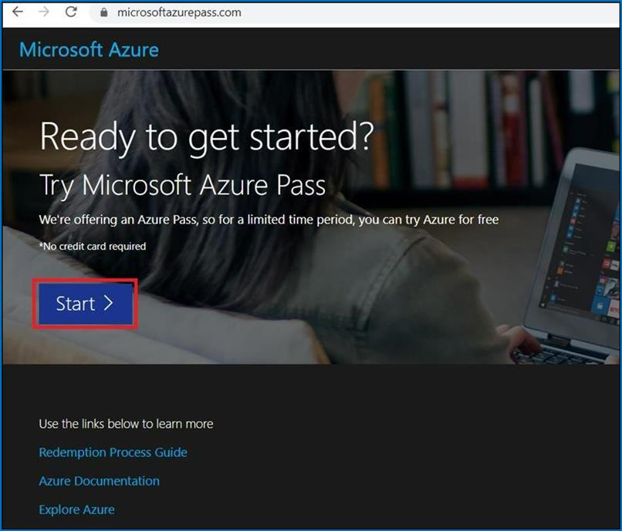

1. Enter your Personal Outlook account details to redeem the provided azure pass.

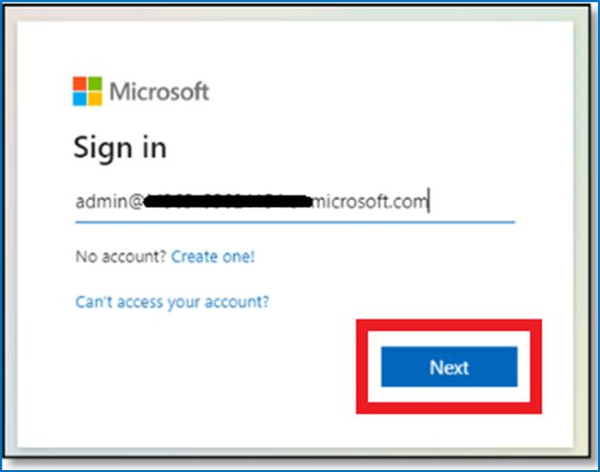

**Note:** Please ensure to use an account that was not previously used to Redeem an Azure Pass It is advisable to create a fresh test outlook account to use for the lab.

1. Click on the **Next** button on the **More information required** prompt.

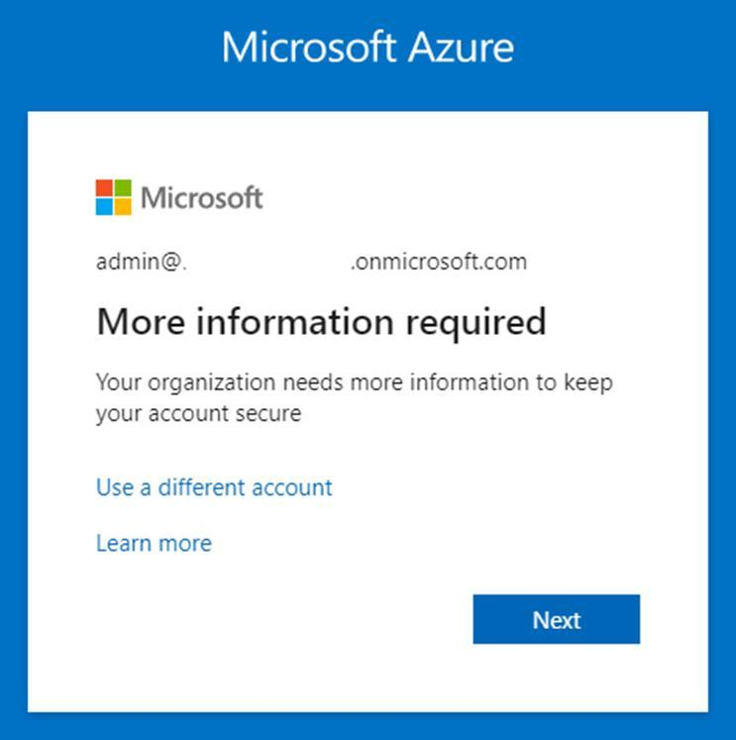

1. Provide the credentials and then complete the MFA sign in

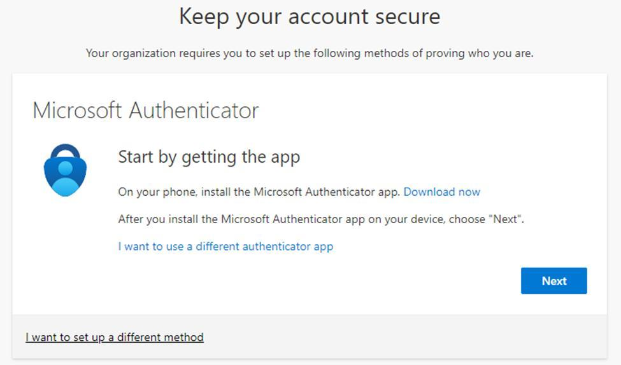

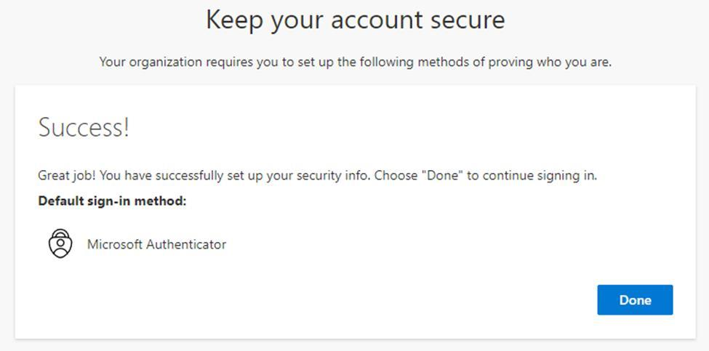

1. Once the authentication is completed you will be redirected to the Azure Pass redemption page.
2. In the **Stayed signed in?** page, click on the **Yes** button.
3. On **The following Microsoft Account will be used for Azure pass** page, click on **Confirm Microsoft Account** button.

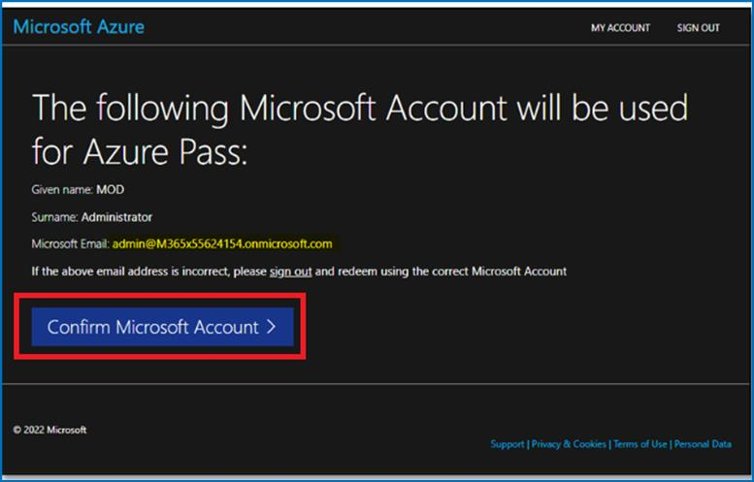

1. Enter the Promocode provided in the lab environment in the **Enter Promo code** field, then enter the characters under the **Enter the characters you see** field and click on the **Submit** button.

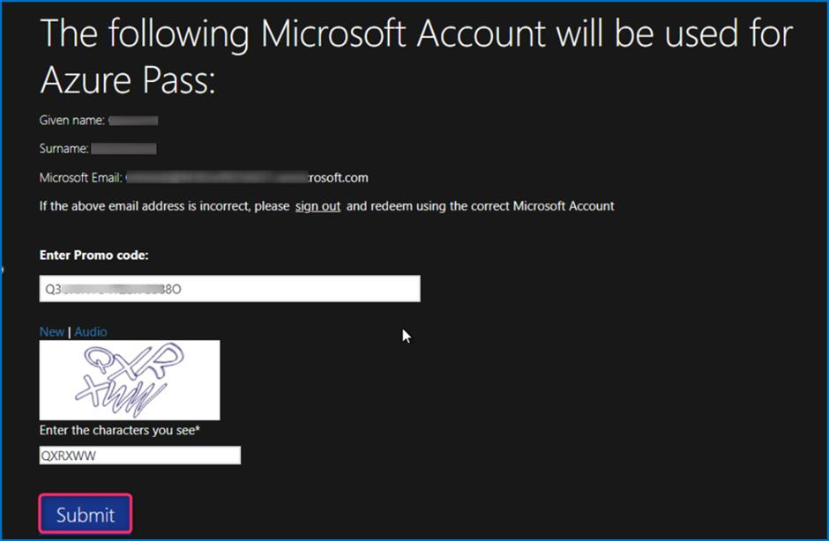

1. **We are processing your request** page will appear, it may take few seconds to process the redemption.

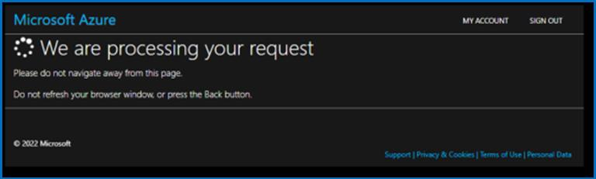

1. Enter the correct details in **Your Profile** page, tick all the check boxes, and then click on **Sign up** button.

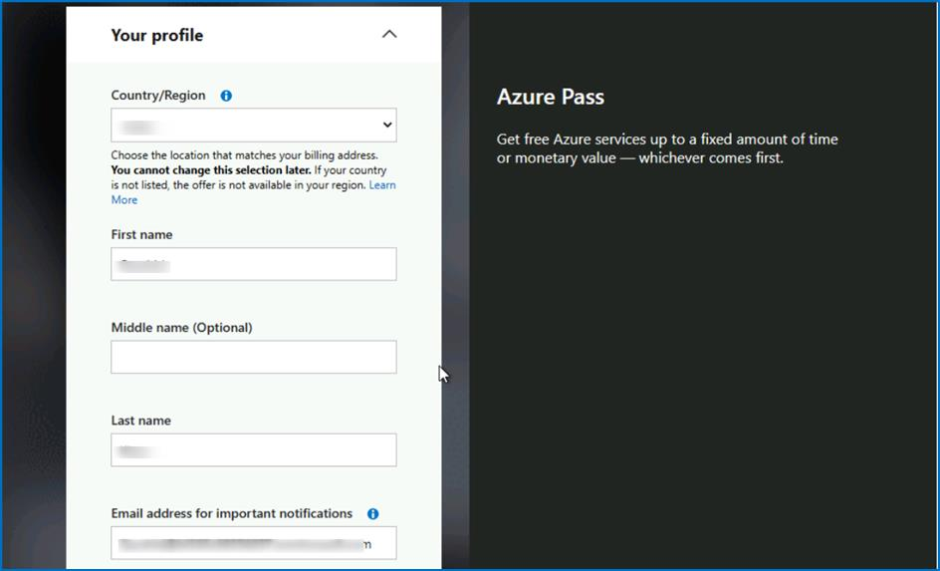

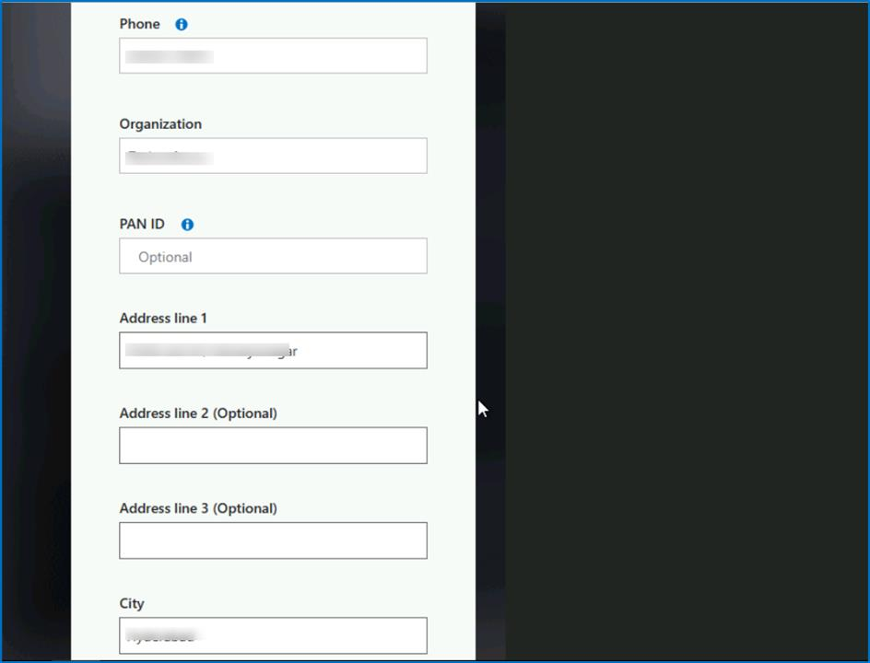

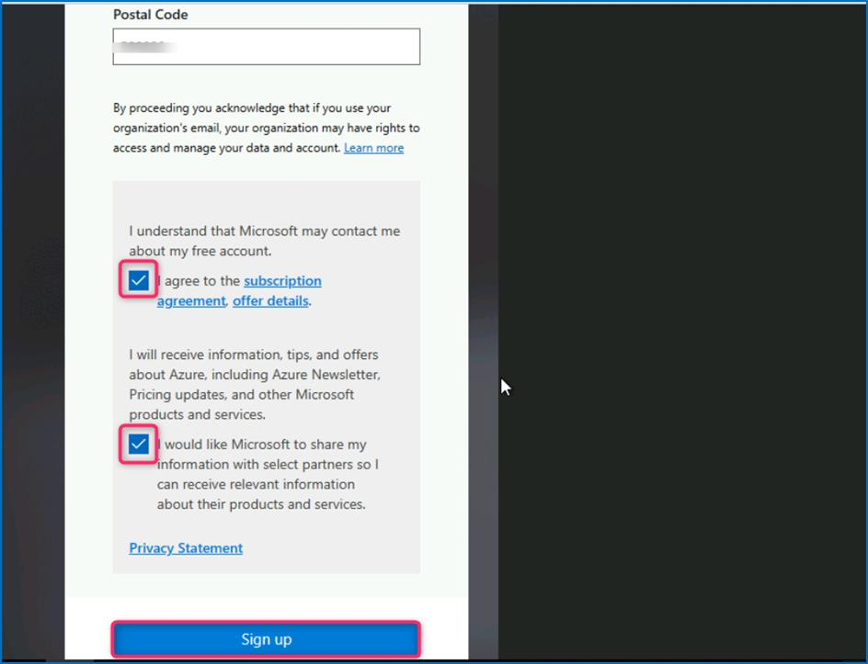

1. On **Are you satisfied with your signup experience** window, enter your feedback and click on the **Submit** button.

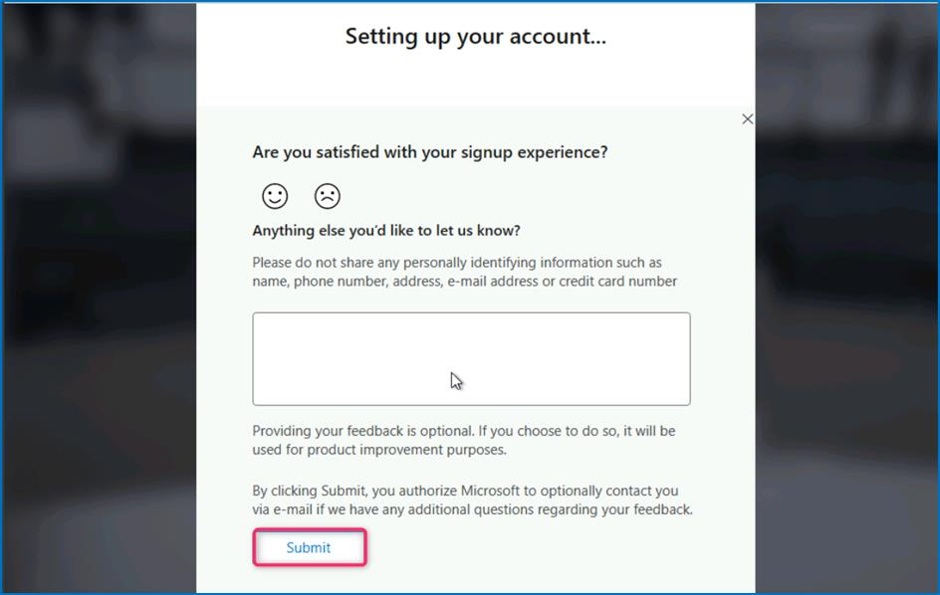

1. It would automatically redirect you to the Azure Portal and now you are ready to use Azure services. On **Welcome to Microsoft Azure** dialog box, click on the **Maybe later** button.

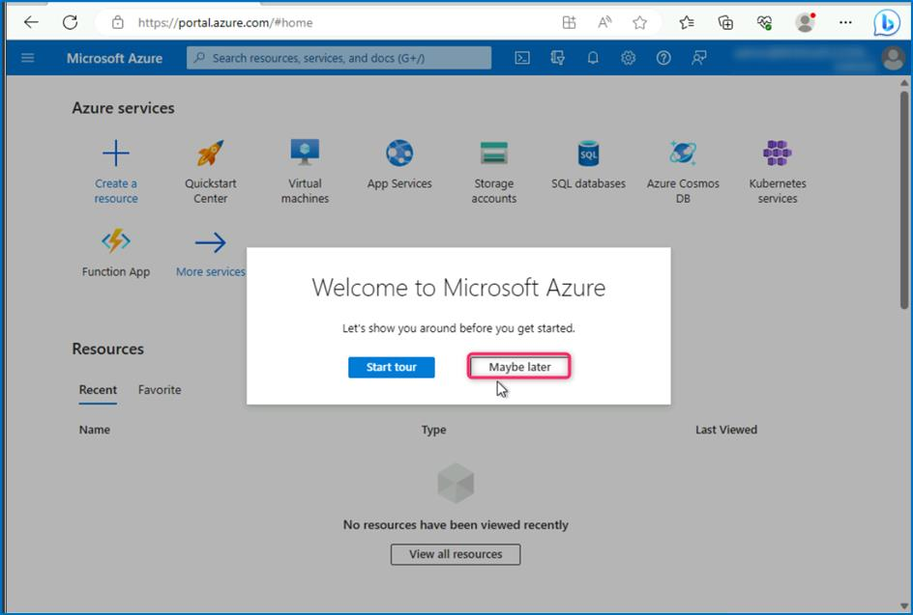

**Task 2 -- Configure Permissions on the Subscription**

1. In the **Azure Portal** **https://portal.azure.com** search box type **subscriptions** and then click **on Subscriptions**.

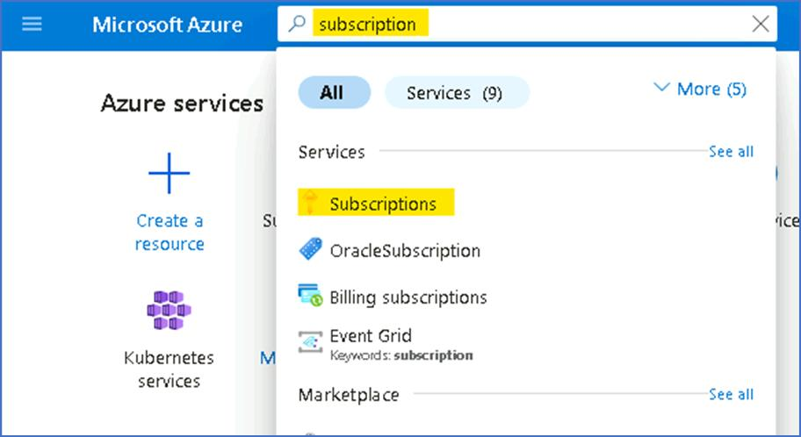

1. From the list of Subscriptions select the **Azure Pass -- Sponsorship**.

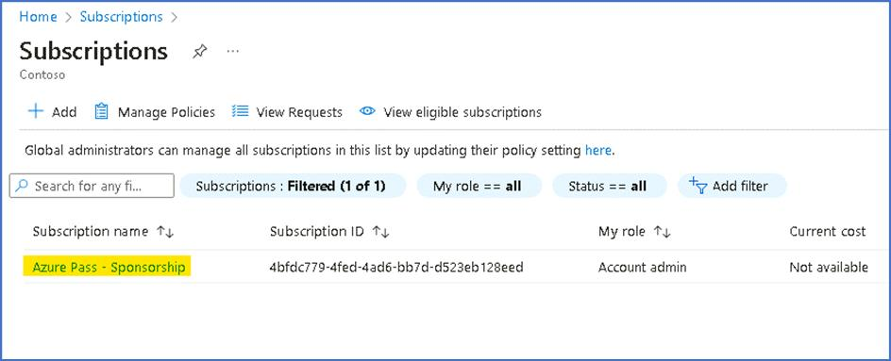

1. On the Azure Pass -- Sponsorship page click on **Access control (IAM)**, then click on **+ Add** drop-down and select **Add role assignment**.

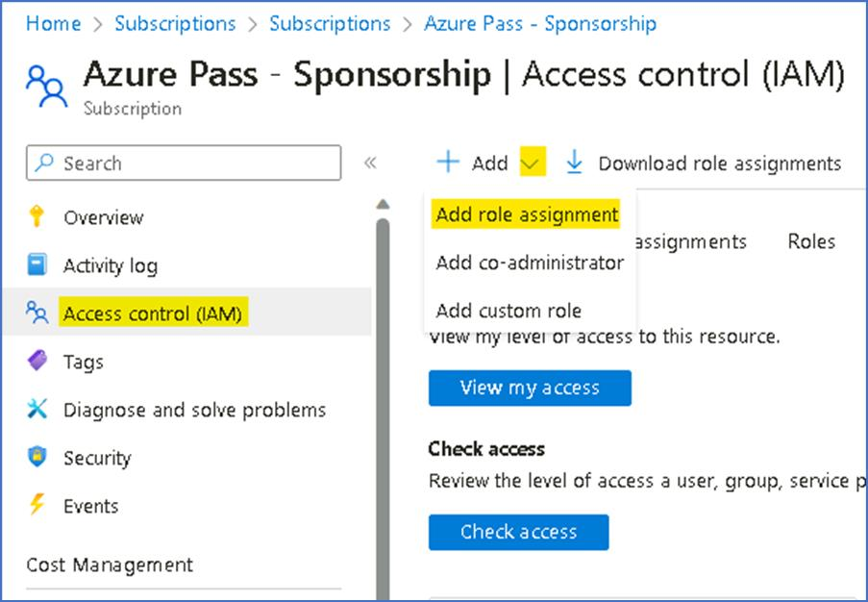

1. On the Add role assignment page, under the **Privileged administrator roles** tab select **Contributor** and then click on **Next**.

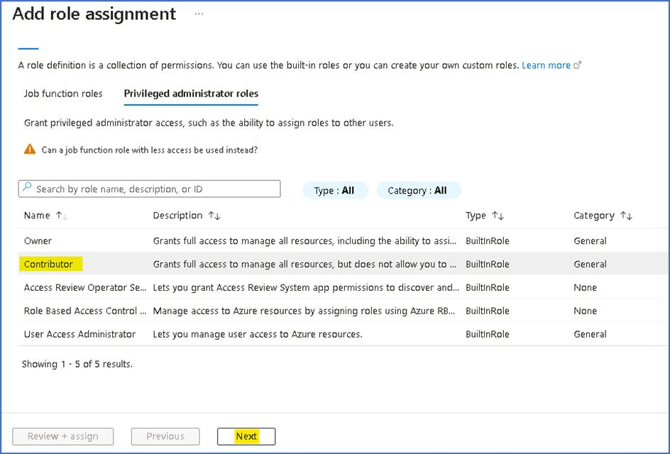

1. On the **Members** tab, click on **+ Select members**, then choose **your outlook account** and then click on the **Select** button.

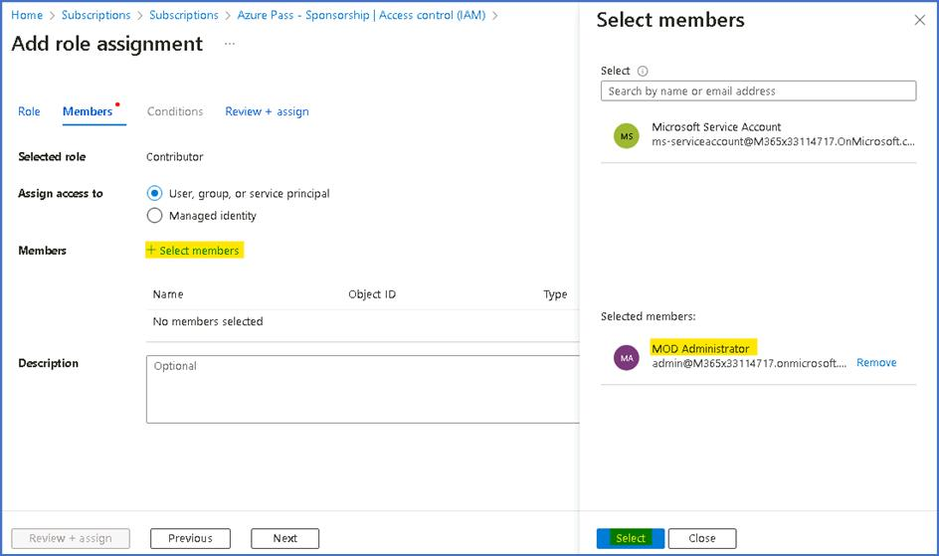

1. Click on **Review + assign** button.

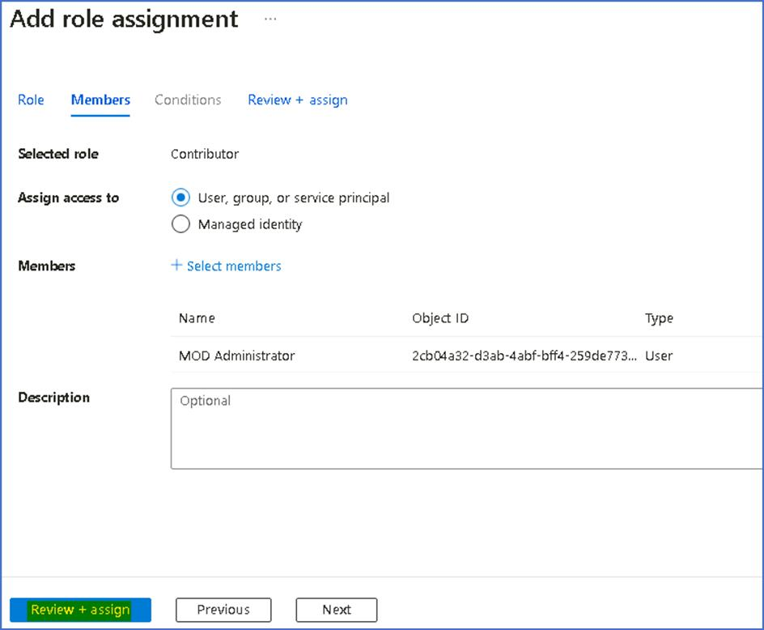

1. Click on **Review + assign** button again.

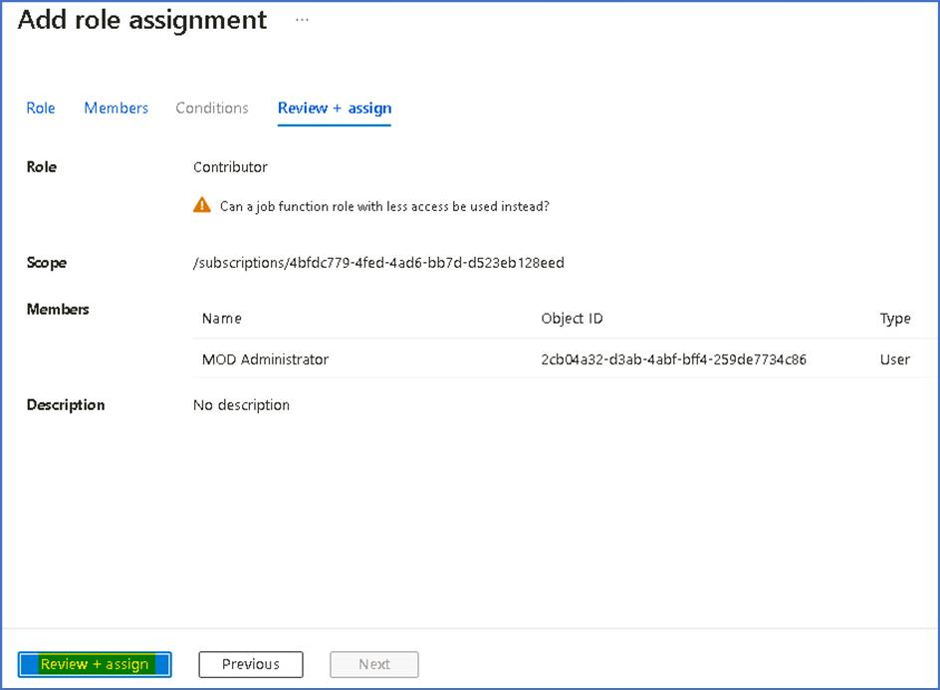

1. You should get the notification as shown in below image.

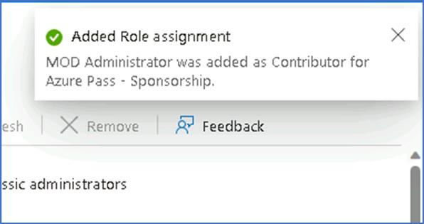

1. Click on the Role assignments tab to view the role assigned in the previous step. We can see the Users listed to whom the Contributor role was assigned.

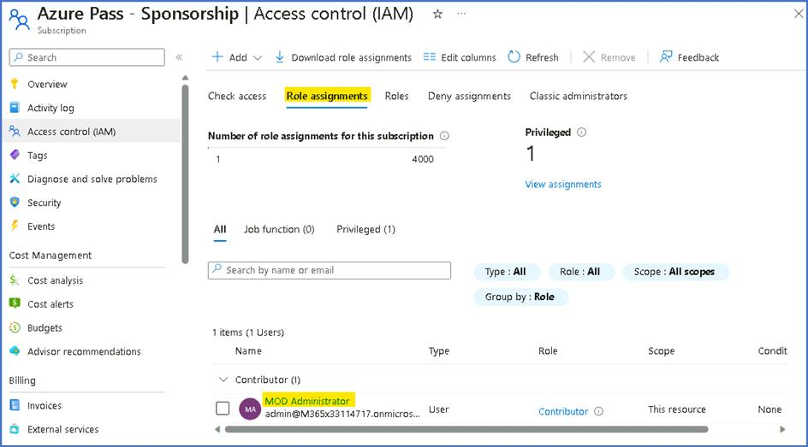

**Task 3 -- Registering required Resource providers**

1. While still on the Subscription page, from the left menu, click on the **Resource Providers** under Settings.

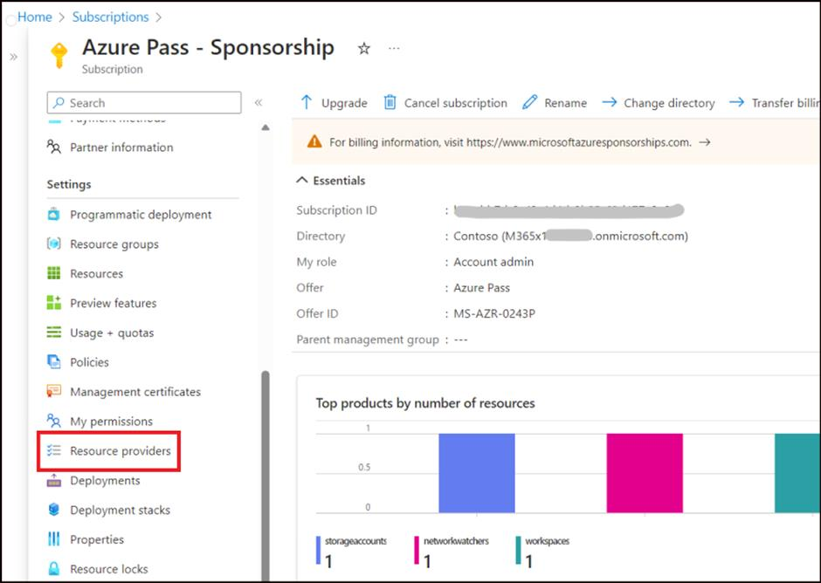

1. In the search bar, type **Microsoft.insight**, select **Microsoft.insight** from the list below and click on Register.

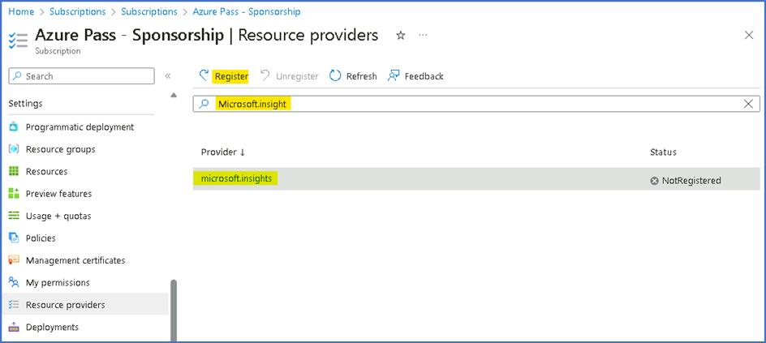

1. A notification stating Successfully registered resource provider is obtained once the registration is successful.

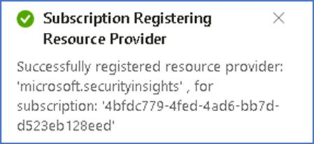

1. Repeat the steps to register the following Resource providers.
   * **Microsoft.web**
   * **Microsoft.SecurityInsights**
   * **Microsoft.Logic**

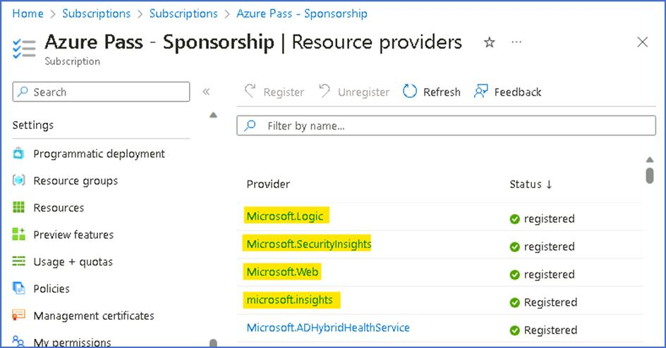

**Task 4 - Security Admin role to be added to Tenant Administrator account**

1. In the browser tab navigate to **https://portal.azure.com/#view/Microsoft_AAD_UsersAndTenants/UserManagementMenuBlade/~/AllUsers** and select **your outlook account**

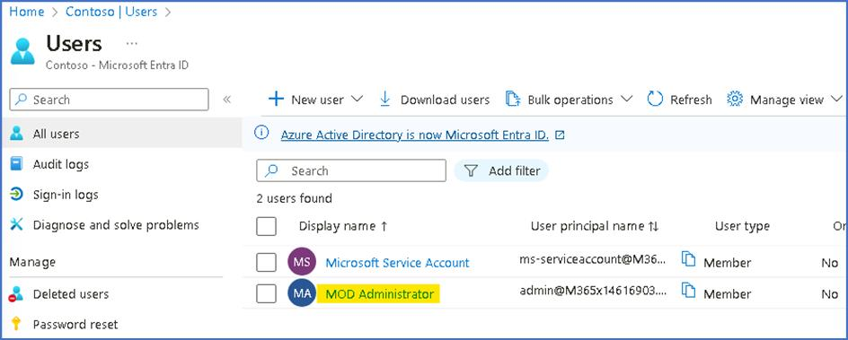

1. Select the **Assigned roles** under Manage and then click on **+ Add assignments.**

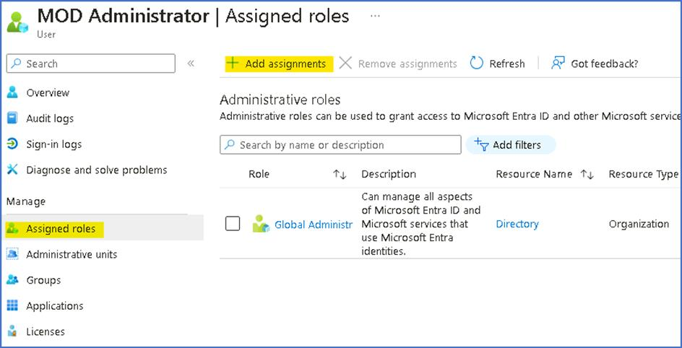

1. Search and select **Security Administrator**, then click on the **Add** button.

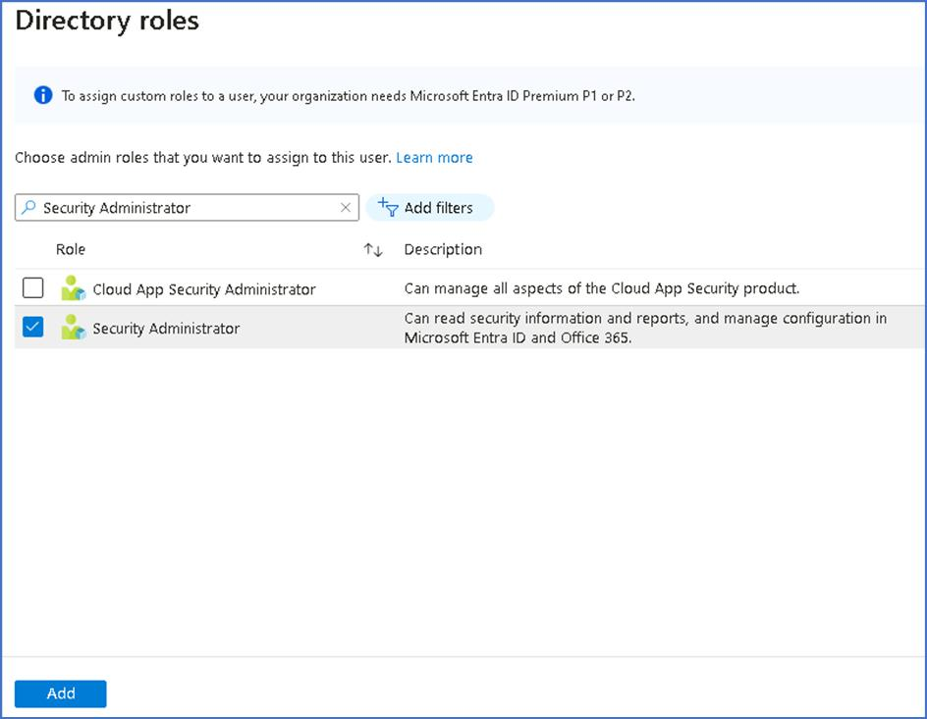

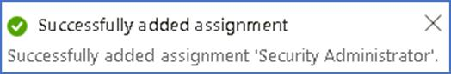

**Task 5 - Enabling the trial for Microsoft Defender for cloud**

1. On the Azure Portal click on **portal menu** and **select Microsoft Defender for Cloud.**

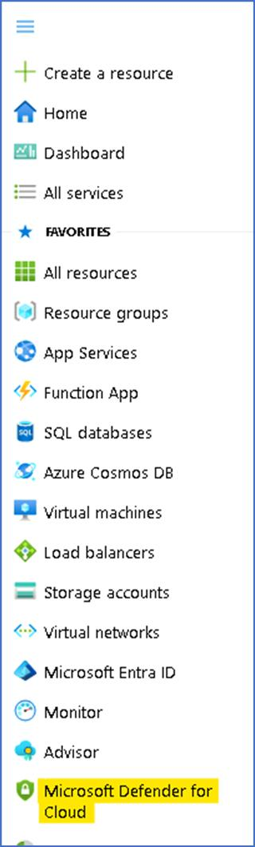

1. Click on **Getting started** page from the left pane, On the **Upgrade** Tab, select subscription (Azure Pass -- Sponsorship) and press Upgrade.

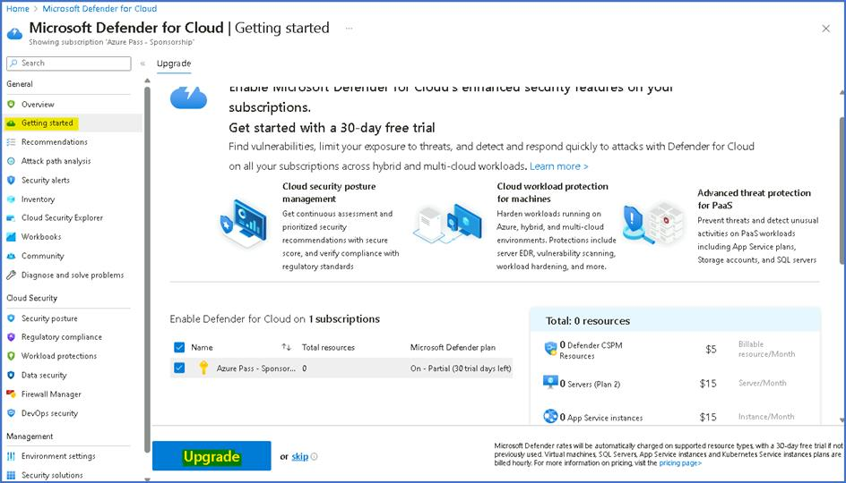

**Note**: You may need to wait for a few minutes for the upgrade to complete.

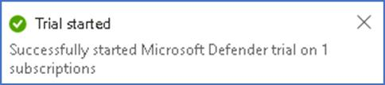

1. Refresh the page and then click on the **Getting started**, then click on **Install agents** tab, then select the **Azure Subscription** and click** Install agents** to install agents to the resources in the subscription.

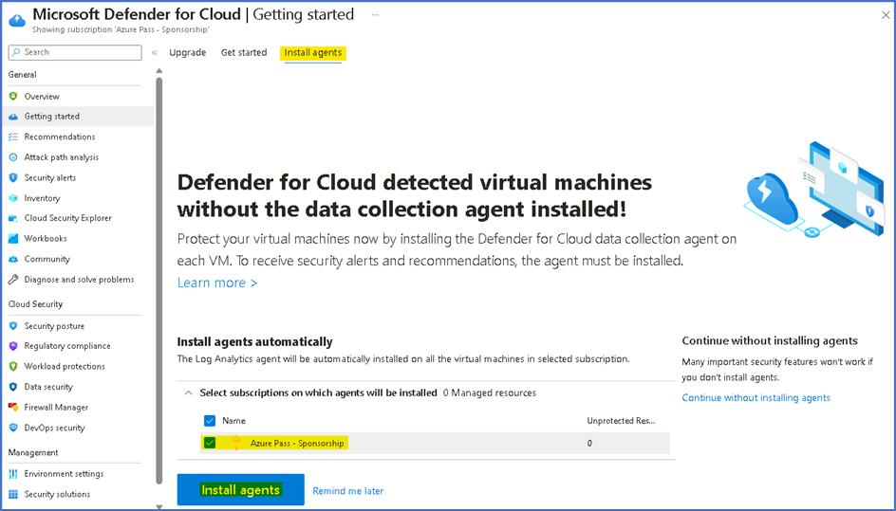

**Note:** You should get the notification as shown in below image "Agents installation initiated"

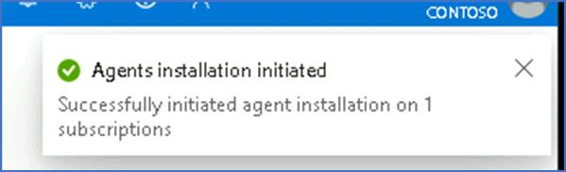

**Task 6 -- Deploy the Microsoft Sentinel.**

In this task we will see how to create a brand-new Microsoft Sentinel workspace.

Navigate to the **http://portal.azure.com** and log in with the **MOD Administrator** credentials provided on the home tab of your lab environment.

In the top search bar, type **Microsoft Sentinel** and click on **Microsoft Sentinel**.

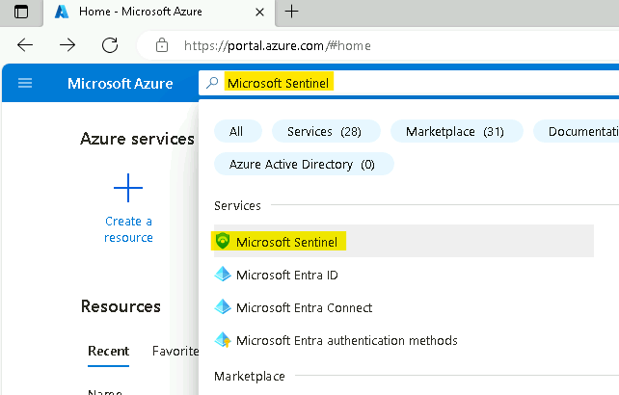

In the **Microsoft Sentinel** screen, click **Create** at the top left.

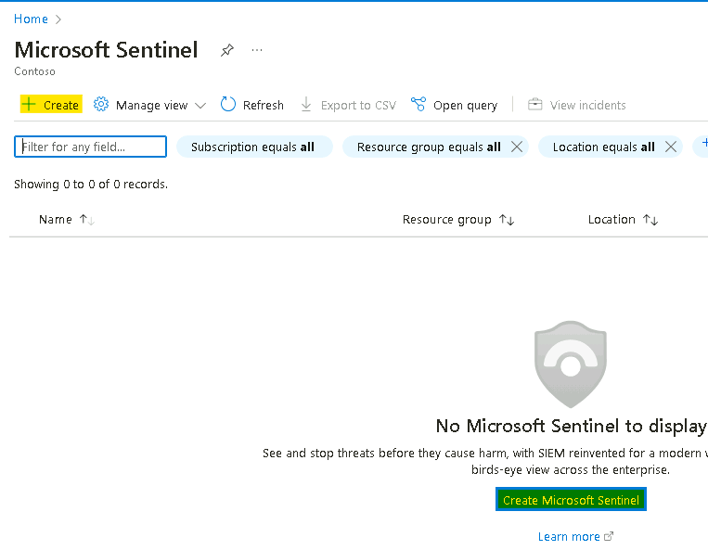

You can choose to add **Microsoft Sentinel** to an existing **Log Analytics** **workspace** or build a new one. We will create a new one, so click on **Create a new workspace**.

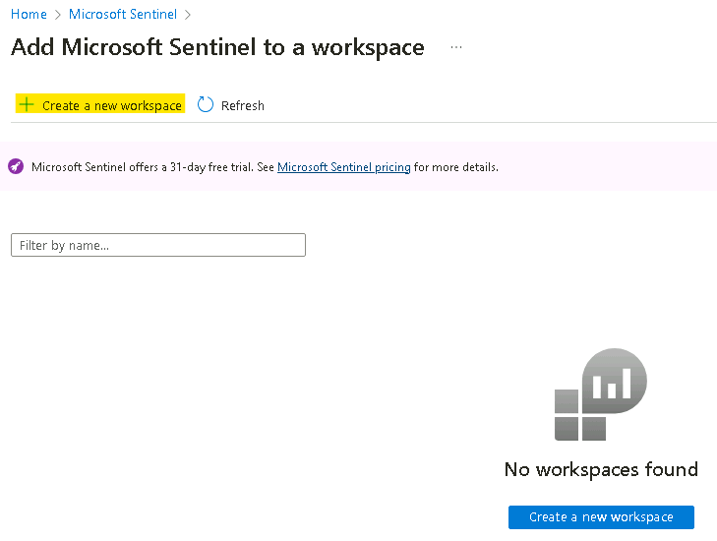

In the Create Log Analytics workspace page, fill out the form as follows:

* Subscription: **Azure Pass - Sponsorship**
* Resource Group: click on **Create new**
* Resource group name: !!**RG4Sentinel!!**
* Region: **East US**
* Workspace Name: !!**SwrkXXXXXXX!! [Substitute XXXXXXX with number from you Tenant name]**
* Click **Review + create**.

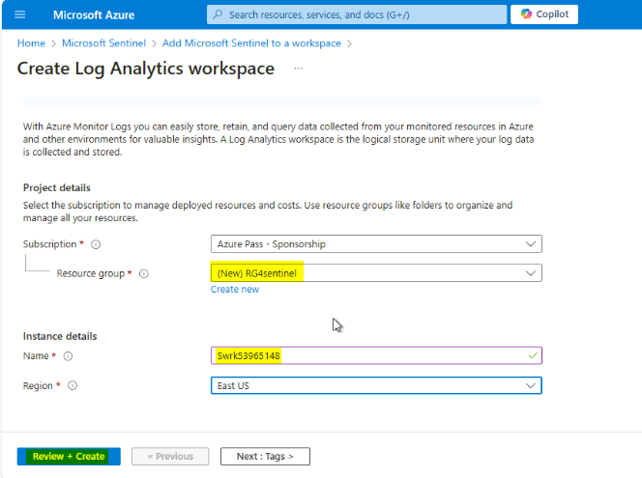

Click **Create** after the validation completes. The creation takes a few seconds.

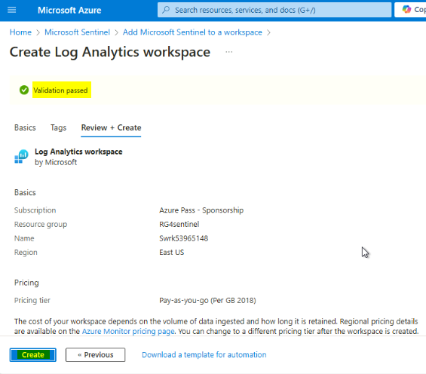

You will be redirected back to the **Add Microsoft Sentinel** to a workspace page, click on the **Refresh** button.

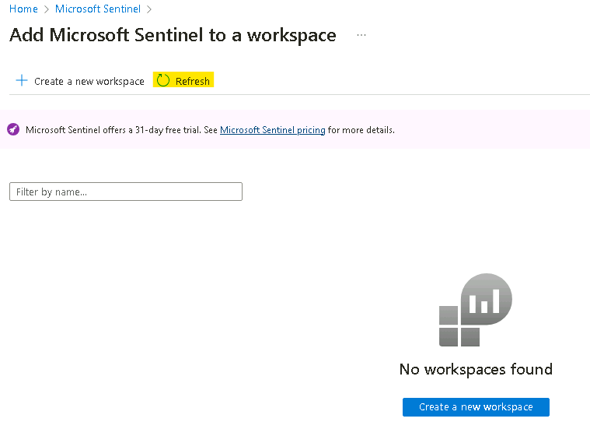

Select your workspace and click **Add** at the bottom.

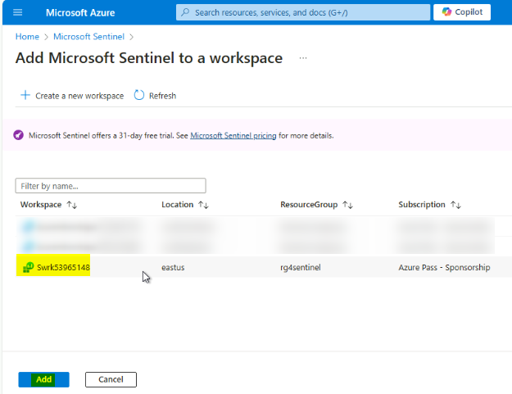

You should receive notification as shown in below image

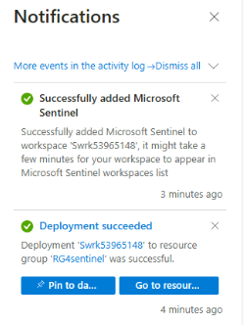

Your Microsoft Sentinel workspace is now ready to use!

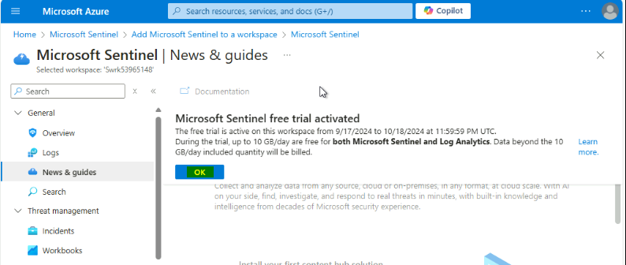

**Task 7: Deploy the Microsoft Sentinel Training Lab Solution**

In this exercise you will deploy the Training Lab solution into your existing workspace. This will ingest pre-recorded data (~20 MBs) and create several other artifacts that will be used during the exercises.

In the Azure Portal (**http://portal.azure.com**), go to the top search bar and type **Microsoft Sentinel Training**. Select the **Microsoft Sentinel Training Lab Solution (Preview)**, a Marketplace item.

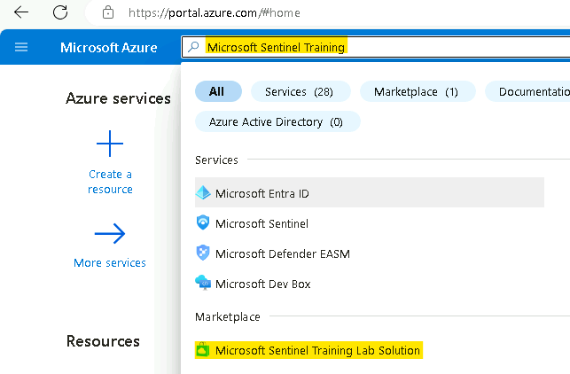

Read the solution description and click **Create** at the top.

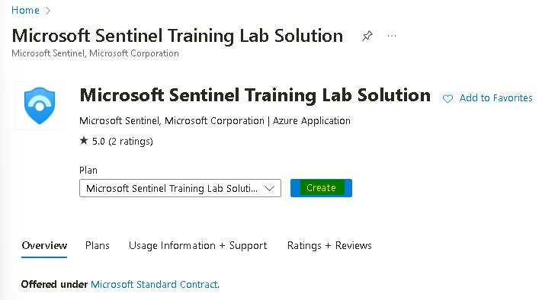

In the **Basics** tab, select **Azure pass - Sponsorship** as the **Subscription**, **RG4Sentinel** as the **Resource Group** and [**SwrkXXXXXXX**](urn:gd:lg:a:send-vm-keys)  as the **Workspace**.

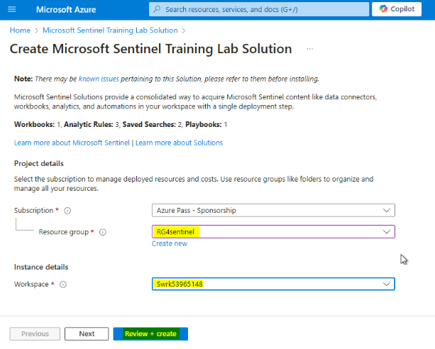

Optionally, review the different tabs (**Workbooks**, **Analytics**, **Hunting Queries**, **Watchlists**, **Playbooks**) in the solution. When ready, click on **Review + create**.

Once validation is ok, click on **Create**. The deployment process takes about 15 minutes.

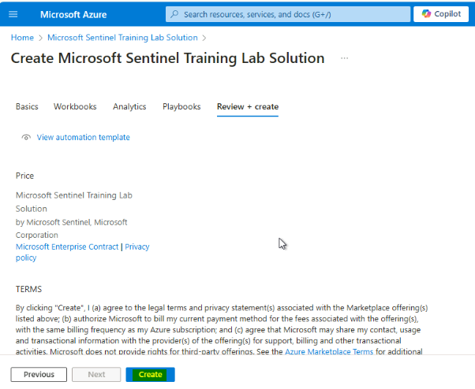

**Note** – The deployment will take up to 15 minutes to complete.

You can proceed ahead with the next exercise while the deployment is in progress.

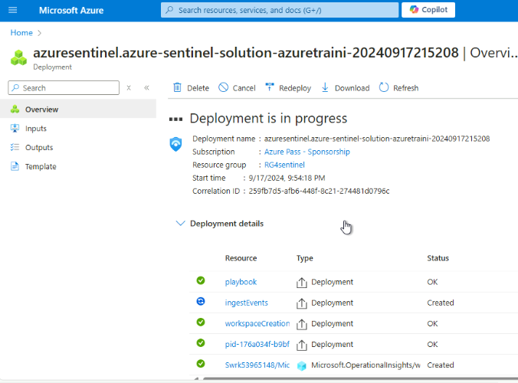

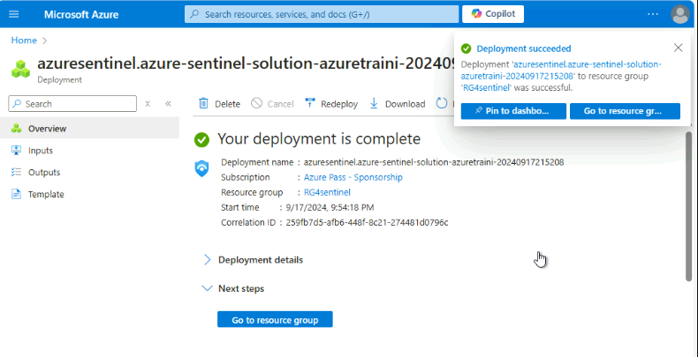

**Task 8 -- Explore the Microsoft Sentinel dashboard**

1. In the top search bar, type Microsoft Sentinel and click on Microsoft Sentinel.

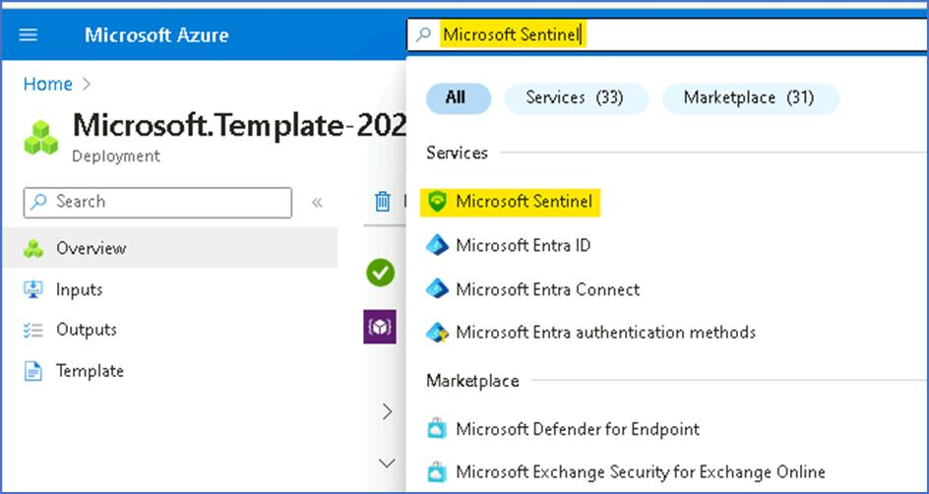

1. On the Microsoft Sentinel screen, select the Log analytic workspace created during the deployment.

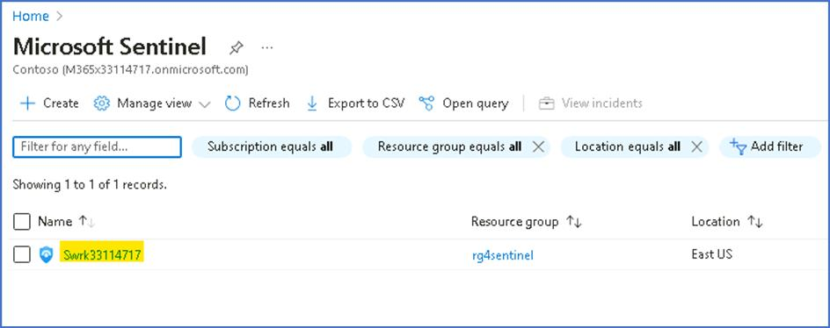

1. The **Overview (Preview)** page provides the Dashboard display details for the below.

i. **Incidents**

ii. **Automation**

iii. **Data**

iv. **Analytics.**

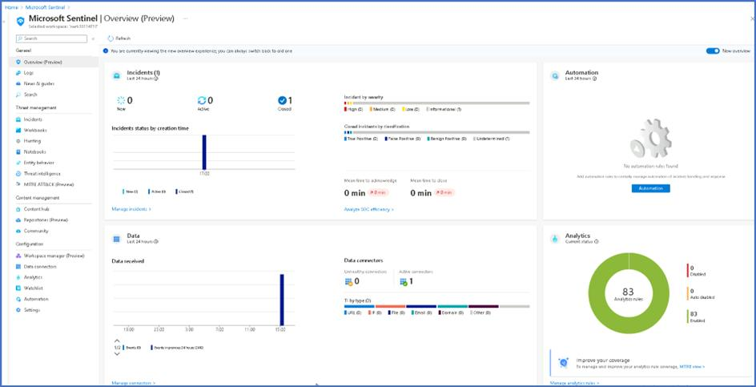

1. Incidents details will populate once the incidents occur in the environment.

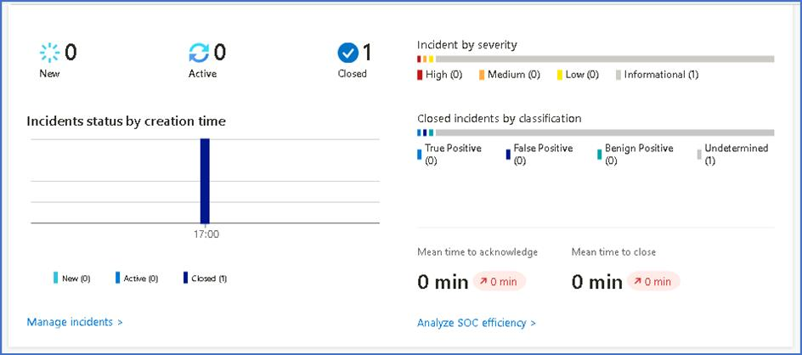

1. The Automation rules that are create will appear under the Automation dashboard.

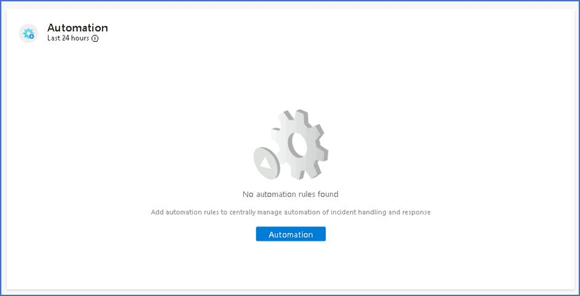

1. The Data dashboard will display the Connector health and Data received

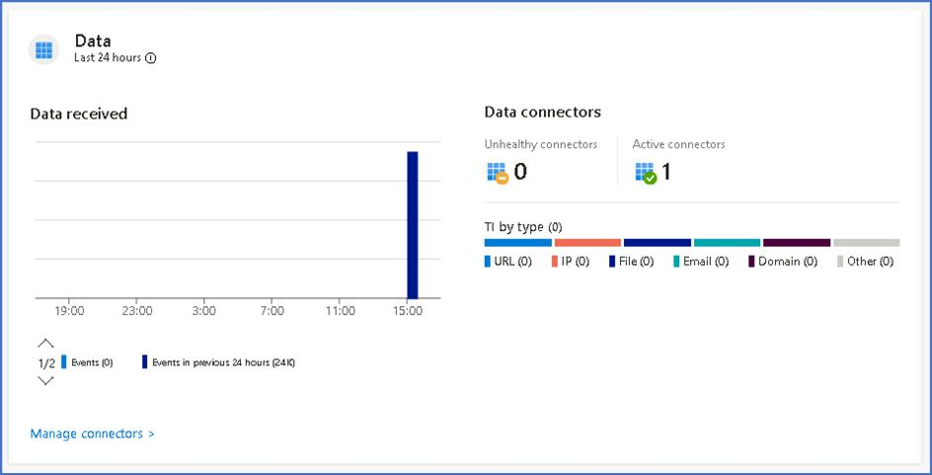

1. The Analytics dashboard will display the details of Analytics rules.

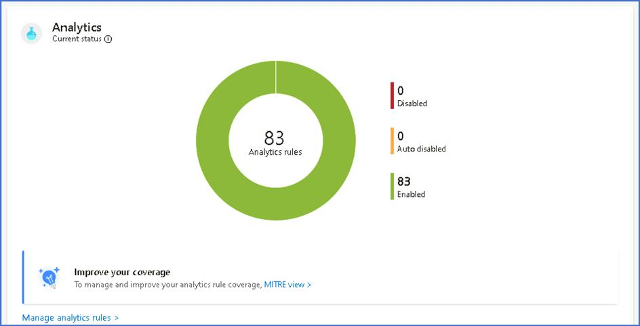

**Task 10 – Configure Microsoft Sentinel Playbook**

In this task, we will create a Playbook that will be later used in the lab.

1. Open a new tab and browse to the Resource group page - https://portal.azure.com/#view/HubsExtension/BrowseResourceGroups
2. Click on the Resource group **RG4Sentinel**.

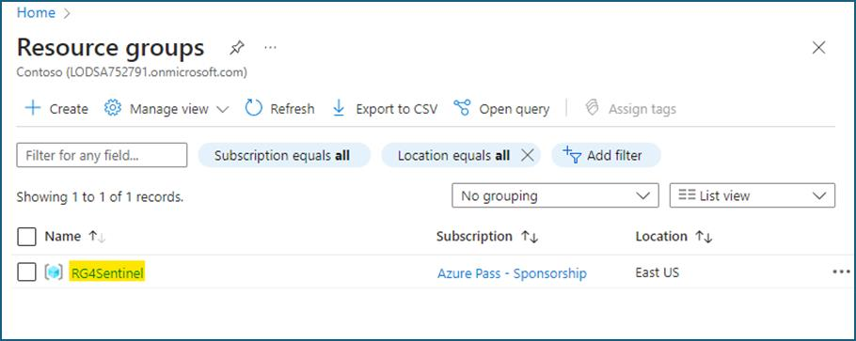

1. Click on **Access control (IAM)**, then click on **+ Add** drop-down and select **Add role assignment**.

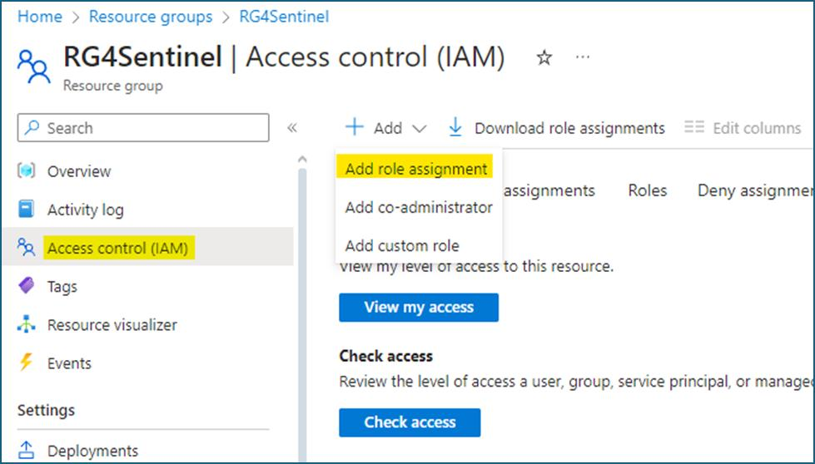

1. On the Add role assignment page, under the **Privileged administrator roles** tab select **Owner** and then click on **Next**.

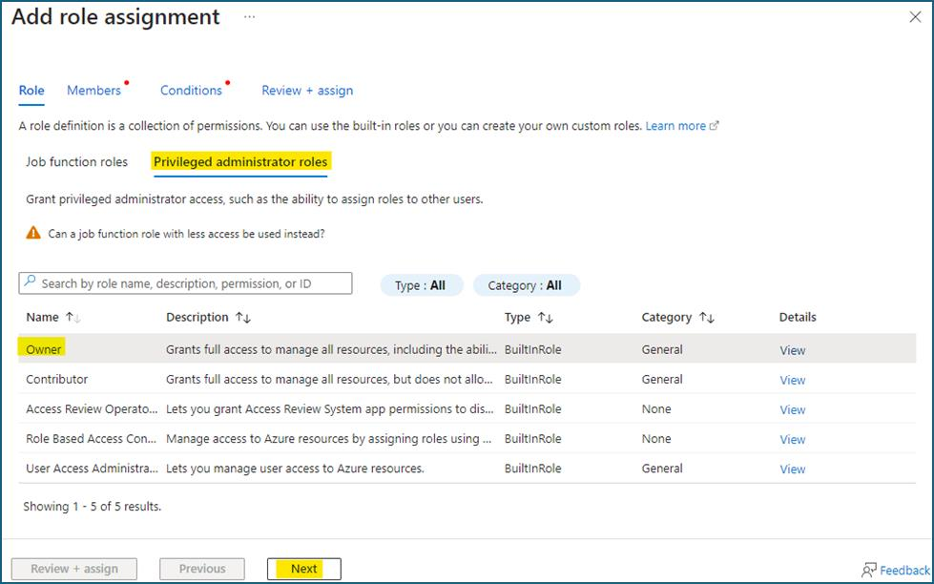

1. On the **Members** tab, click on **+ Select members**, then choose **your outlook account** and then click on the **Select** button.

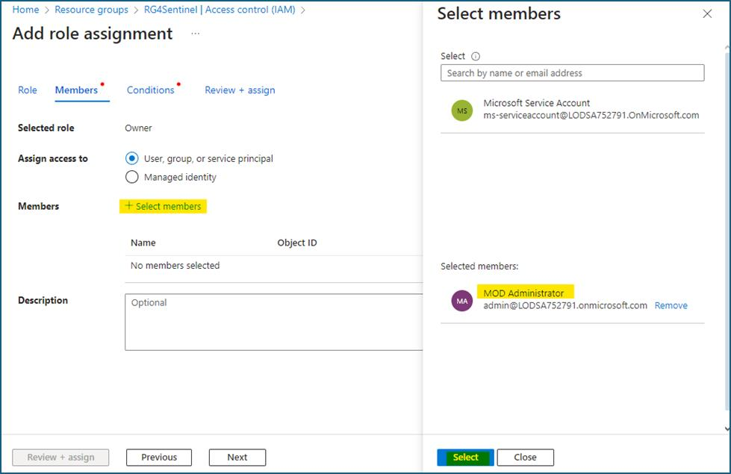

1. Click on the **Next** button.
2. On the Conditions tab, click on the **Allow user to assign all roles (highly privileged)** radio button and click on **Review + assign**.

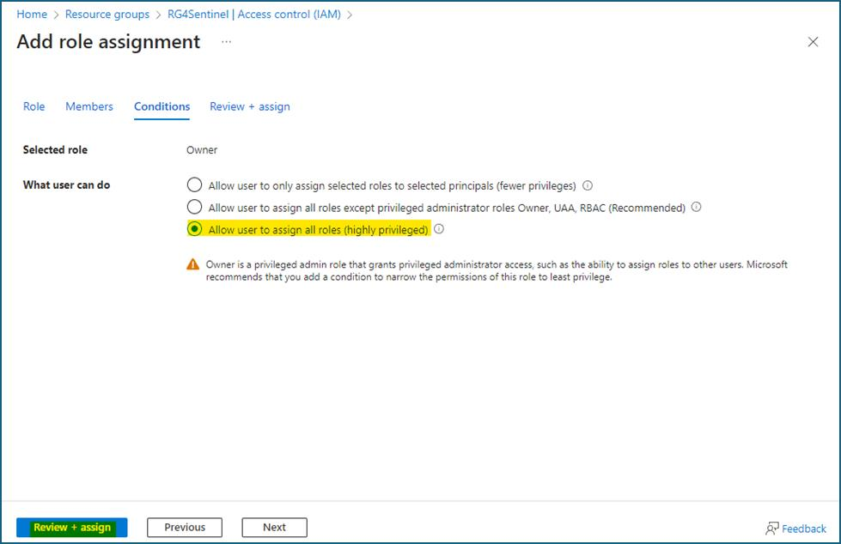

1. On the **Review + assign** tab, click on the **Review + assign** button.

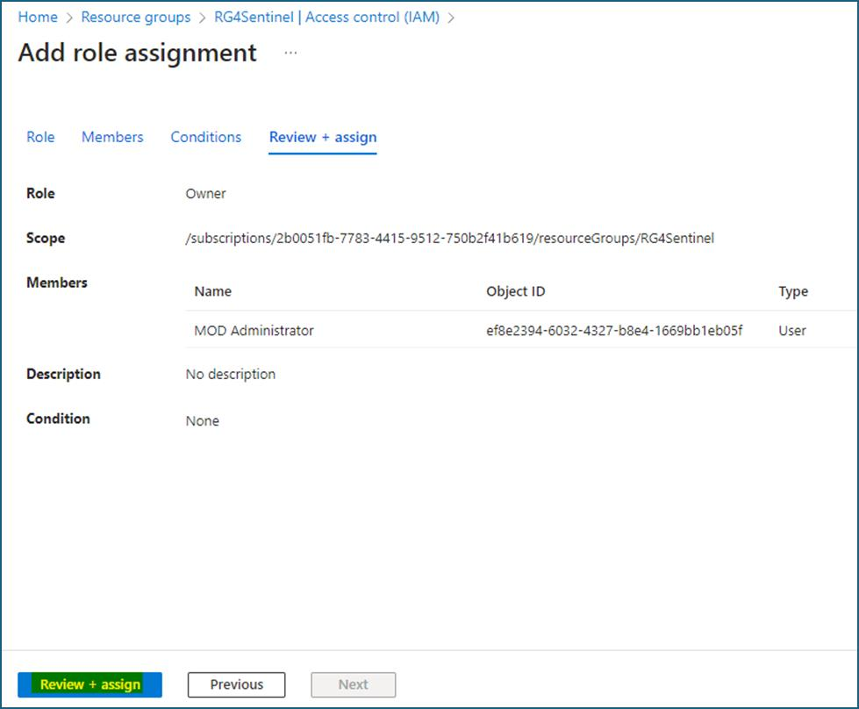

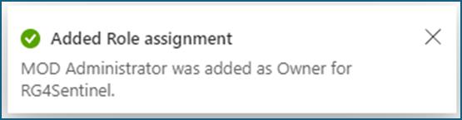

1. From the **Microsoft Sentinel** navigation menu, go to **settings**. Select the **Settings** tab at the top of the page.

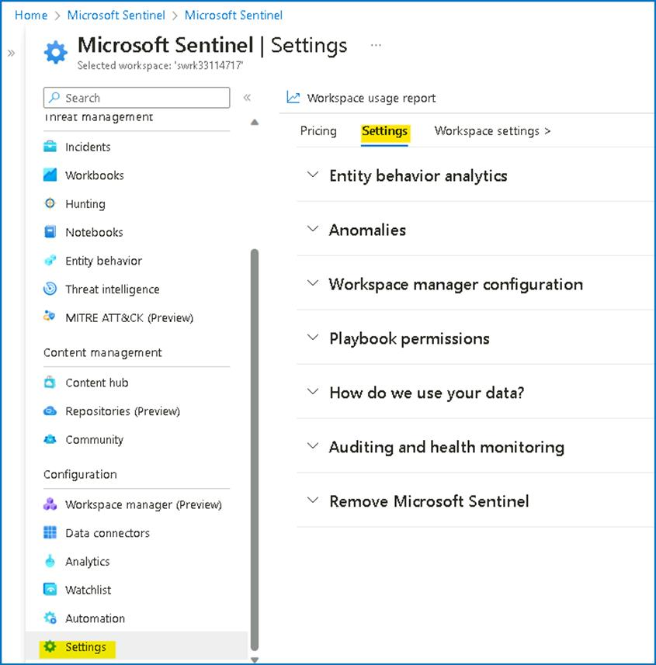

1. Scroll down and under **Playbook permissions**, select **Configure permissions**.

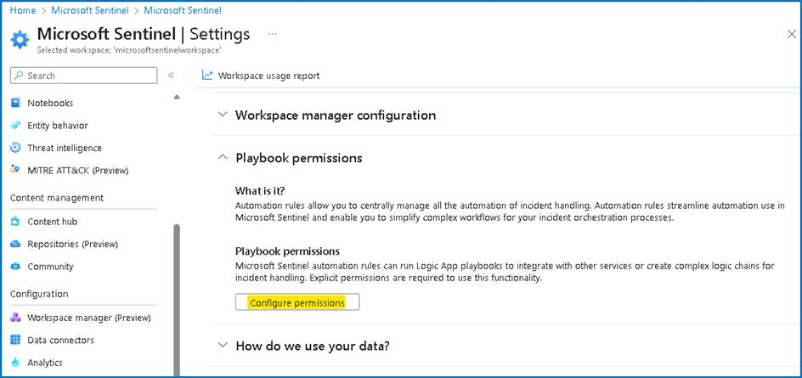

1. Select **RG4Sentinel** and select **Apply**.

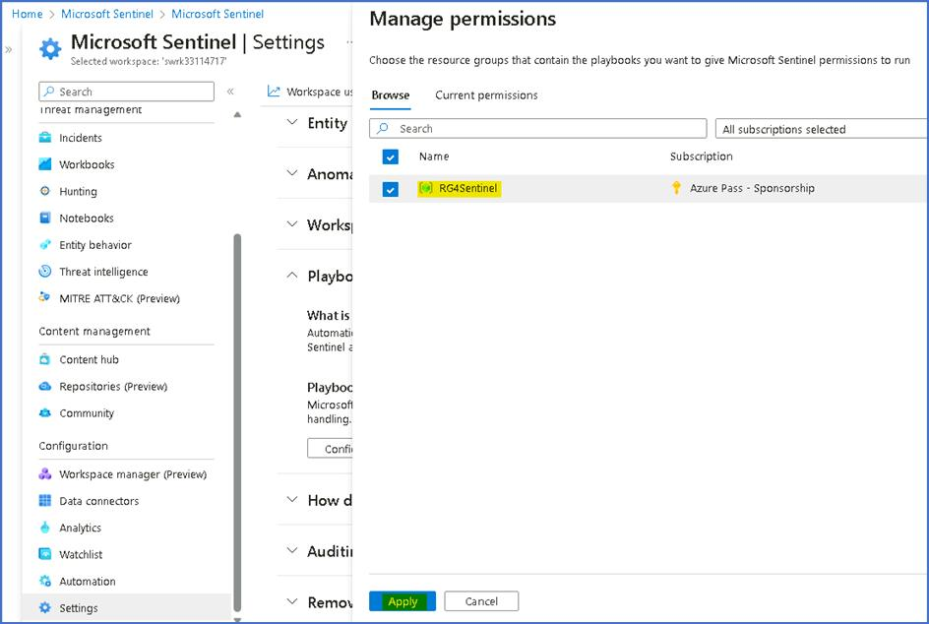

1. You will see a message that you **Finished adding permissions**.

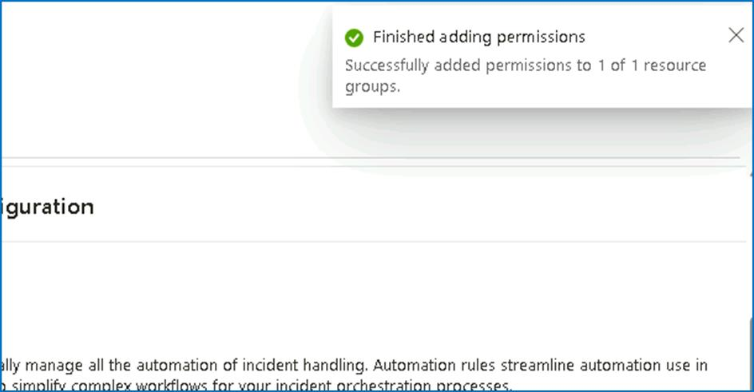

1. From the **Microsoft Sentinel** navigation menu, select **Automation**.

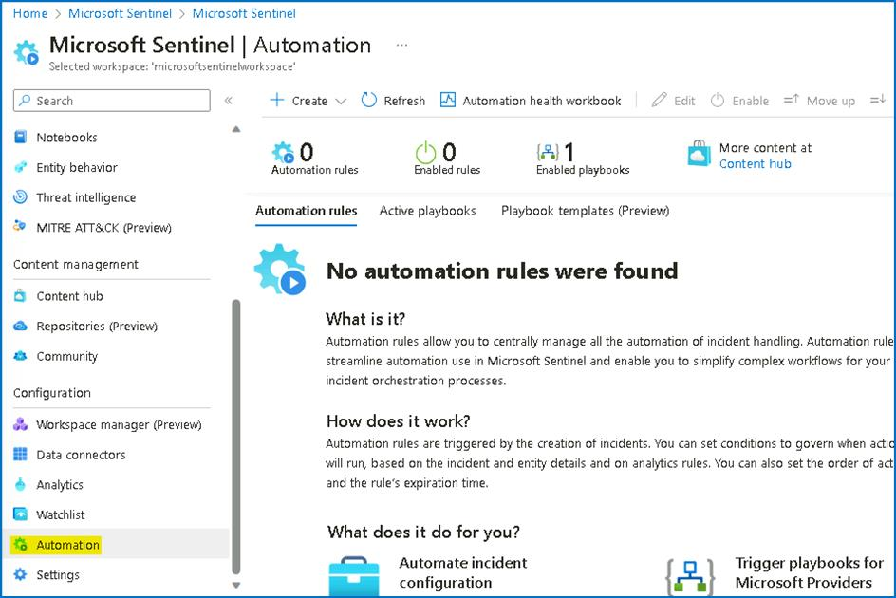

1. From the top menu, select **Create** > **Playbook with incident trigger**.

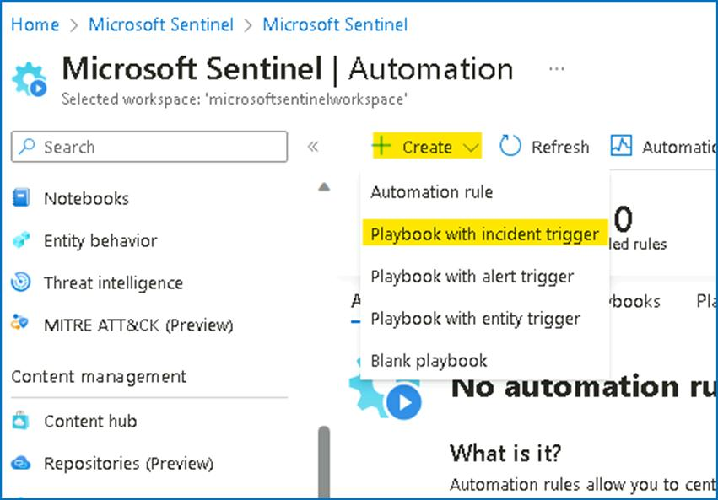

1. Add the following details and click on **Next : Connections**.
   * Subscription -- **Azure Pass - Sponsorship**
   * Resource group -- **RG4Sentinel**
   * Playbook name -- **customplaybook**
   * Check the box near Enable diagnostics logs in log analytics.

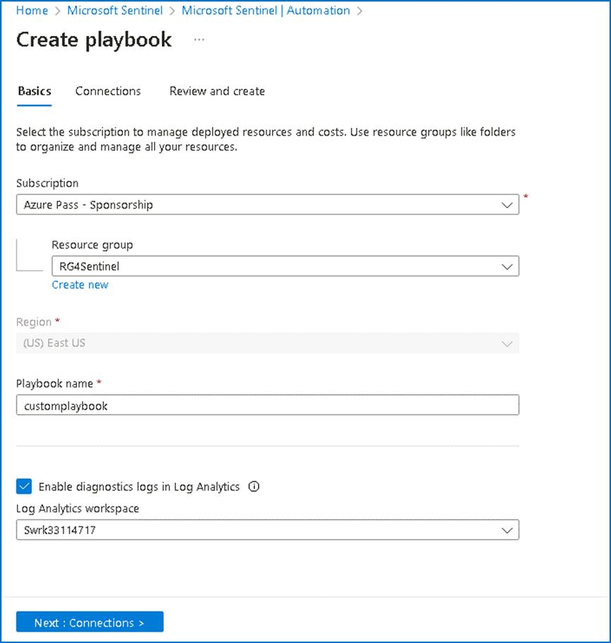

1. Click on **Next: Review and create**.

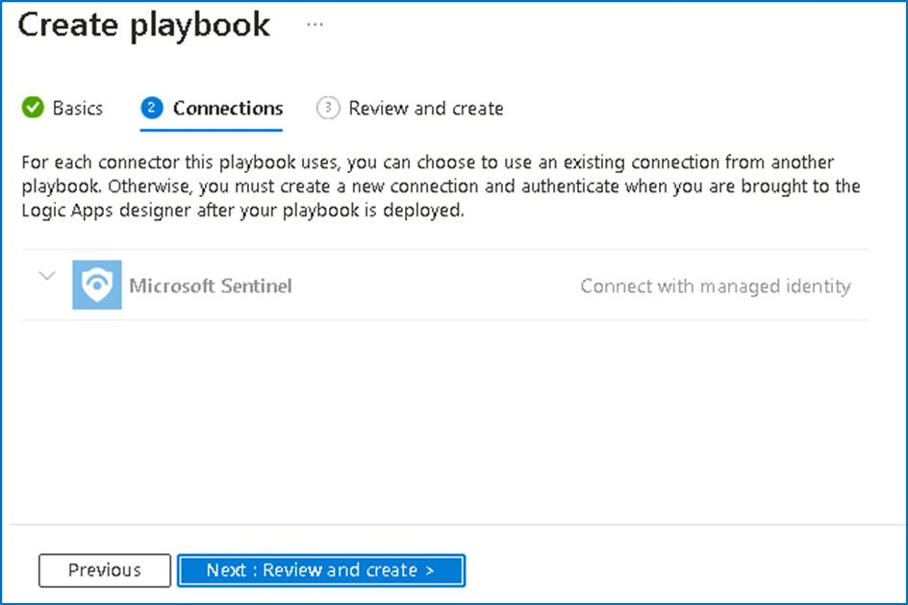

1. Then click on **Create playbook** button.

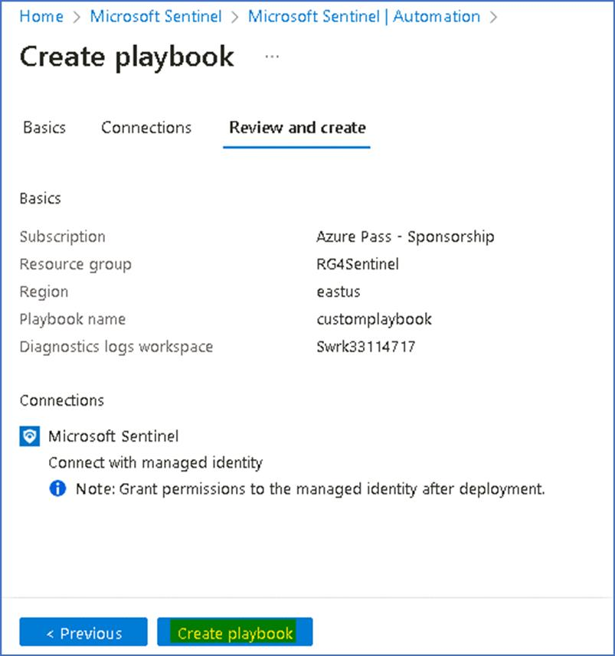

1. Click on **Enable Legacy Designer**

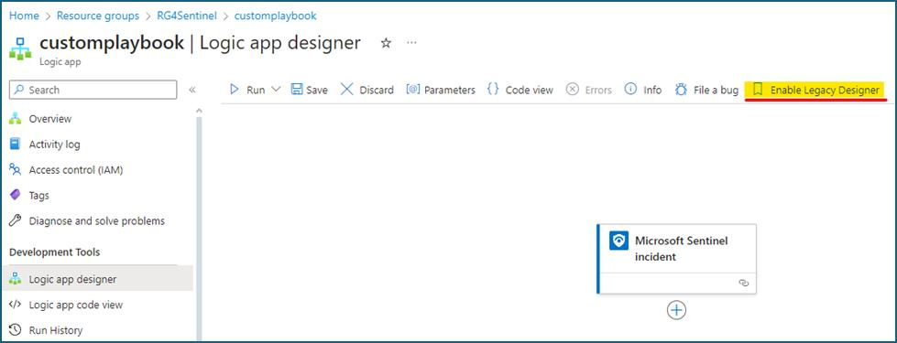

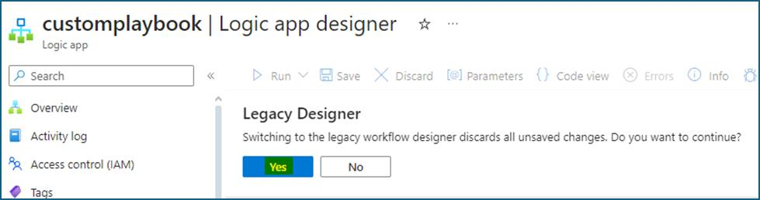

1. On the Add an action search for **Add comment to incident** and select **Add comment to incident (V3) (Preview)**.
2. In the logic app designer, select **+ New step**.

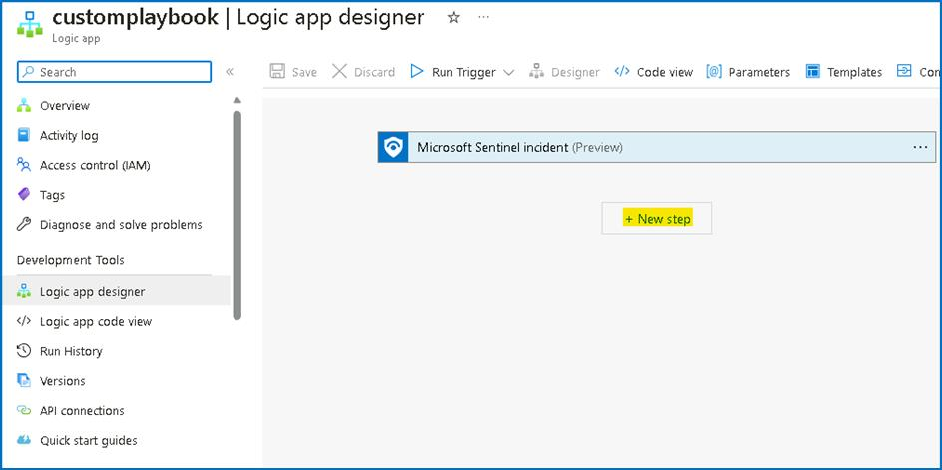

1. Search for **Add comment to incident** and select **Add comment to incident (V3) (Preview)**.

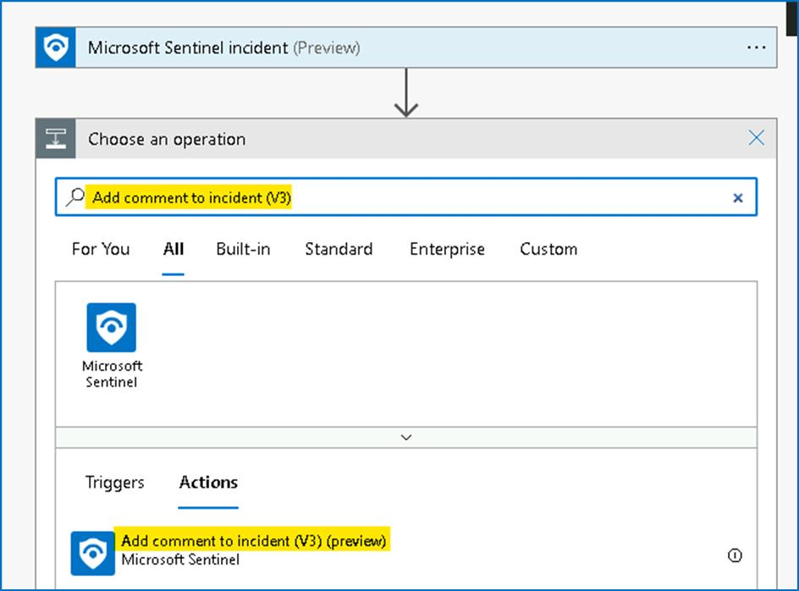

1. In the Incident ARM ID, select **Add dynamic content** and click on **Incident ARM ID**.

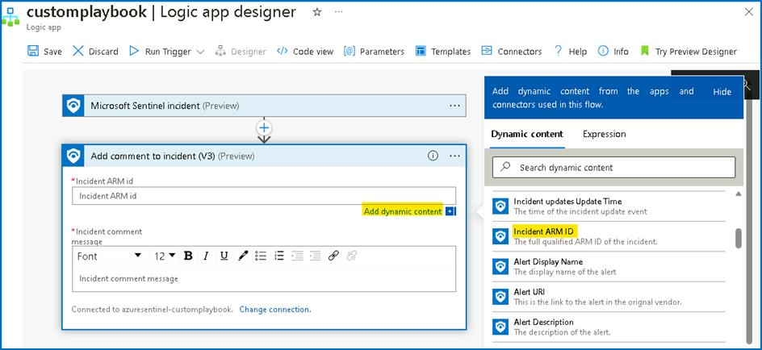

1. In the comment section type -- **This comment marks the successful run of our custom playbook**.
2. If you do not see the step Connected to **azuresentinel-customplaybook** select **Change Connection**.

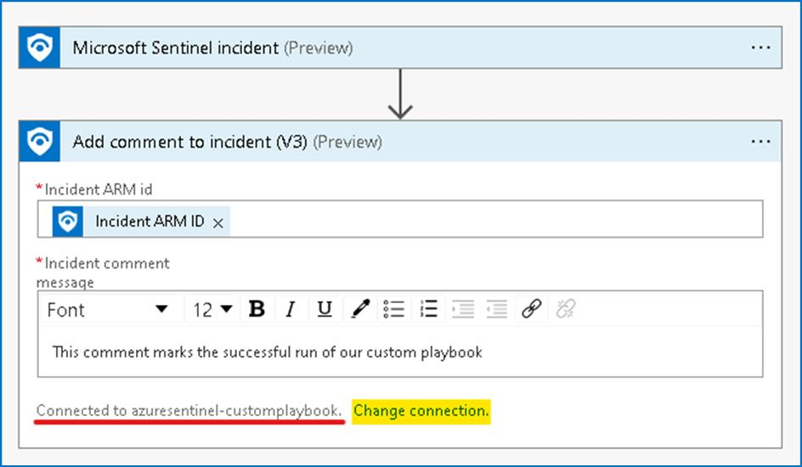

1. Select **azuresentinel-customplaybook**.

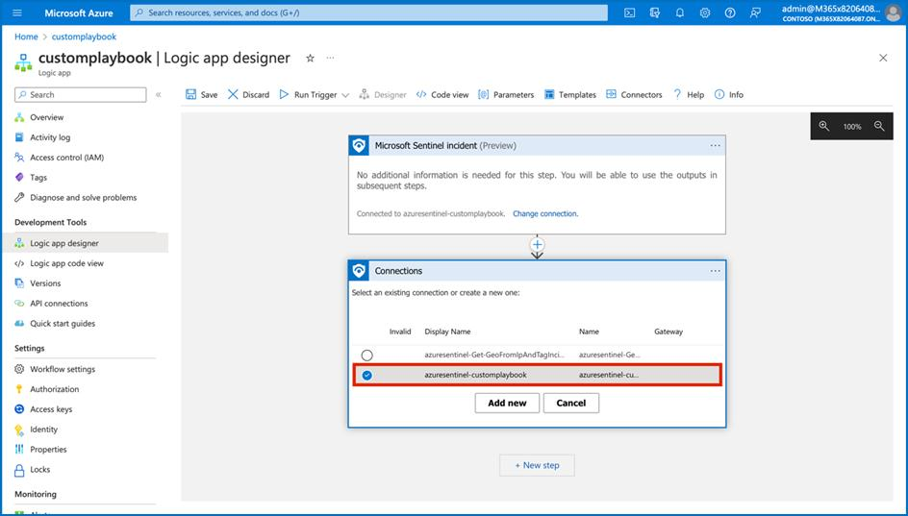

1. Click **Save**.

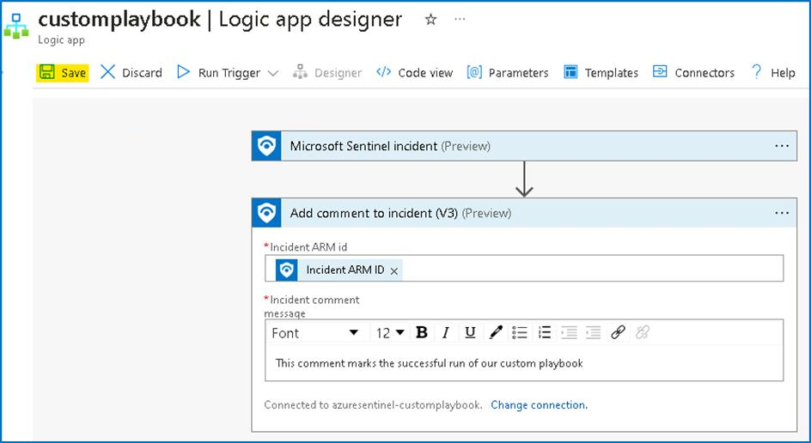

Congratulations! You successfully created a playbook that adds the comment to any incidents. You can modify the steps according to your need in the flow designer to create custom automation flow.

**Task 9 - Configure Microsoft Sentinel Playbook**

In this task, we will configure a Playbook that will be later used in the lab. This will allow the playbook to access Sentinel.

1. From the Azure Portal **http://portal.azure.com** click on the Portal menu and select **Resource Groups**.

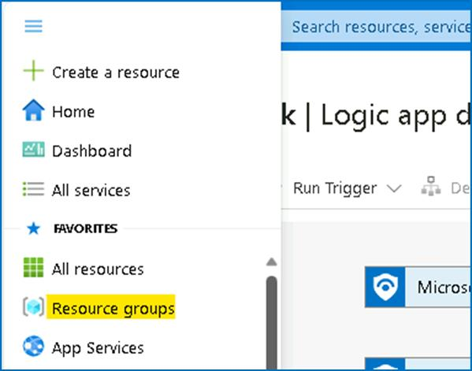

1. Select **RG4Sentinel**.

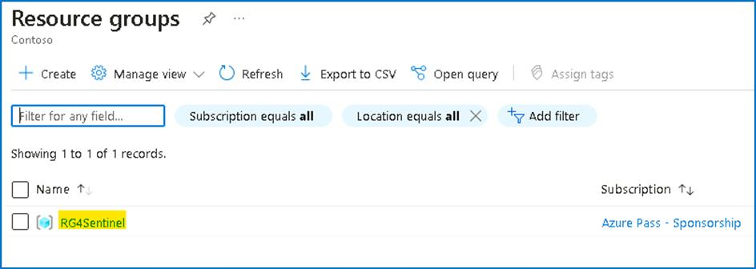

1. In the resource group you should see an API Connection resource called **azuresentinel-Get-GeoFromIpAndTagIncident**, click on it.

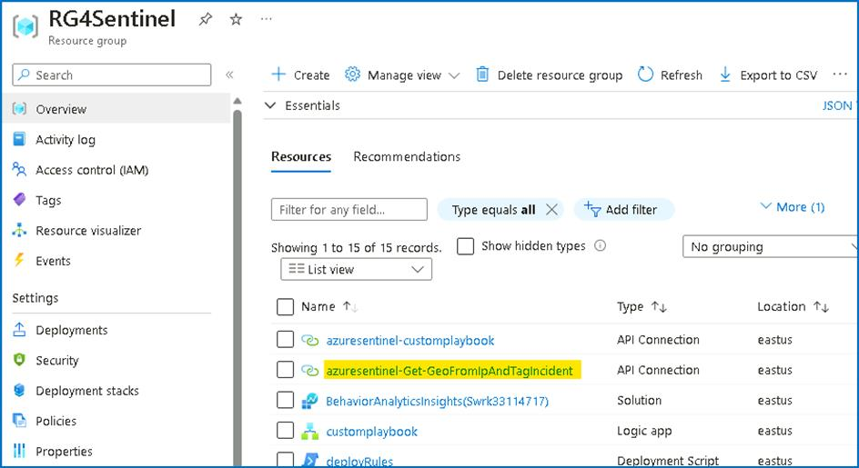

1. Click on **Edit API connection** under **General**.

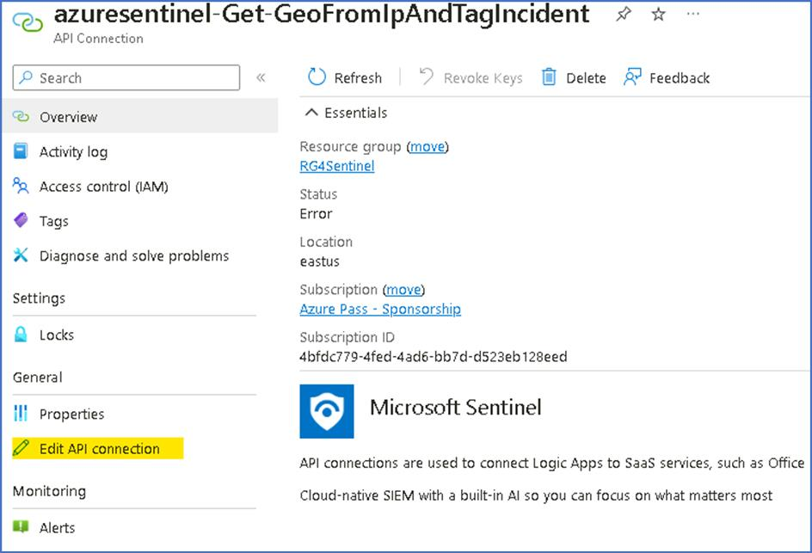

1. Click on **Authorize** and a new window will open to choose an account.

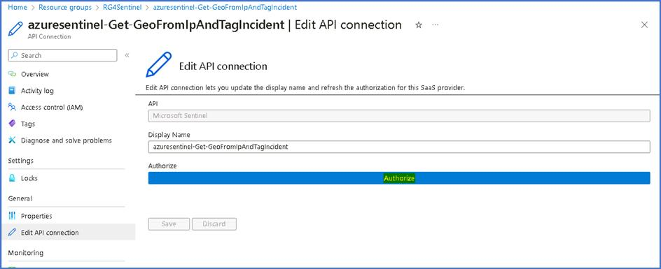

1. Select the **your outlook account** account that you are logged in with. If prompted to sign in, sign in with the credentials given on the **Resources tab** of your lab.

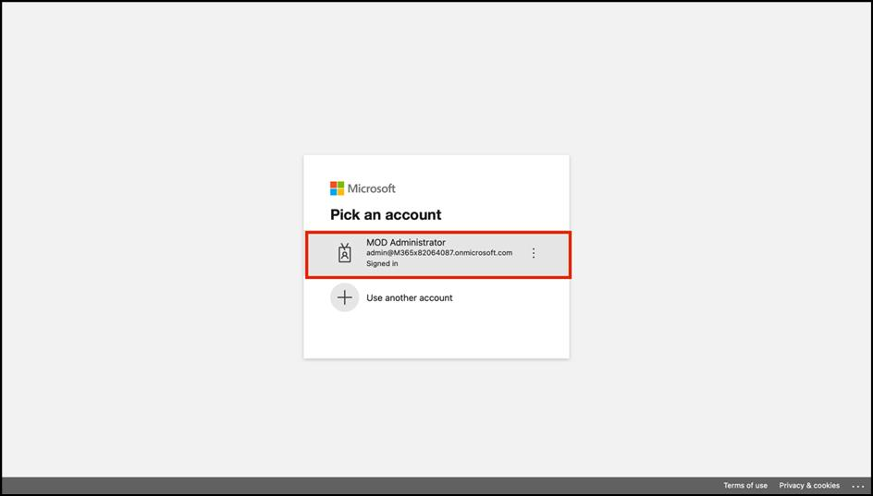

1. Click **Save** once the authorization is successful.

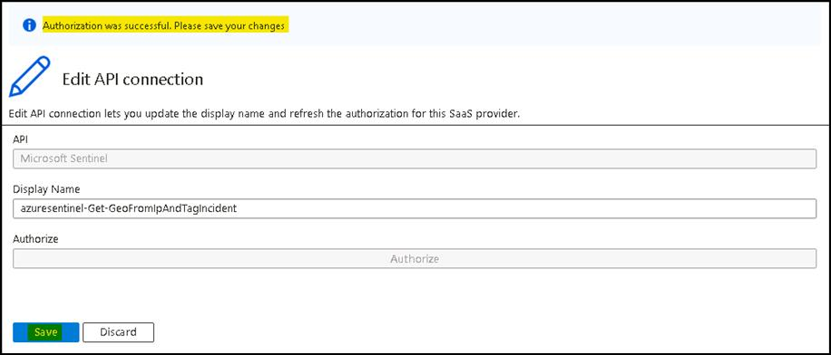

1. You should receive notification as shown in below image

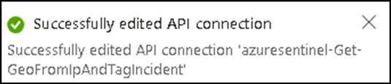

Congratulations, you have completed Lab 1!

**Lab 2 -- Enable Data Connectors in Microsoft Sentinel**

**Objectives**

In this Lab you will learn how to enable Data Connectors in Microsoft Sentinel to bring alerts and/or telemetry from different sources.

**Prerequisites**

This lab assumes that you have completed Lab 1, as you will need an Microsoft Sentinel workspace provisioned.

Some of the data connectors that will be used in this lab, require some specific permissions on the workspace or your azure subscription. If you don\'t have the appropriate permissions, you can still continue doing the rest of the labs.

**Exercise 1 -- Enabling Data Connectors in Microsoft Sentinel**

**Time - 30 minutes**

**Task 1 - Enabling Azure Activity data connector**

1. On the Azure Portal **http://portal.azure.com** and search for **Microsoft Sentinel** and click on **Microsoft Sentinel**.

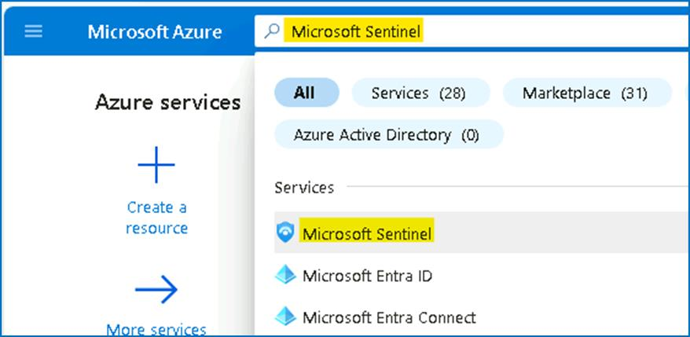

1. Select **SwrkXXXXXXX**.

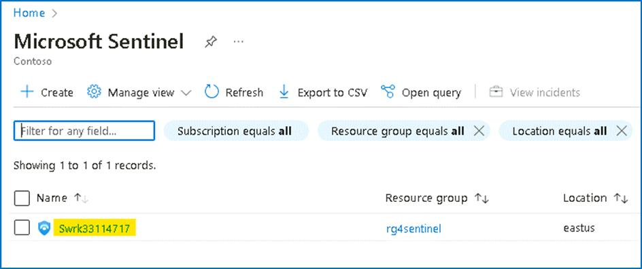

1. Now select **Data Connectors** under **Configuration** section.

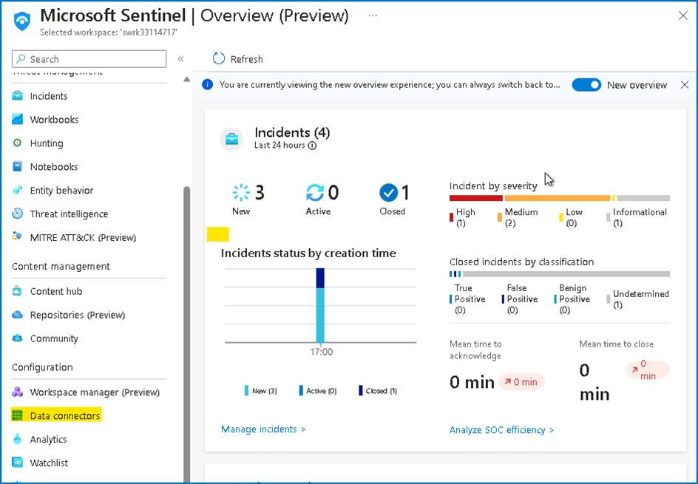

1. You should be able to see the **Data connectors** already available based on the selection made during the deployment.

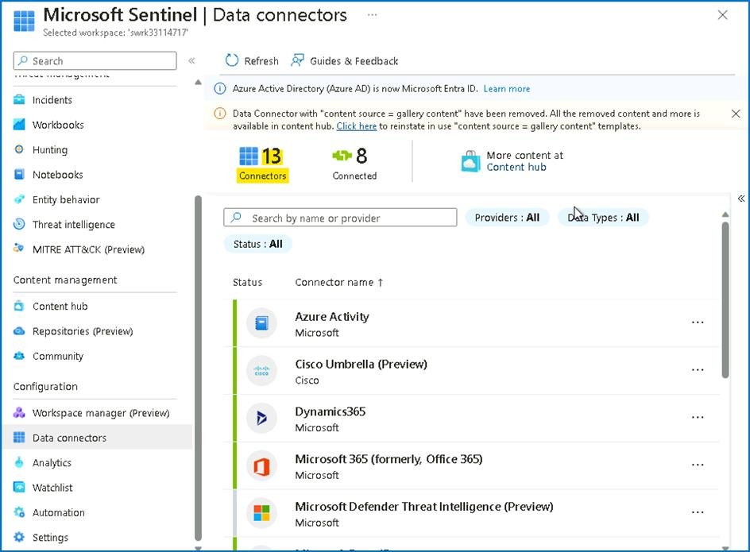

1. On the data connectors screen, select the **Azure Activity** connector and click on **Open connector page**.

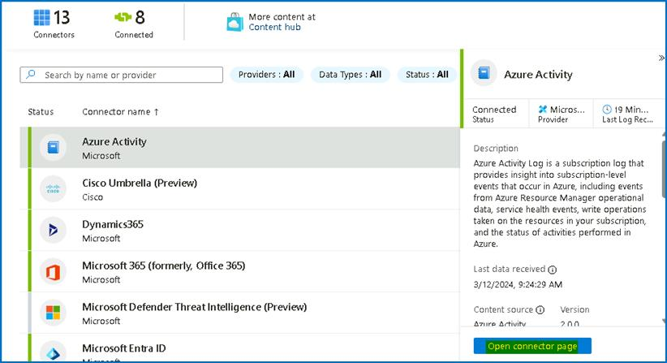

1. On the **Azure Activity connector** page, go to option number **2. Connect your subscriptions through diagnostic settings new pipeline**. This method leverages Azure Policy and it brings many improvements compared to the old method (more details about these improvements can be found here). Click on the **Launch Azure Policy Assignment** wizard, this will redirect you to the policy creation page.

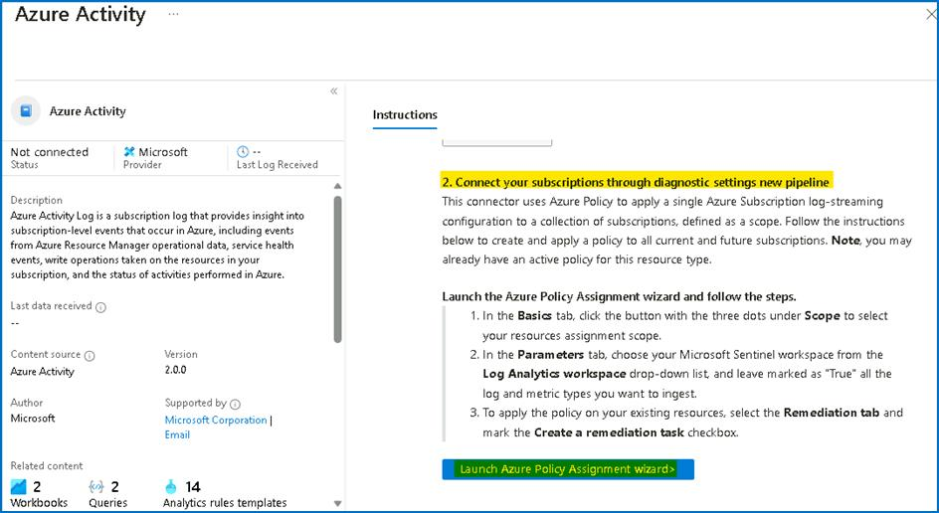

1. On the **Scope** selection select **Azure Pass -- Sponsorship** and under **Resource Group** select **RG4Sentinel**. Click **Select**.

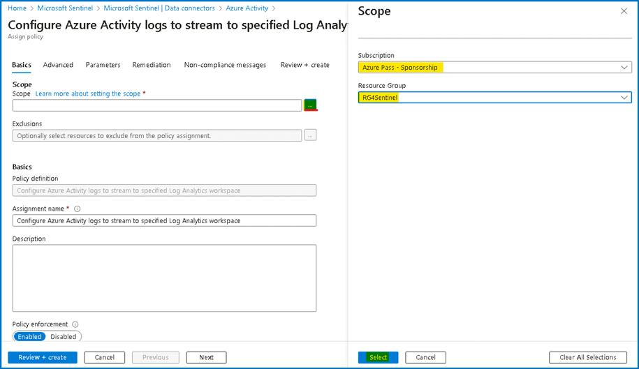

1. Go to the **Parameters** tab. On the **Primary Log Analytics workspace** select the **SwrkXXXXXXX**.

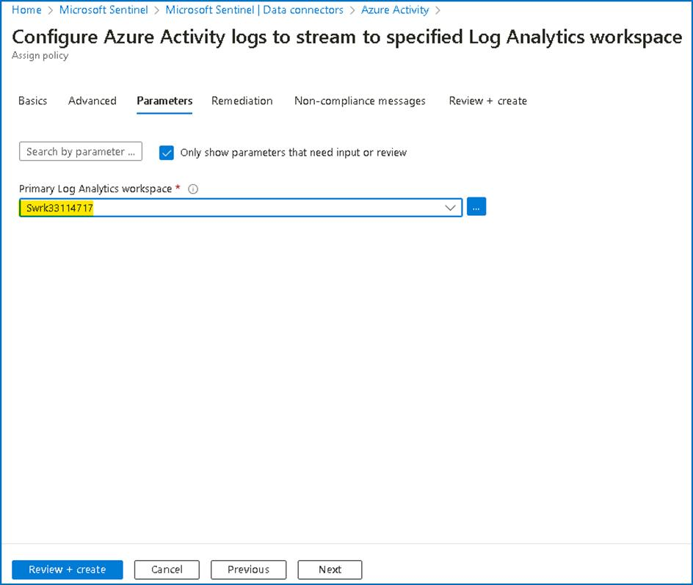

1. Under **Remediation** tab, select the check box besides **Create a remediation task** and then click on **Review + create** button

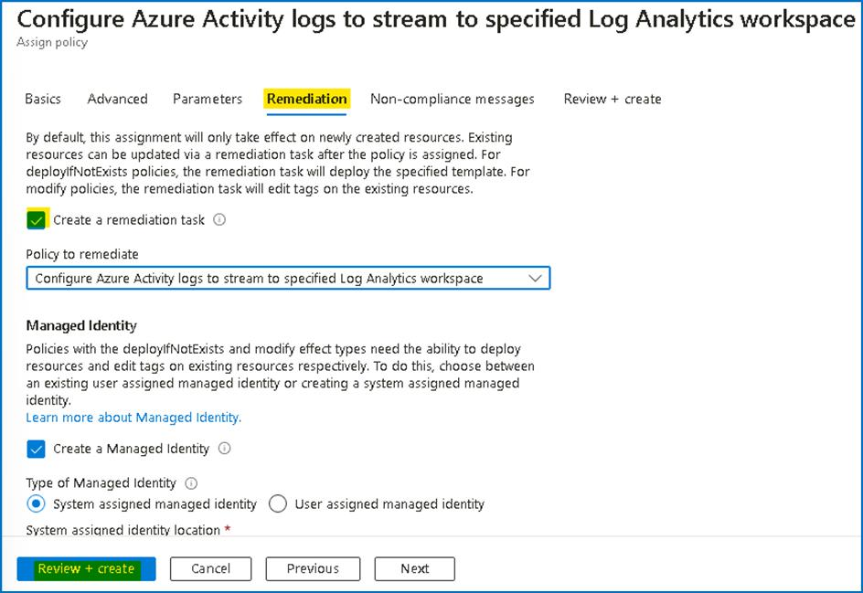

1. On the **Review + create** tab, click on the **Create** button.

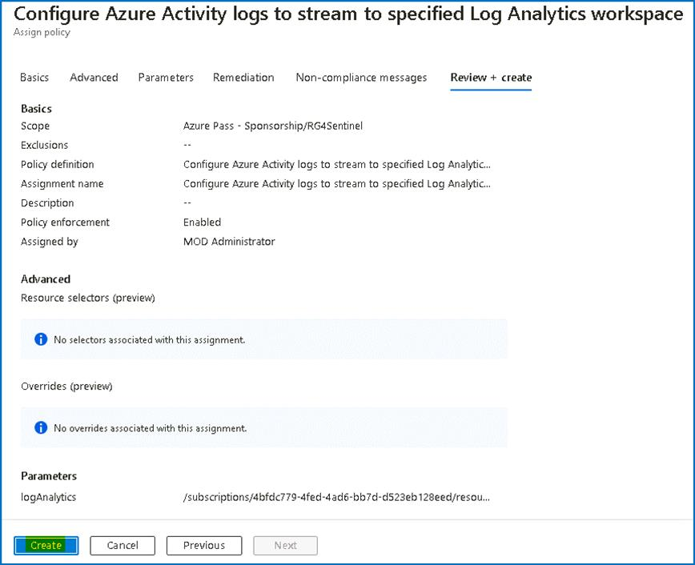

1. In the **Notification** pane you will be able to see the '**Role Assignments creation succeeded**', '**Remediation task creation succeeded**' and '**Creating policy assignment succeeded**' notifications.

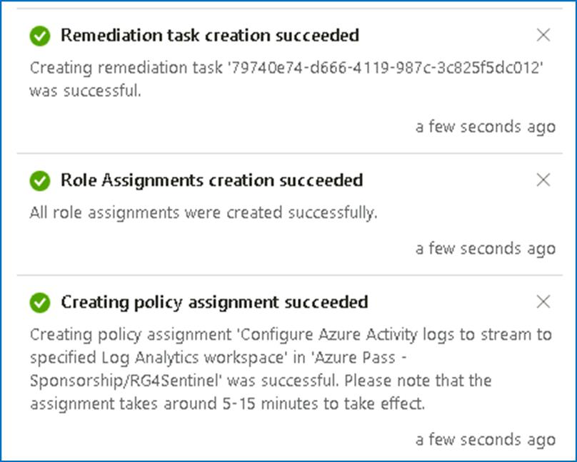

1. On the **Azure Activity connector** page you will be able to see the connection status.

**Note**: It is normal if you don't immediately see the connector showing as connected and in green, it takes around 30 minutes for the process to complete. Also, each subscription has a maximum of 5 destinations for its activity logs. If this limit is already reached, the policy created as part of this exercise won't be able to add an additional destination to your Microsoft Sentinel workspace.

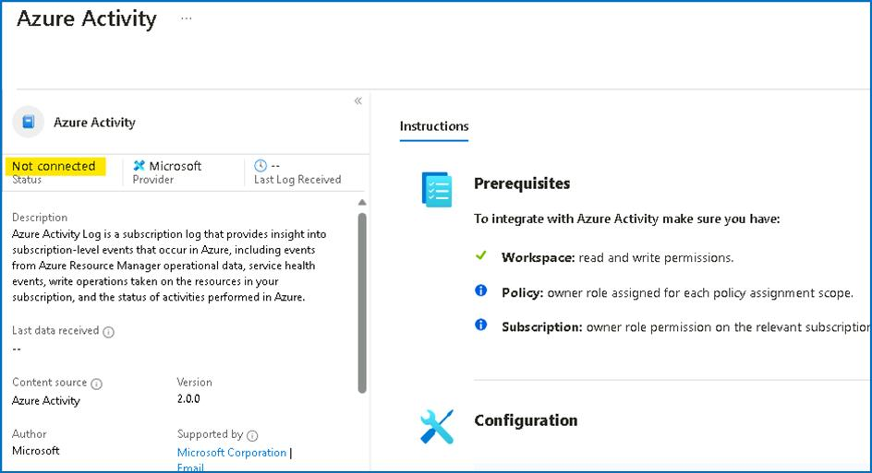

1. Continue to the next task then you can check back after 30 minutes.
2. Close the **Azure Activity** connector blade to go back to the **Data Connectors** page.

**Task 2 - Enabling Microsoft Defender for Cloud data connector**

This task shows you how to enable the Microsoft Defender for Cloud data connector. This connector allows you to stream your security alerts from Microsoft Defender for Cloud into Microsoft Sentinel, so you can view Defender data in workbooks, query it to produce alerts, and investigate and respond to incidents.

1. On the **Data connectors** screen, type **defender for cloud** in the search bar, select the **Subscription-based Microsoft Defender for Cloud (Preview)** connector and click on **Open connector page**.

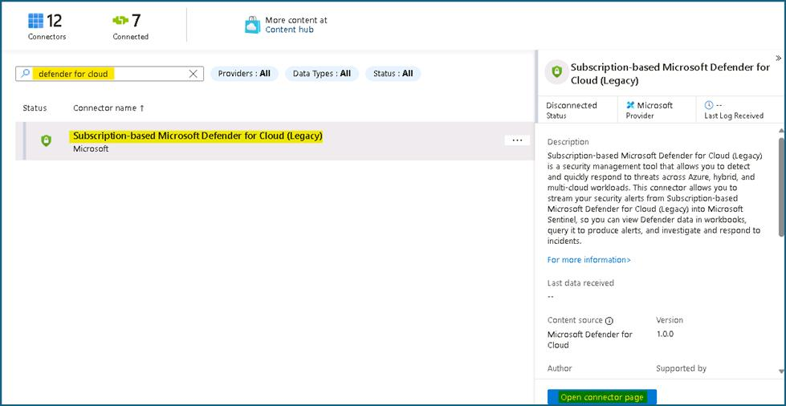

1. On the **Subscription-based Microsoft Defender for Cloud (Preview)** connector page, under **Configuration** section click on the **Connect** button.

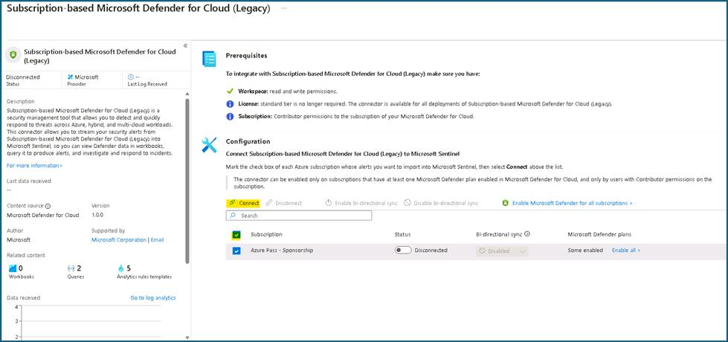

1. You should receive the notification as Connected successfully. **If may be possible that the notification may not appear**.

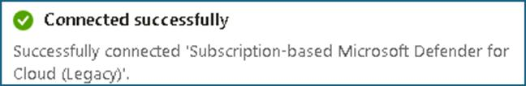

1. Wait for 3-5 minutes and then refresh the page, the Status of the connector should also be updated to **Connected**.

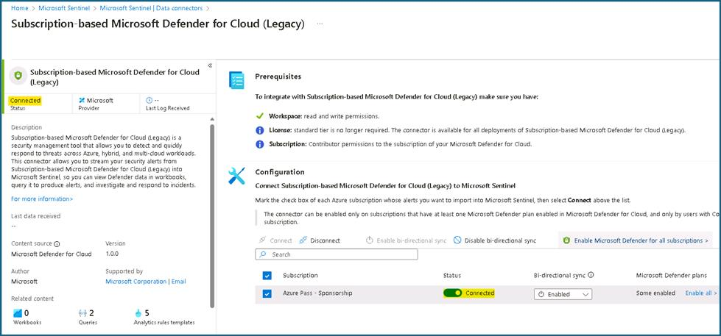

**Task 3 - Enabling Microsoft Defender Threat Intelligence connector**

The **Microsoft Defender Threat Intelligence** (MDTI) connector to your Sentinel workspace, which ingests Microsoft Threat Intelligence indicators automatically into the ThreatIntelligenceIndicator table. MDTI provides a set of indicators and access to the https://ti.defender.microsoft.com portal at no additional cost, with the premium features of the MDTI portal and API requiring licensing.

The *Threat Intelligence* content solution includes the data connectors for all supported forms of Threat Intelligence.

**NOTE:** Sentinel also supports importing Threat Intelligence indicators via the TAXII protocol using the **Threat Intelligence - TAXII** data connector, so if you have your own preferred TI source, you can add that to your workspace instead.

1. On the Azure Portal **http://portal.azure.com** and search for **Microsoft Sentinel** and click on **Microsoft Sentinel**.



1. Select **SwrkXXXXXXX**.



1. From the left menu choose the ***Microsoft Defender Threat Intelligence (preview)*** connector and click **Open Connector Page** at the bottom right.

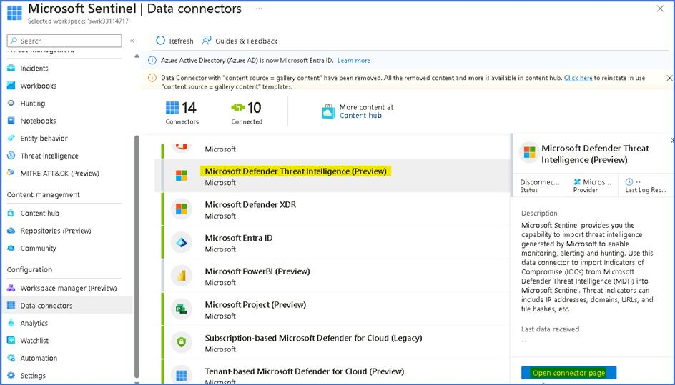

1. On the Connector page, from the **Import indicators** list, leave the default "**All available**" selected, and click **Connect**.

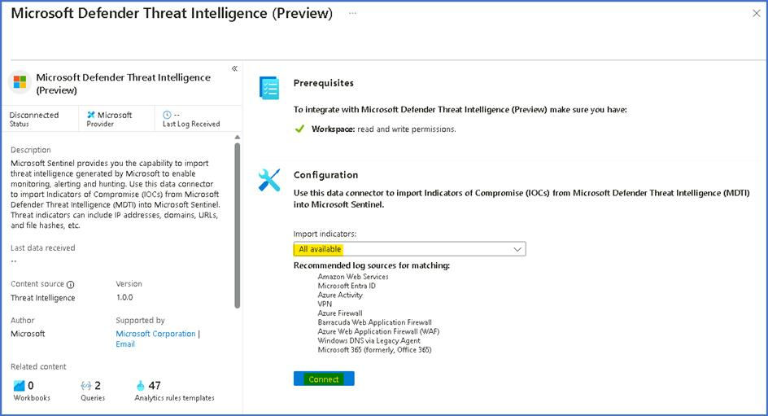

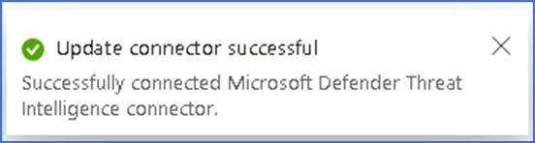

1. The Status of the Connector should be updated to **Connected.**

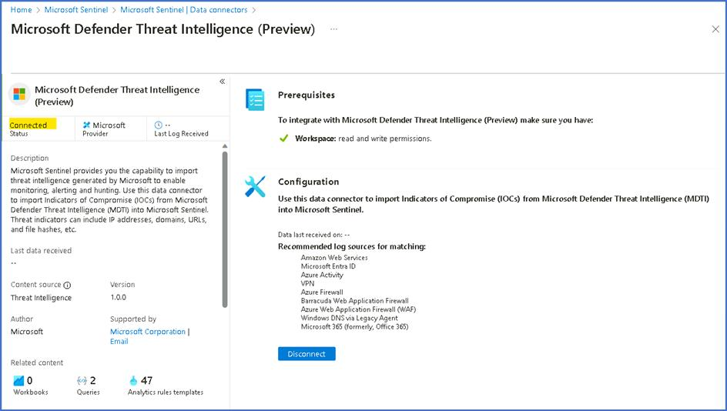

1. Threat Intelligence indicators will start being ingested into the **ThreatIntelligenceIndicator** table.

**Task 4 - Enabling Threat Intelligence TAXII data connector**

This task shows you how to enable the Threat Intelligence - TAXII data connector. This connector allows you to send threat indicators from TAXII servers to Microsoft Sentinel. Threat indicators can include IP addresses, domains, URLs, and file hashes.

1. Open a new tab in the Edge browser and then sign up for a free TAXII 2.0 feed. Navigate to **https://pulsedive.com/register** and enter the Email ID of **your outlook account** account. Agree to the terms and select **Register**.

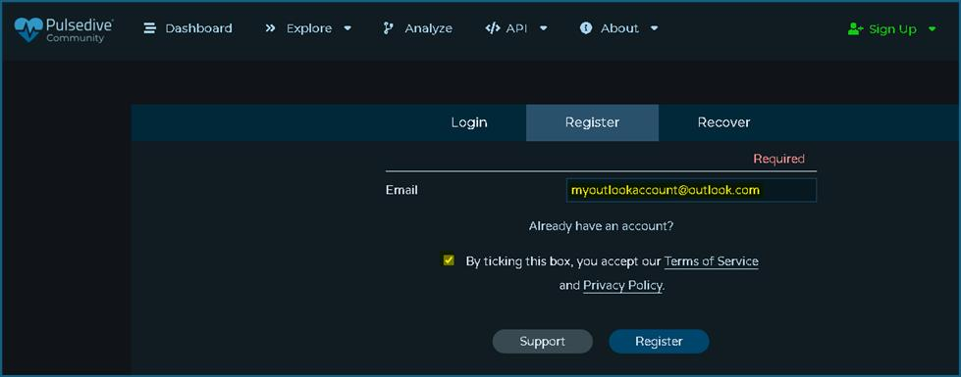

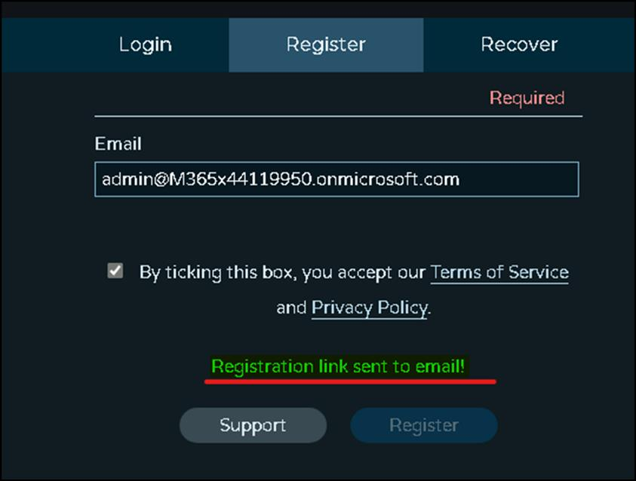

1. To confirm the registration, in a new tab open the email for your outlook account by navigating to **https://outlook.office.com/** and verify the email ID.
2. Click on the link received in the email from **Pulsedive**.

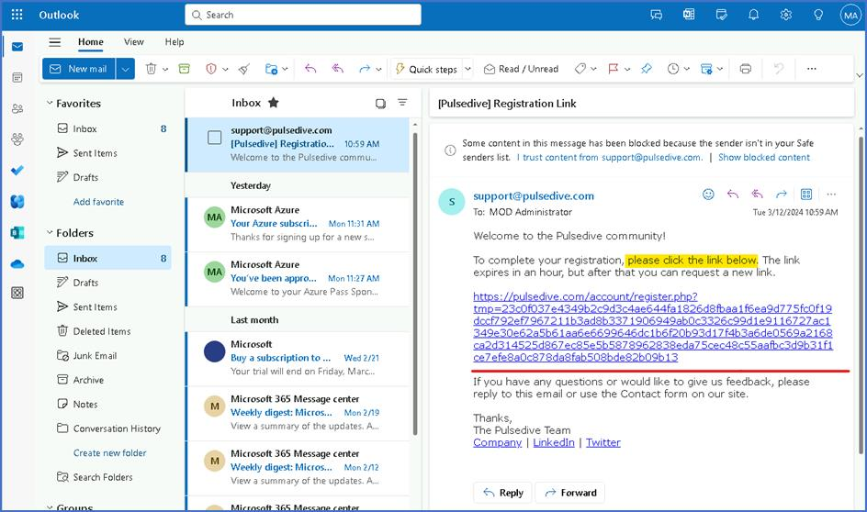

1. Fill in the following details and complete the registration, after accepting the terms.
   * Username: **tadminxxxxxx** (substitute **xxxxxx** with random number)
   * Password: **Pa$$w0rd@123**
   * Confirm Password: **Pa$$w0rd@123**
   * Job Title: **Administrator**
   * Company or Organization: **Contoso**

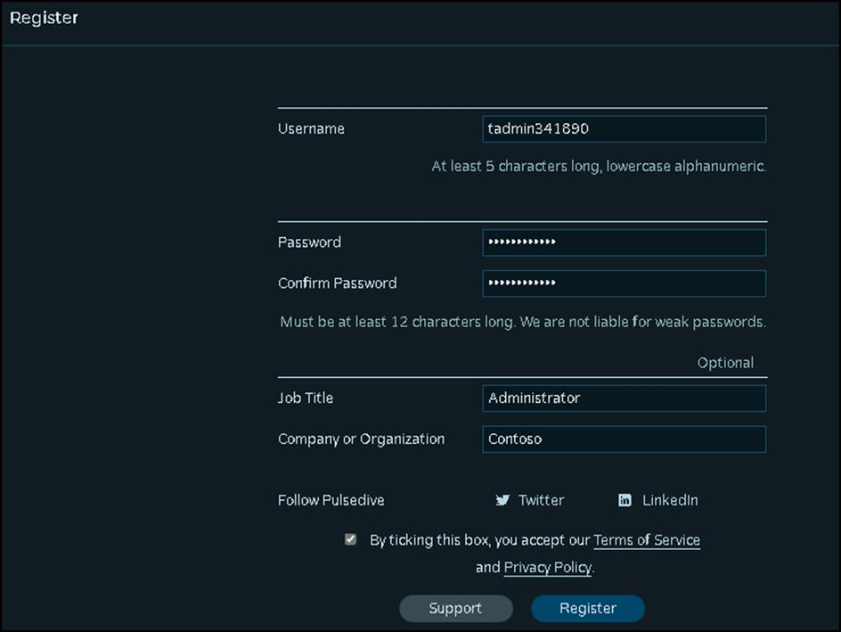

1. Go to **https://pulsedive.com/register** and click on **Login**. Login using the following credentials.
   * Username: **tadminxxxxxx**
   * Password: **Pa$$w0rd@123**

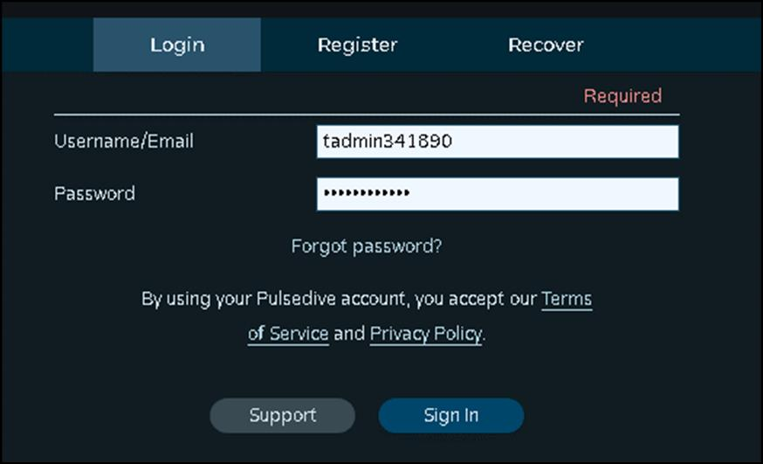

1. From the dashboard, select **API** and then click on **STIX via TAXII**.

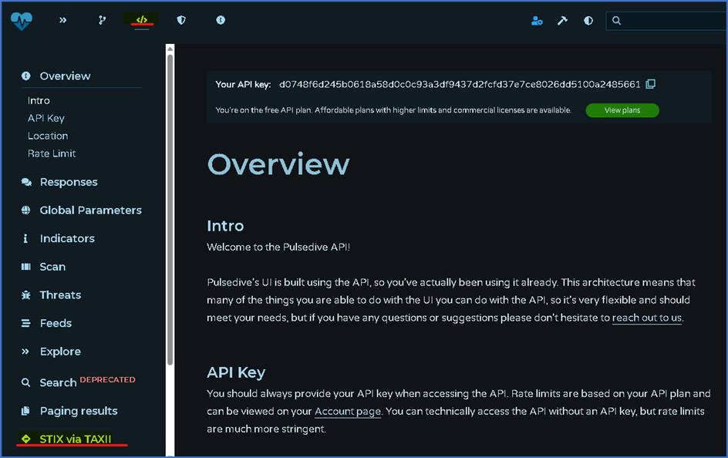

1. On the page scroll down to the Query String section, copy the value given near parameter named key and paste it in a notepad file.

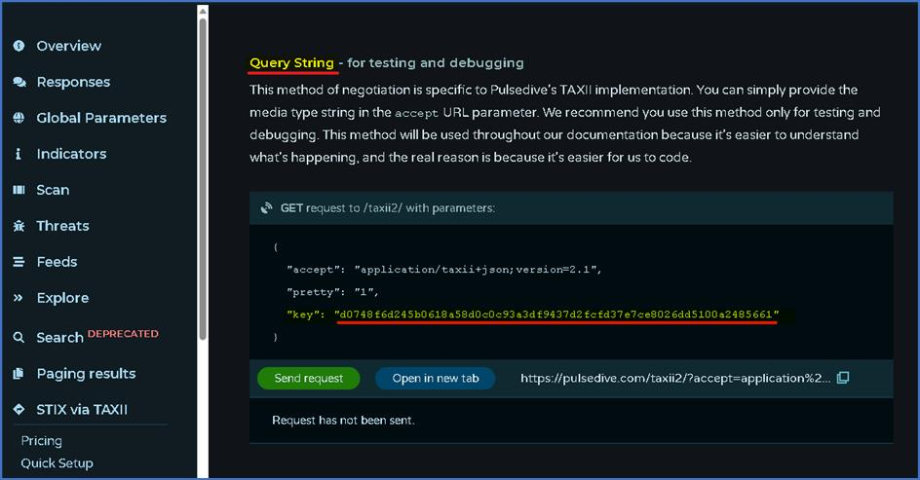

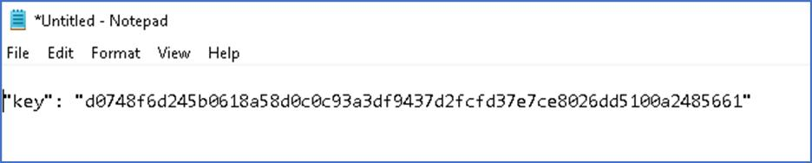

1. Search for or scroll to **Pulsedive test data**. Copy and paste the **Collection ID** to the notepad file for later reference.

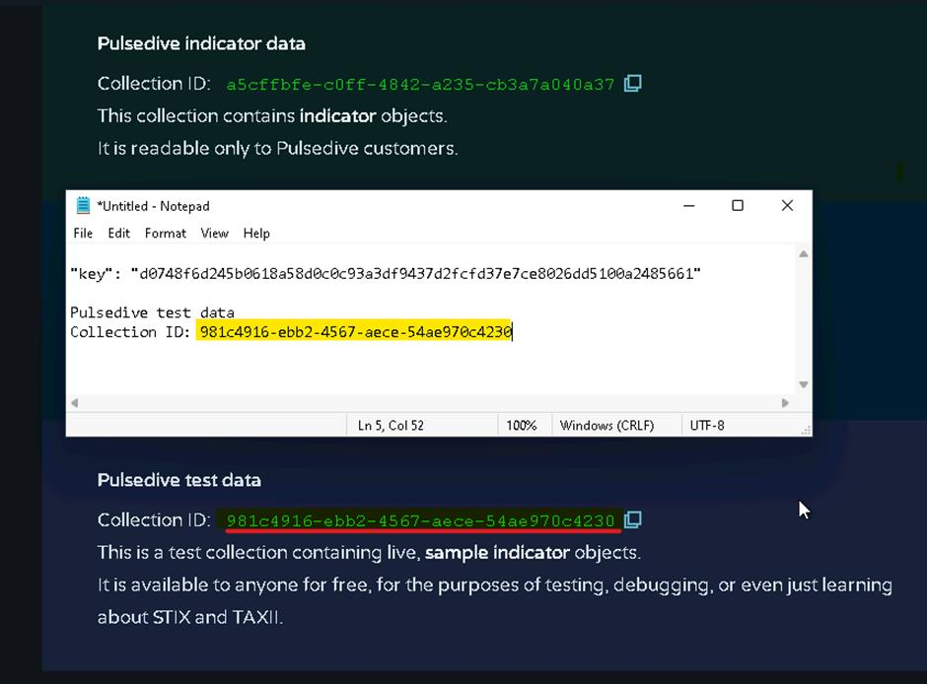

1. Switch back to the tab with the Azure Portal page, now select **Data Connectors** under **Configuration** section.

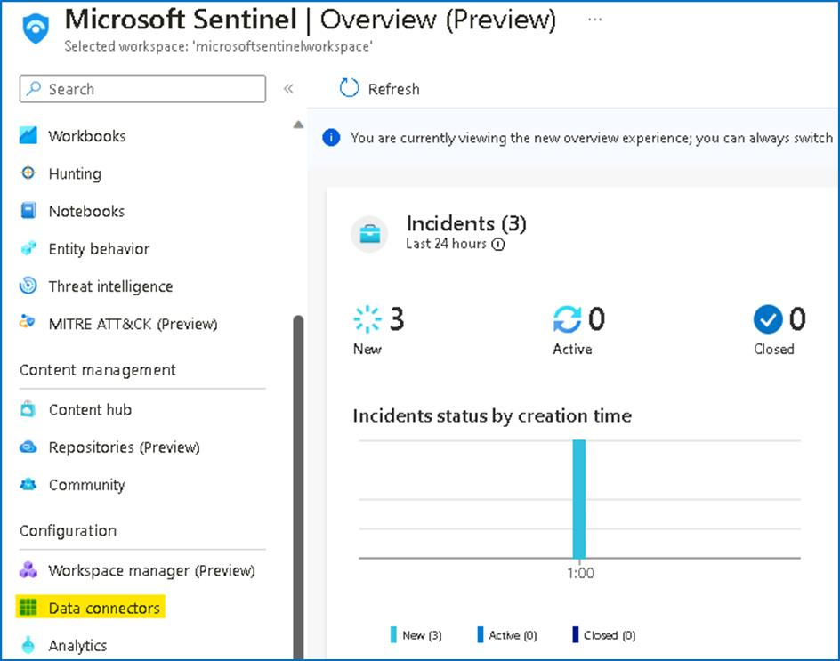

1. On the data connectors page, type **taxii** in the search bar, select the **Threat intelligence - TAXII** connector and click on **Open connector page**.

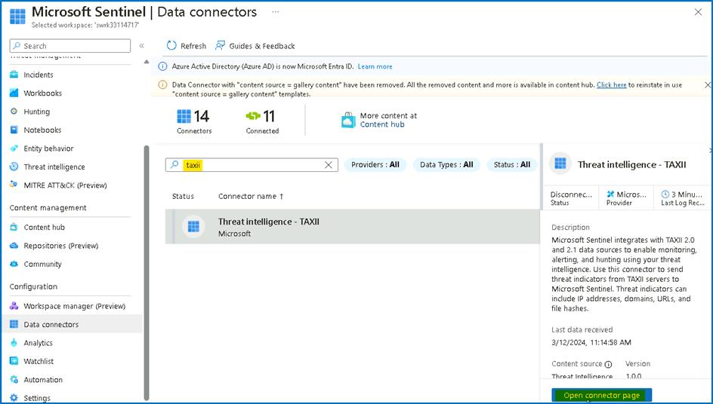

1. In the **Threat Intelligence - TAXII** connector page, add the following information under Configuration menu:
   * Friendly name (for server): **Pulsedive**
   * API root URL: **https://pulsedive.com/taxii2/api/**
   * Collection ID: **Paste the one that we copied earlier**.
   * Username: **taxii2**
   * Password: The key that we copied earlier
   * Import Indicators: **All available (review all available options)**
   * Polling frequency: **Once a day**
2. Click **Add** and wait until the operation completes.

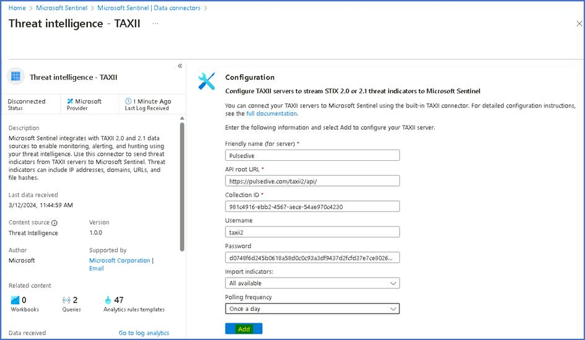

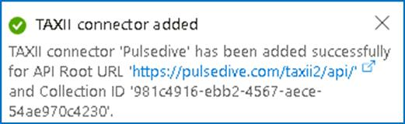

1. We should be able to see the list of the Servers as shown in the below image

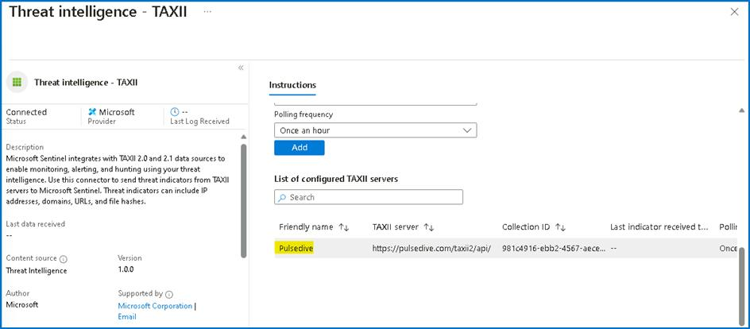

**Task 5: Creating custom data connector**

1. In the File explorer browser to **C:\Labfiles\** and open the **Lab2_ connector_ARM_Template.txt** and review the **ARM template**.
2. Switch back to the browser tab with the Azure Portal **https://portal.azure.com** and search for **Deploy** and Select **Deploy a custom template**.

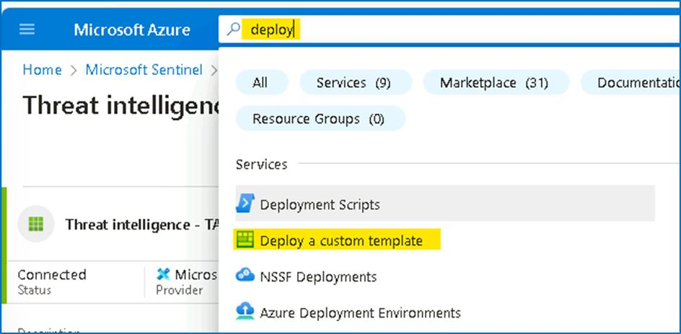

1. Select **Build your own template in the editor**.

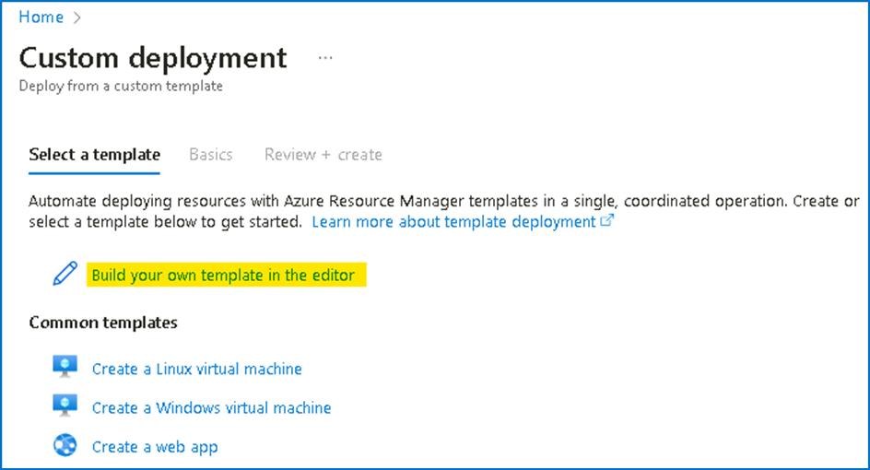

1. Click on the **Load file** button and browse to **C:\Labfiles\Lab2_ connector_ARM_Template.txt** and select **OK**. Then click on **Save** button.

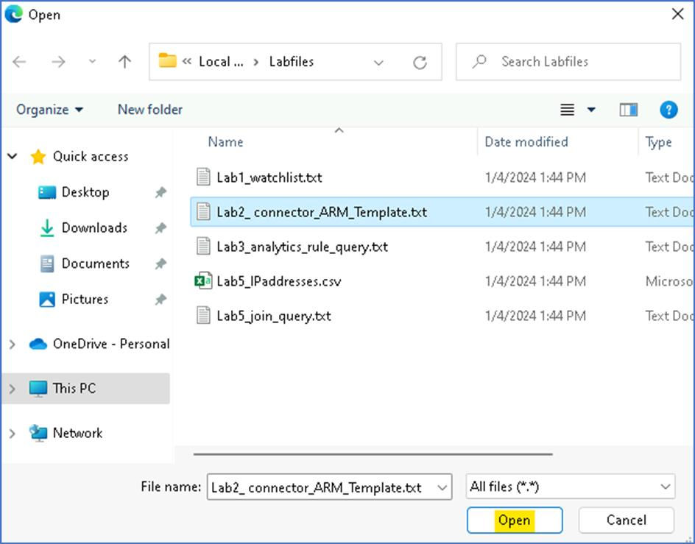

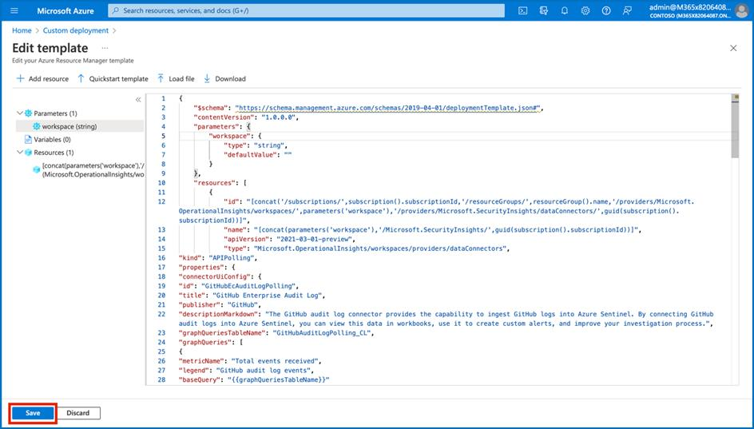

1. In the basics tab, fill in the following information.
   * Subscription -- **Azure Pass - Sponsorship**
   * Resource group - **RG4Sentinel**
   * Region -- **East US**
   * Workspace -- **Name of the Sentinel workspace**
2. Then select **Review + Create**.

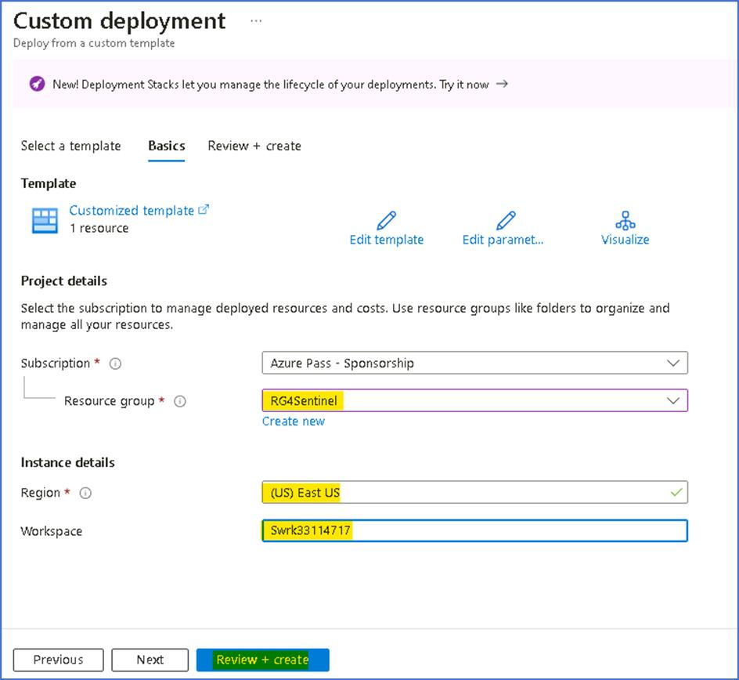

1. Select **Create**.

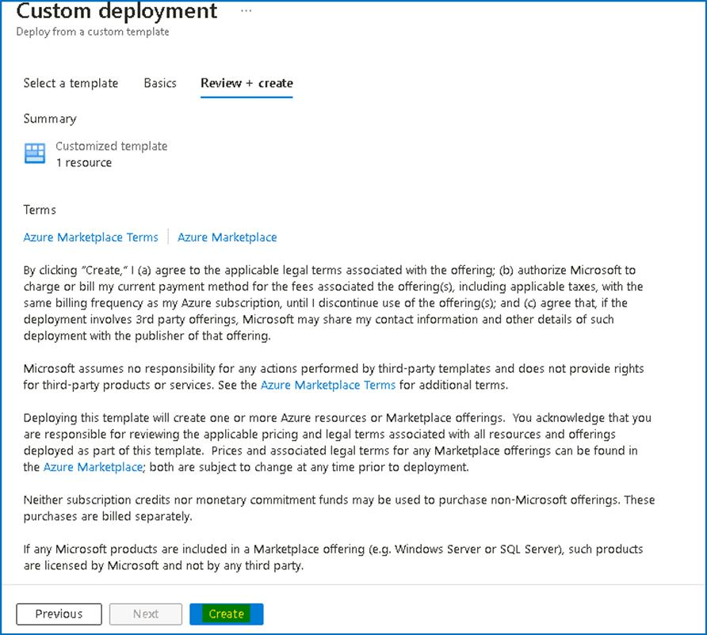

1. Once the deployment is complete select **Go to resource**.

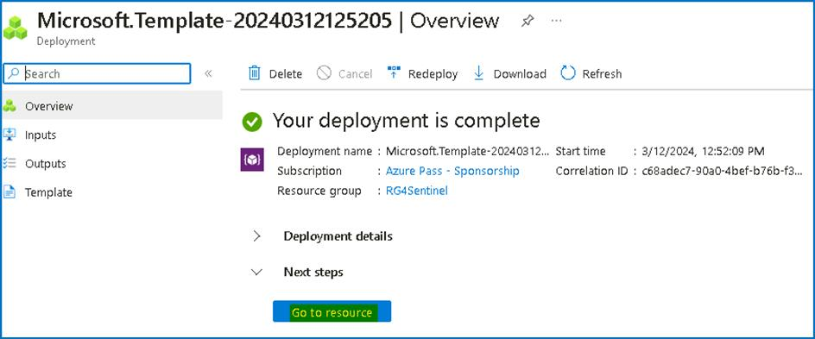

1. You will be able to see the connector created successfully.

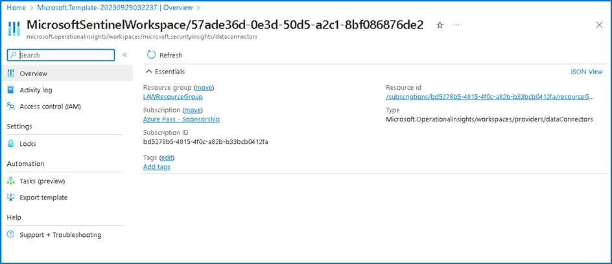

1. Navigate back to **Data connectors** page on the Microsoft Sentinel and you should be able to see the Data connector created. In the list search for **GitHub**

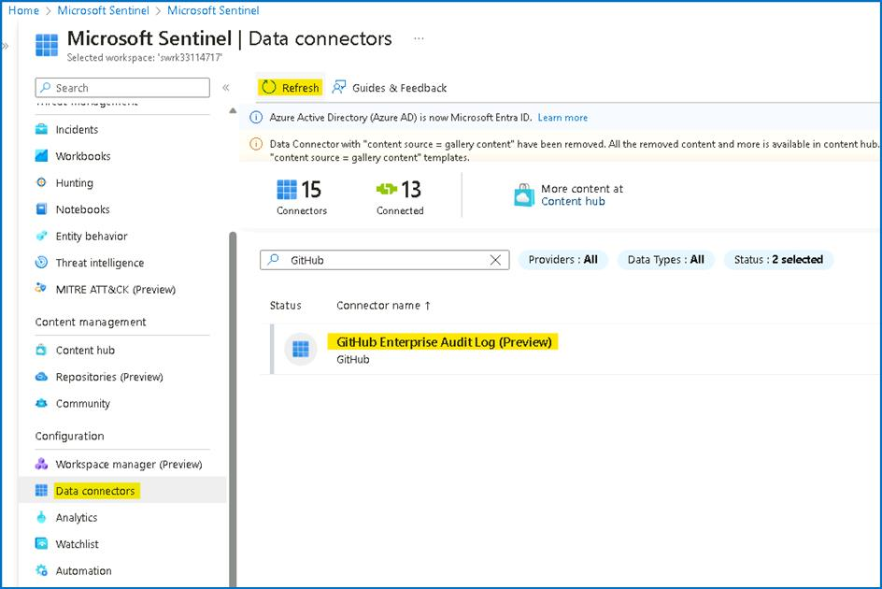

1. Click on the **Open connector page** button.

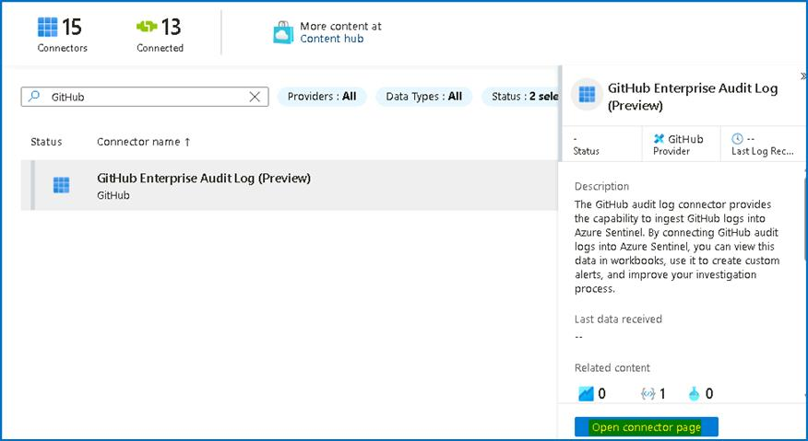

1. **Optionally** You can configure the connector like other Data connectors with the additional configuration from your own **[Github Organization account]{.underline}**.

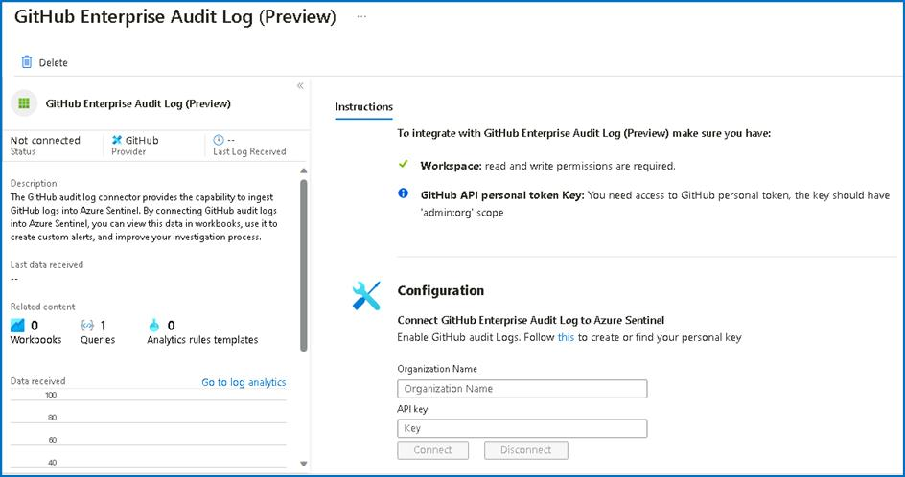

**Lab 3 -- Analytics Rules and Incident Management**

**Objectives**

This Lab guides you through the Analytics Rule part in Microsoft Sentinel and shows you how to create different type of rules (Security Detections).

**Prerequisites**

This Lab assumes that **[you have completed Lab 1]{.underline}**, as the data and the artifacts that we will be using in this Lab need to be deployed on your Microsoft Sentinel instance.

**Time - 40 minutes**

**Task 1 -- Analytics Rules overview**

1. On the Azure Portal **http://portal.azure.com** and search for **Microsoft Sentinel** and click on **Microsoft Sentinel**.



1. Select **SwrkXXXXXXX**.



1. On the left menu navigate to **Analytics** and select **Rule template** section

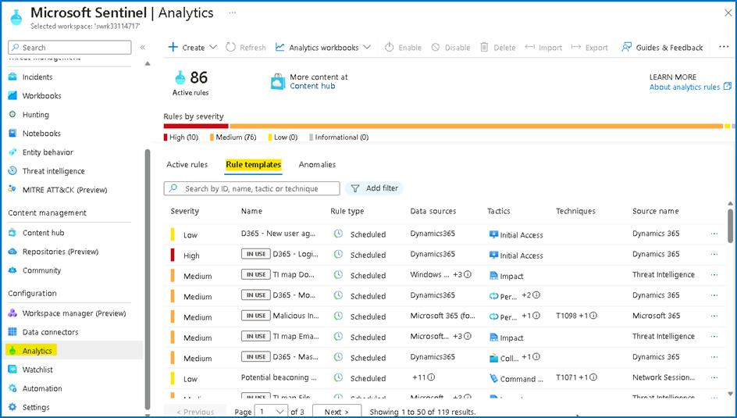

1. Click on Rule templates tab and review the default analytics rules templates, then click on **Add filter** then select **Data Sources**.

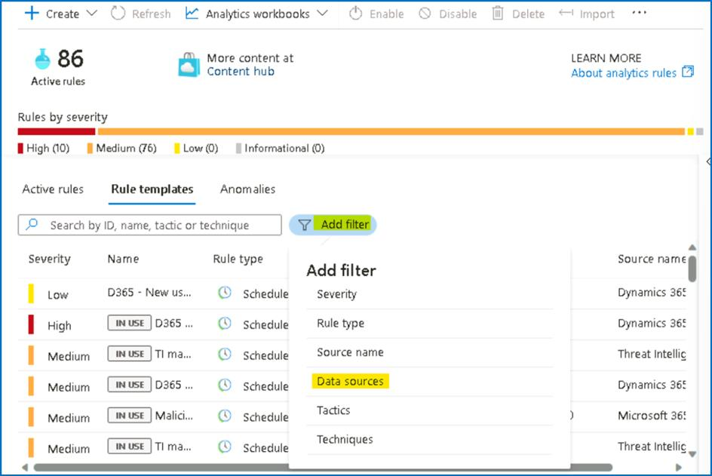

1. Check **Security Events via Legacy Agents**, select **Apply**. Now review all the analytic rules on the above data source.

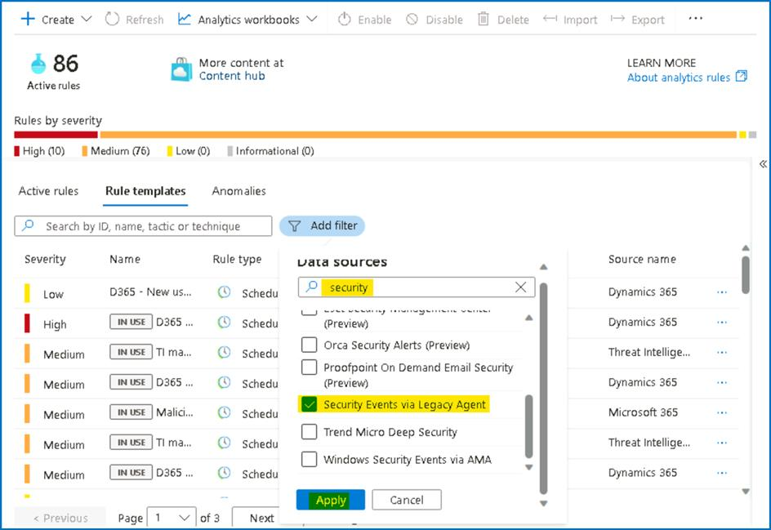

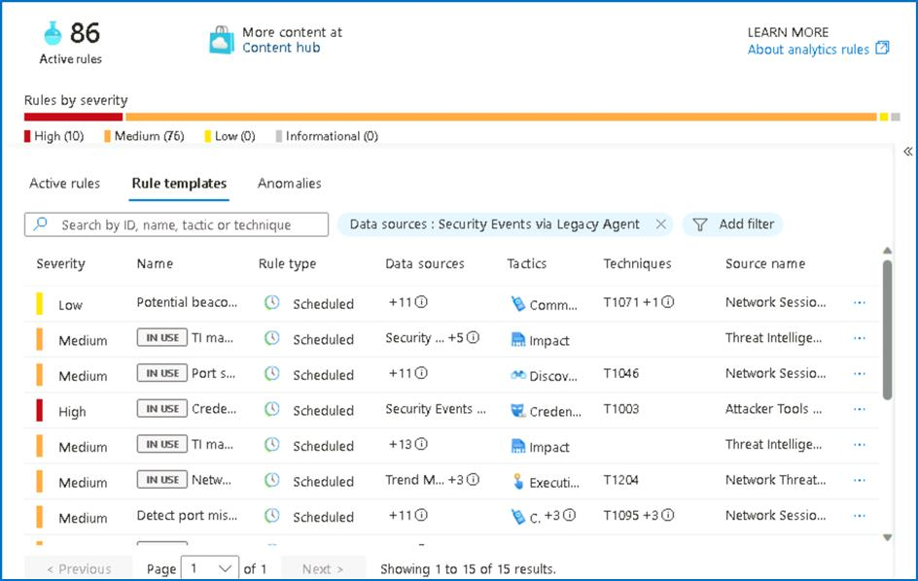

1. In the rule search bar type **Anomalous RDP Login** for the rule name. Select the rule and open the side panel.

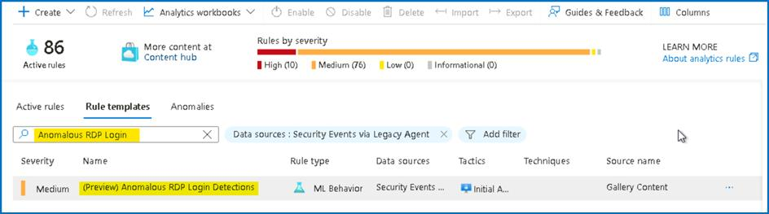

1. To review the rule logic and possible configuration options, in the right lower corner press **Create rule**.

**Note** - If the Create rule button does not appear, ensure the panel is enabled from the right side of the screen.

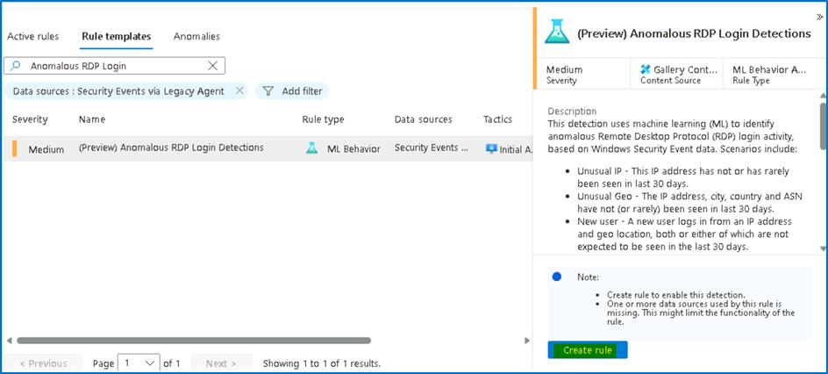

1. Review the rule definition like tactics and severity. Press **Next: Automated response** in the bottom of the page.

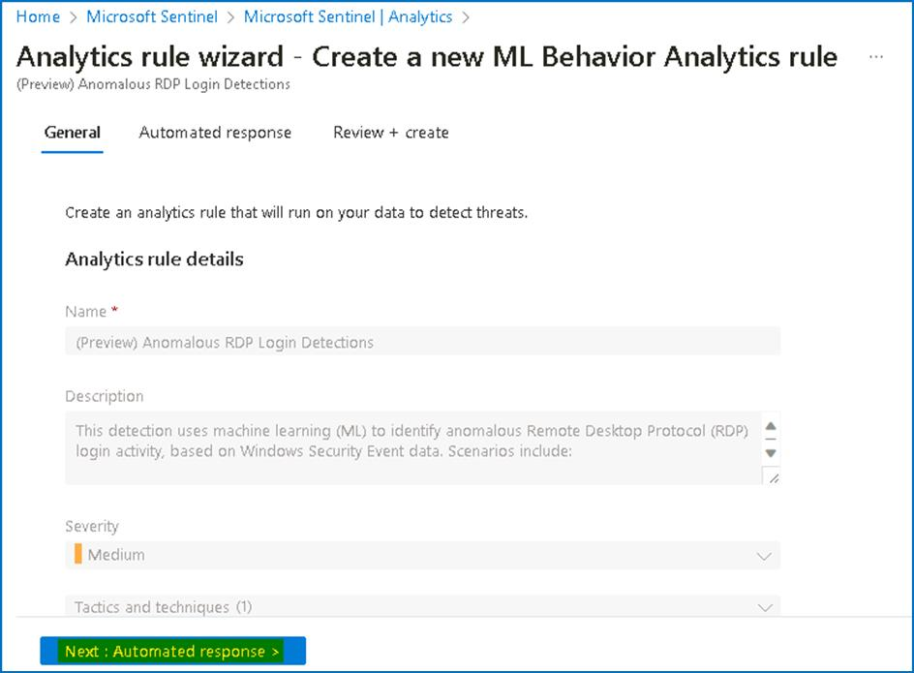

1. On the Automated response tab, click on **+ Add new** to create new Automation rule by referring to the image shown below.

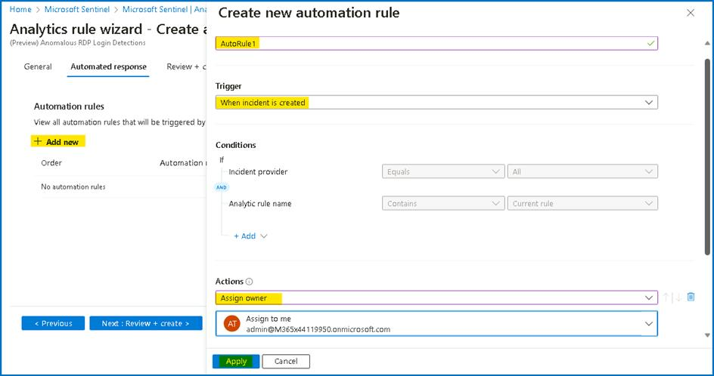

1. After you reviewed the rule configuration options, close this page and navigate back to the main **Microsoft Sentinel Overview** screen. Continue to the next exercise.

**Task 2 - Creating Microsoft Sentinel custom analytics rules**

Microsoft Sentinel is a cloud-native SIEM and as such, it acts as single pane of glass for alerts and event correlation. For this purpose, and to be able to ingest and surface alerts from Microsoft Security Products, we create a **Microsoft incident creation rule**. In this exercise, we will review this feature and create one example rule with a filtering option to help the analyst deal with alert fatigue.

1. While still on the **Microsoft Sentinel** under the **Analytics** section click on **+Create** and select **Microsoft incident creation rule**.

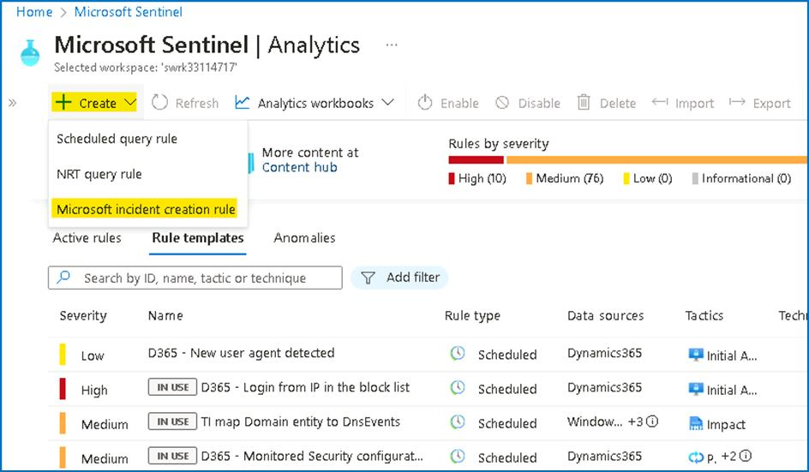

1. In the rule name enter "**Defender for Cloud only medium and high Alerts**".

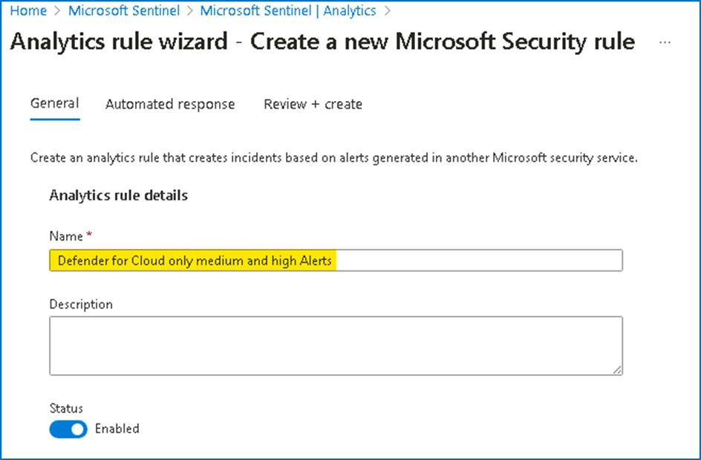

1. In the Microsoft security service dropdown select **Microsoft** **Defender for Cloud**.
2. In the **Filter by severity** select custom and select the checkboxes for **High** and **Medium**.
3. Click on **Next: Automated response**.

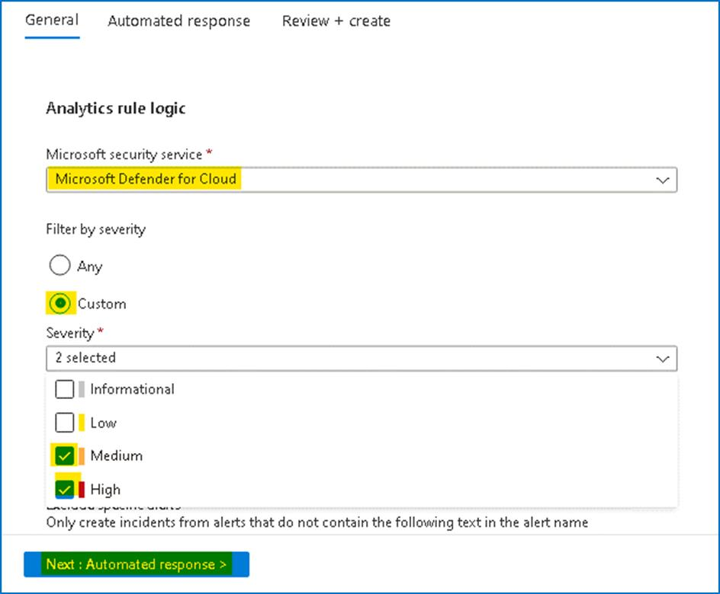

1. In the above **"Automated response"** page you can attach automation rule that can generate automation tasks that can assist your SOC with repetitive tasks, or Security remediation. Click on **Next: Review + create**.

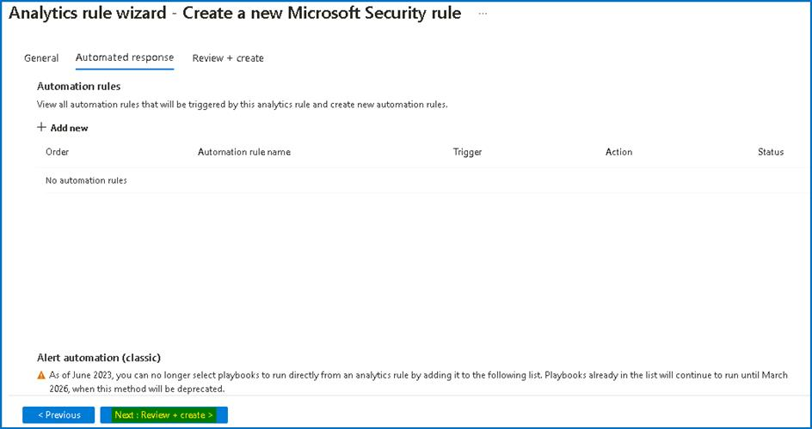

1. On the Review + create page, click on the Save button.

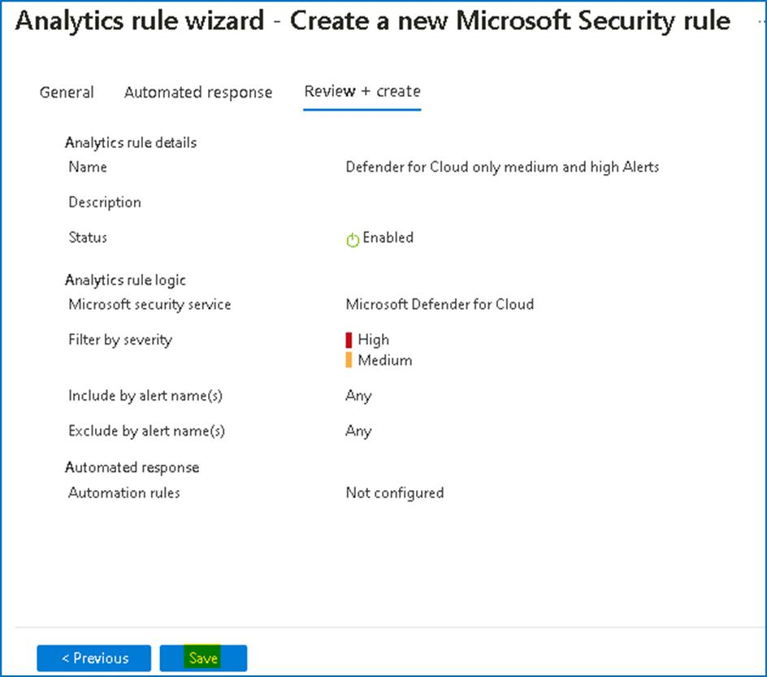

1. Stay on the **Analytics** page and continue to the next **Exercise**.

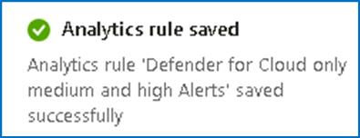

**Task 3 - Reviewing Microsoft Sentinel incident tools and capabilities**

Fusion rule is a unique kind of detection rule. With Fusion rule, Microsoft Sentinel can automatically detect multistage attacks by identifying combinations of anomalous behaviours and suspicious activities That are observed at various stages of the kill-chain.

In this task, we will learn how to distinguish and review **Fusion rule** in Microsoft Sentinel.

1. In the analytics page on **Rule templates** tab, click **Add filter** and select **Rule Type**

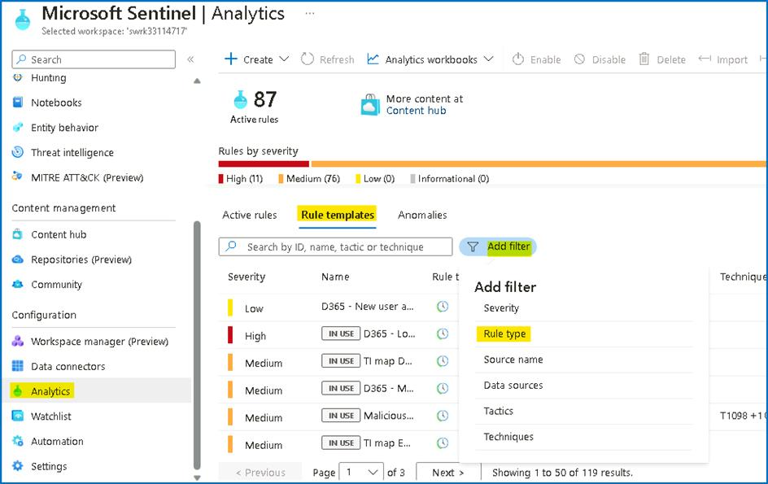

1. Select the check box for **Fusion** and then click on **Apply**.

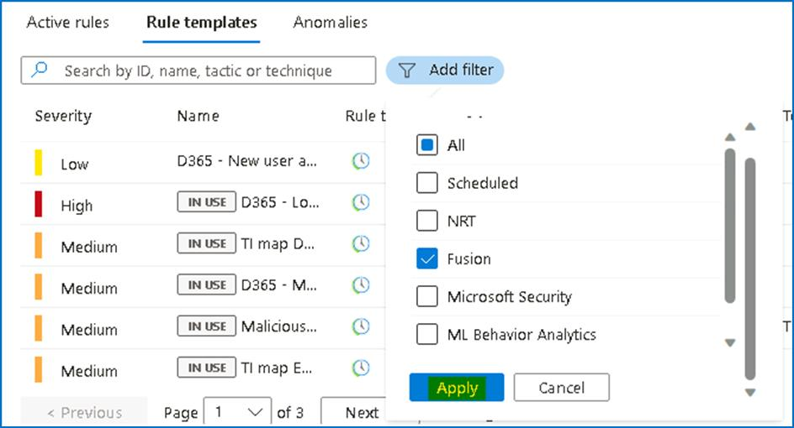

1. In the template screen notice the tag **IN USE** as this rule template enabled by default.

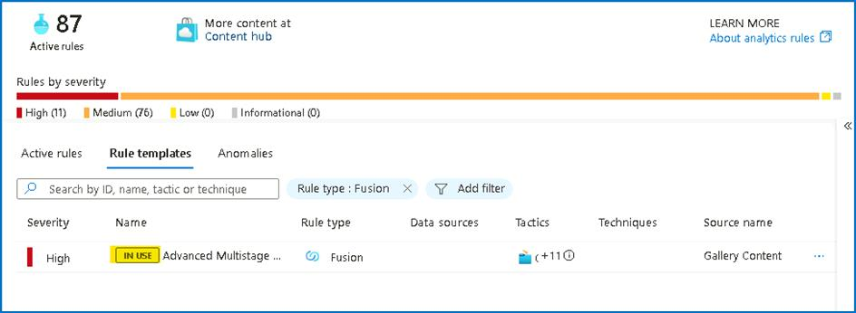

1. From the detail panel, review the details for the **Advanced Multistage Attack Detection** rule . Stay on the same page for next exercise.

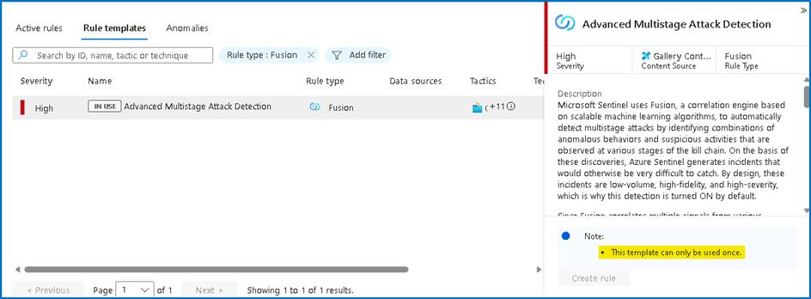

As Fusion rules produce security incidents with high fidelity and simulation can be challenging, we are adding an example of an incident that was created from fusion detection.

**Task 4 - Create Microsoft Sentinel custom analytics rule**

1. In the left menu click on the **Logs** close the pop-up and navigate to the search **Canvas**.

**Note**: in this lab we are using custom logs that replace the Out-off-the-box tables.

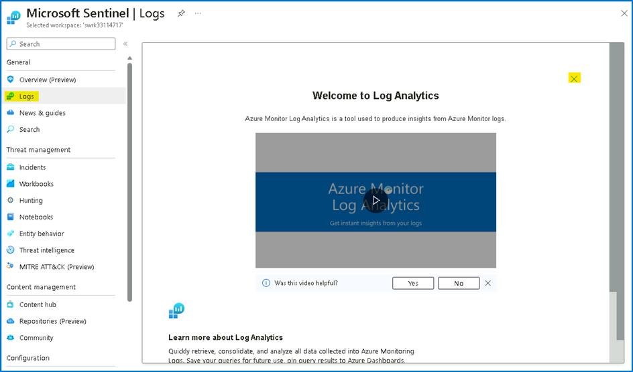

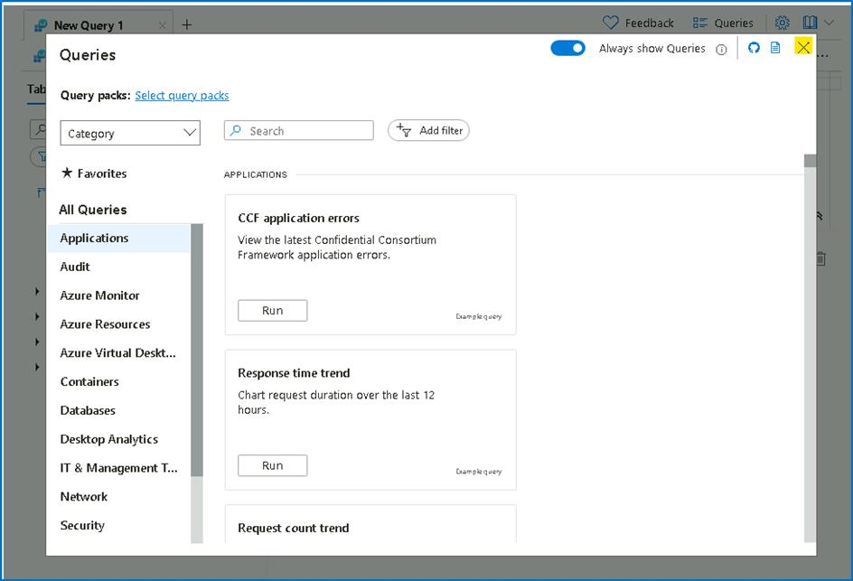

1. To check if this operations are being captured as part of your collection strategy, run the search query below to see the list of activities Microsoft Sentinel captured in the last 24hr

**OfficeActivity_CL | distinct Operation_s**

1. You will be able to see the **New-InboxRule** operation is indeed captured in your logs.

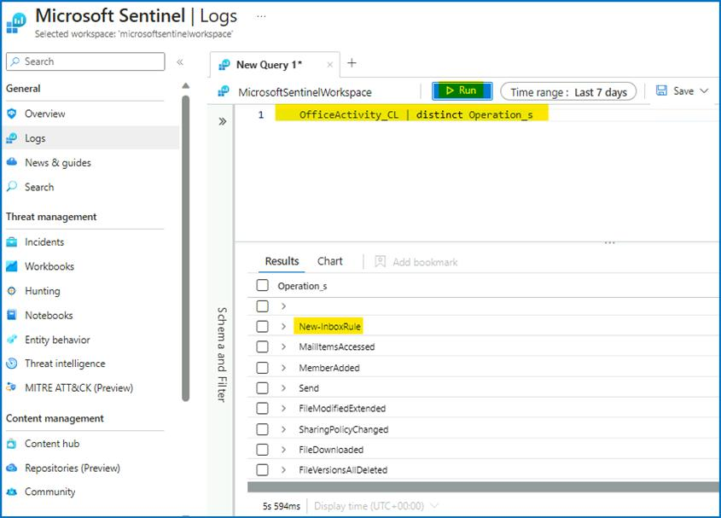

1. Navigate to the **Analytics** from the navigation bar. In the top bar click on **+Create** and select **scheduled query Rule**.

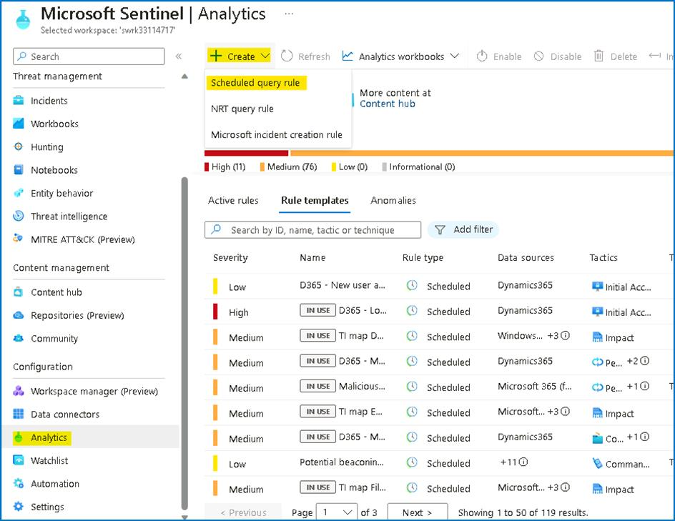

1. On the **Analytics rule wizard - Create a new Scheduled rule** page, provide the below details.
   * In the Name type "**Malicious Inbox Rule - custom**".
   * In the rule **Description** enter **This rule is detecting on delete all traces of phishing email from user mailboxes.**
   * In the **Tactics and techniques** select **Persistence *\*and****Defence Evasion\**.
   * In the rule **Severity** select **medium**.
   * Click **Next: SET rule logic>**.

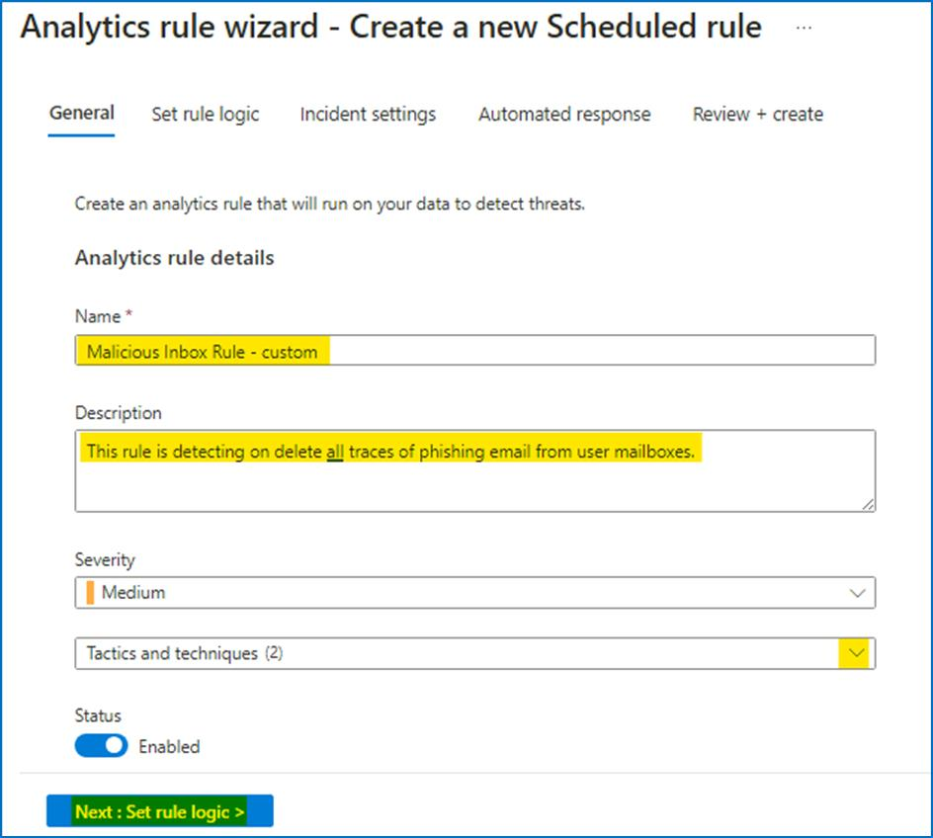

1. In the **Rule logic** page, review and copy the query from the file **Lab3_analytics_rule_query.txt** given in **C:\Labfiles\**
2. We can view the rule creation estimating by pressing **Test with current data** in the right side.

**Note** - You may need to scroll down if the Result Simulation is not visible on the side.

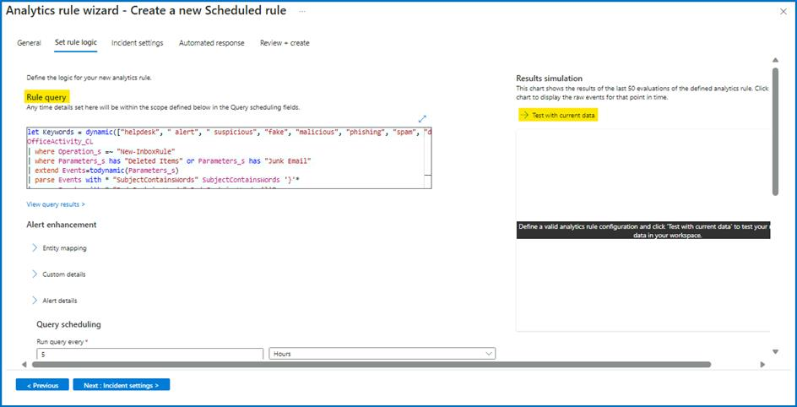

1. You will be able to see the number of hits.

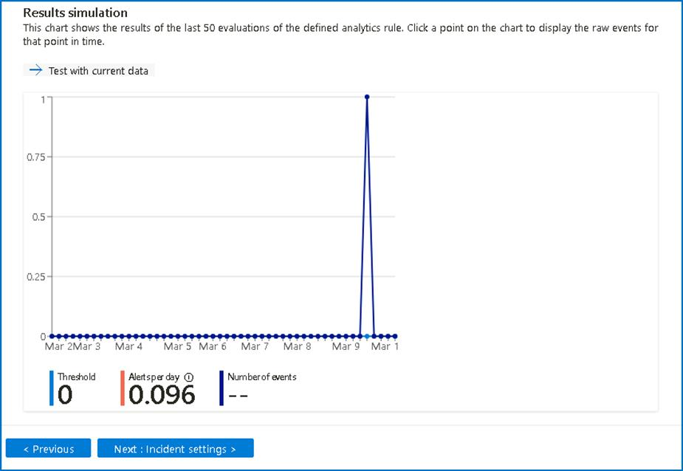

1. Under the **Alert enrichment** expand the **Entity mapping** section that will allow us to map our fields to well-known categories:

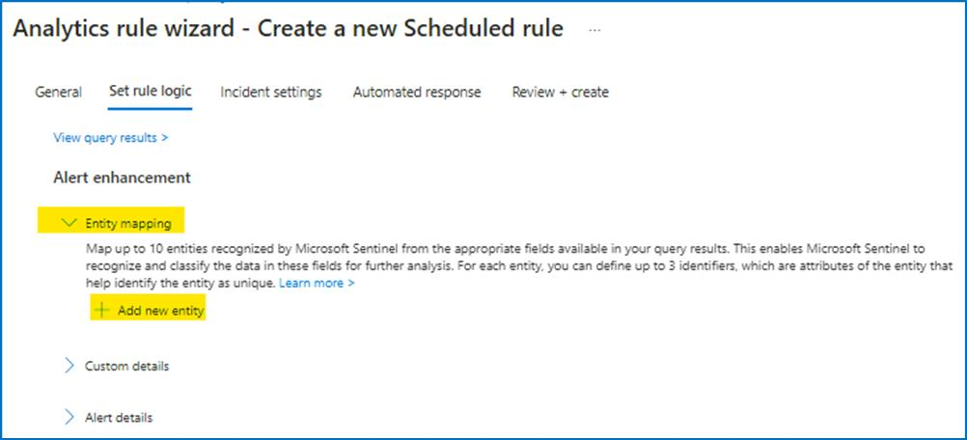

* + In the **Entity type** open the supported list of entities and select **Account**.

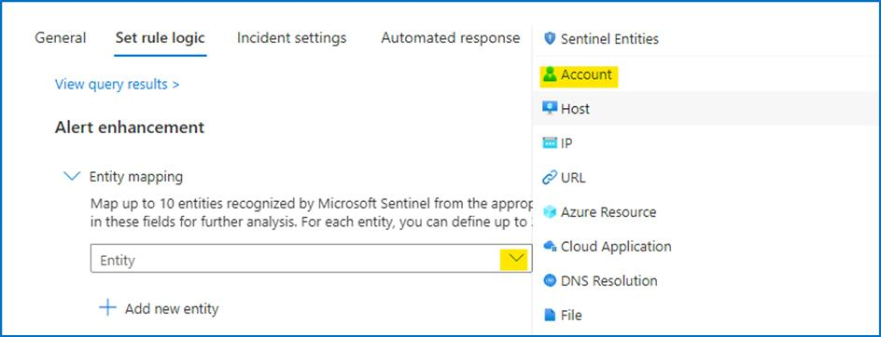

* + From the **Identifier** dropdown menu select **FullName** and from **Value** drop down menu select **UserId__s.**

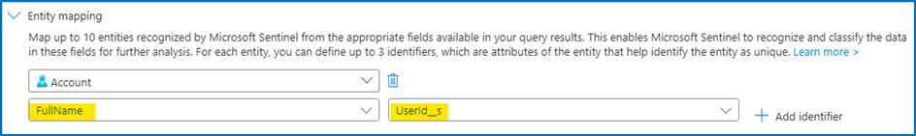

* + Click **+ Add new entity** and this time select **Host** entity. From **Identifier** dropdown menu select **FullName** and from **Value** dropdown menu select **OriginatingServer_s**
  + Click**+ Add new entity**, select **IP** from **Entity type** dropdown menu, in the **Identifier** select **Address** and for **Value** select **ClientIPAddress** value.

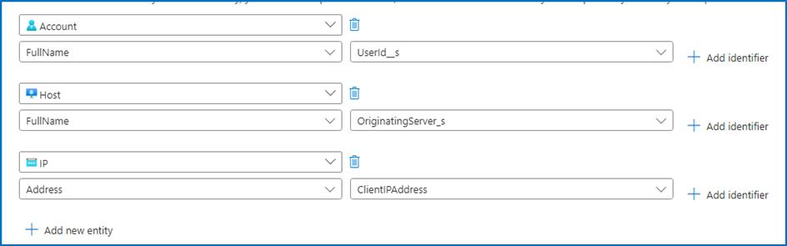

1. Expand the **Alert details** feature and create custom **Alert Name Format.**
   * In the **Alert Name Format** enter the dynamic title **"Malicious Inbox Rule, affected user {{UserId__s}}"**

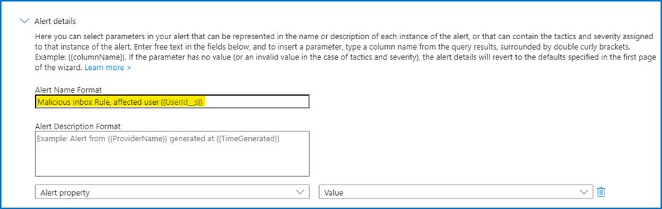

1. Scroll down and in the **Query scheduling** set the **run query every** to **5 minutes** and the **Lookup data to last 12 Hours** (This scheduling might not be ideal for production environment and should be tune). If you deployed the lab more than 12 hours ago, you will need to change the lookback period.

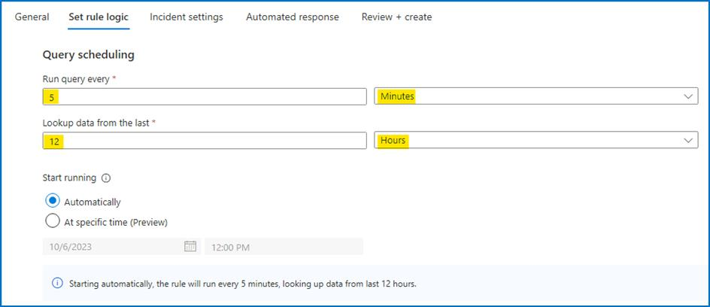

1. In the **Suppression** leave it to **Off**. Click the **Next:Incident settings**>.

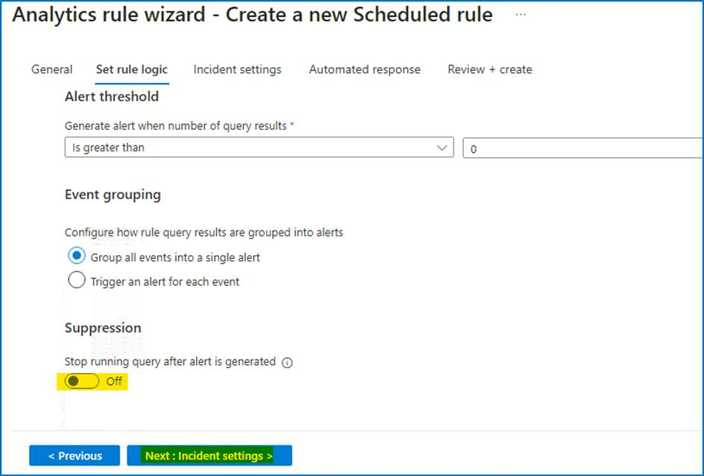

1. To reduce the number of alerts, **implement Alert grouping** feature. To do so, follow the steps below:
   * In the **Incident settings** under **Alert grouping** change it to **Enabled**.
   * Modify the **Limit the group to alerts created within the selected time frame** to **12 hours**.
   * Select the **Grouping alerts into a single incident if the selected entity types and details matches** and select the **Account** and Alert detail as **Name**.

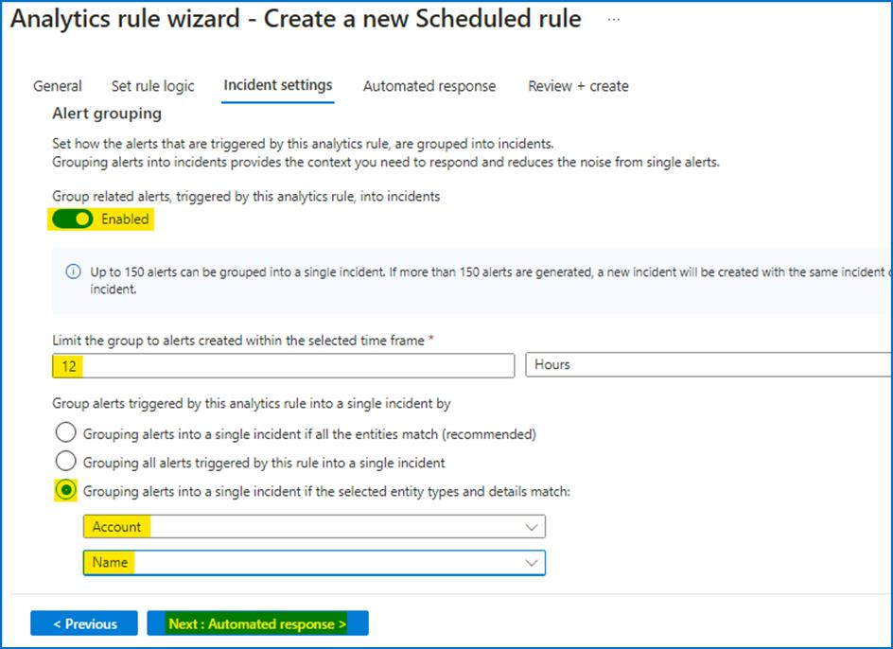

1. Click on **Next: Automated response** and also press **Next:Review** and **Create** this newly analytics rule.

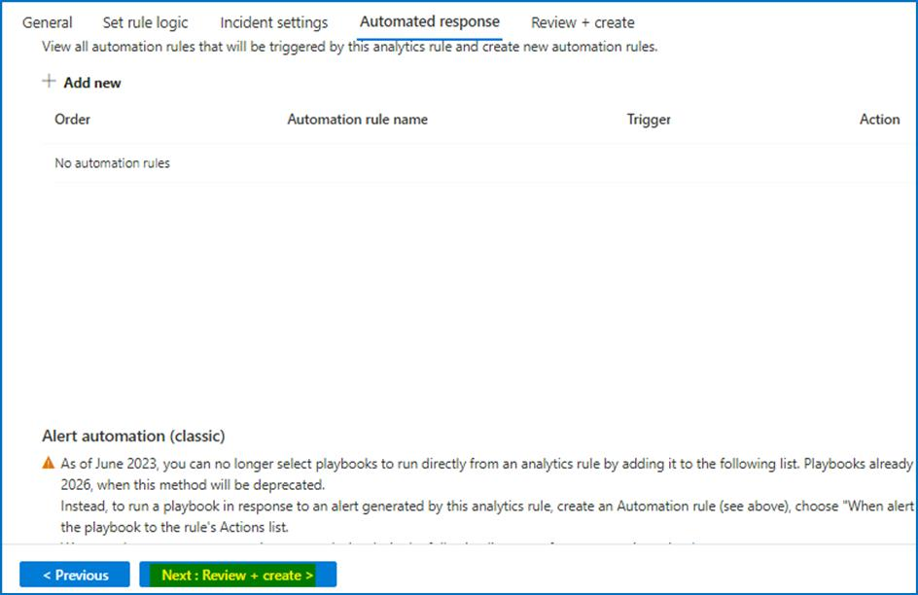

1. On the **Review + create** tab, review the details and then click on **Save** button.

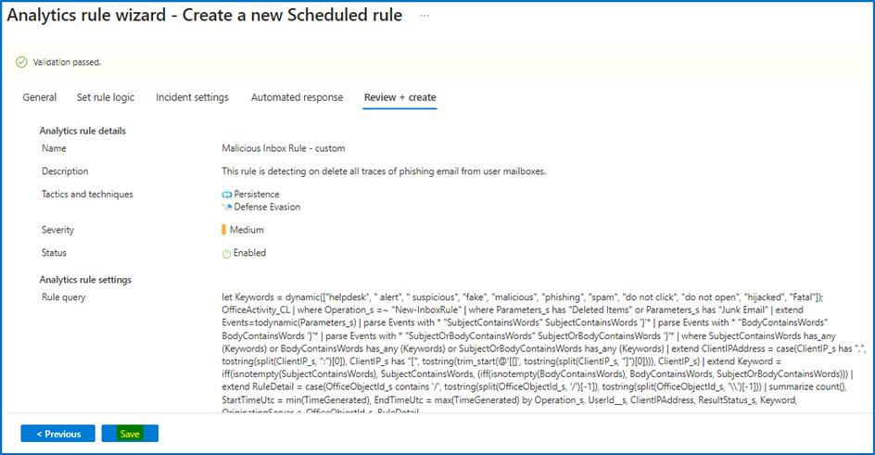

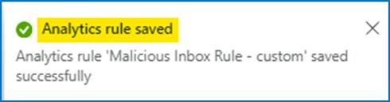

**Task 5 - Review resulting security incident**

After we created the custom analytics rule that detect us for malicious inbox rule rules. Let\'s review the incident that was created from this analytics rule.

1. On the main **Microsoft Sentinel** main page, select **incidents** and review the incident page. If you do not see any incidents. Set the time span for **Last 30 days** from the top bar.

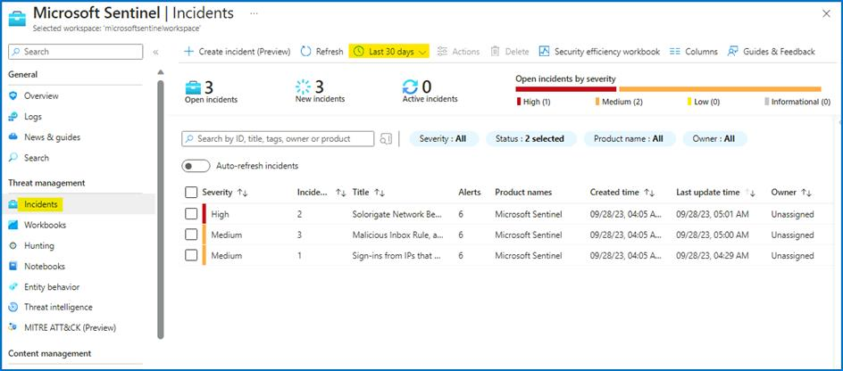

1. Locate a new incident with title **\"Malicious Inbox Rule, affected user**[**AdeleV@contoso.OnMicrosoft.com**](mailto:AdeleV@contoso.OnMicrosoft.com)**\"** notice that the name adapts and the effected user name added to the incident name.

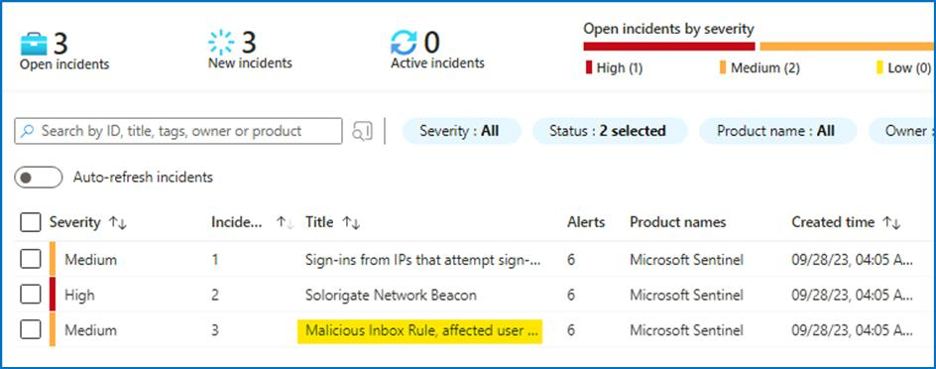

1. In the right pane we can review the incident preview, this view will gave us high level overview on the incident and the entity that related to it.

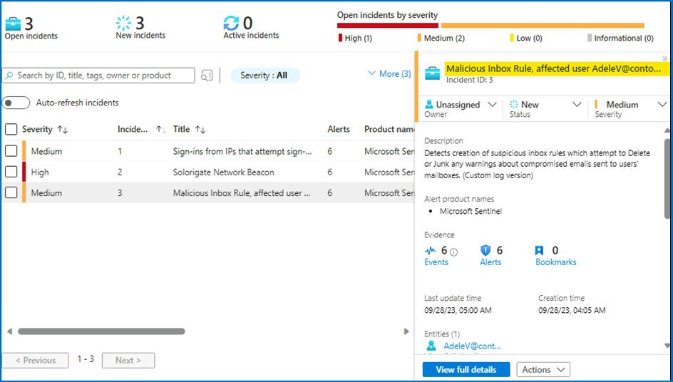

1. Click on the "**view full details**".

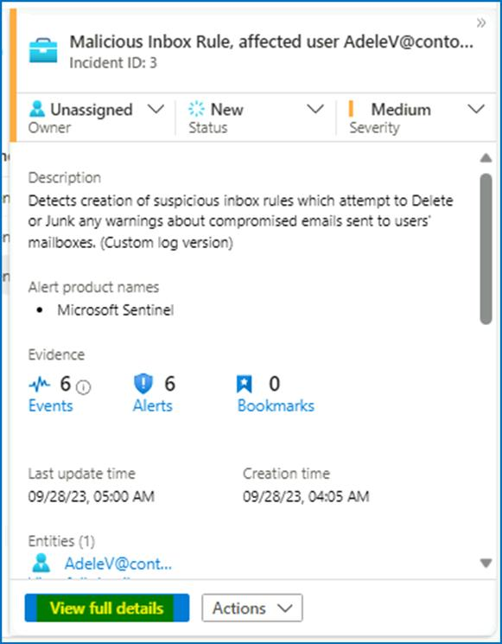

1. In the incident full details page you are able to see **Incident timeline** (effective when you have more than one alert in a given incident).

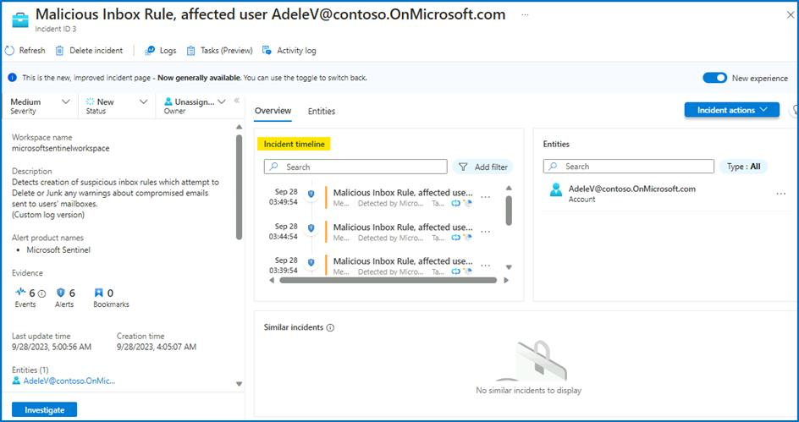

1. Click on the Entities tab to review the names of the Entities associated with the incident.

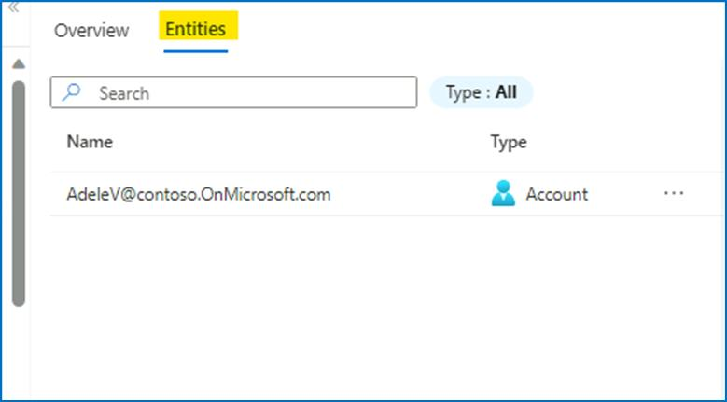

1. Click on the entity **"AdeleV@contoso.OnMicrosoft.com"** and then click on **View full details** button.

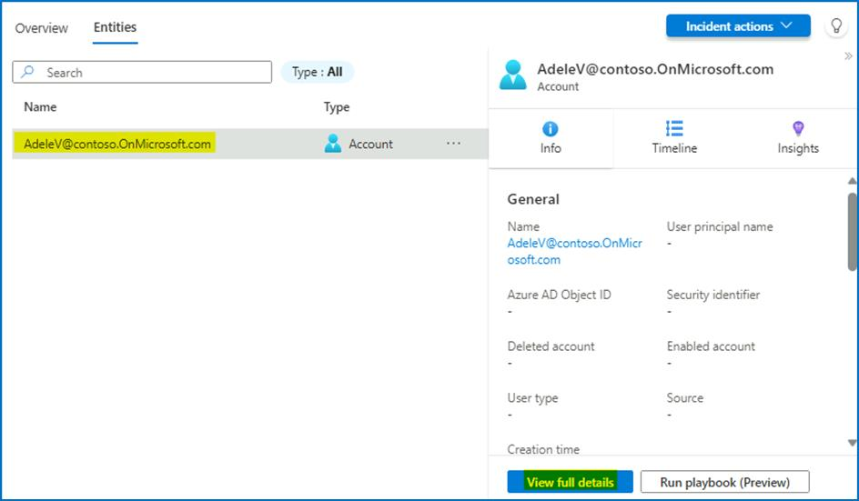

1. This action will navigate us to the user entity page, this page will give us holistic view on the user entity, with all its activity and related alerts. Ensure to select the time to be more than **Last 14 Days**.

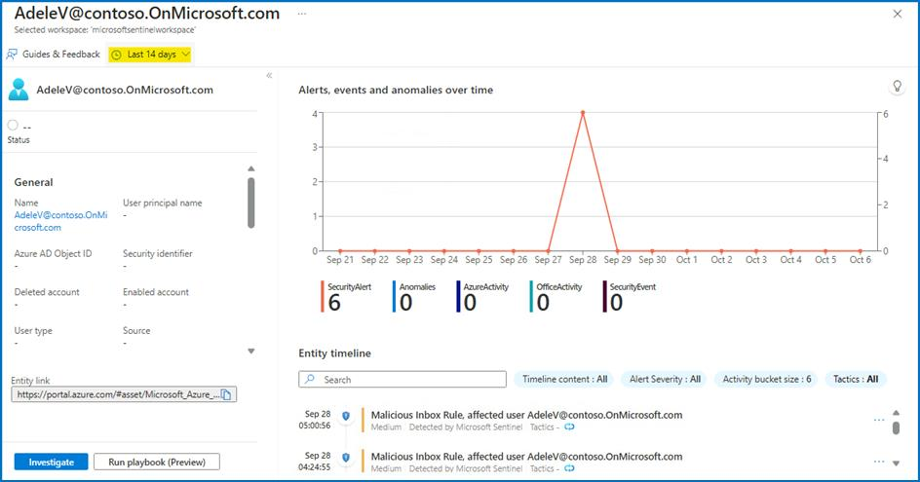

**Task 6 - Handling Incident "Sign-ins from IPs that attempt sign-ins to disabled accounts."**

1. On the Azure Portal **http://portal.azure.com** and search for **Microsoft Sentinel** and click on **Microsoft Sentinel**.



1. Select **SwrkXXXXXXX**.



1. On the left menu navigate to Incident page and select the **Sign-ins from IPs that attempt sign-ins to disabled accounts** incident and on the right pane you can see the incident preview with the high level information about the incident.

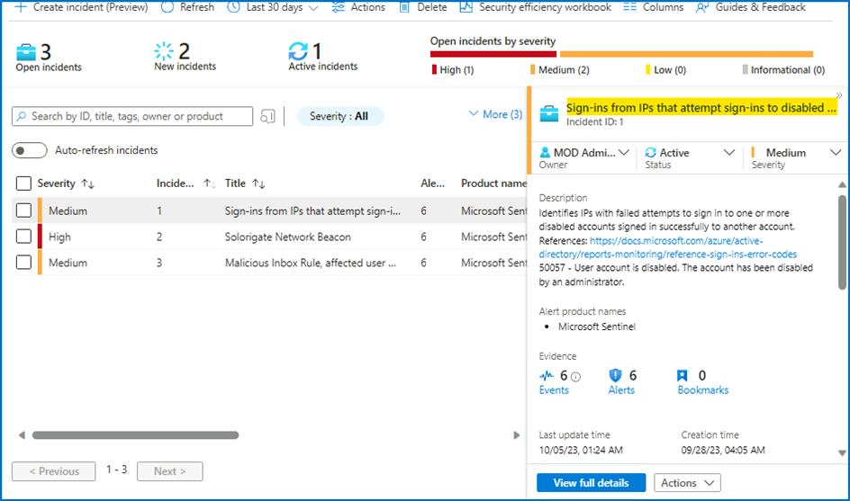

1. Click on the **View full details** button.

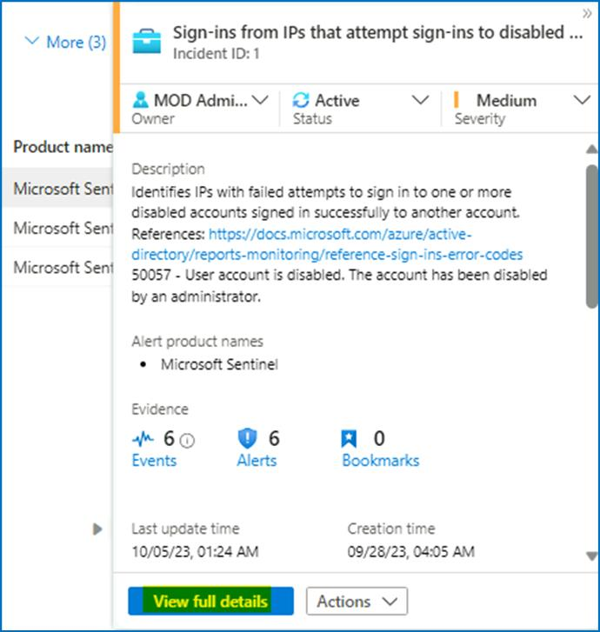

1. On the **Incident** page, select the number of **Alerts**.

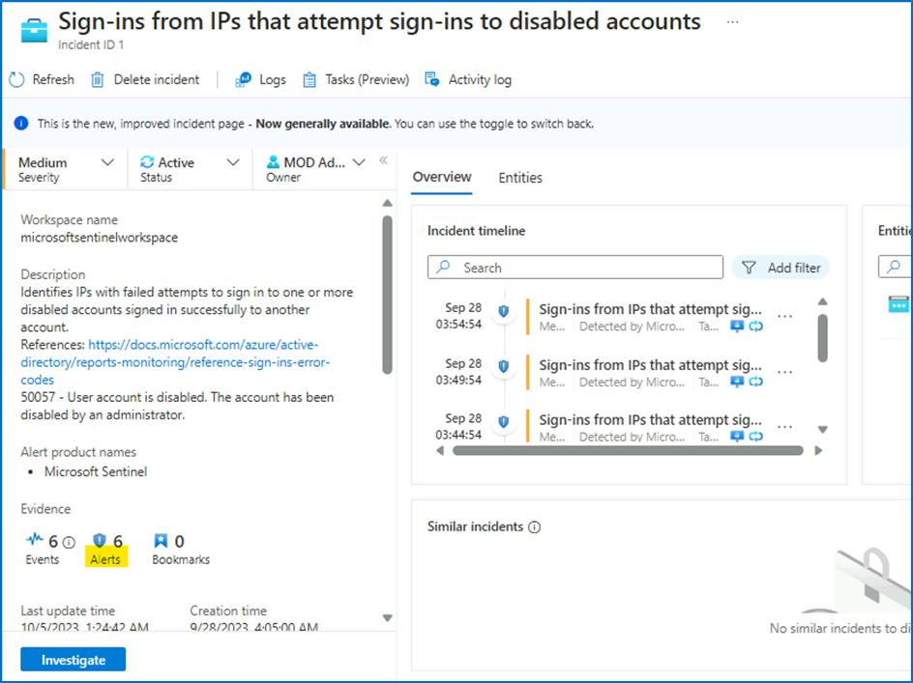

1. You can see the raw logs showing all the events as the result of the query.

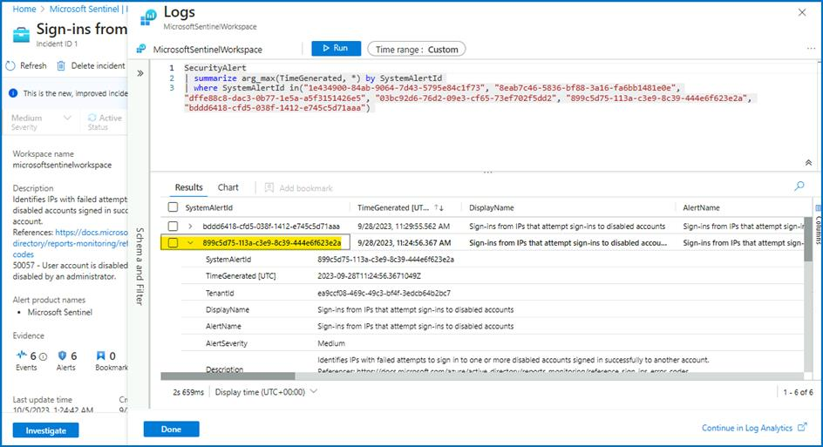

1. In raw log search, expand the **ExtendedProperties**, these properties will help us to decide if this incident is correlated to other events.

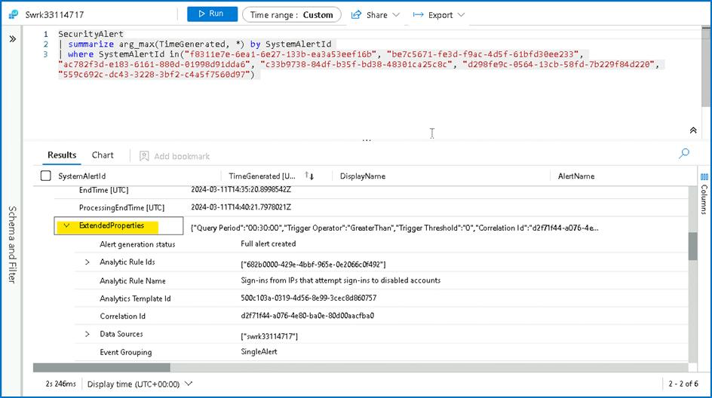

1. Navigate back to the Incident page by clicking **Done**.

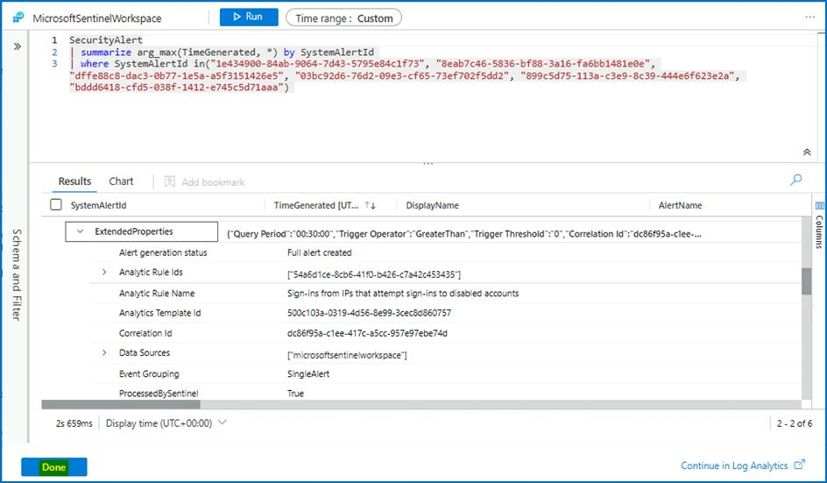

1. In the **Overview** tab, under **Incident Timeline**, select **3 dots** near the latest alert and select **Run Playbook**.

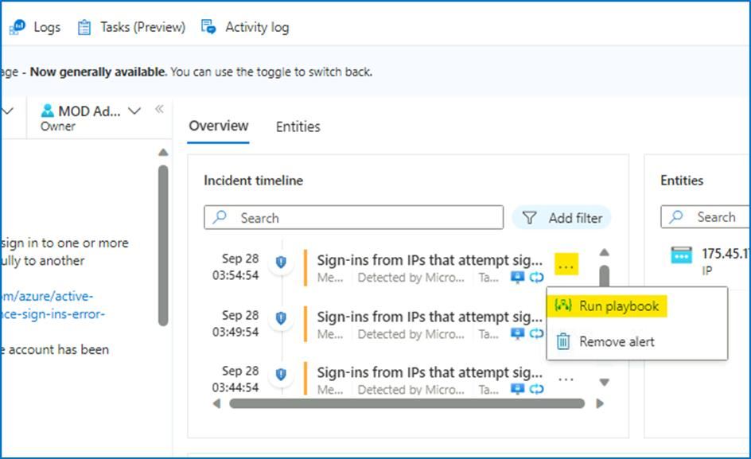

1. Click on **Run** button for the playbook **Get-GeoFromIpAndTagIncident**.

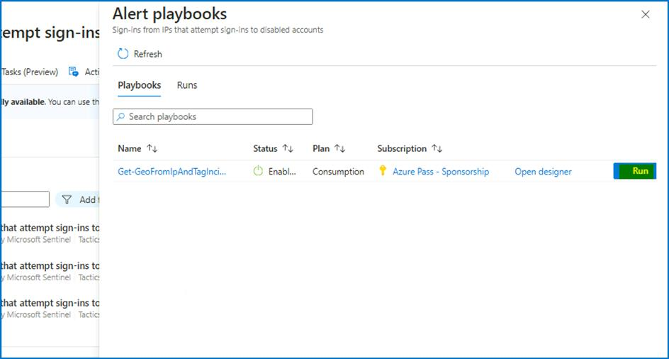

1. If the playbook is configured correctly, it should finish in a couple of seconds and you should be able to see the notification of a successful run.

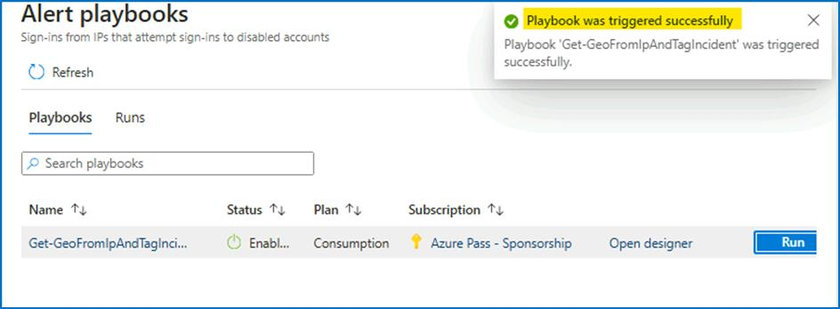

1. You can also navigate to **Run** tab to check if the **Playbook** ran successfully.

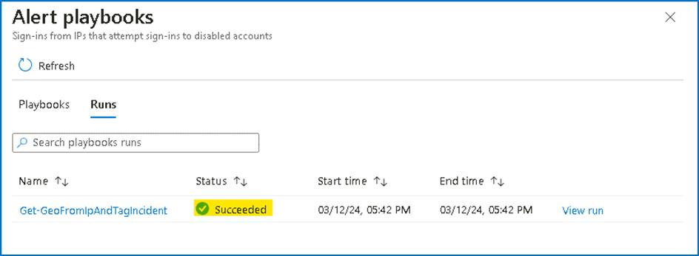

1. Close the dialogue box and navigate back to the main **Incident** page.

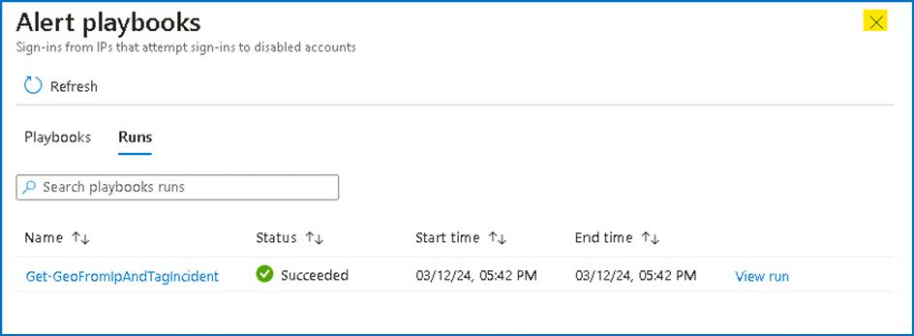

1. Select **Refresh** and now you will notice that new tags are added to the incident.

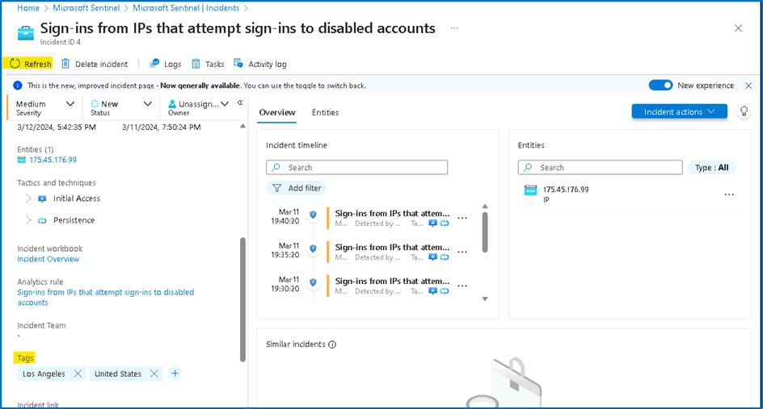

1. Note down the **IP address** under **Entities** into a notepad file. It will be used in the further steps of the lab.

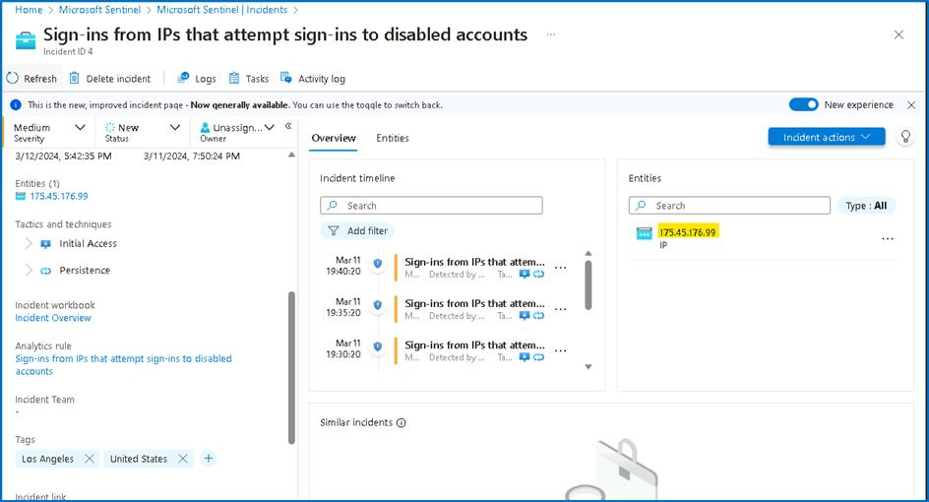

1. Go to **Azure Portal Home page** by selecting Home from the top left corner of the page.

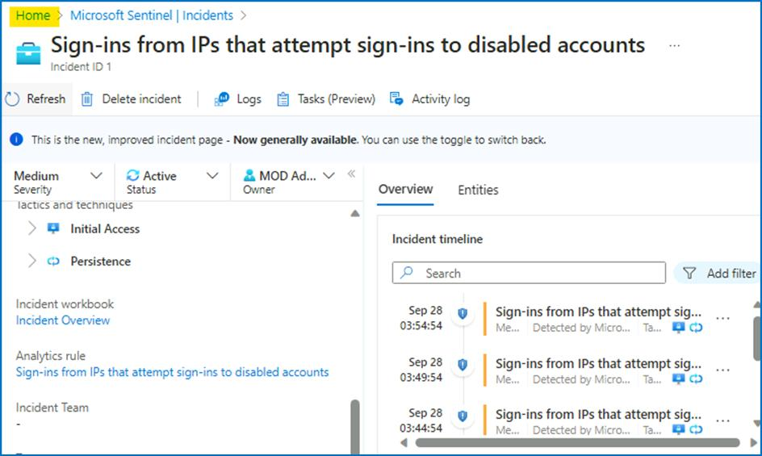

1. Click on Resource groups and then select the **RG4Sentinel** Resource Group.

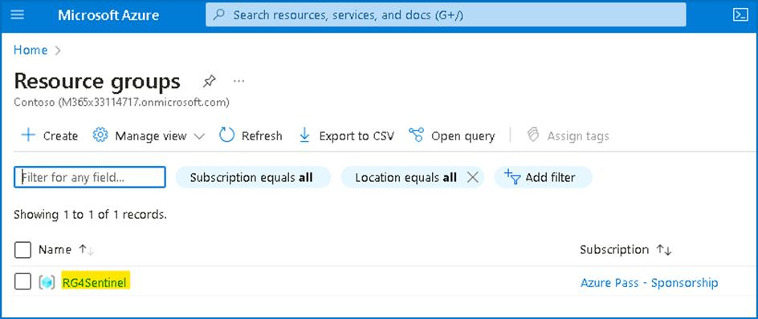

1. Locate the Logic app named **Get-GeoFromIpAndTagIncident**.

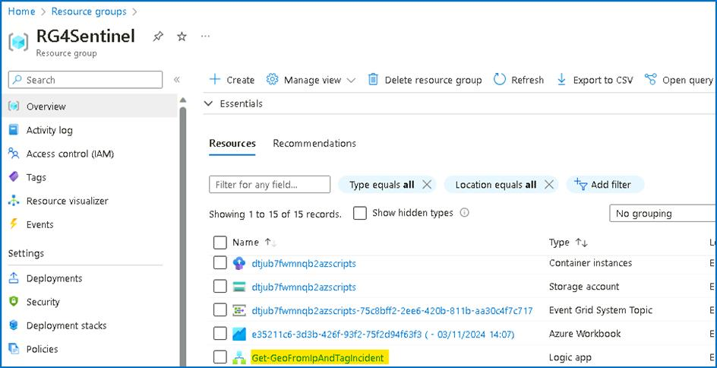

1. Click on the last playbook run.

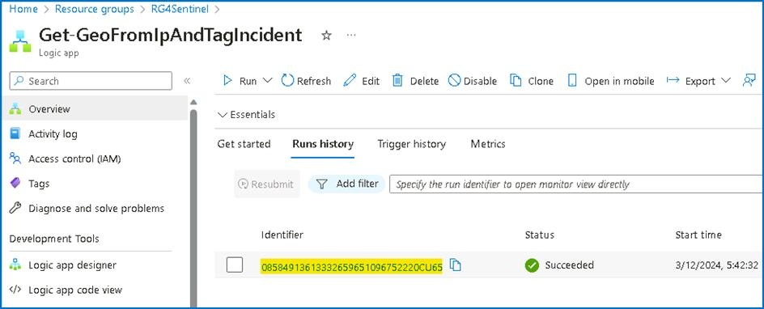

1. You will be able to review the execution steps.

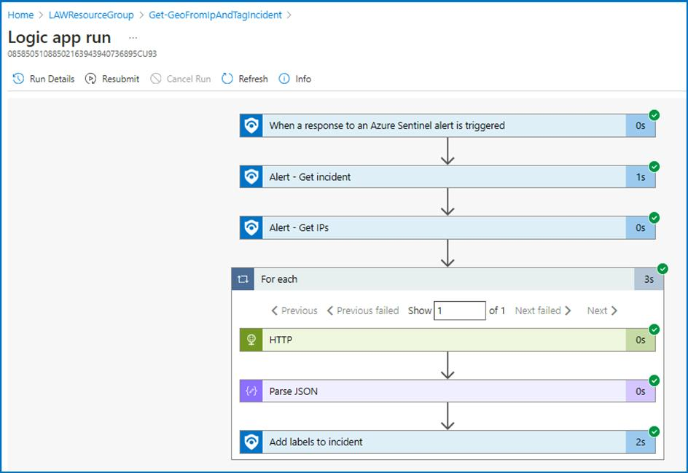

1. From the Azure portal go to **Home** > **Microsoft Sentinel** > **SwrkXXXXXXX**. In the left navigation click on **Workbooks**.

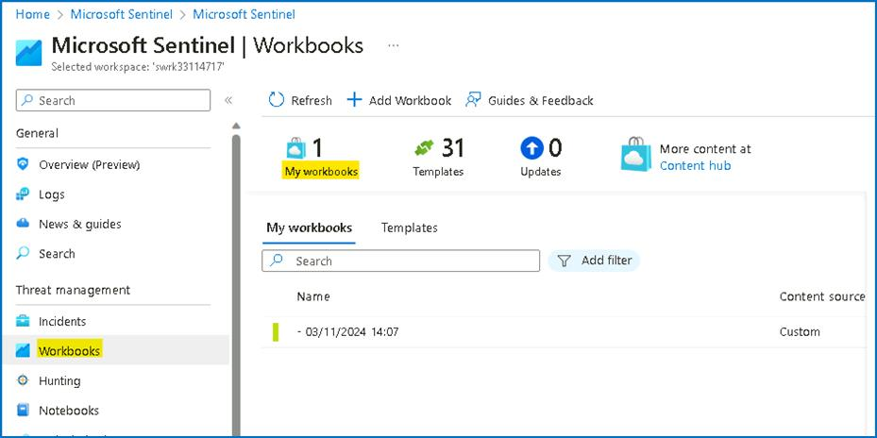

1. In the right page press panel select **View saved workbook**.

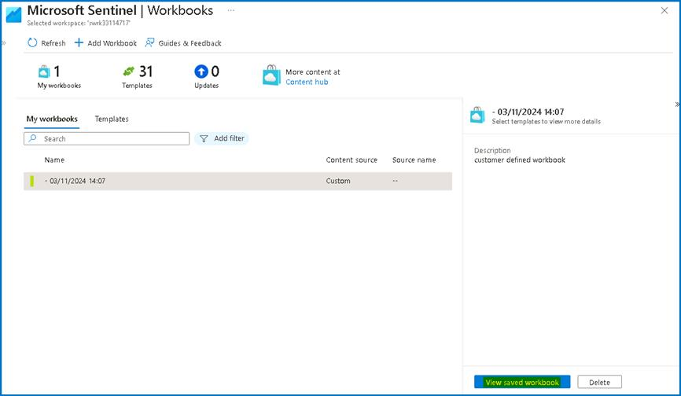

1. It will open **Investigation Insights - < date >**, the saved Workbook.

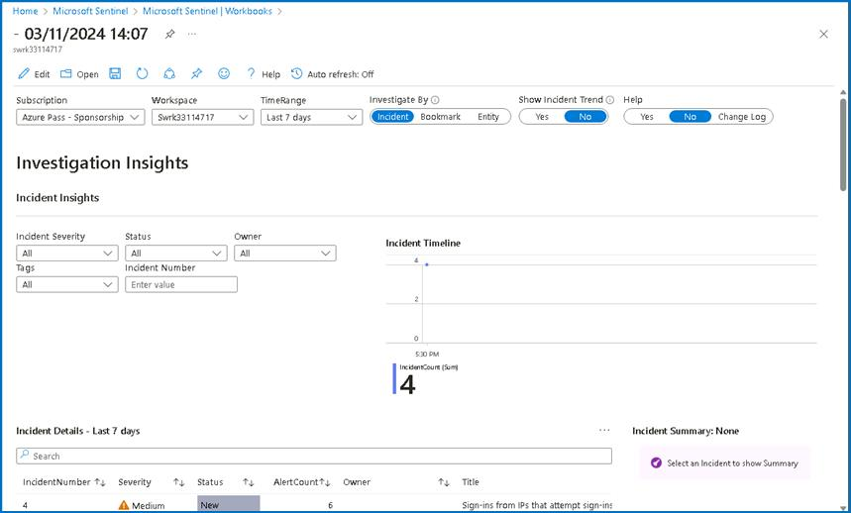

1. Validate that in the properties selector, your workspace is set to **SwrkXXXXXXX** and the subscription is set to **Azure Pass - Sponsorship**.

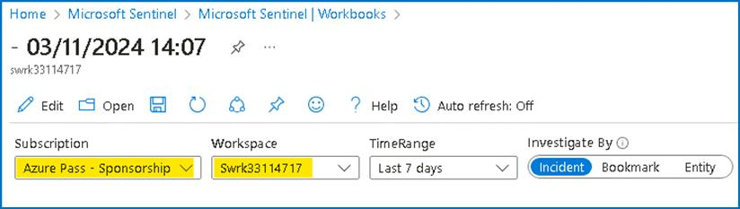

1. As the subject of the investigation is the suspicious IP, we want to see all the activity done by this IP. So in the properties selector, switch on the **investigate by** to **Entity**.

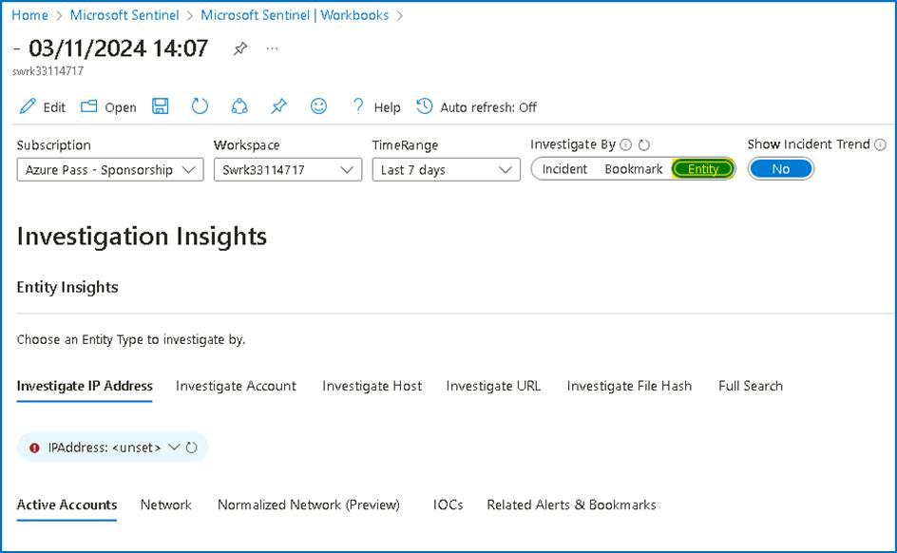

1. In the **Investigate IP Address** Tab, add the suspicious IP - **175.45.176.99** that we noted in one of the previous steps.

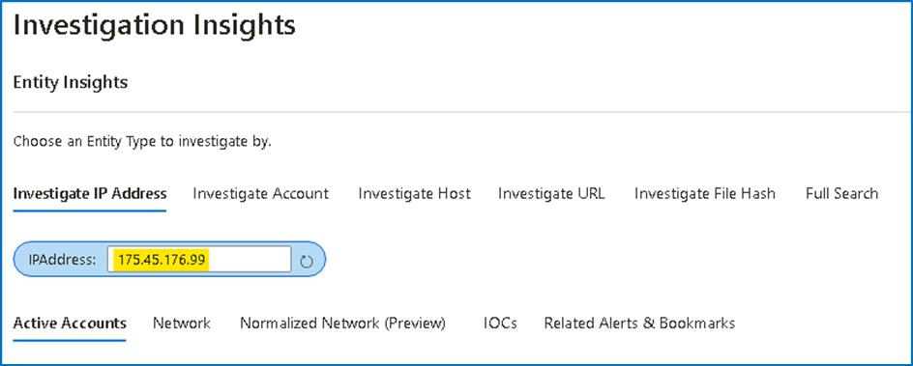

1. Under the Activity Detail you will be able to review successful logins from this IP with the user **Adele**, and also some failed logins to disabled accounts, ensure to set the time span to Last 7 Days.

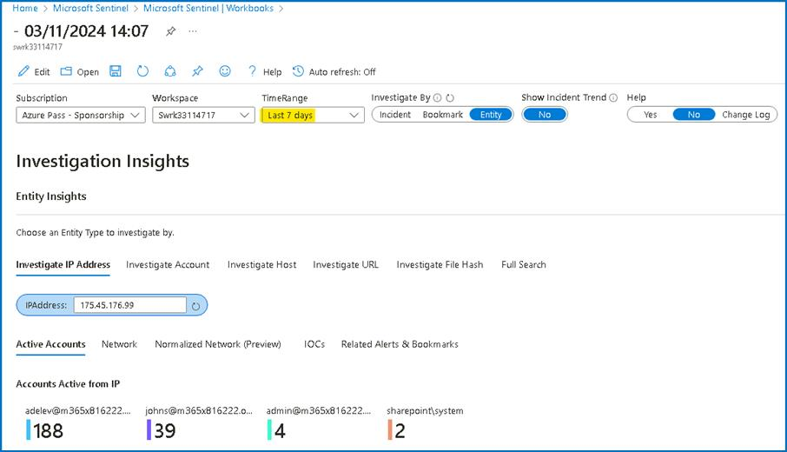

1. Scroll down and click on **Details** column [**twice**] to arrange the activity logs in an order to easily find the failed logins to disabled account.

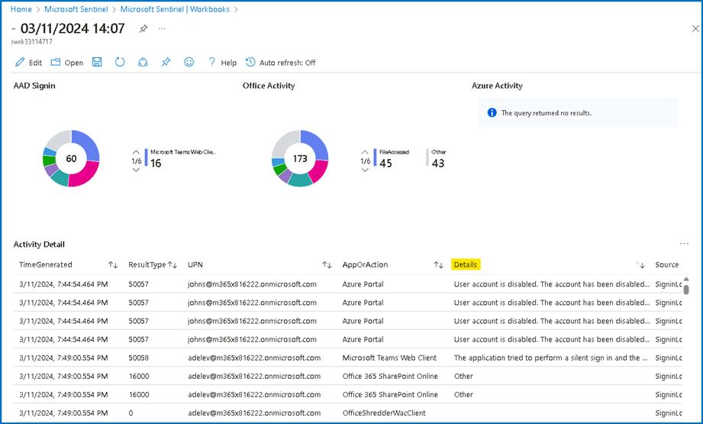

Suppose the User [**adelev@m365x816222.onmicrosoft.com**](mailto:adelev@m365x816222.onmicrosoft.com) is validated in the internal HR system. From the information we collected, it seems that **Adele** is part of the security Red team, and this suspicious activity is the part of an exercise they conducted.

Hence, the SOC manager ask us to add this IP to the whitelisting IP's, so that the system will not trigger incident on it any more. To do this we will follow the following steps.

1. From the Investigation insights page, click on the **Microsoft Sentinel** link.

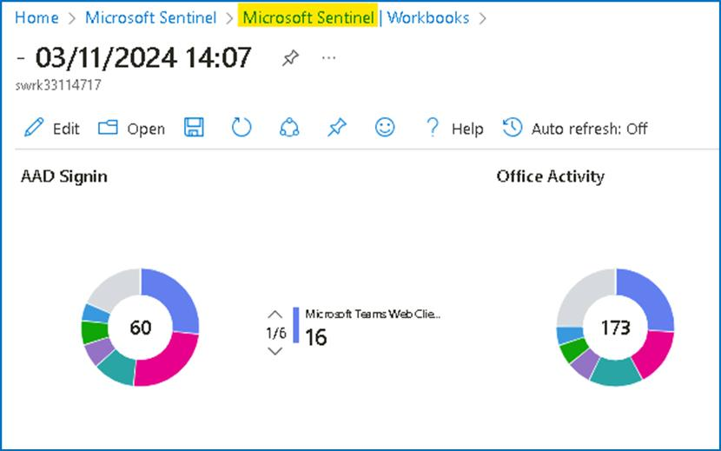

1. From the navigation select **Incidents**, then click **on Sign-ins from IPs that attempt sign-ins to disabled accounts**. Click on **View full details**.

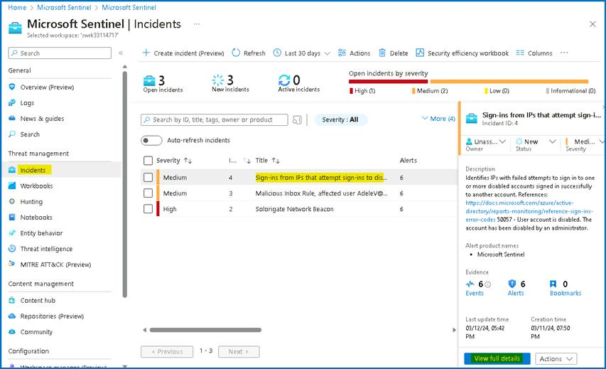

1. On the main incident page, select the relevant incident and press **Incident** **Actions > Create automation Rule**.

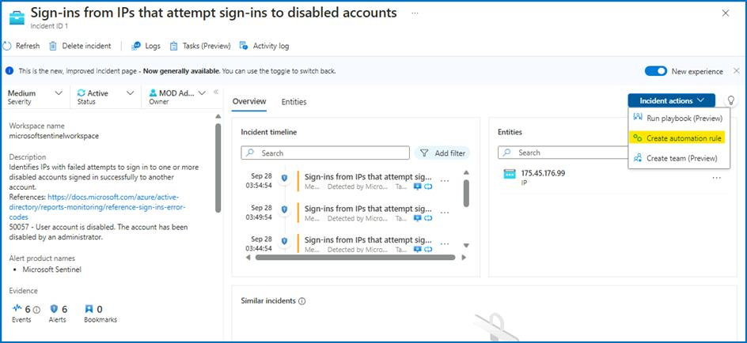

1. In the expanded screen, we will see all the incident identifiers (the IP, and the specific Analytics rule). Set the rule expiration after two days and press **Apply**.

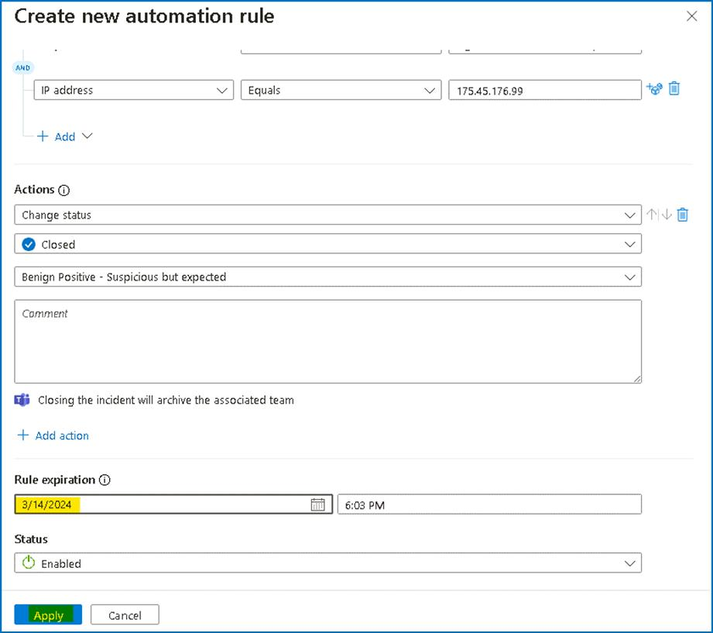

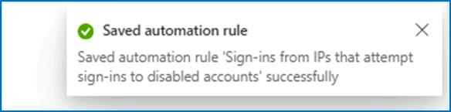

1. On the main Incident page, under status, select **Close** from the drop down, classify the Incident as **Benign Positive - Suspicious but expected** and select **Apply**.

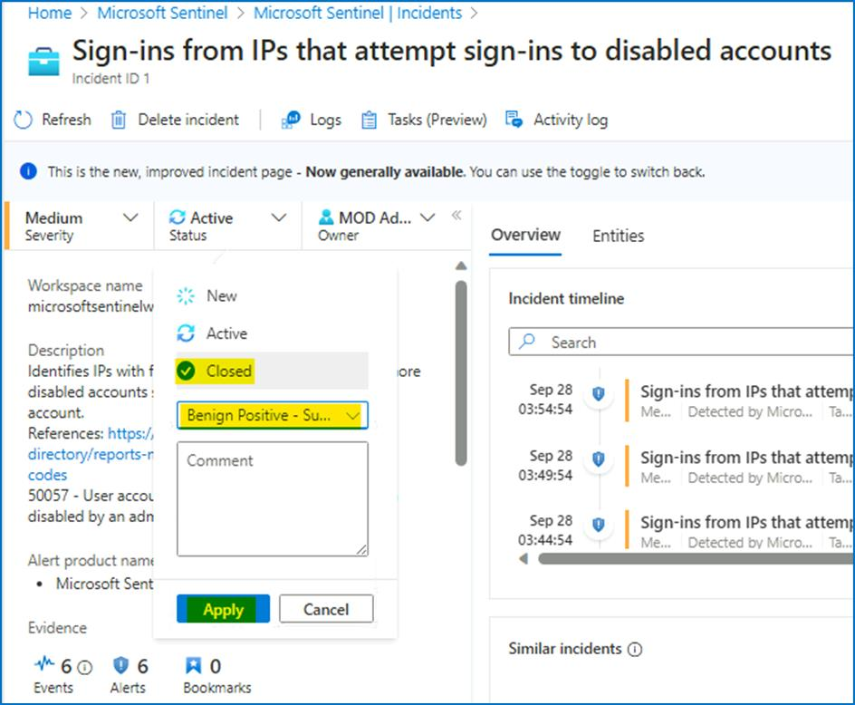

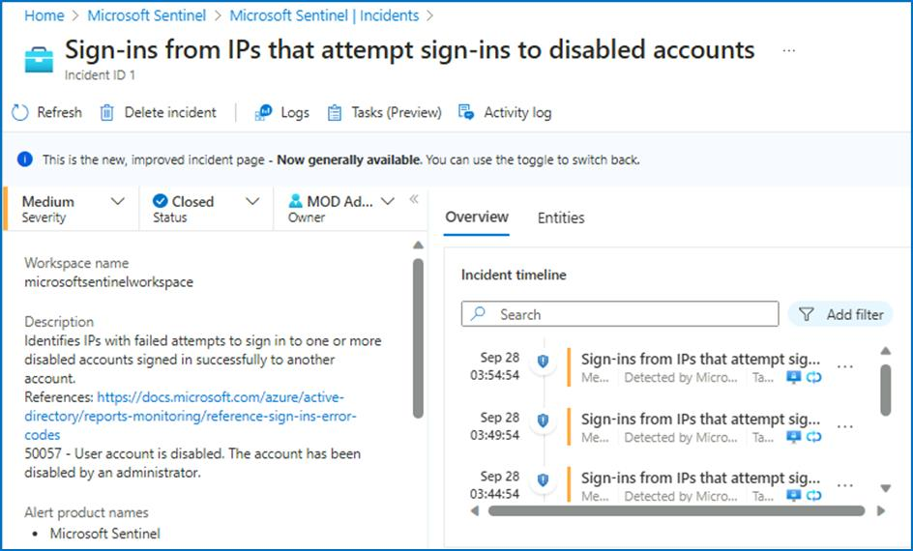

**Task 7 - Handling "Solorigate Network Beacon" incident**

1. On the Azure Portal **http://portal.azure.com** and search for **Microsoft Sentinel** and click on **Microsoft Sentinel**.



1. Select **SwrkXXXXXXX**.



1. Now click on **Incidents** to open the incidents page. This page will show by default all the open incidents in the last 24hr. Set the time span for **Last 30 days** from the top bar.

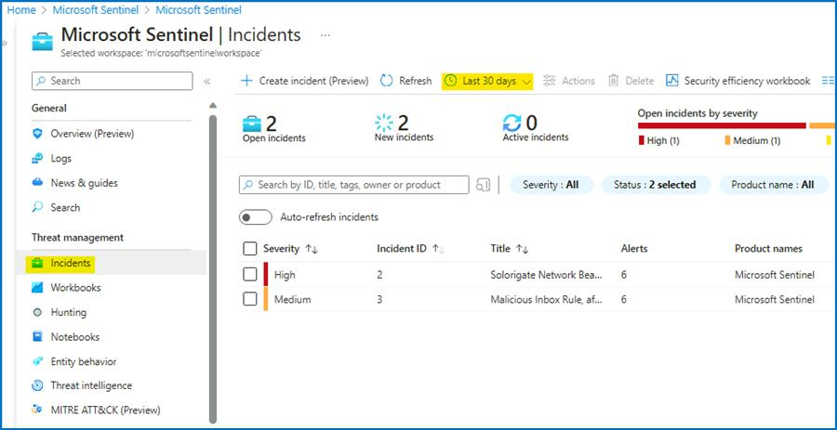

1. From the list of active incidents, select "**Solorigate Network Beacon**" incident. Select **View full details**.

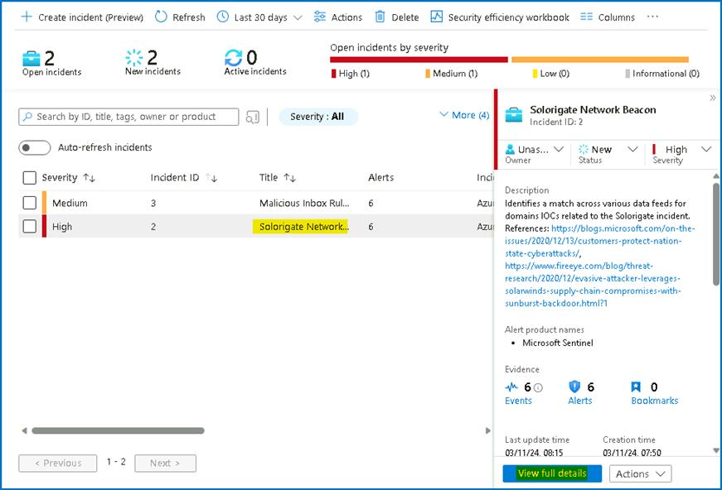

1. Under **Owner**, select **Assign to me** from the dropdown, to assign the incident to yourself and click **Apply**.

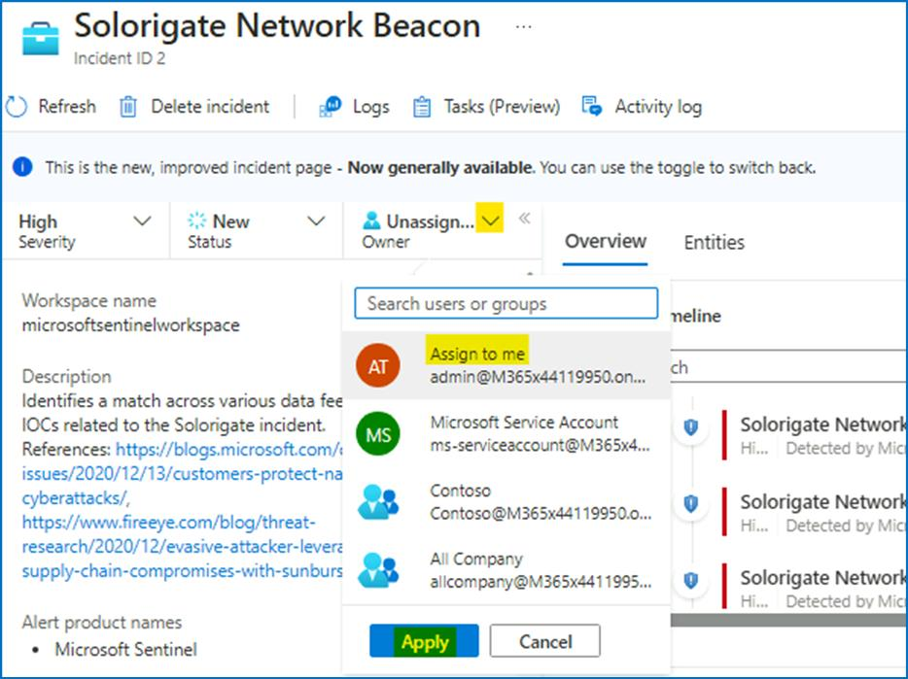

1. Read the description of the incident. As you can see, one of the domain IOCs related to **Solorigate** attack has been found. In this case, domain **avsvmcloud.com** is involved.

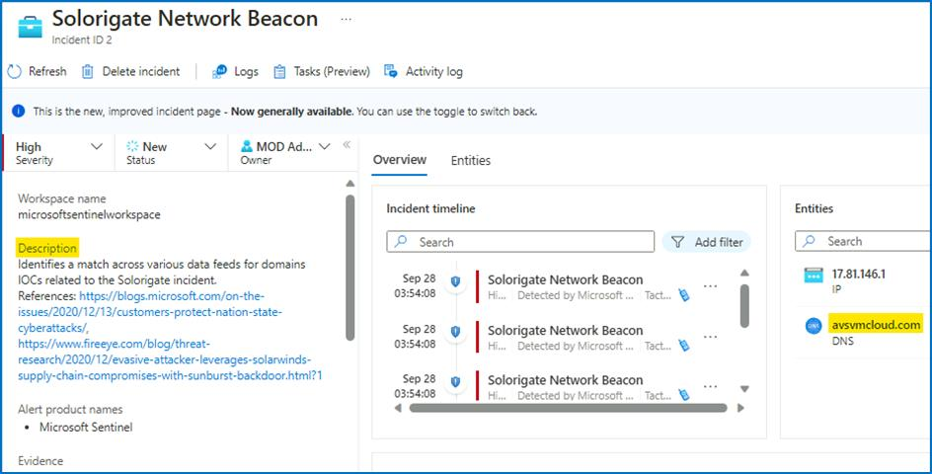

1. From the right side of the screen select **Incident actions** > **Run playbook (Preview)**.

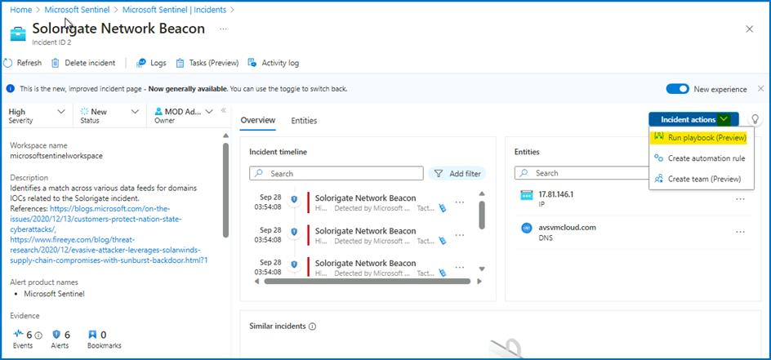

1. Click on the **customplaybook**

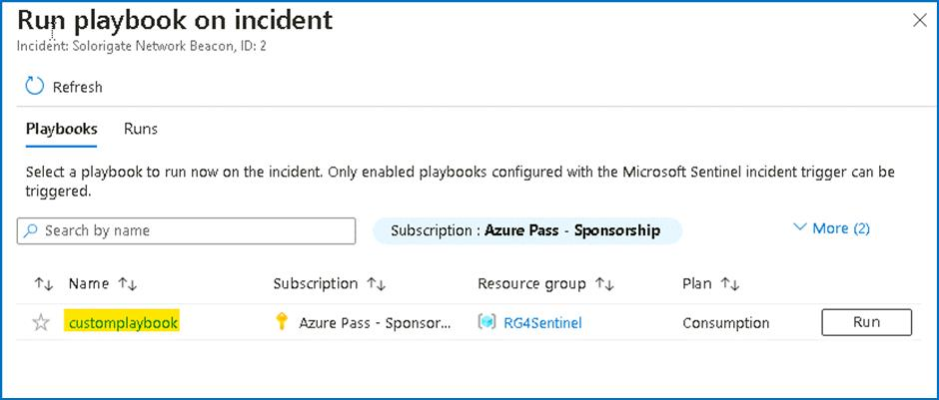

1. Then click on the **Run** drop down and select **Run**

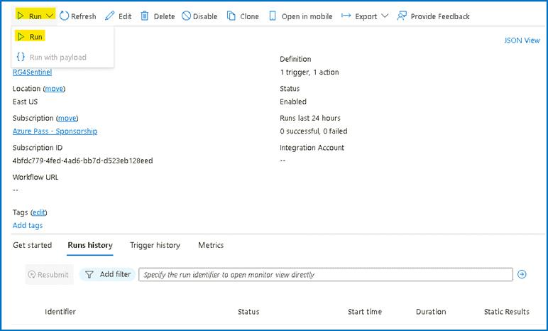

1. You will be able to see the notification that the **Successfully checked the trigger.**

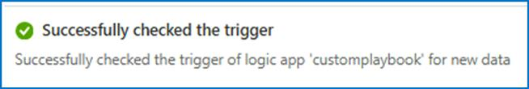

**Task 8 - Hunting for more evidence**

As a next step, you would like to identify the hosts that might have been compromised. As part of your research, you find the following guidance from Microsoft. In this article, you can find a query that will do a SolarWinds inventory check query. We will use this query to find any other affected hosts.

1. On the Azure Portal **http://portal.azure.com** and search for **Microsoft Sentinel** and click on **Microsoft Sentinel**.



1. Select **SwrkXXXXXXX**.



1. Now click on **Hunting** and then select the **Queries** tab.

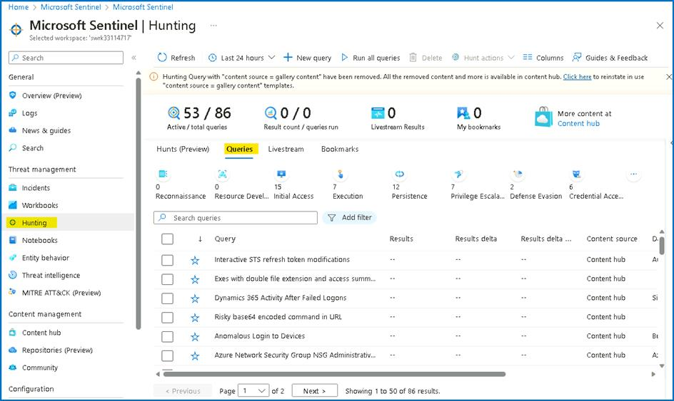

1. In the search box, type "**solorigate**". Select **Solorigate Inventory check** query.

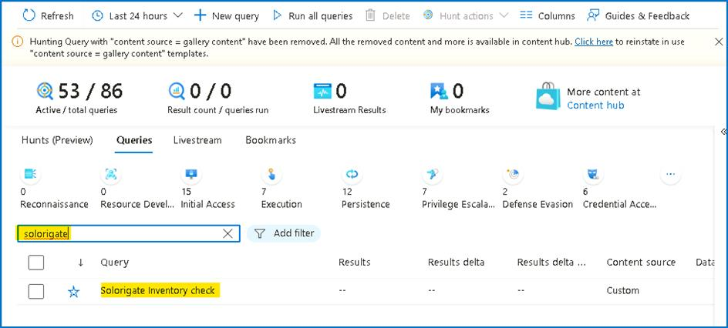

1. Click on **Run Query**.

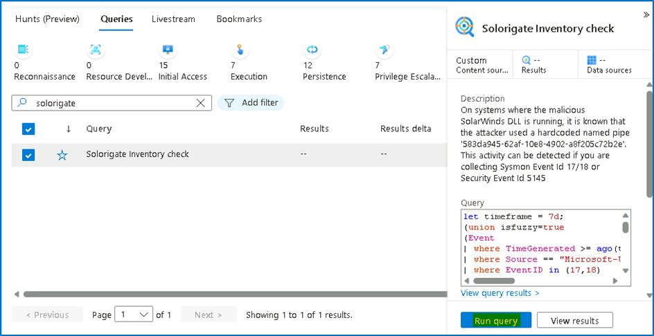

1. You should see a total of three results. Click on the **3 Results** or **View Results**.

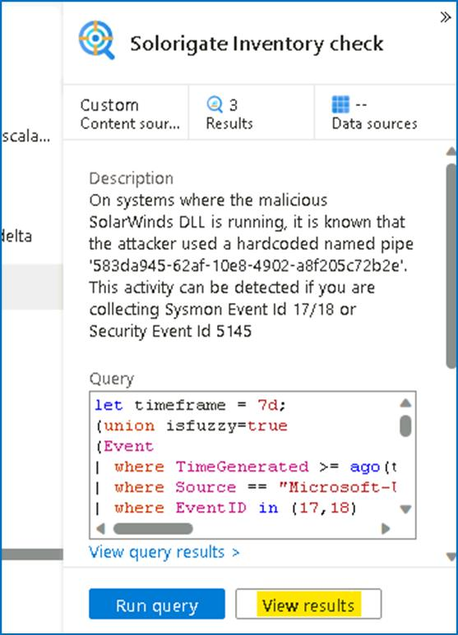

1. As you can see, under **AccountCustomEntity**, there are two additional computers where the malicious DLL and named pipe has been found. Bookmark those additional records, by selecting them and then clicking on **Add bookmark**.

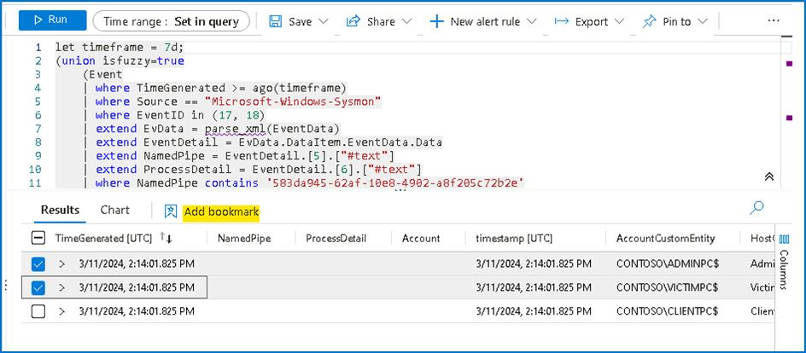

1. In the flying pane that appears, click on **Create** to create the bookmarks. As you can see entity mapping to already done for you.

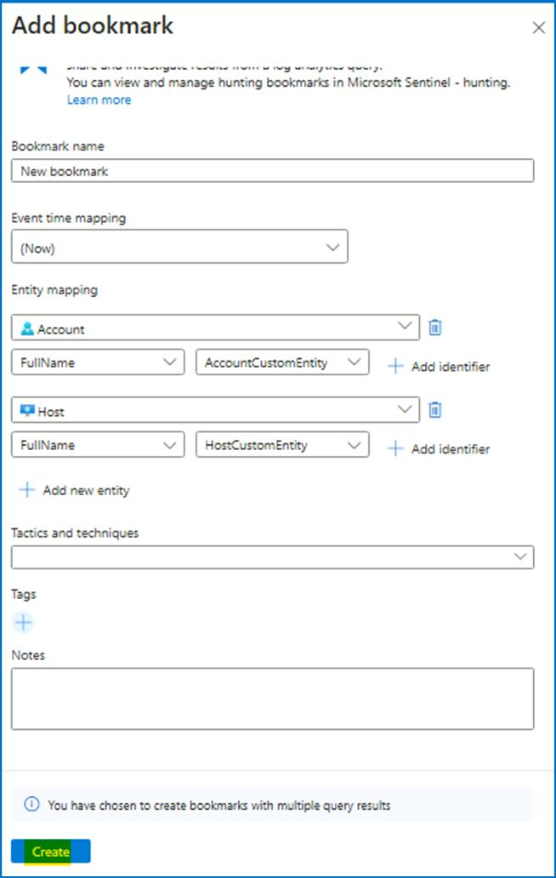

1. Wait until the operation finishes and close the log search using the ✖ at the top right corner.

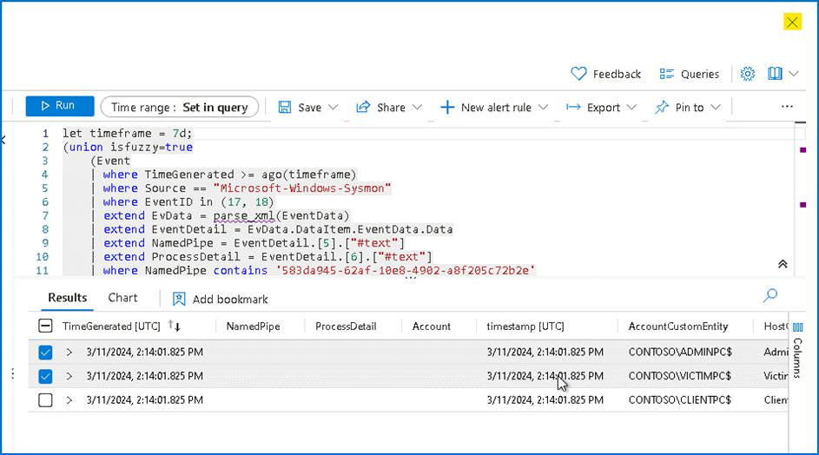

1. Click on **Bookmarks** tab inside **Hunting** menu and click **Refresh**, where you should see your two new bookmarks created.

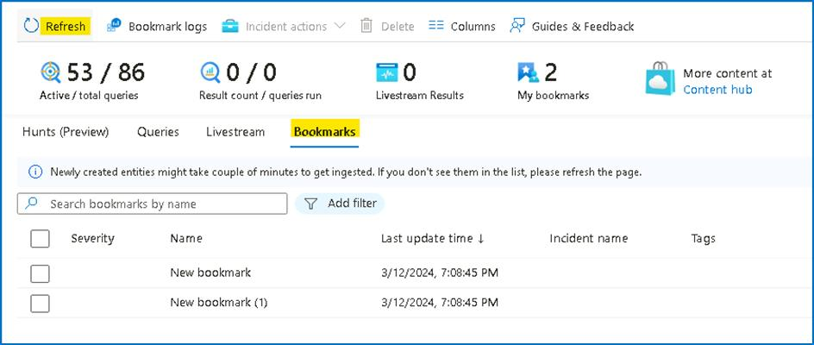

1. Select both of them and click on **Incident actions** at the top and then **Add to existing incident**.

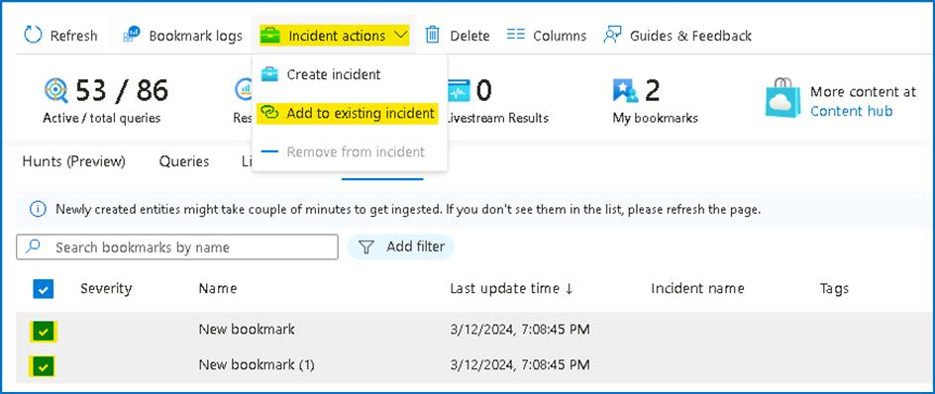

1. From the list, pick the **Solorigate incident** that is assigned to you, and click **Add**.

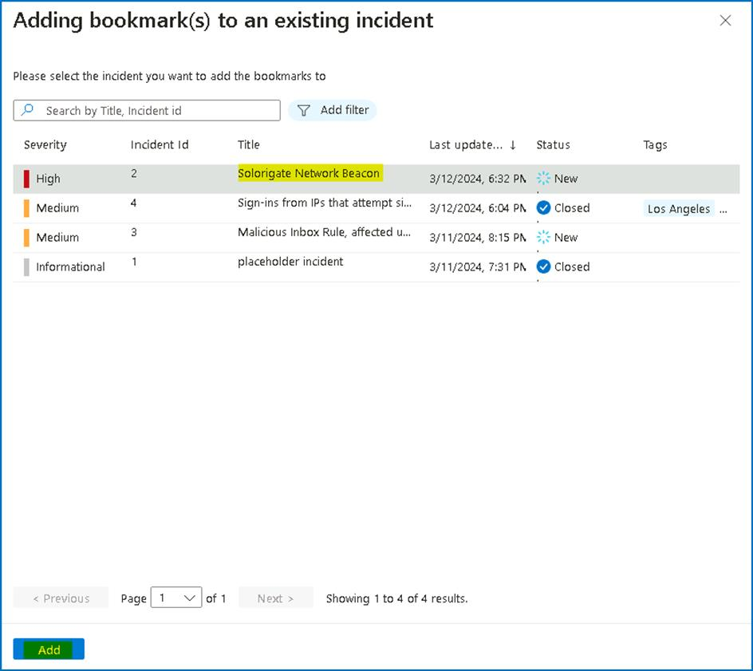

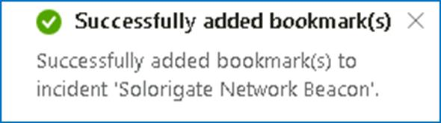

1. At this point you can ask the Operations team to isolate the hosts affected by this incident. Continue to the next task without closing the window.

**Task 9 - Adding IOC to Threat Intelligence**

Now, we will add the IP address related to the incident to our list of IOCs, so we can capture any new occurrences of this IOC in our logs.

1. Click on **Incidents** under Threat management.

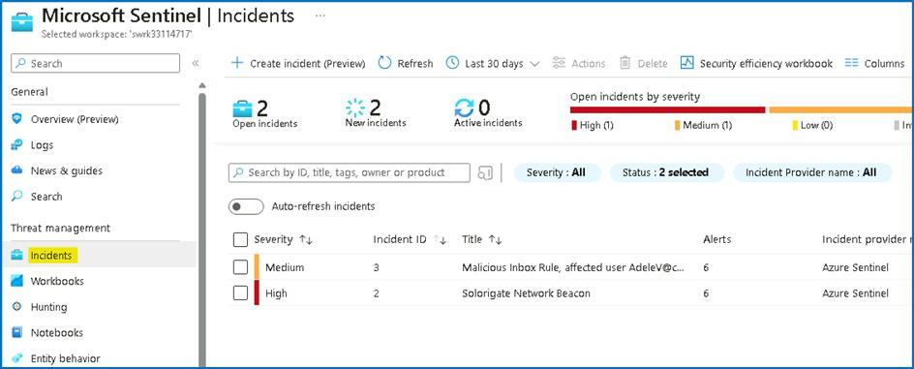

1. Select the **Solorigate incident** and click on View full details.

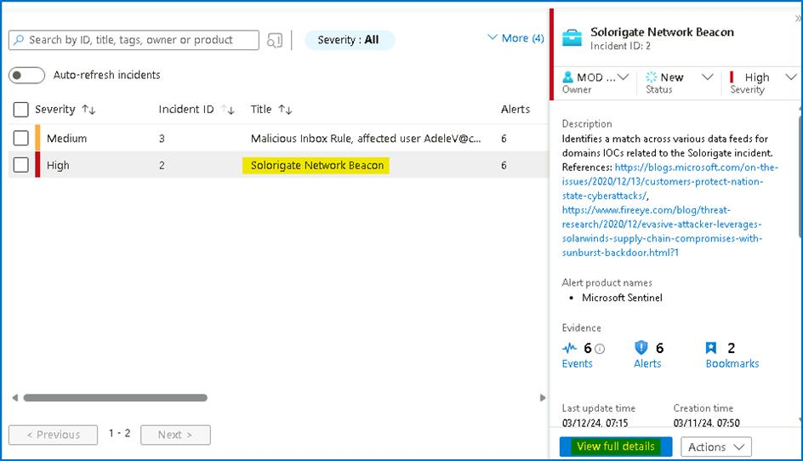

1. Note down the **IP address** entity involved. Notice that you have now more computer entities available (the ones coming from the bookmarks).

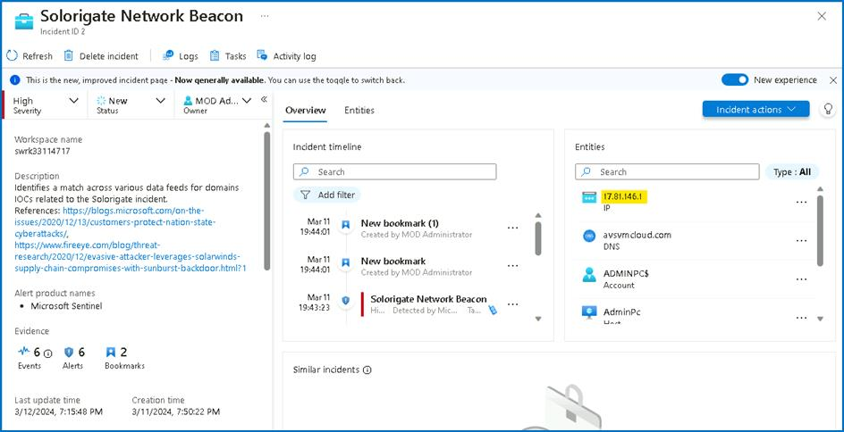

1. Click on **Threat Intelligence** under Threat management and click **Add new**

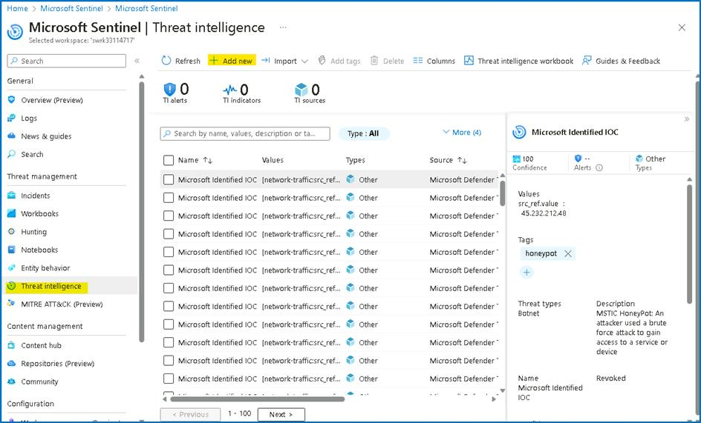

1. Enter the following details in the **New indicator** dialog, with **Valid from** being today\'s date and **Valid until** being two months after. Then click **Apply**.
   * Types -- **ipv4-addr**
   * Ipv4 address -- **The address we copied in the previous step of this exercise.**
   * Name -- **Threat1**

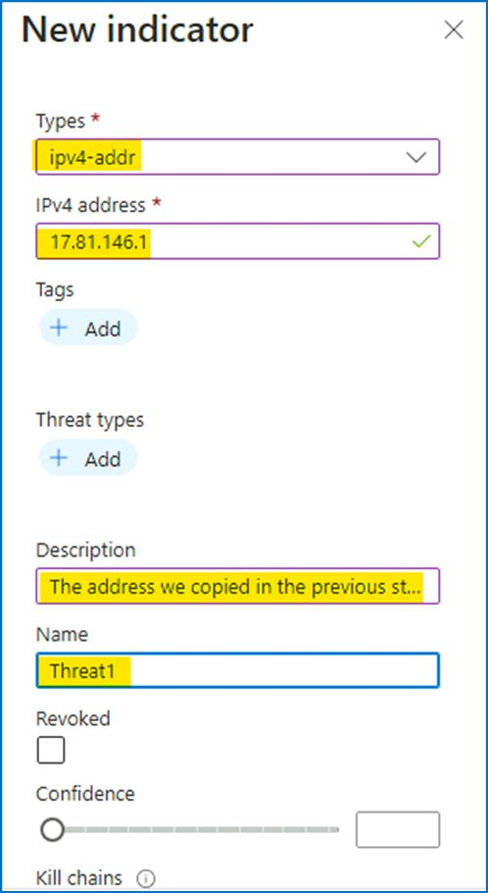

1. Enter the **Valid from** and **Valid until** dates and then click on **Apply**

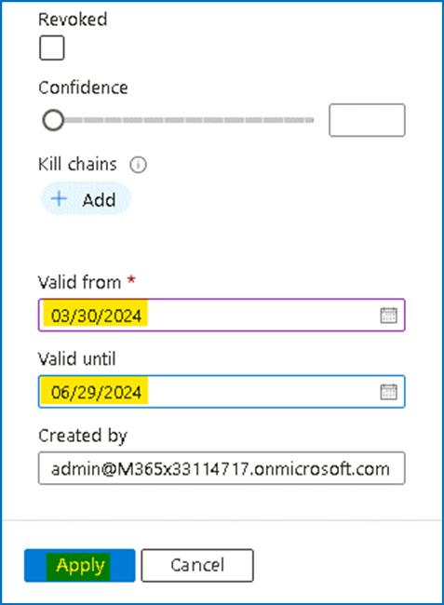

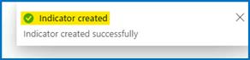

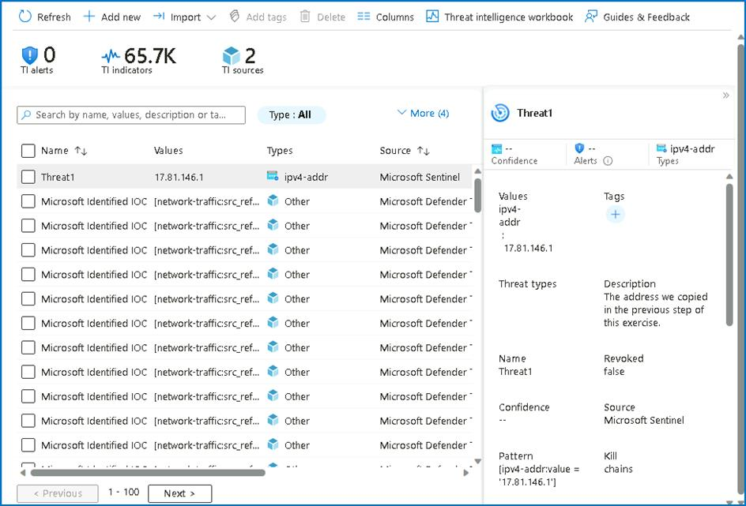

**Lab 4 -- Hunting queries and Watchlists**

**Objective**

Our security researchers shared the following article describing techniques used in the SolarWinds supply chain: Identifying UNC2452-Related Techniques for ATT&CK **https://medium.com/mitre-attack/identifying-unc2452-related-techniques-9f7b6c7f3714**

Based on the article, our SOC leads understand that to be able to see the full picture of the attack campaign and spot anomalies on our data set, we need to run a proactive threat hunt based on the MITRE tactics and techniques described in this article.

Review the above article that highlights MITRE attack techniques and the corresponding tools and methods. In this exercise, we will focus on T1098. To get a greater understanding of this technique, review this article: **https://attack.mitre.org/techniques/T1098/**

**Prerequisites**

This Lab assumes that you have completed Lab 1, as the data and the artifacts that we will be using in this Lab need to be deployed on your Microsoft Sentinel instance.

**Exercise 1 -- Overview of Hunting queries and Watchlist**

**Time - 20 minutes**

**Task 1 - Hunting on a specific MITRE technique**

1. On the Azure Portal **http://portal.azure.com** and search for **Microsoft Sentinel** and click on **Microsoft Sentinel**.



1. Select **SwrkXXXXXXX**.



1. Now click on **Hunting** and then select the **Queries** tab.

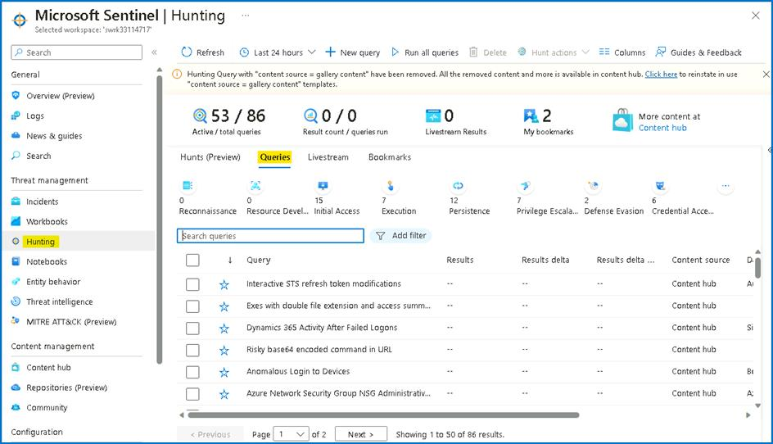

1. In the hunting page, we can see that **Microsoft Sentinel** provides built-in **hunting queries** to kick start the proactive hunting process.

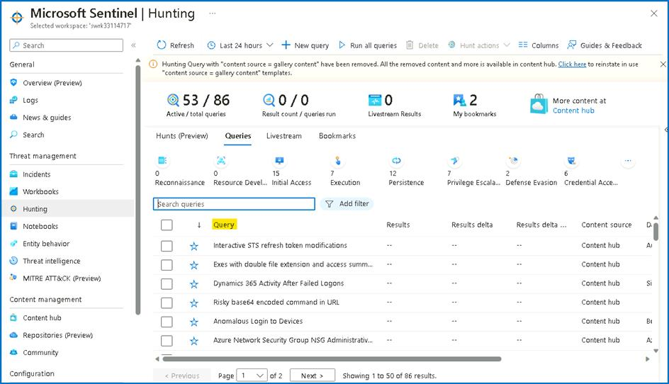

1. On the metric bar we can see statistics about how many queries are "**active**" and have the required data sources to run in your environment. There are also metrics showing how many **queries have been run** in during your current session, and how many of these **queries produced results**. We also see counts of the number of **Livestream results** and **bookmarks** created during the hunting process.

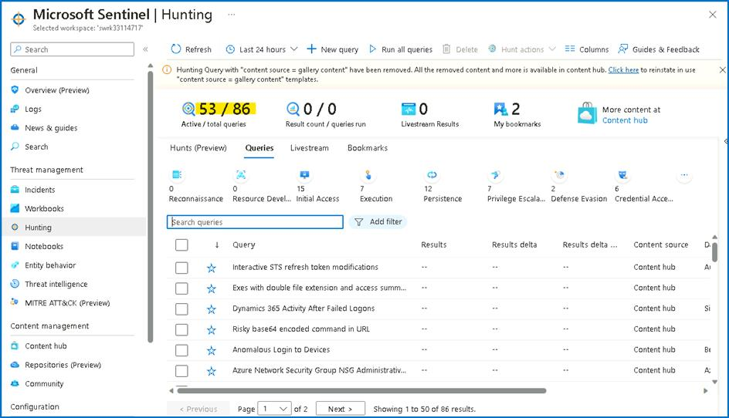

1. On the top action bar, shown in the above diagram, we can find the **Run All queries** button. Clicking on this button runs all active queries. This can take a significant amount of time depending on the number of queries and amount of log data being queried. To get results faster, it helps to **filter** down the set of queries to the specific set you need to run.

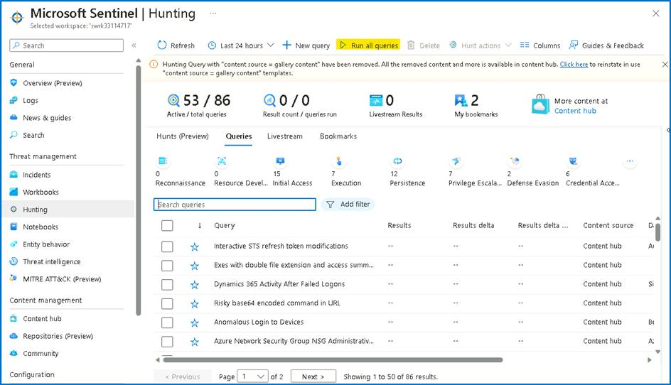

1. Microsoft Sentinel provides many different attributes to filter down to just the queries you want to run. To filter by **MITRE technique**, click **Add filter**, select **Techniques.**

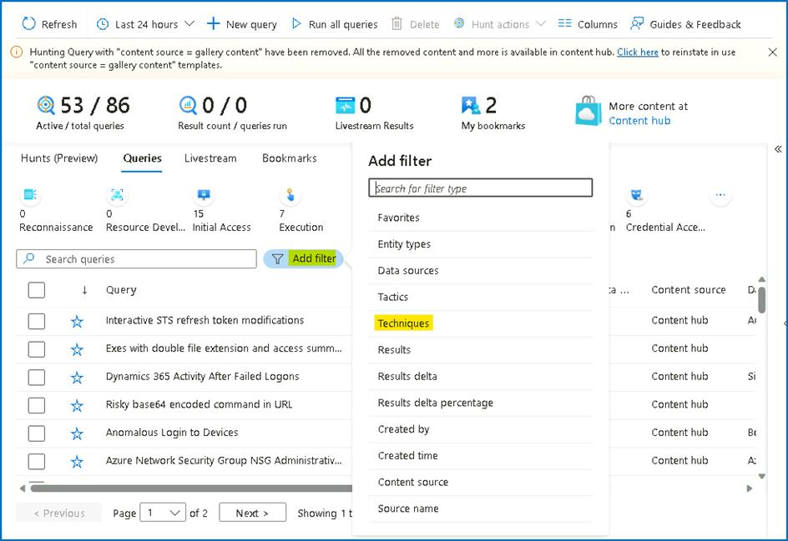

1. In the **Techniques** value field, only select **T1098 --** **Account Manipulation** and click **Apply**.

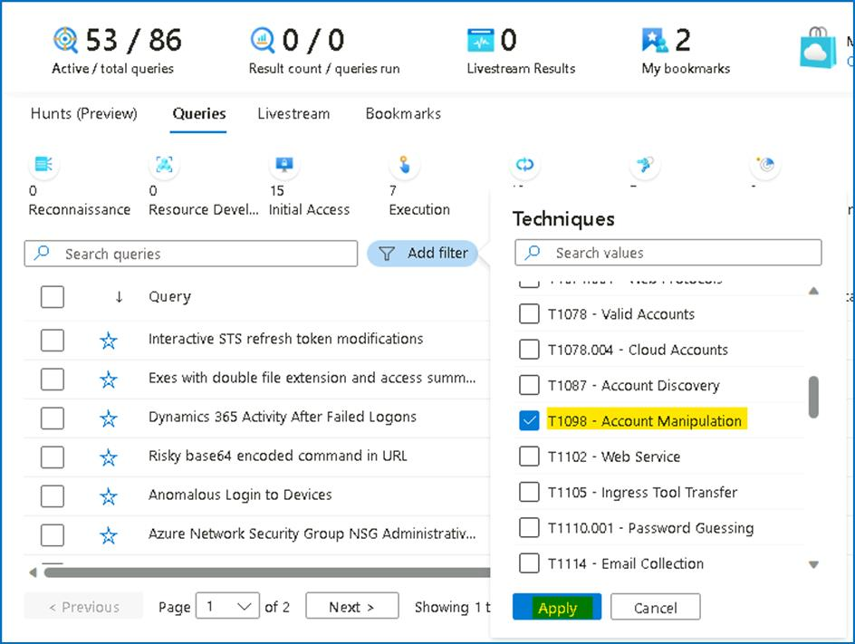

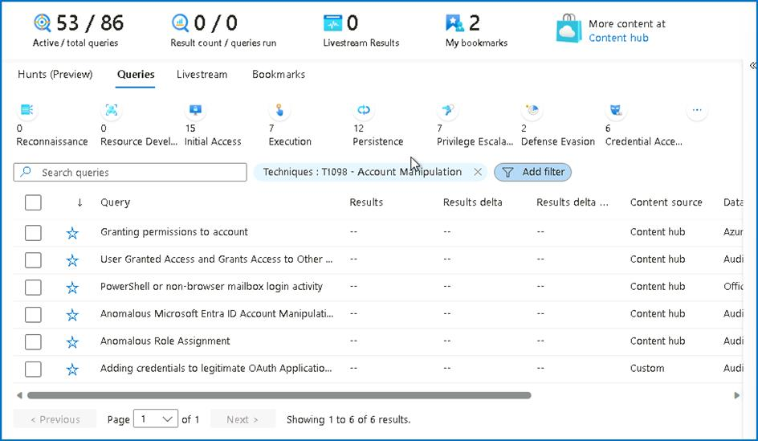

1. Review all the queries in the table using this technique. In this phase we can multi-select all of queries run them as a batch. To do so, press on the multi-select checkboxes for the queries you want to run.
2. Select the filtered queries. Notice that the **Run All Queries** button has changed into the **Run selected queries** button. Click this button to run the queries.

**Note**: in some cases, you will need to modify the selected time range based on the time you deploy the lab to get query results.

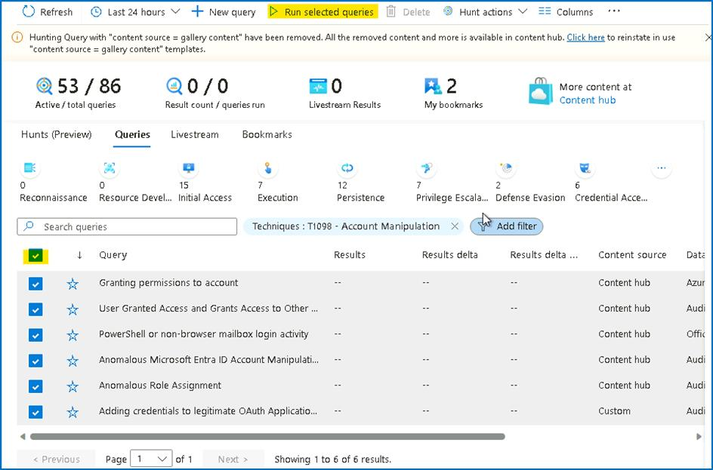

1. Once you have **Run selected queries**, the results start popping on the screen. In our case we immediately spot that the **Adding credentials to legitimate OAuth Applications** query returns several results.

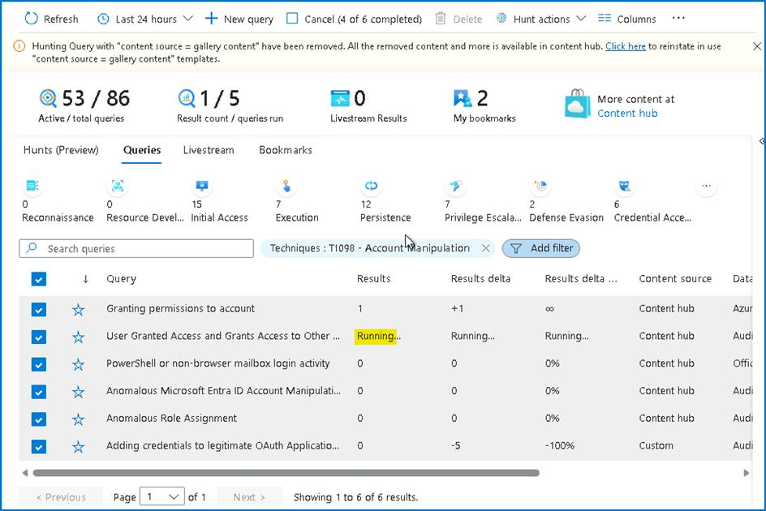

1. Select this query and in the right pane press on **View query results**. This will navigate us to the log analytics screen to view the hunting query content and run it.



1. On the **Logs** screen, once the hunting query finishes executing, we can see all the data that returned with the parsed fields and columns. From high overview we can see that we have the actor **IP** and the **username** that run this operation.

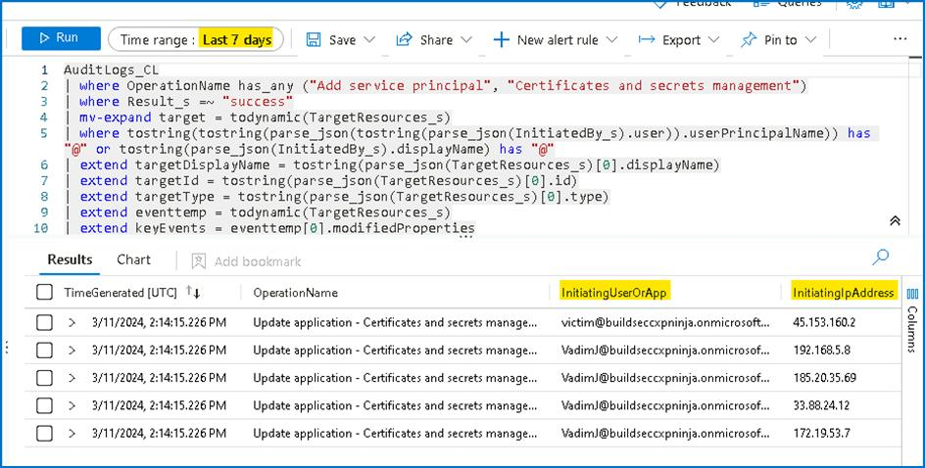

1. Expand one of the results and check the fields. As you can see, we are able to spot the Azure AD application name, the added key name and type the IP, username of the actor and other relevant information that help us understand the specific action.

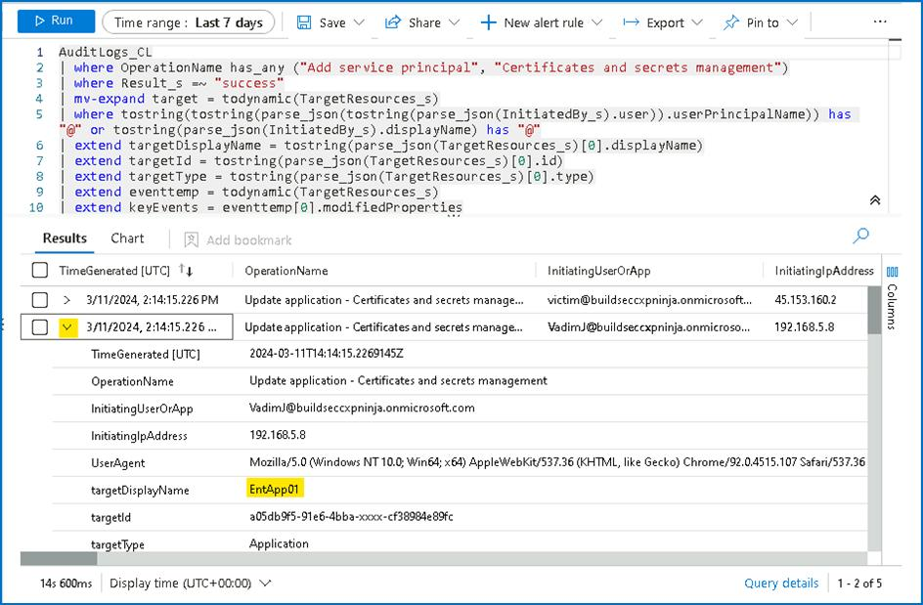

Our SOC analysts needs to know which application from all the above result set is critical and has a security risk. One way to do this is to open Azure Active Directory for each application from the hunting results, check their permissions, and validate the risk. Our SOC analyst follows the organization knowledge base that guides him to review a list for all the AAD applications with their risk levels.

**Task 2 - Bookmarking hunting query results**

While reviewing query results in Log Analytics, we use Microsoft Sentinel's bookmarking feature to store and enrich these results. We can extract entity identifiers and then use entity pages and the investigation graph to investigate the entity. We can add tags and notes to the results to say why it is interesting. Bookmarks will also preserve the query and time range that generated the specific row result so that analysts can reproduce the query in the future\ If as part of our investigation, we determine that the bookmarked query result contains malicious activity, we can create a new incident from the bookmark, or attach the bookmark to an existing incident.

1. On the **Logs** screen, select the row using the checkbox on the left-hand side of the table. Click **Add bookmark** in the action menu just about the results table.

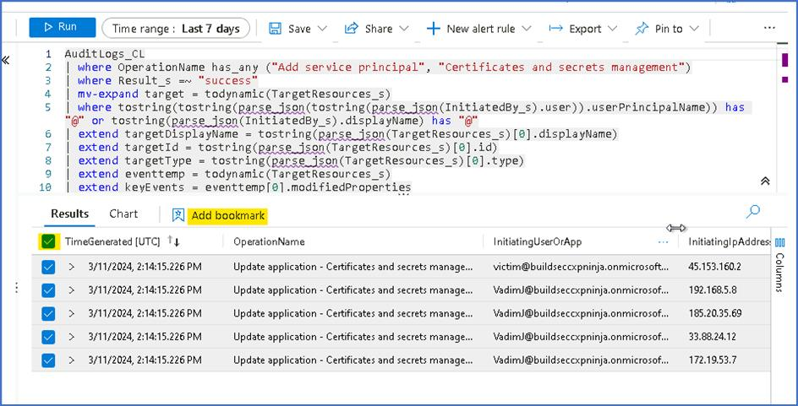

1. On the right-hand bookmark pane modify the values as following.

* **Bookmark Name** to **victim@buildseccxpninja.onmicrosoft.com> added key to purview-spn App with High Risk**.
* Using the drop down in the **entities** section of the **bookmark pane**, map the **Account** entity to the **InitiatingUserOrApp** column.
* Map the **IP entity** to the **InitiatingIpAddress** column.
* We will also add a tag to map it to the main attack story. In the **tags** section write, **"solorwinds"**
* Click on **Create** at the bottom of the blade to create the bookmark.

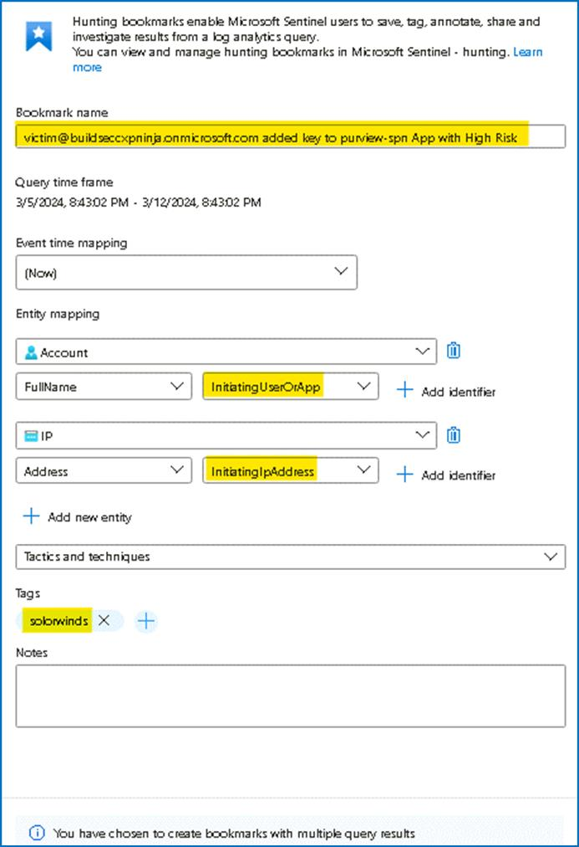

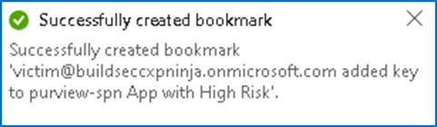

**Task 3 - Create a watchlist**

This task will show you how to use Microsoft Sentinel watchlists in event correlation and enrichment. Once created, you can use watchlists in your search, detection rules, threat hunting, and response playbooks.

1. On the Azure Portal **http://portal.azure.com** and search for **Microsoft Sentinel** and click on **Microsoft Sentinel**.



1. Select **SwrkXXXXXXX**.



1. Now click on **Watchlist** under Configurations, then click on **+** **New**.

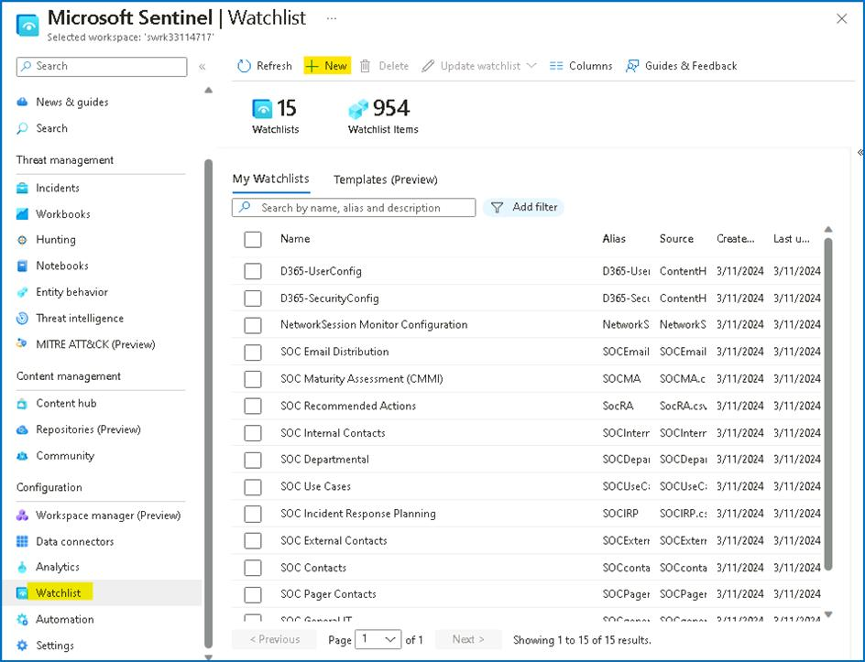

1. In the watchlist wizard enter the following and click ***Next: Source***:
   * Name: **PenTestsIPaddresses**
   * Description: **IP addresses used during penetration tests**
   * Watchlist Alias: **PenTestIPaddresses**

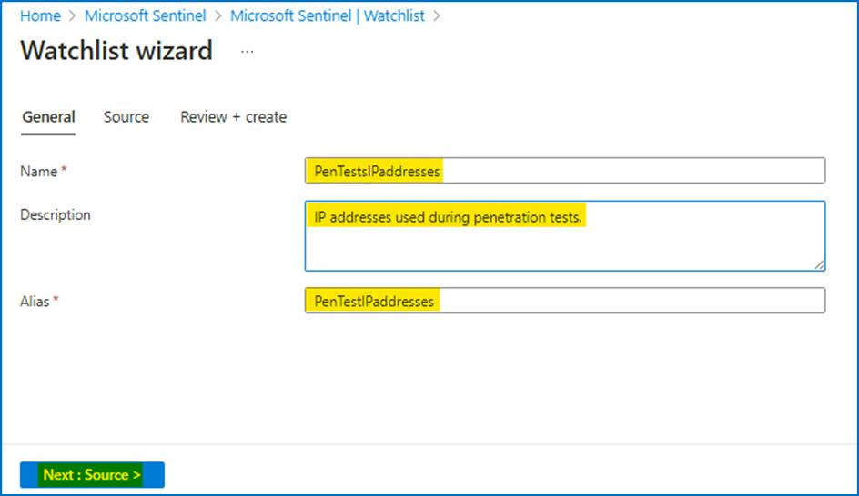

1. In the watchlist wizard, upload the file **C:\Labfiles\Lab4_IPAddresses.csv** from your desktop, under **SearchKey**, select **IPAddress**, review the **File Preview** and click **Next: Review and Create\***.

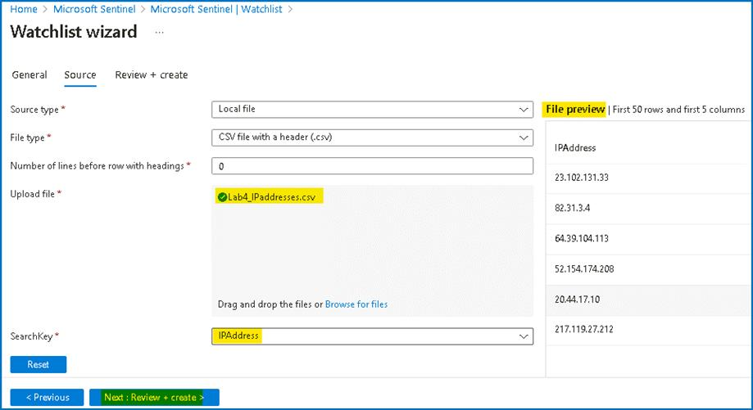

1. On the Review + create tab, click on **Create** to finish the wizard.

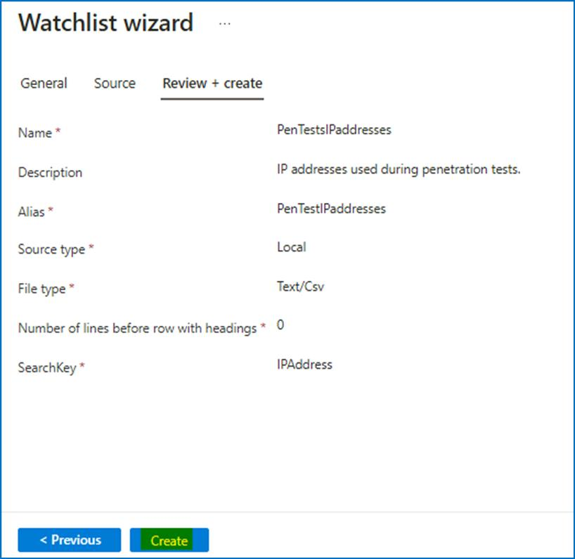

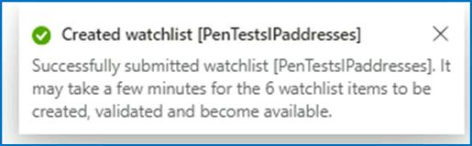

1. You should be back on the **Watchlist** page, click on **Refresh** button to view the newly created watchlist.

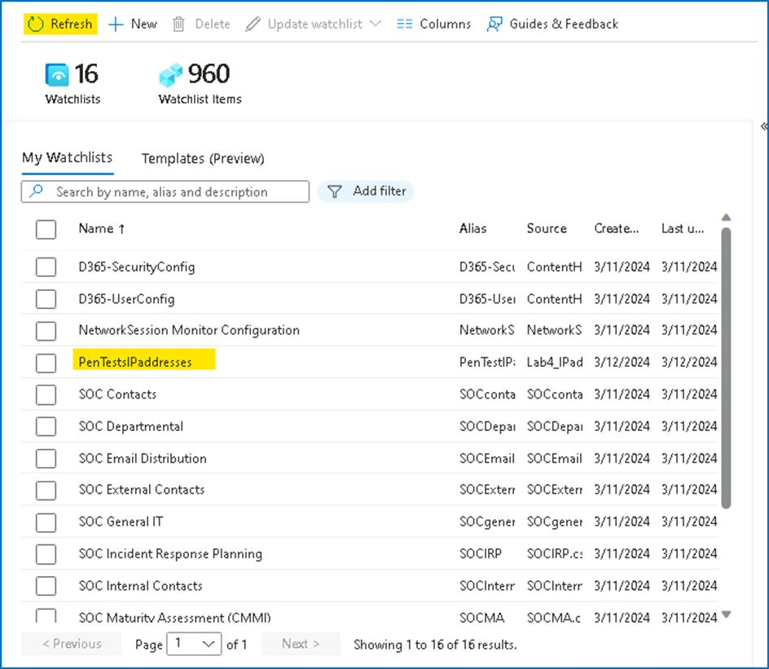

1. The watchlist data takes about **3-5 minute** to be available in the workspace. Wait until the **Rows** number changes from 0 to 6. Then click on **View in Log Analytics**. It might take a few minutes to show up.

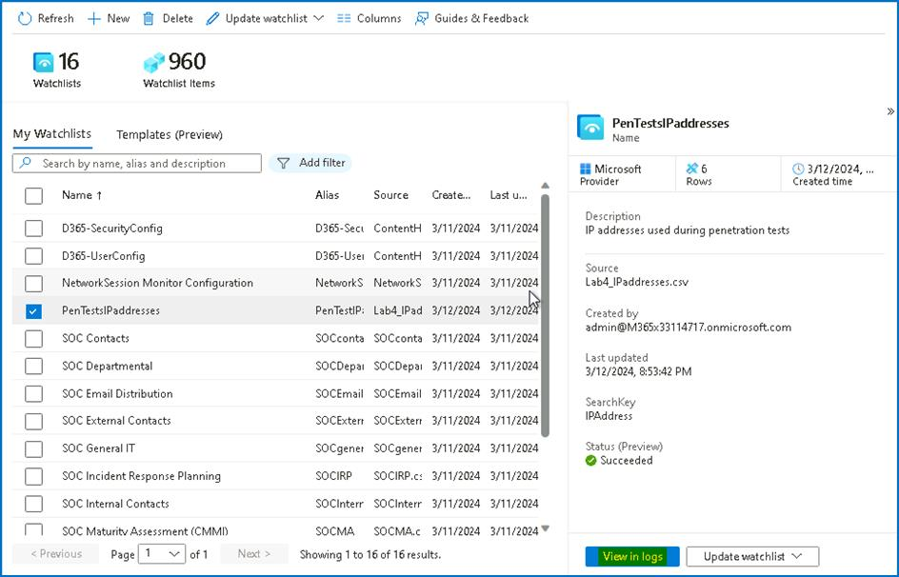

1. On the Logs details, the Results should appear as shown in below image.

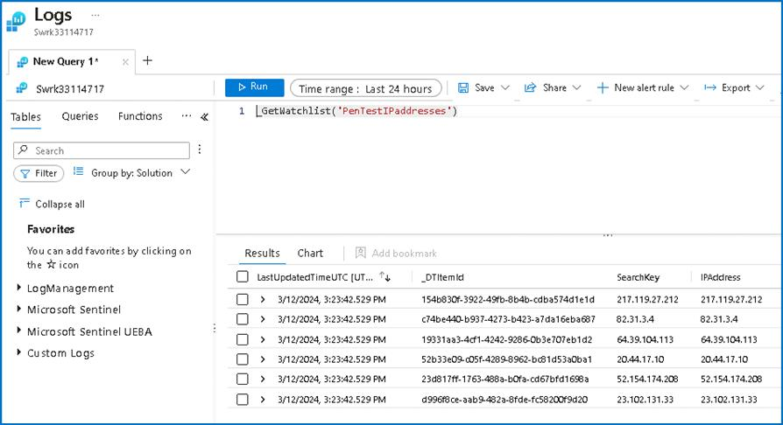

1. We can run the below query to get all the defined watchlists.

**_GetWatchlistAlias**

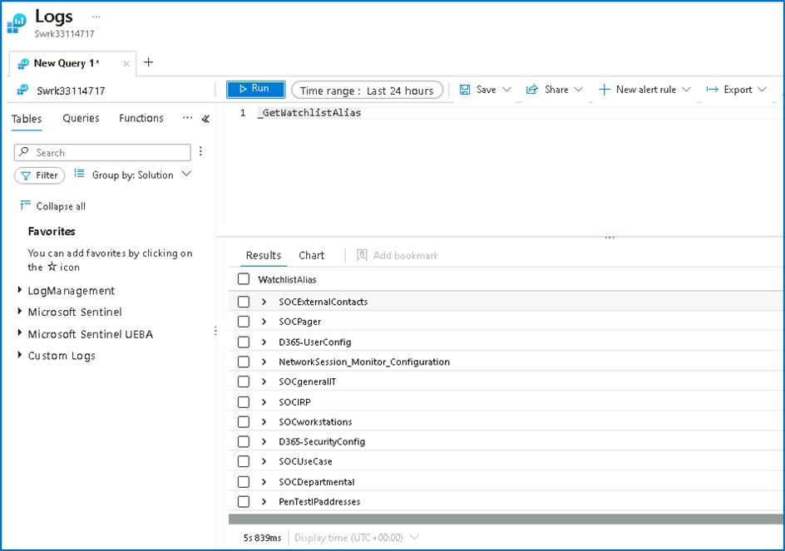

Congratulations, you have completed Lab 4!

**Lab 5 - Threat Intelligence connector and Content hub**

This Lab will demonstrate how to use Microsoft Sentinel Threat Intelligence (TI) features and product integration points. During this Lab we rely on TI data that we ingested in earlier labs, so please make sure you have completed previous Labs. In this Lab we will also discover how to visualize and use this data as part of investigation and detection.

**Exercise 1 - Exploring the Microsoft Defender Threat Intelligence (Preview) connector.**

**Time - 40 minutes**

**Task 1 -- Enabling the Microsoft Defender Threat Intelligence (Preview) connector**

This connector is currently in preview and ingests Microsoft Threat Intelligence indicators automatically into the ThreatIntelligenceIndicator table. MDTI provides a set of indicators and access to the https://ti.defender.microsoft.com portal at no additional cost, with the premium features of the MDTI portal and API requiring licensing.

**Note** -- The **Microsoft Defender Threat Intelligence (Preview)** connector for was enabled in Lab 2 -- Task 2.

1. On the Azure Portal **http://portal.azure.com** and search for **Microsoft Sentinel** and click on **Microsoft Sentinel**.



1. Select **SwrkXXXXXXX**.



1. Click on **Data Connectors** under Configuration select **Microsoft Defender Threat Intelligence (Preview)**.

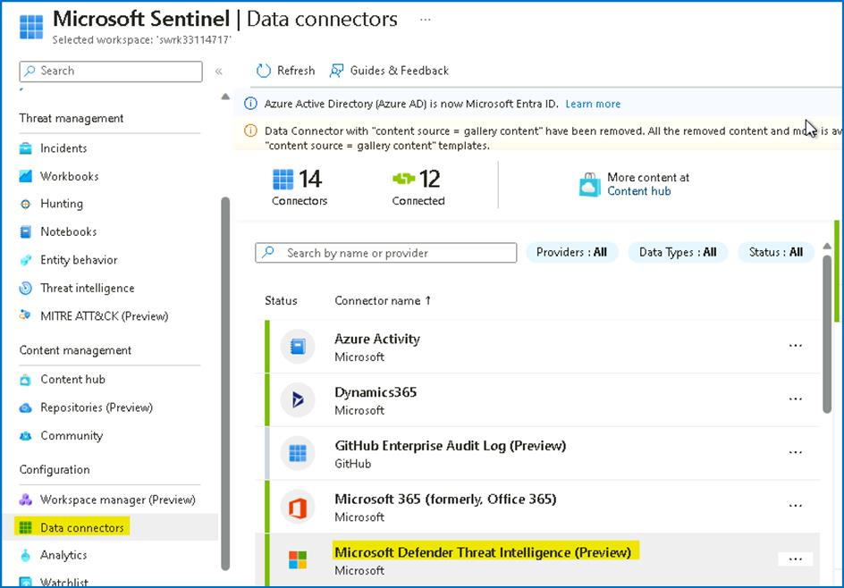

1. On the bottom right pane click on **Open connector page**

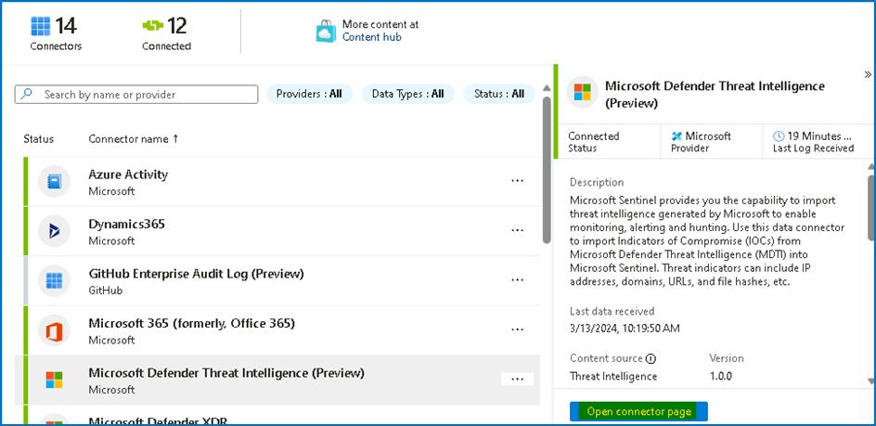

1. Review the data received and confirm that the connector is already ingesting indicators.

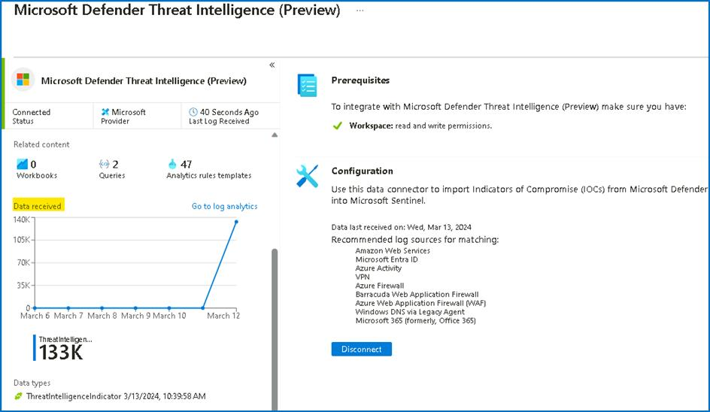

1. Close the **Microsoft Defender Threat Intelligence (Preview)** Connector page, to return to the Microsoft Sentinel home page.

**Task 2: Review and manage TI IOC's in Microsoft Sentinel Threat intelligence menu.**

After we ingested our TI data into the ThreatIntelligenceIndicator table, our mission is to review how our SOC can leverage and manage the TI menu to allow us to search, tag and manage the lifecycle of IOCs.

1. On the **Microsoft Sentinel** left menu click on the **Threat intelligence** under Threat management. This menu is a visual representation of the ThreatIntelligenceIndicator table.

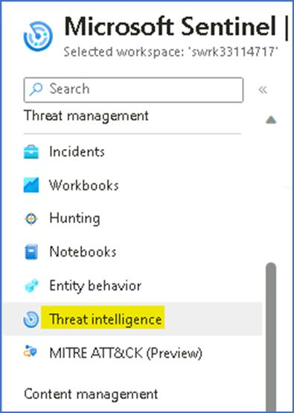

1. Select one IOC from the main pane and notice that the right pane changed accordingly and present the metadata of the selected IOC.

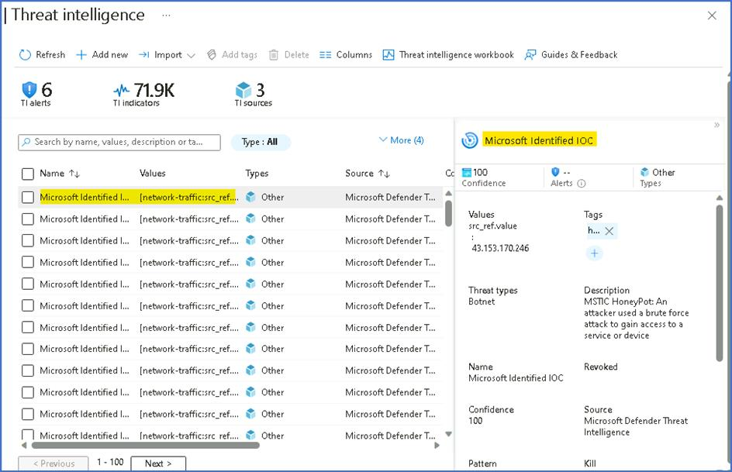

1. On the top area of the main blade, we can filter the list of the IOC's based on a specific parameters. In our case, we only ingested one type of IOC (IP), but the **Type** filter allow us to filter based on different types. If we ingested IOC's from multiple TI data sources, the **source** filter allows us to slice it.

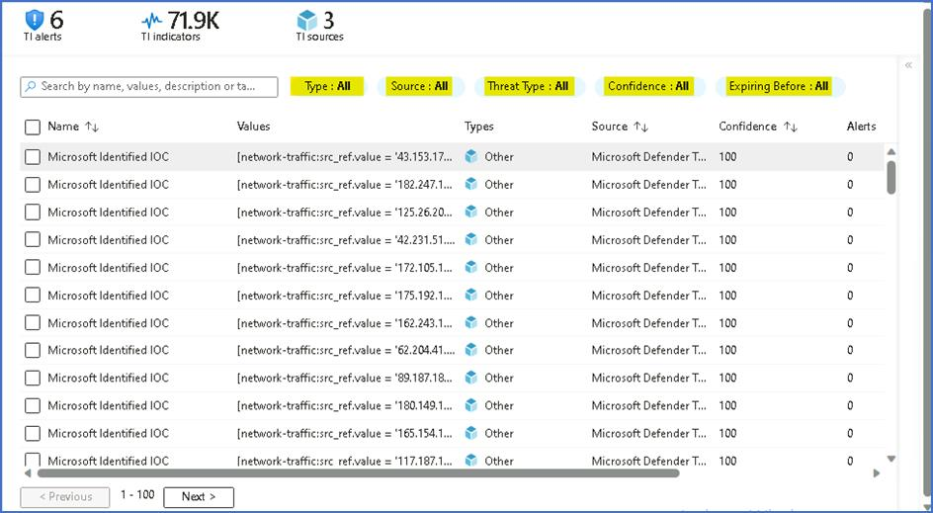

**Task 3 - Review the TI data into Microsoft Sentinel Logs interface.**

The ingested Indicators of Compromise (IOC) coming from any of these TI feeds, is stored in a dedicated table called **ThreatIntelligenceIndicator**, and visible on the Threat Intelligence menu on the left navigation menu.

1. On the left navigation click on **Logs**, this will redirect you to the Log Analytics query interface. On the query interface we can see on the left side the tables with the relevant fields.

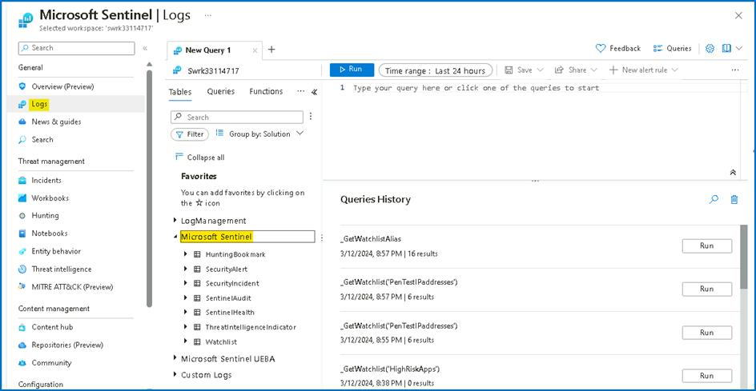

1. Microsoft Sentinel built-in tables have a predefined schema, to be able to see the **ThreatIntelligenceIndicator** schema, run the following query:
2. ThreatIntelligenceIndicator

| getschema

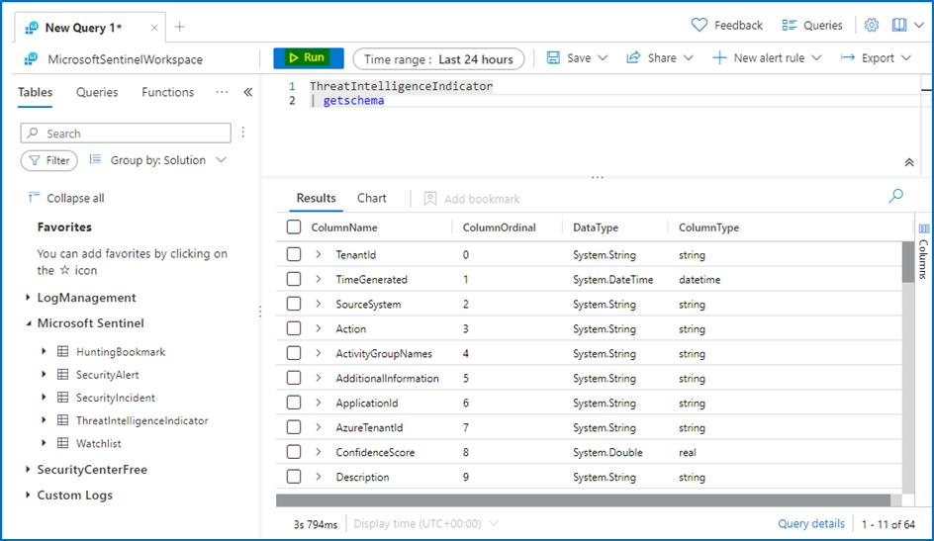

1. Let's explore and delve into the TI table. Run the following query which takes 10 records from the table:
2. ThreatIntelligenceIndicator

| take 10

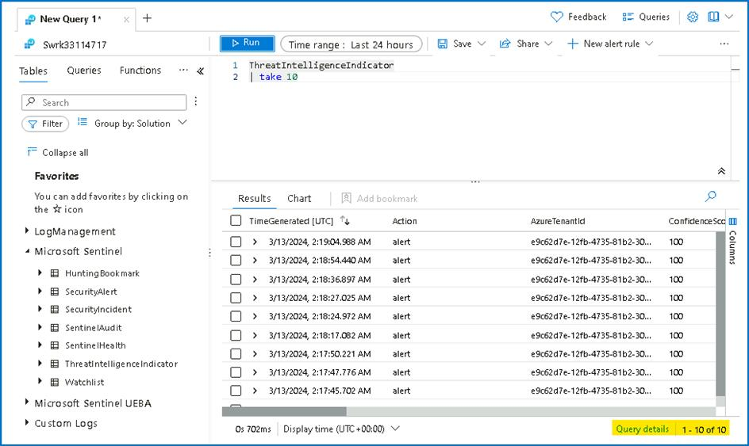

1. To understand if a specific IOC is active, we need to have a closer look at the following columns:
   * **ExpirationDateTime [UTC]**
   * **Acitve**



**Task 4 - Adding new TI IOC manually in Microsoft Sentinel Threat intelligence menu**

Part of the SOC analyst\'s job is to manually add an IOC into the TI index from time to time. This allows other data sources and detections to correlate and detect interaction with this IOC.

1. On the **Threat intelligence** top menu, click on **Add new**,

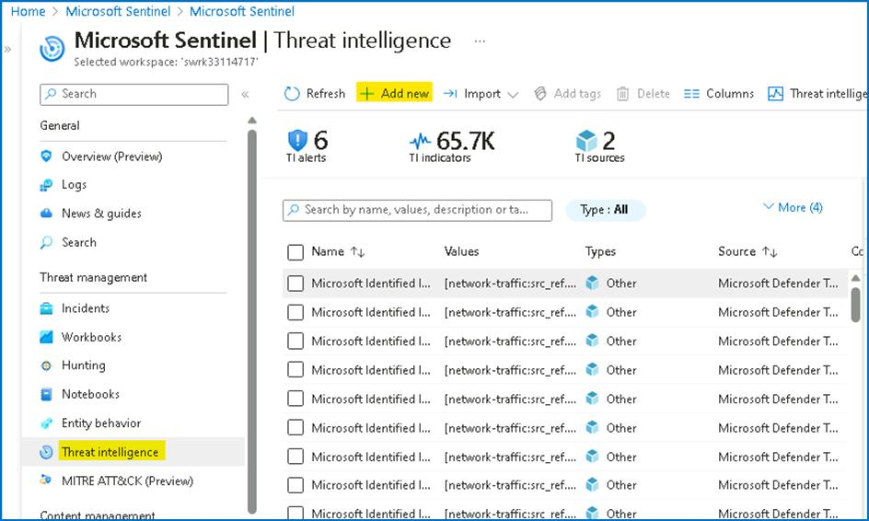

1. On the **New indicator** dialog provide the below details and then click on **Apply** button
   * Types -- **url**
   * URL - **http://phishing.com**
   * Tags - **Incident 4326**
   * Thread types - **malicious-activity**
   * Description -- **this URL is found in Incident 4326**
   * Name -- **url indicator**
   * Confidence level -- 80
   * Set the **Valid from** as today date
   * **Valid until** two weeks from today.

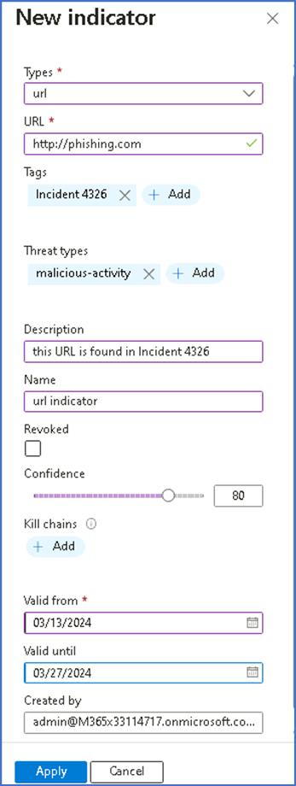

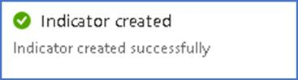

1. Notice to the newly created IOC on the TI menu.

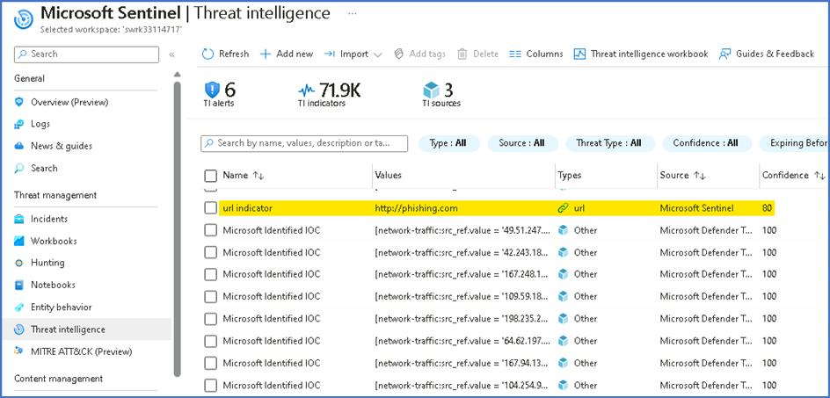

1. Be aware that every new IOC added in the TI menu, will be automatically added to the ThreatIntelligenceIndicator table. You can validate it by opening the **Logs** menu and run the query below.

**Note** -- It can take about 5 mins to have the result shown.

ThreatIntelligenceIndicator

| search "http://phishing.com"

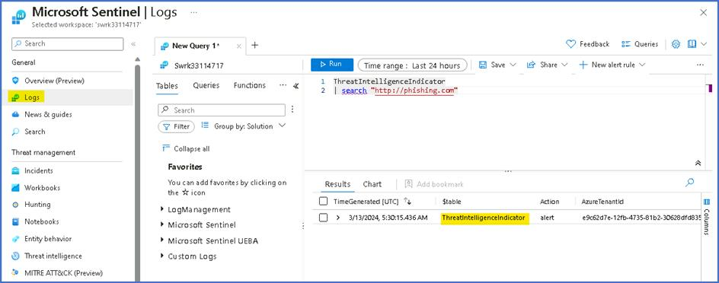

1. Select the newly created manual IOC and press **Delete** button.

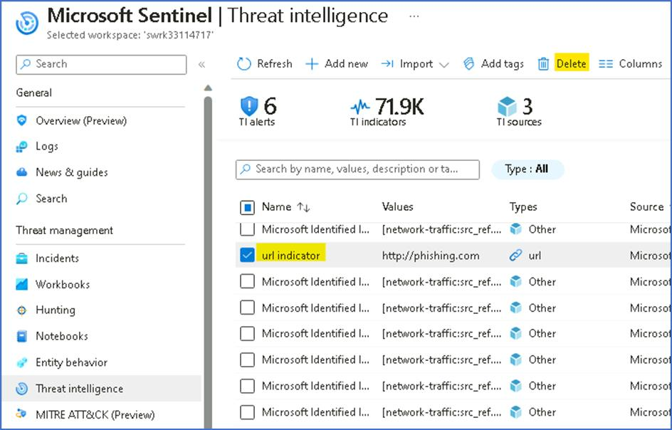

**Task 5 - Reviewing Analytics Rules based on Threat Intelligence data**

1. From the **Microsoft Sentinel** page, click on **Analytics** and then click on the **Rule Templates** tab.

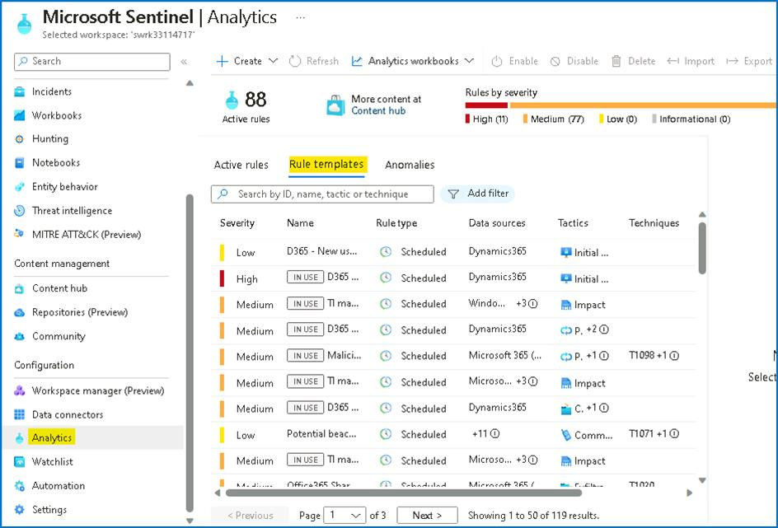

1. Click on **Add filter** and then select the **Data Sources** filter.

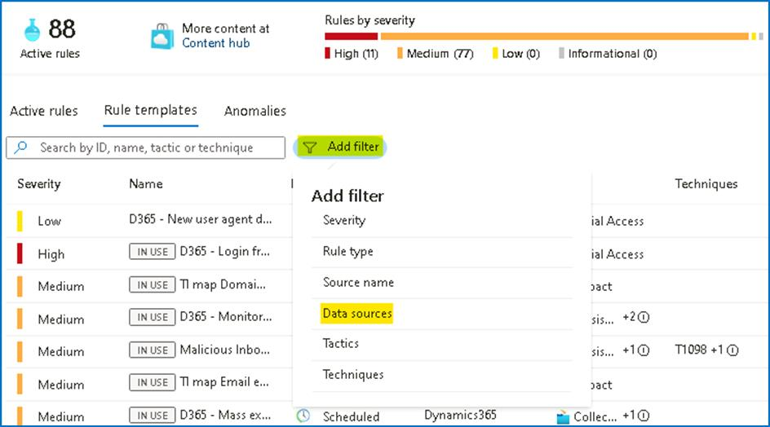

1. Select **Microsoft Defender Threat Intelligence (Preview).** Click **Apply** to apply the filter.

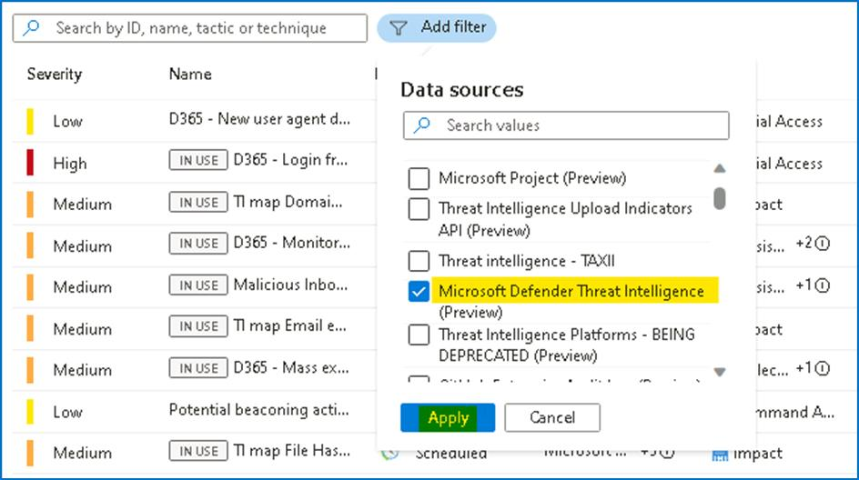

1. As you can see, there is a long list of resulting alert templates. These all will correlate your different data sources with the IOCs present in your TI table (**ThreatIntelligenceIndicator**), to detect any trace of malicious indicators of compromise in your organization\'s logs.

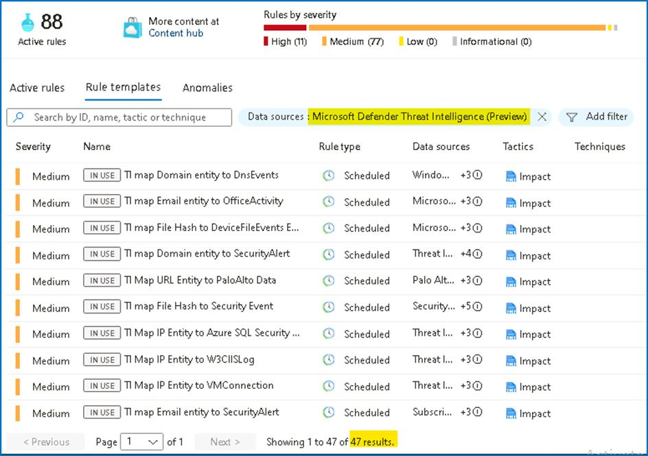

1. As you may know, it is free to enable analytics rules in Microsoft Sentinel, so the best practice is to enable all the ones that apply to data sources that you are ingesting.

**Task 6 - Enabling Threat Intelligence Matching Analytics rule**

1. From the Microsoft Sentinel page, click on **Analytics** and click on **Rule Templates** tab. Clear previously applied filters if any.

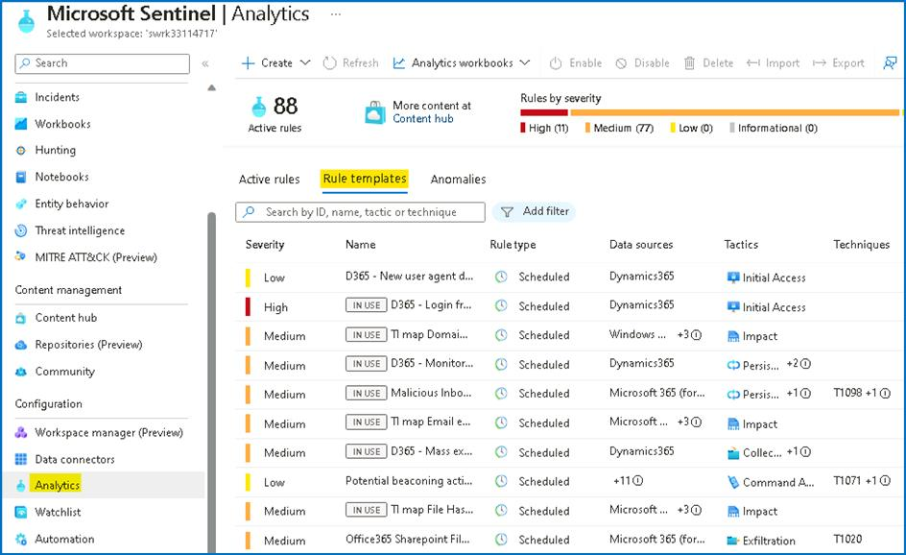

1. Click on Add filter and then choose **Rule Type** filter and select **Threat Intelligence**.

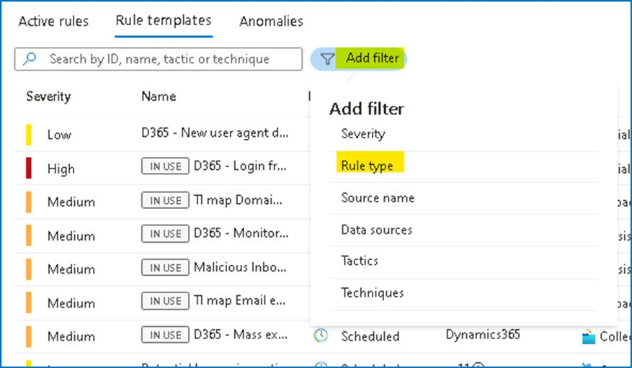

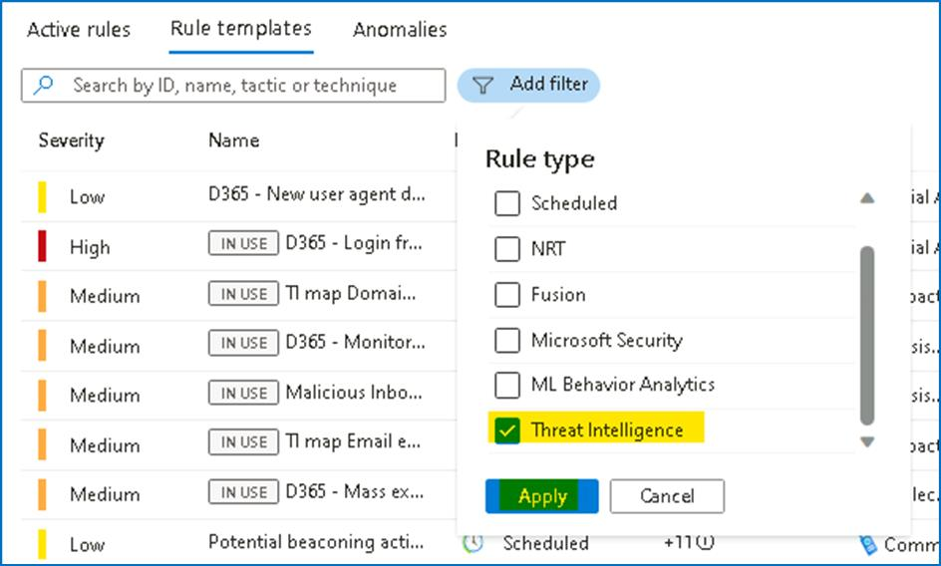

1. The resulting rule template matches Microsoft-generated threat intelligence data with the logs you have ingested into Microsoft Sentinel. The alerts are very high fidelity and are turned ON by default. Visit this link for more information about this type of rule.

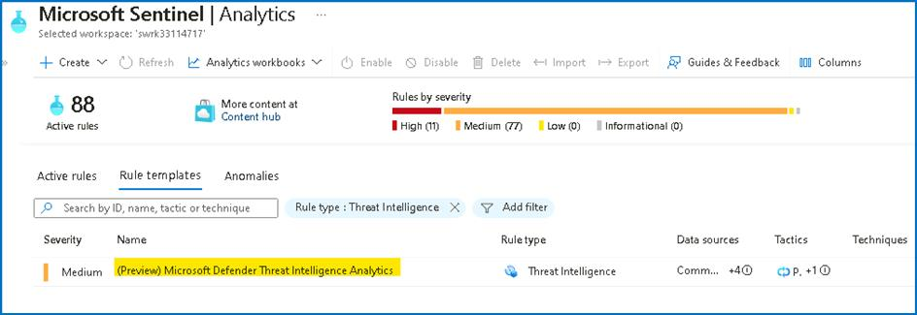

1. Select the rule template and notice the different data sources that are supported (at the time of writing, these are CEF, Syslog and DNS). Click on **Create rule**.

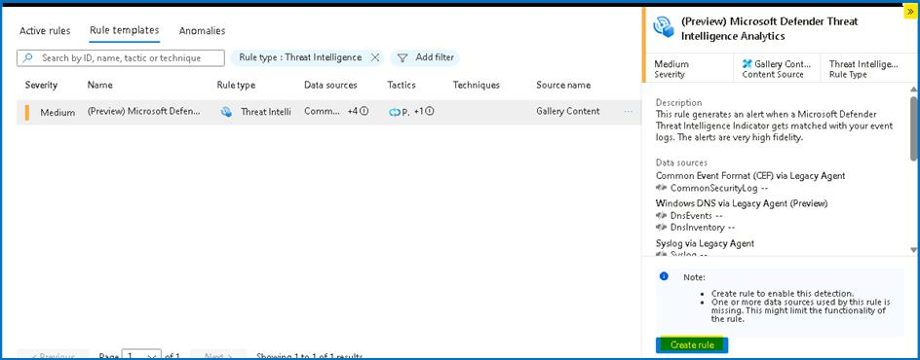

1. In the wizard, click on **Review and Create**.

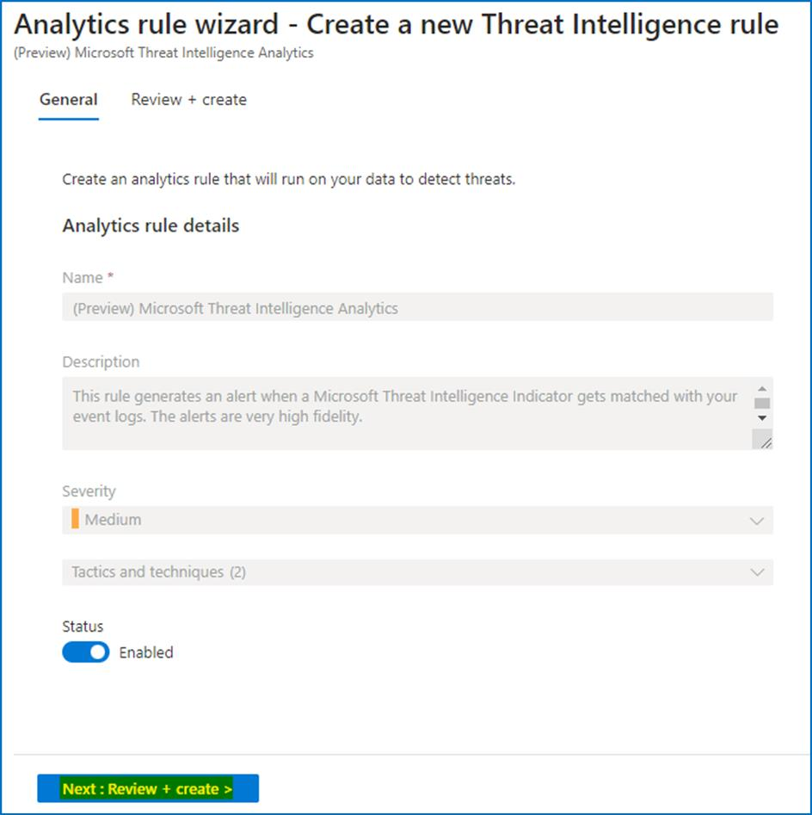

1. Click on the **Save** button to create the Rule

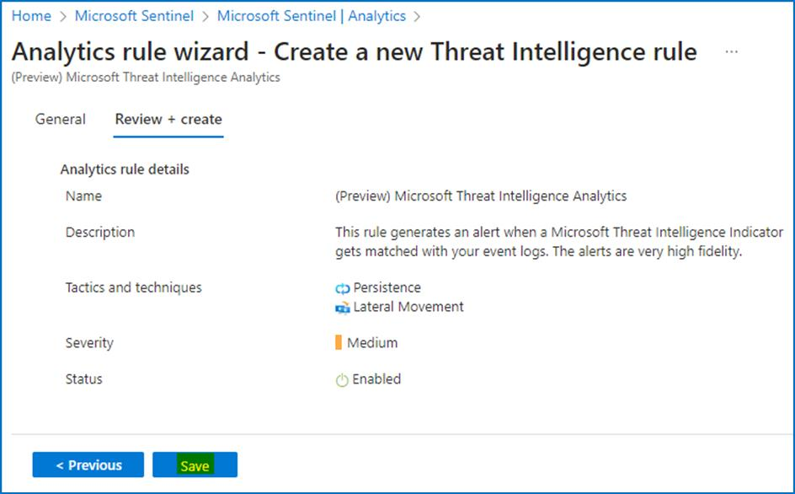

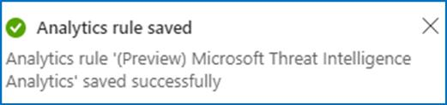

**Task 7 -- Explore and visualize Threat Intelligence workbook**

1. While still on the **Microsoft Sentinel** page, click on **Workbooks** under **Threat management** and then click on **Add workbook**.

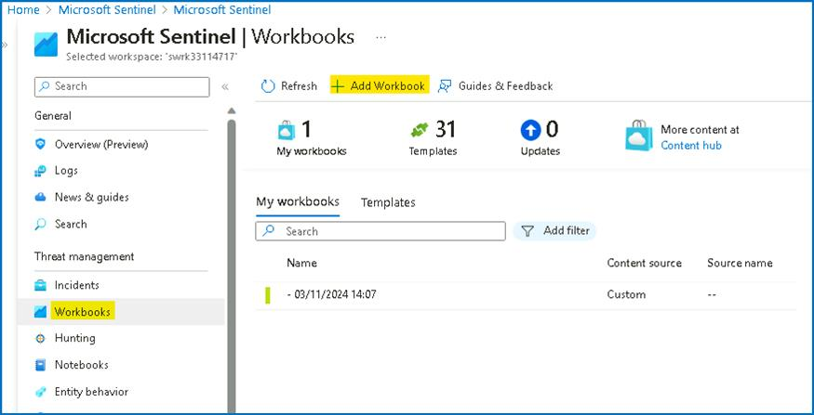

1. You will find some pre-built visualizations that show you the indicators imported into Sentinel over time, by type and provider. To modify or add a new chart, select the **Edit** button at the top of the page to enter editing mode for the workbook.

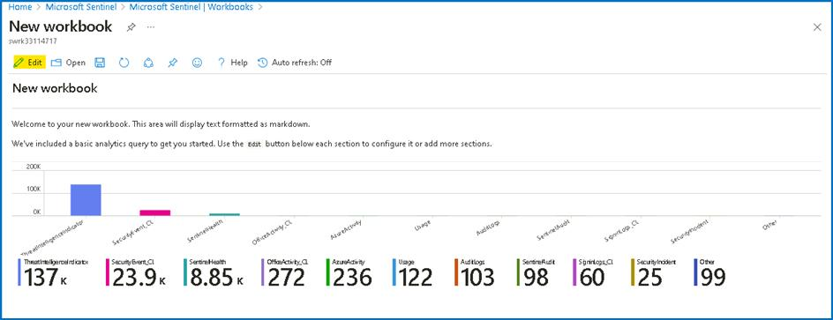

1. Add a new chart of threat indicators by threat type. To do this, scroll to the very bottom of the page and select **Add** > **Add Query**.

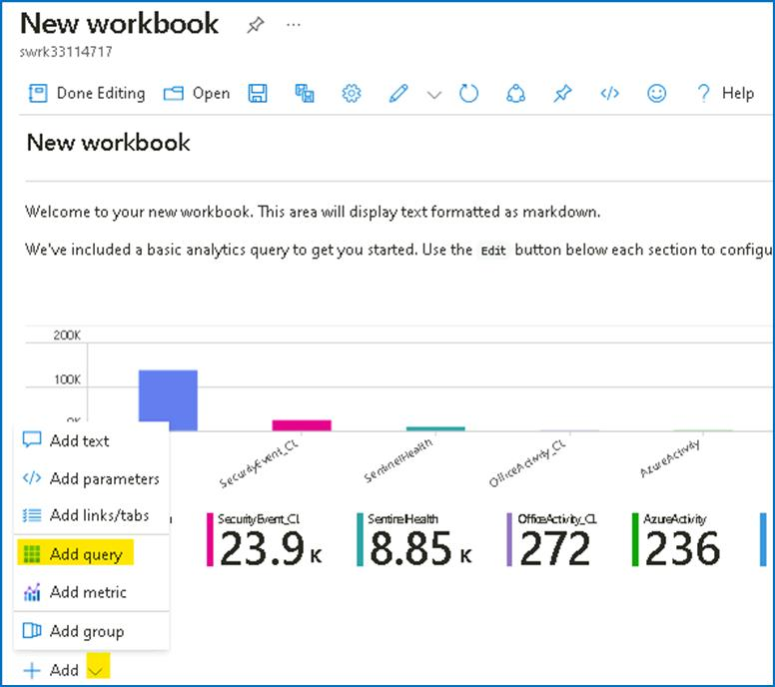

1. Add the following text to the Log Analytics workspace Log Query text box and then click on the **Run Query** button.
2. ThreatIntelligenceIndicator

| summarize count() by ThreatType

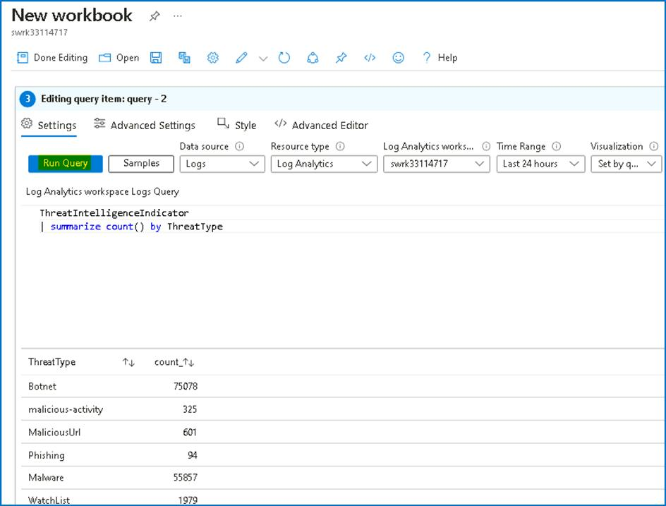

1. In the Visualization drop-down, select **Bar chart**.

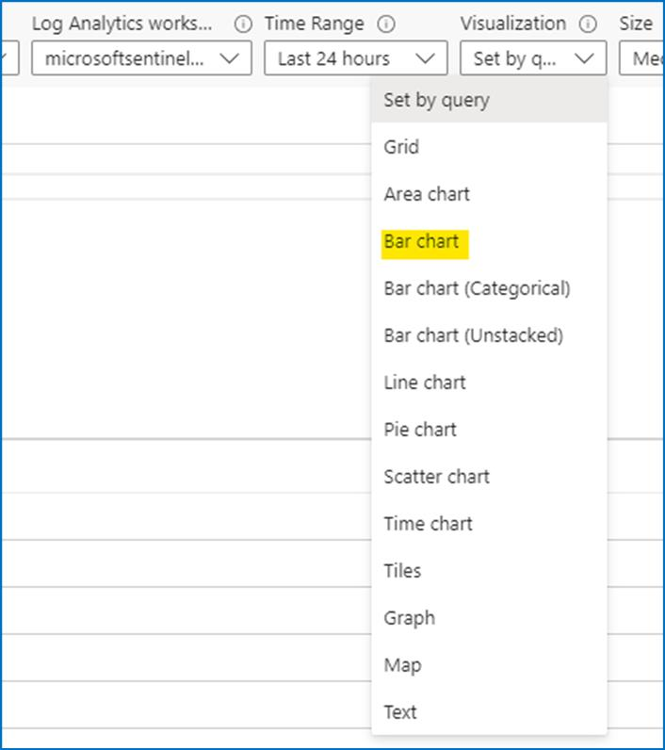

1. Select the **Done editing** button. You've created a new chart for your workbook.

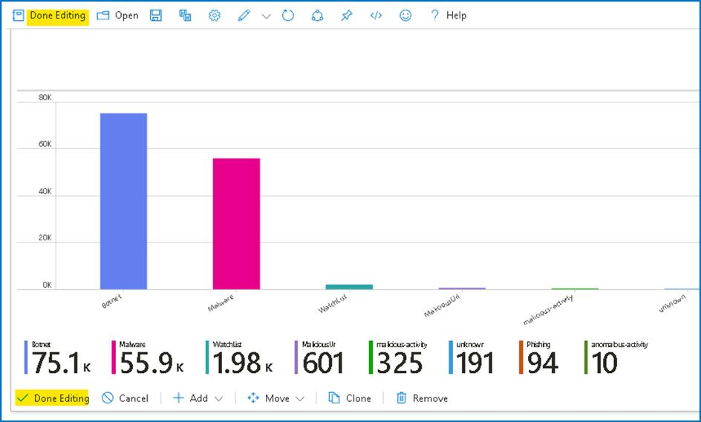

1. Click on the **Save** button and on the Workbook details tab, provide the Resource group details and then click on the **Apply** button.

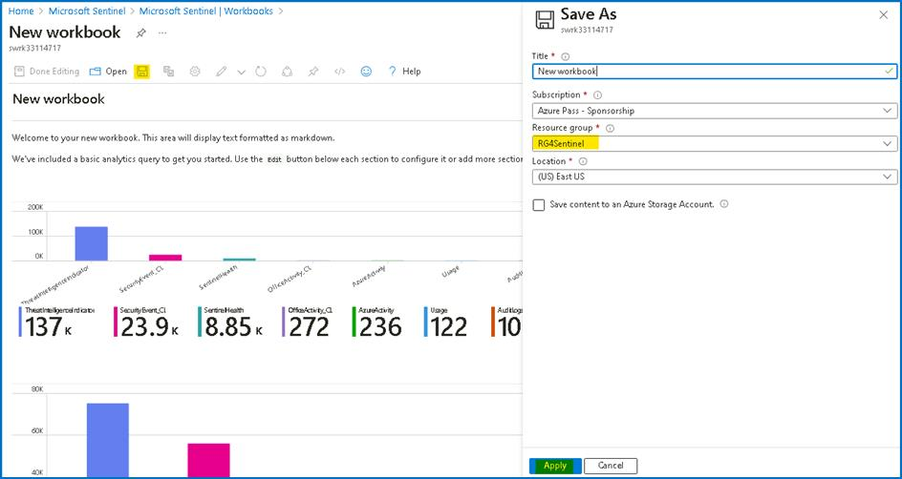

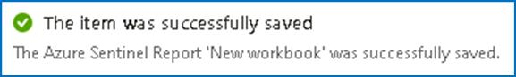

**Exercise 2 -- Exploring the Microsoft Sentinel Content hub.**

**Time - 20 minutes**

**Task 1 -- Overview of Microsoft Sentinel Content hub**

1. On the Azure Portal **http://portal.azure.com** and search for **Microsoft Sentinel** and click on **Microsoft Sentinel**.



1. Select **SwrkXXXXXXX**.



1. Now click **Content hub** under **Content Management**.

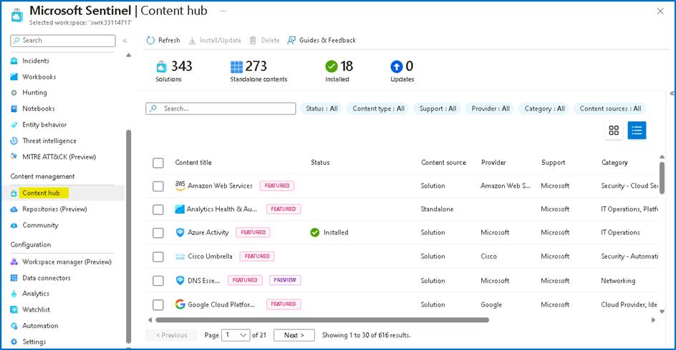

1. In the search bar, type **Cloudflare**. You will see a single result corresponding to Cloudflare solution. You could also search using the filtering options at the top.

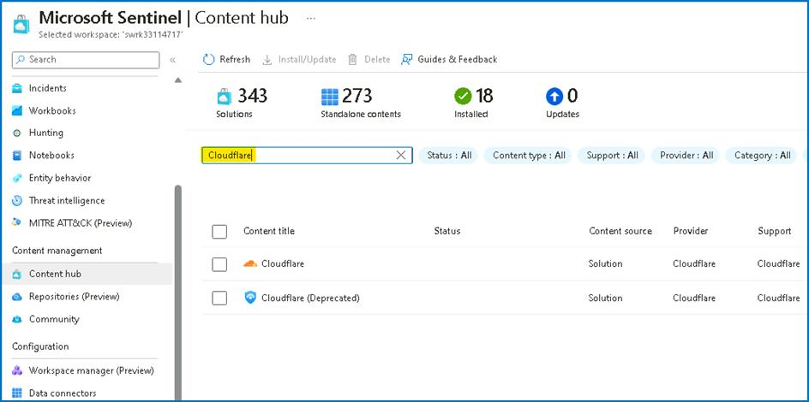

1. Select the Cloudflare solution. As you can see on the right pane, here we have information about this solution, like category, pricing, content types included, solution provider, version and also who supports it. Click **Install**.

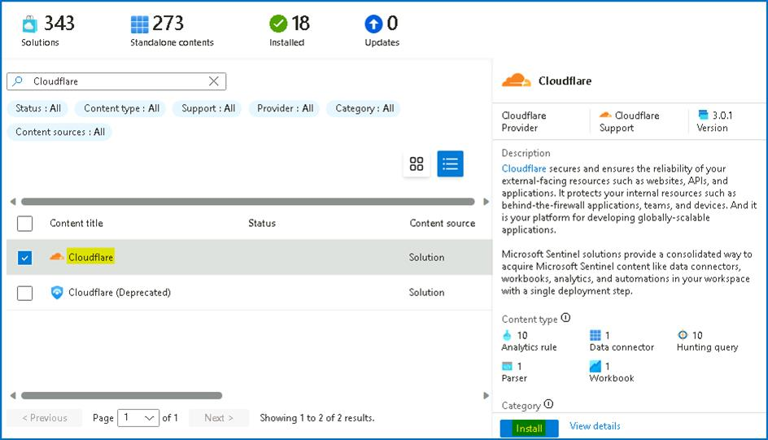

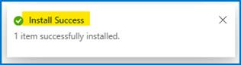

1. Click on the **Manage** button.

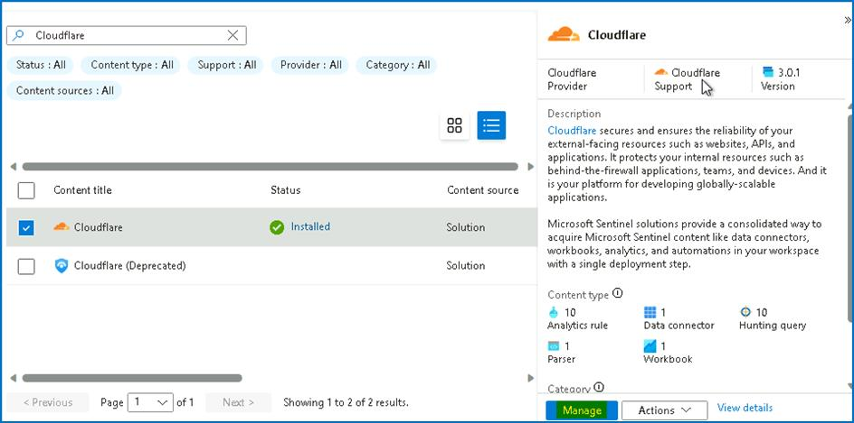

1. Notice the different artifacts that are included in this solution: **Data Connector, Parser, Workbook, Analytics Rules** and **Hunting Queries**. Each Solution can contain a different set of artifacts.

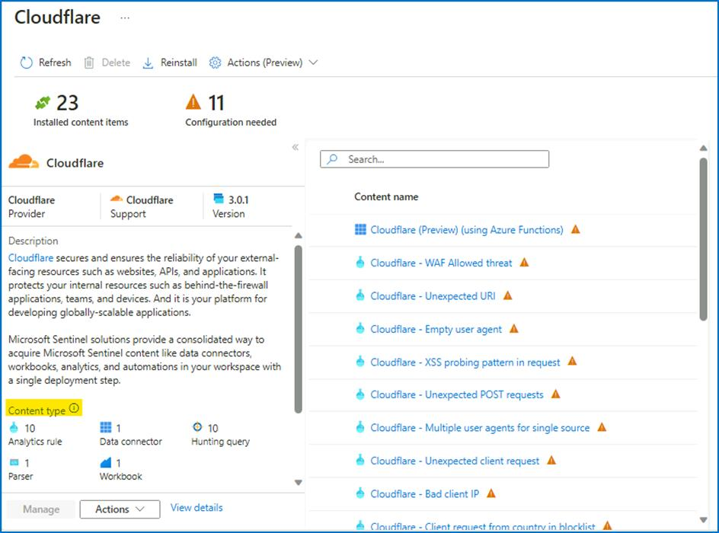

1. Close the **Cloudflare for Microsoft Sentinel** information page and you can navigate to other solutions. In the next exercise, we will install one of them.

**Task 2 - Deploying a new solution from Content hub**

1. From the Microsoft Sentinel portal, navigate to **Content hub** under **Content Management**



1. In the search bar, type **dynamics 365 CE**. Select on the **Dynamics 365 CE Apps** solution and click on **View Details**. Notice the content being added by this solution (Data Connector, Analytics Rules, Workbook, Hunting Queries and Watchlists).

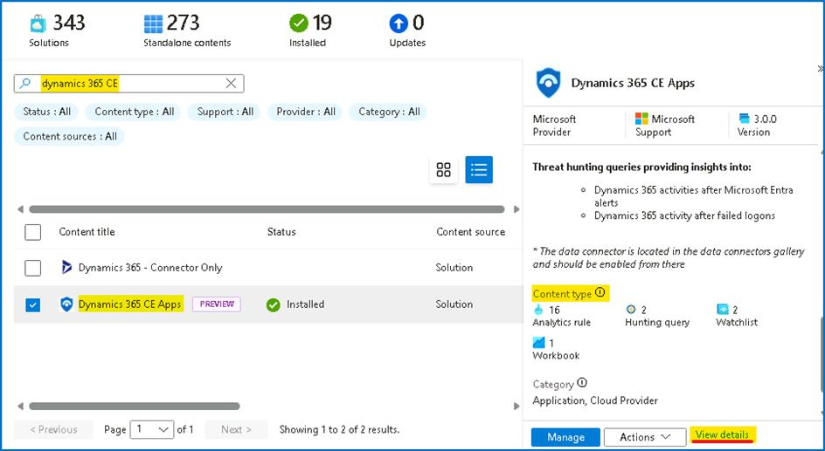

1. Click on **Create**.

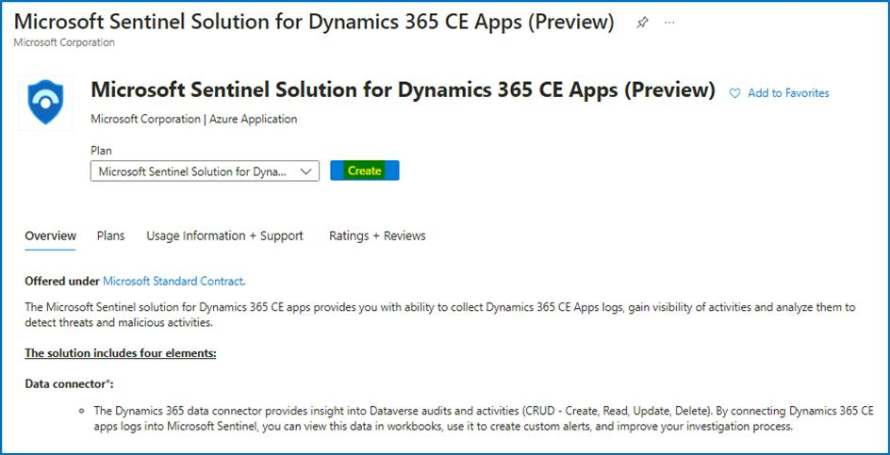

1. On the **Create Microsoft Sentinel Solution for Dynamics 365 CE Apps (Preview)** page provide the below details.

a. Subscription -- **Azure Pass -- Sponsorship**

b. Resource group -- **RG4Sentinel**

c. Workspace -- **Swrk33114717**

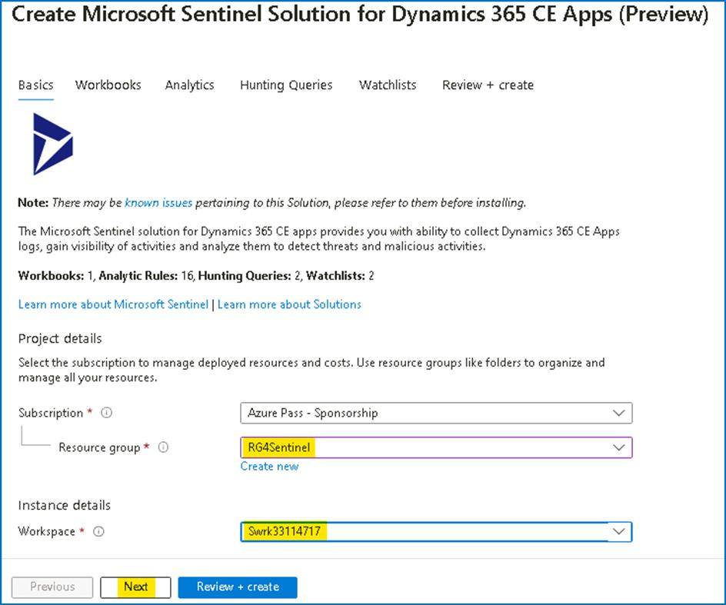

1. Click on **Next** and review the information on the **Workbooks** tab.

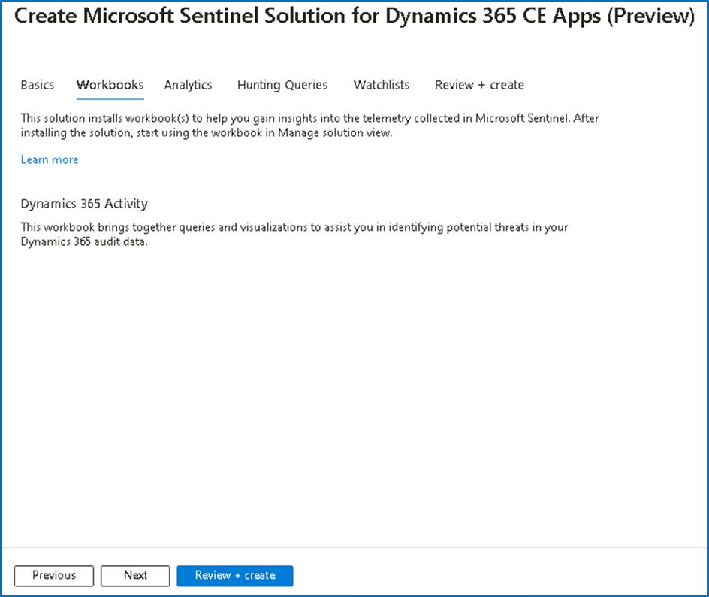

1. Click on **Next:** and review the information on **Analytics** tab.

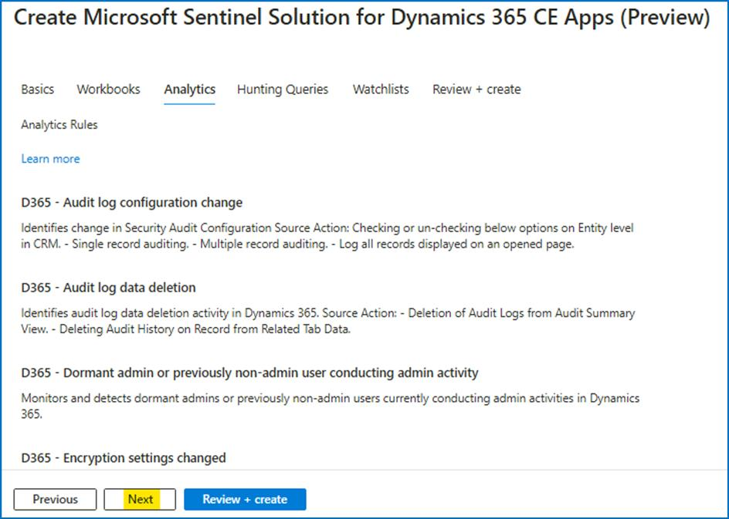

1. Notice the different **Analytics Rules** that will be added to your workspace. Click **Next.**

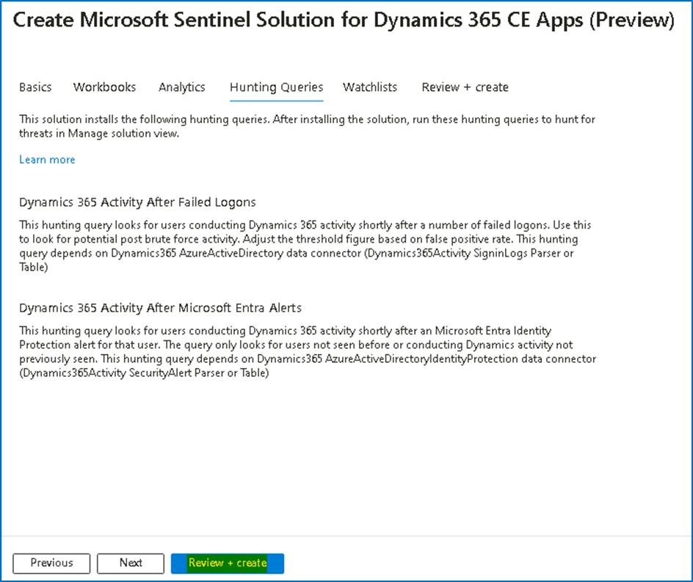

1. On the **Hunting Queries** tab, notice the Hunting Queries included in the solution. Click **Next: Review + create**.

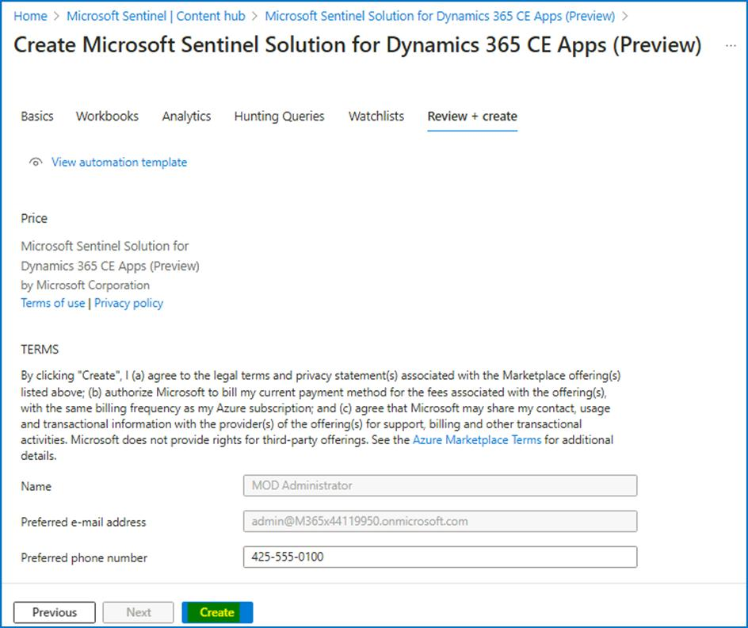

1. A final validation will run. If everything is ok, click on **Create** button. The deployment will kick off and finish in a few seconds.

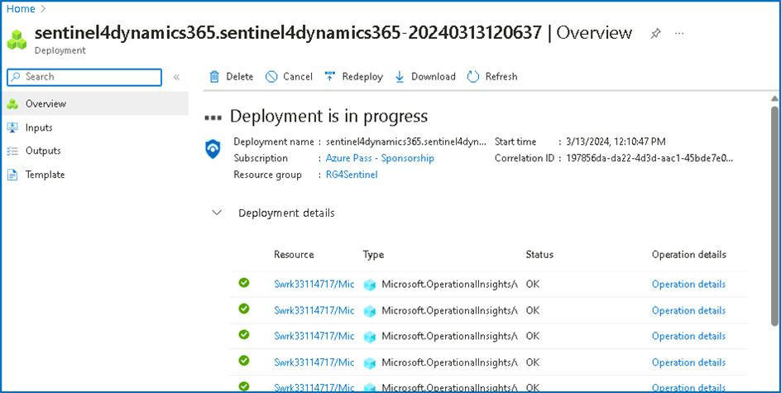

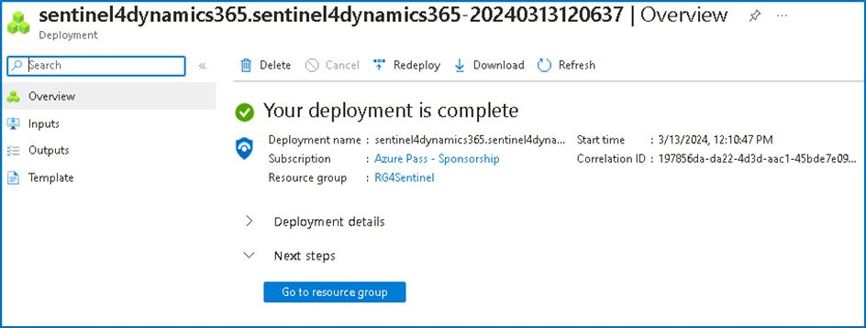

**Task 3 - Reviewing and enabling deployed artifacts**

1. Navigate back to **Microsoft Sentinel** home page and click on **Analytics**, and select the **Rule Templates** tab.

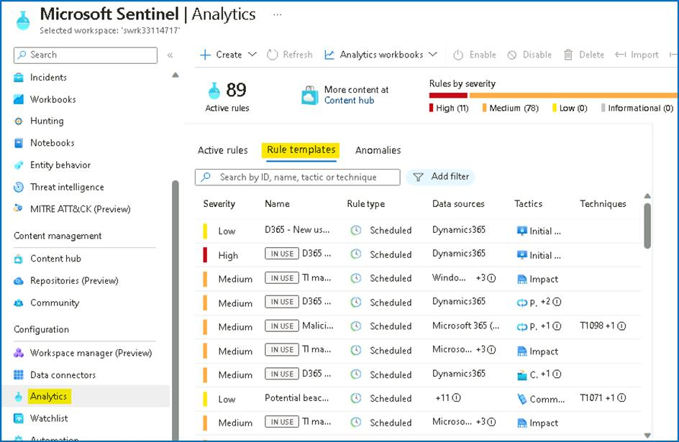

1. Type **Dynamics** in the search box. You should see **16** different analytics rules that look at **Dynamics 365 data**.

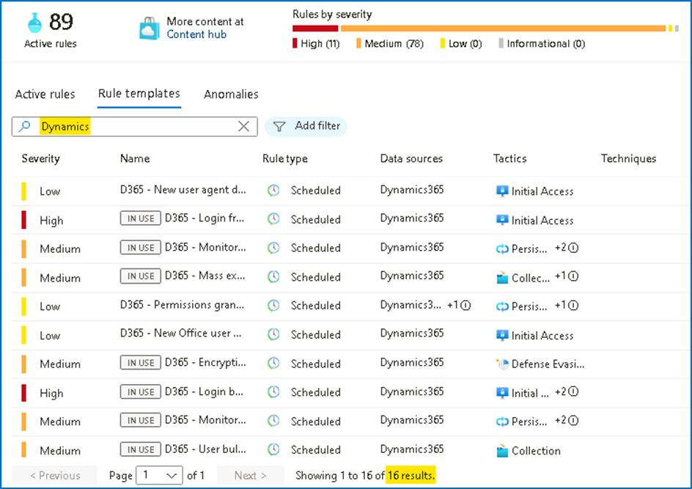

1. Notice that these rules are available as **templates**. In a real-world environment, you would need to create them in order to use them.
2. Navigate to **Workbooks** under Threat Management. Search for **Dynamics** Like the analytics rules the workbook exists as a template. This should be empty unless you have enabled the Dynamics 365 connector.

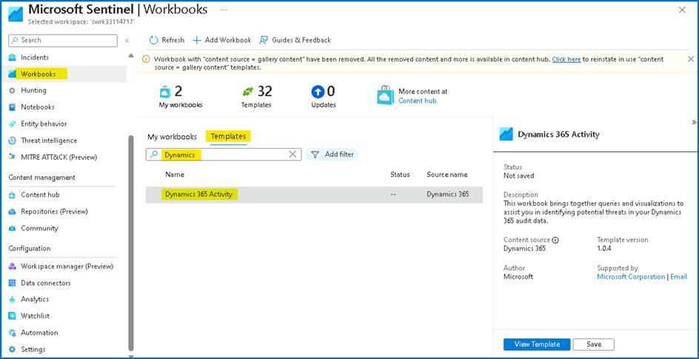

1. Navigate to **Hunting**, go to **Queries** tab and search for **dynamics 365** You should see 2 new queries that use data coming from Dynamics 365.

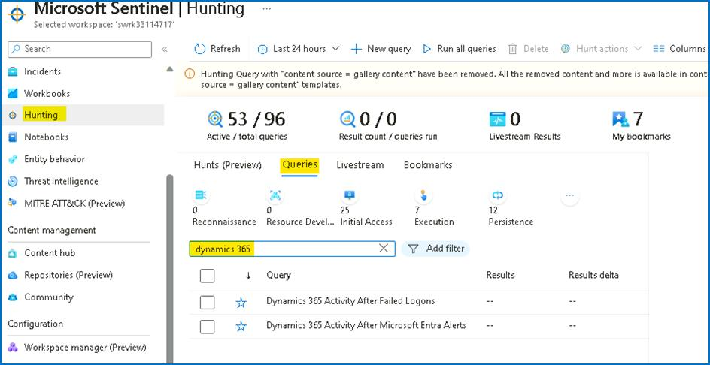

1. Navigate to **Watchlist** under Configuration. Search for **d365**. Notice you have two new watchlists.

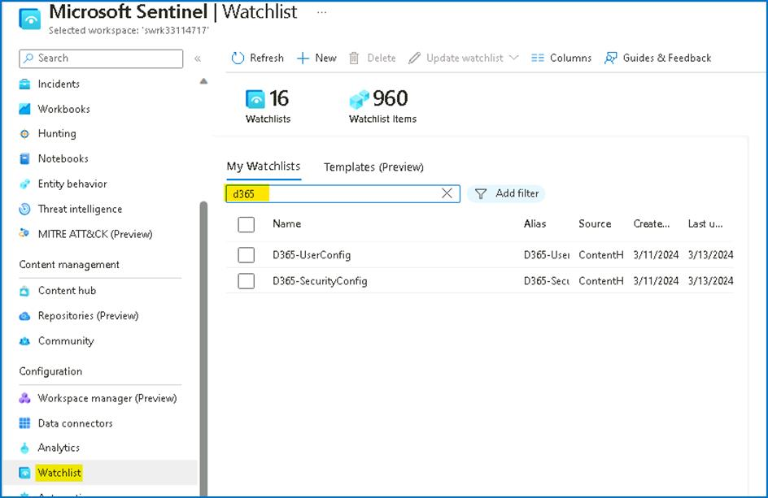

Congratulations, you have completed Lab 5!.

**Lab 6 - UEBA with Microsoft Sentinel**

**Exercise 1: Explore UEBA with Microsoft Sentinel**

**Time - 20 minutes**

You are a Security Operations Analyst working at a company that implemented Microsoft Sentinel. Once you have connected your data sources to Microsoft Sentinel, you can visualize and monitor the data using the Microsoft Sentinel adoption of Azure Monitor Workbooks, which provides versatility in creating custom dashboards.

Microsoft Sentinel allows you to create custom workbooks across your data, and also comes with built-in workbook templates to allow you to quickly gain insights across your data as soon as you connect a data source.

**Task 1: Explore Entity Behavior**

In this task, you will explore Entity behavior analytics in Microsoft Sentinel.

1. On the Azure Portal **http://portal.azure.com** and search for **Microsoft Sentinel** and click on **Microsoft Sentinel**.



1. Select **SwrkXXXXXXX**.



1. Now click on **Entity behavior** under Threat management.

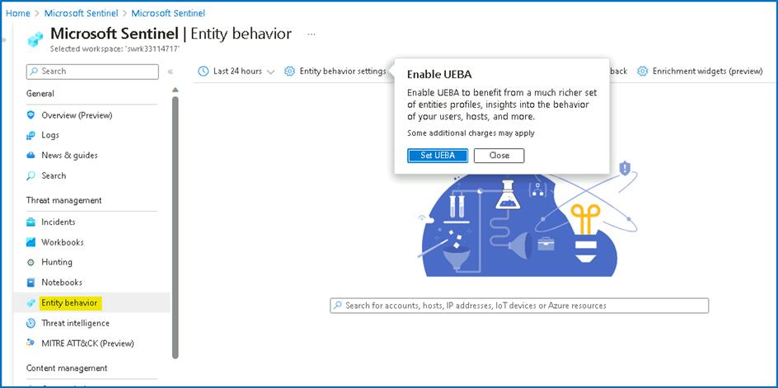

1. On the popup from **Entity behavior settings**, select **Set UEBA**.

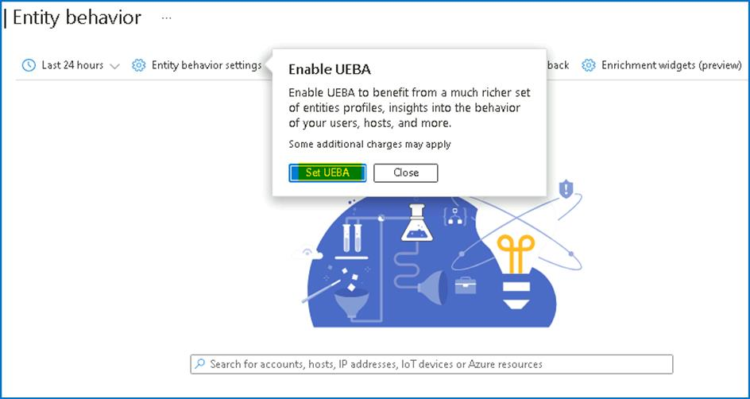

1. On the next page, you should notice that **UEBA** is already enabled as a part of the Deployment done in Lab 1.

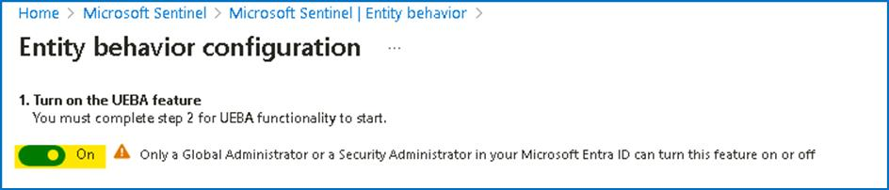

1. For the section **2. Sync Microsoft Sentinel with at least one of the following directory services**, notice the Microsoft Entra ID is already selected, click on the **Apply** button.

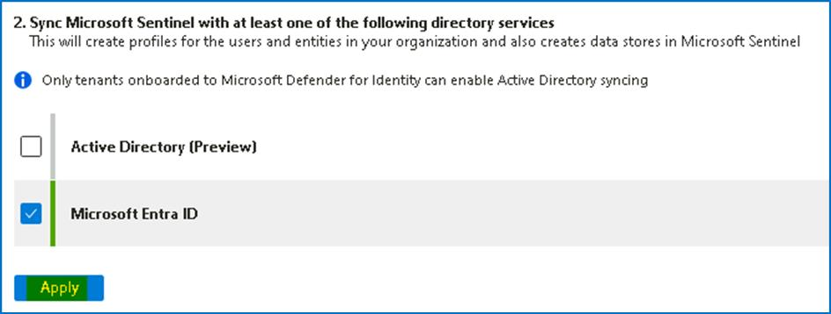

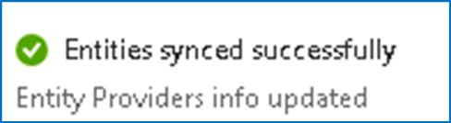

1. For the section 3. , select all 3 data sources and then click on the Apply button.

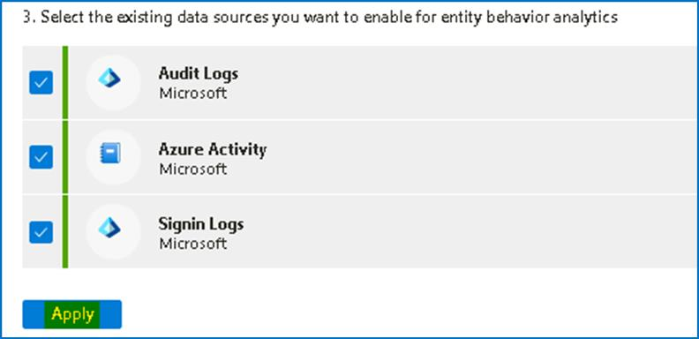

1. You should receive the Notification as shown in below image. The page will automatically be redirected to the Entity behaviour page.

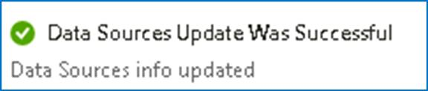

1. The confirms that the Entity behaviour is configured successfully.

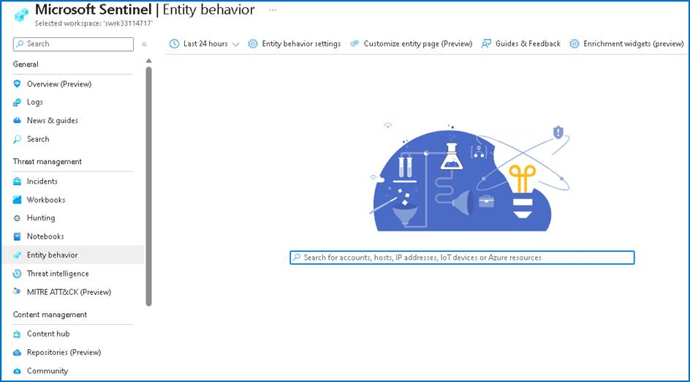

**Task 2: Confirm and review Anomalies rules**

In this task, we will confirm if Anomalies analytics rules are enabled.

1. While on the Microsoft Sentinel page click on **Analytics** under configuration, then select the **Anomalies** tab.

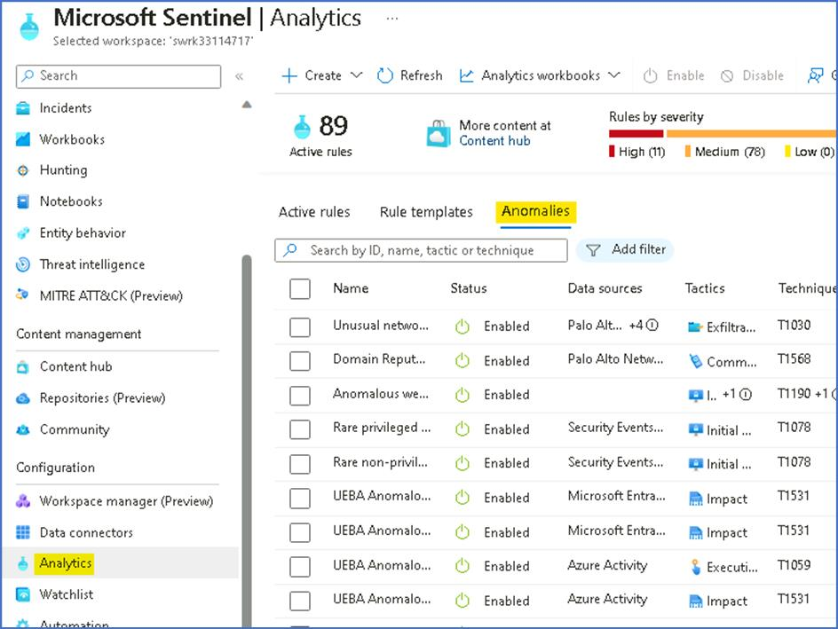

1. Select any rule and then select **Edit** on the rule blade.

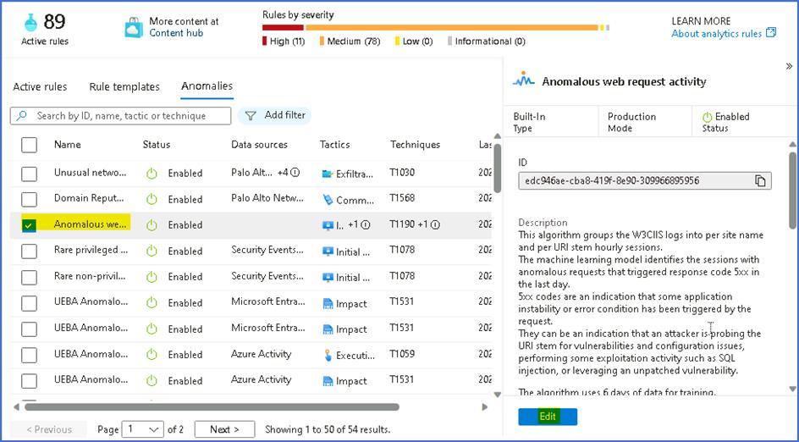

1. Review the **General** tab information. Notice the **Mode** is **Production** and then select **Next: Configuration**.

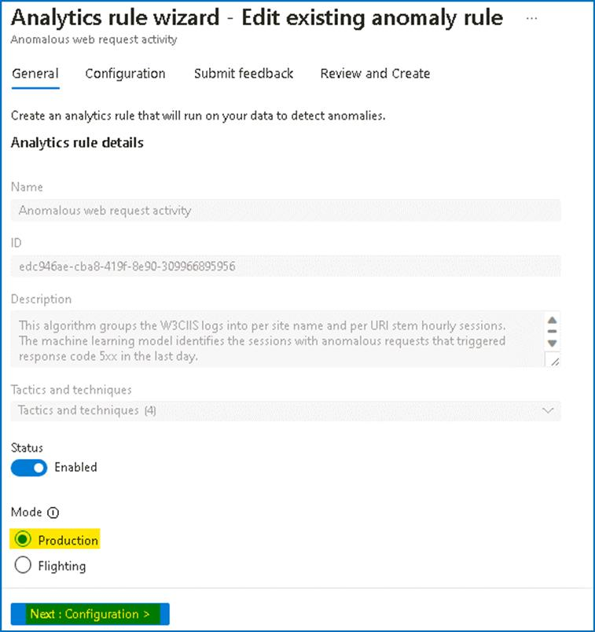

1. Review the ***Configuration*** tab information. Notice that you cannot change the **Anomaly score threshold**.

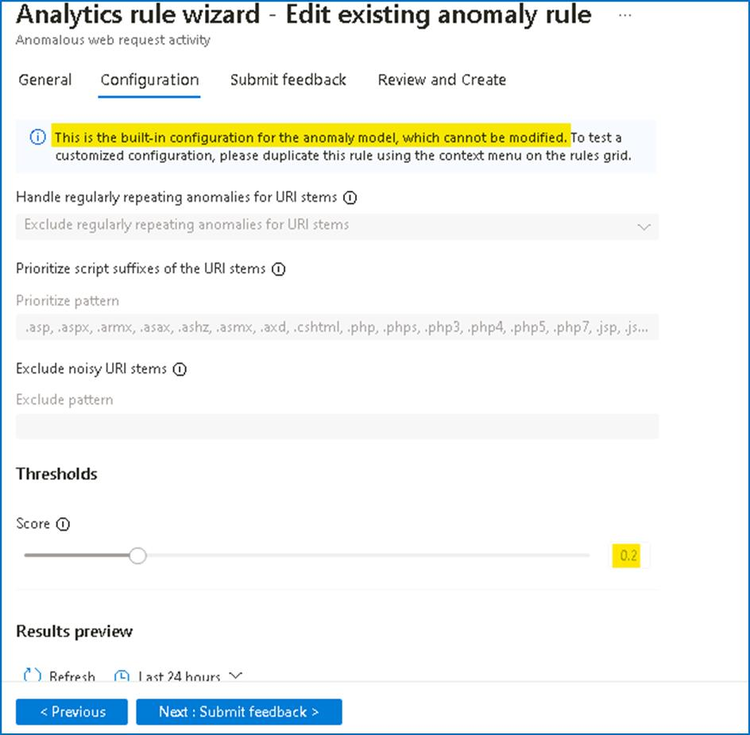

1. Then select **X** in the top right corner to exit the Analytics rule wizard.
2. Scroll right to the analytics rule you selected until see and select the ellipsis **(...)** icon. Select **Duplicate**

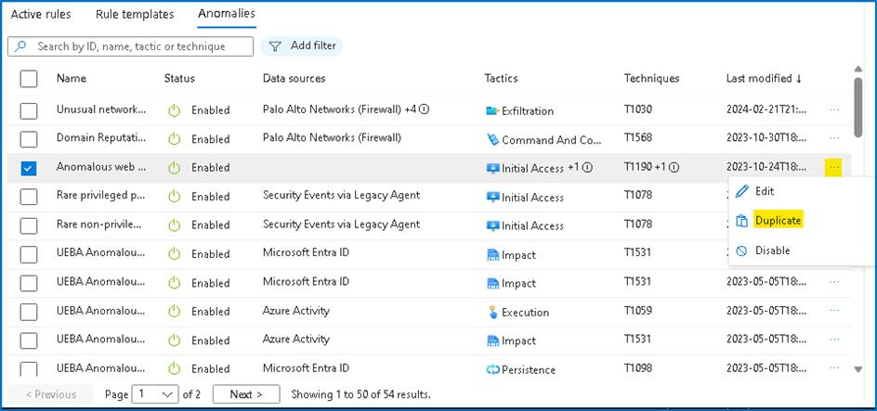

1. Scroll left to review the new rule with the **FLGT** tab at the beginning of the name. Select **FLGT** rule and then select **Edit** on the rule blade.

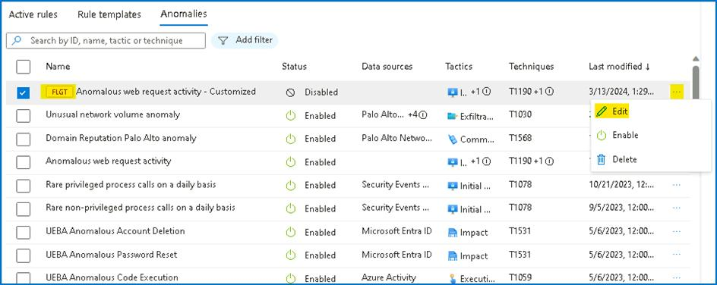

1. Review the **General** tab information. Set the status to **Enabled**, you will notice the **Mode** is **Flighting** and then select **Next: Configuration**.

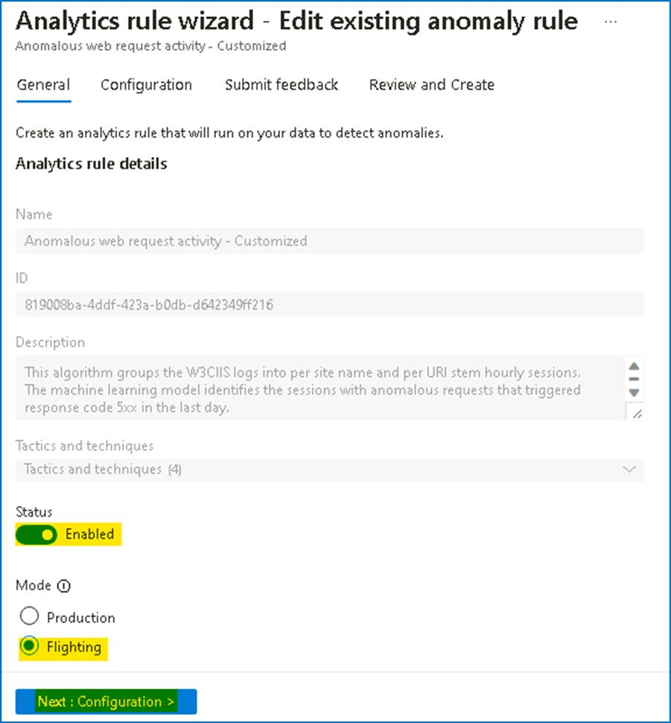

1. Review the **Configuration** tab information. Notice that you can now change the **Anomaly score threshold**.

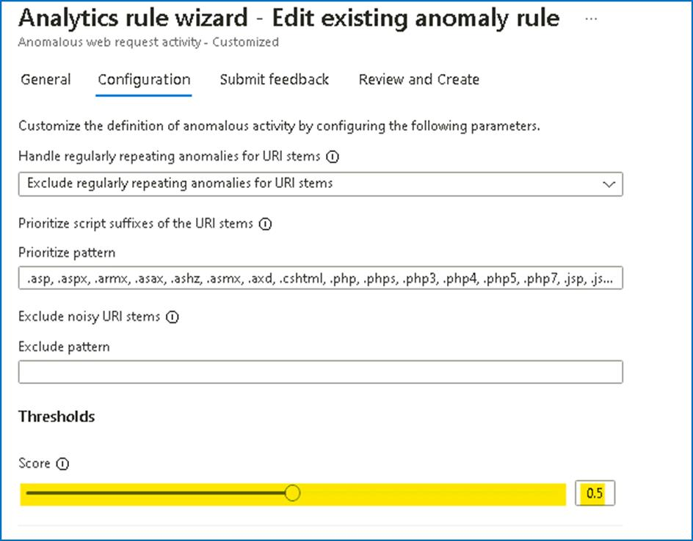

1. Set the value to **1** and then select **Next: Submit Feedback**.

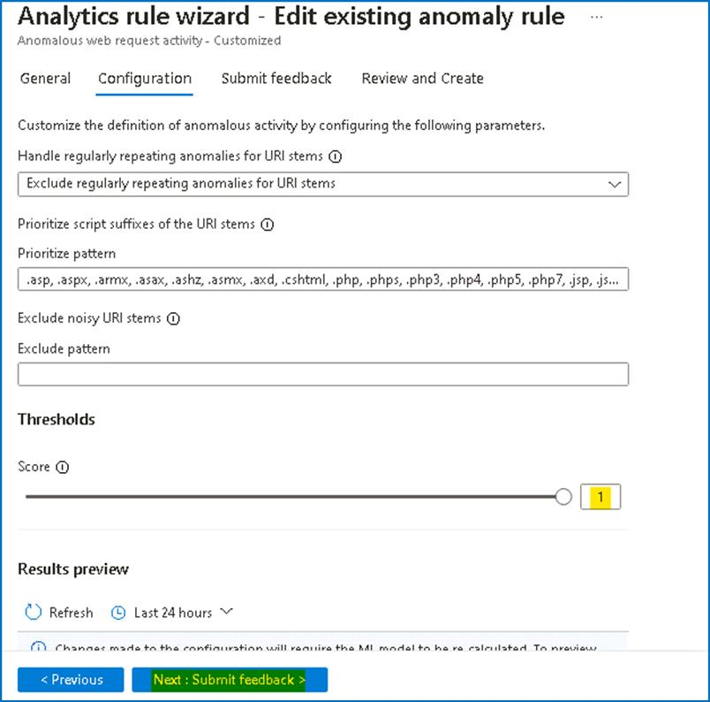

1. Provide the feedback and then click on **Next: Review + create**.

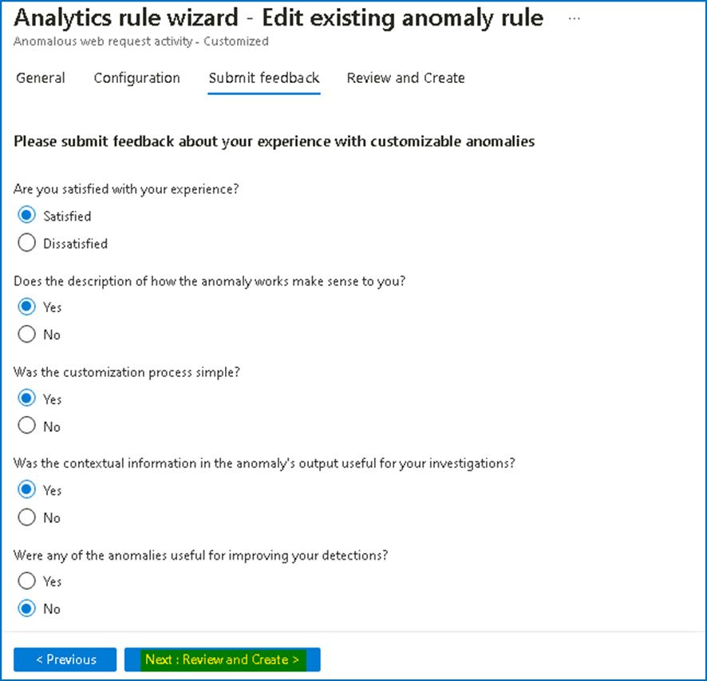

1. After the Validation is completed, click on Save button to update the rule

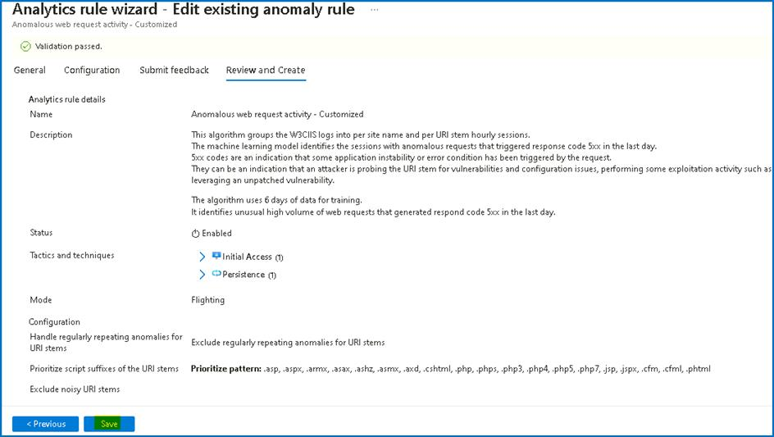

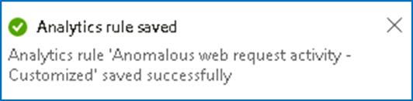

1. If the **FLGT Analytic rule** still shows **Disabled**, then right-click on it and select **Enable** option.

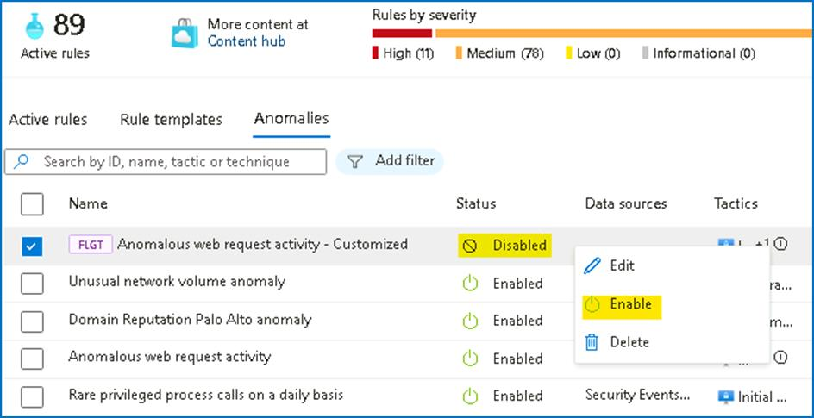

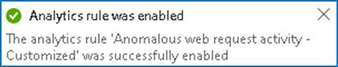

1. Now it should be enabled.

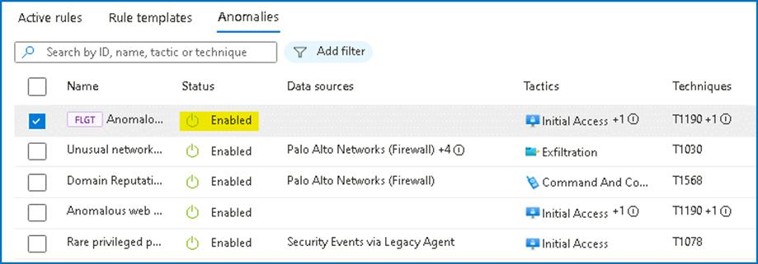

**Lab 7 - Exploring Microsoft Sentinel Advanced Features**

**Exercise 1: Getting started with Notebooks in Microsoft Sentinel**

**Time - 10 minutes**

You are a Security Operations Analyst working at a company that implemented Microsoft Sentinel. You need to explore the benefits of threat hunting with Microsoft Sentinel Notebooks. You can use notebooks to:

* Perform analytics that are not provided out-of-the box in Microsoft Sentinel, such as some Python machine learning features.
* Create data visualizations that are not provided out-of-the box in Microsoft Sentinel, such as custom timelines and process trees.
* Integrate data sources outside of Microsoft Sentinel, such as an on-premises data set.

**Task 1: Exploring Notebooks**

In this task, you will explore using notebooks in Microsoft Sentinel.

1. On the Azure Portal **http://portal.azure.com** and search for **Microsoft Sentinel** and click on **Microsoft Sentinel**.



1. Select **SwrkXXXXXXX**.



1. Now click on **Notebooks** under the **Threat management** area.

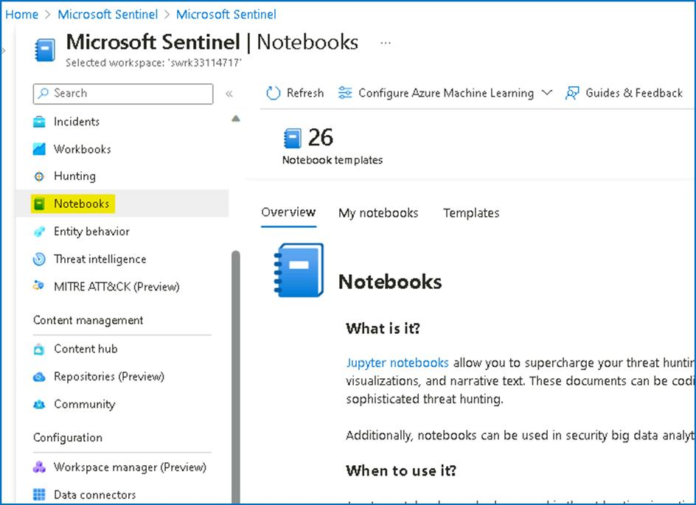

1. Next, you need to create an **AzureML** Workspace. Select **Configure Azure Machine Learning** and then select **Create new Azure ML workspace** button in the command bar.

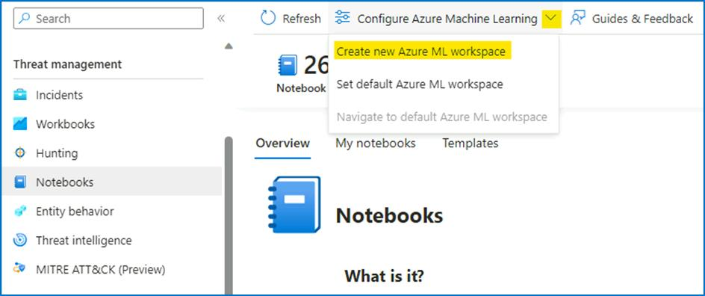

1. On the Azure Machine Learning page, provide the below details,

a. Subscription - **Azure Pass-Sponsorship**.

b. Resource group - **RG4Sentinel**

In the Workspace details section do the following:

c. Name: **AzureMLWorkspace** .

d. Region -- **East US**

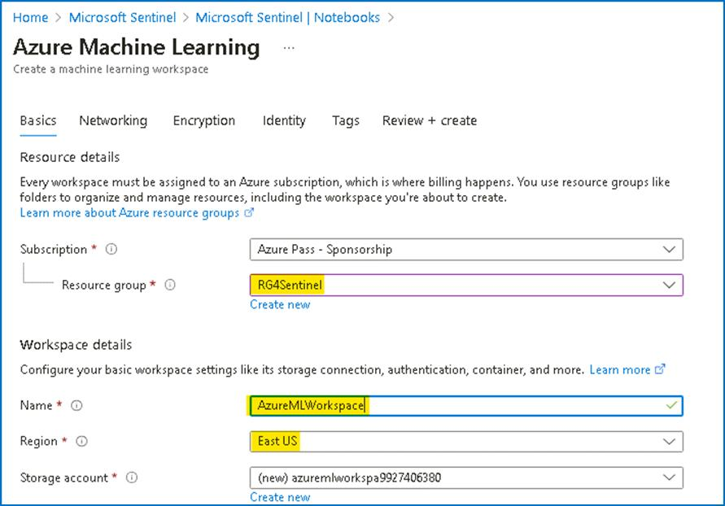

e. Keep the default **Storage account**, **Key vault**, and **Application insights** information.

f. The **Container registry** option can remain as **None**.

1. At the bottom of the page, select **Review + create**.

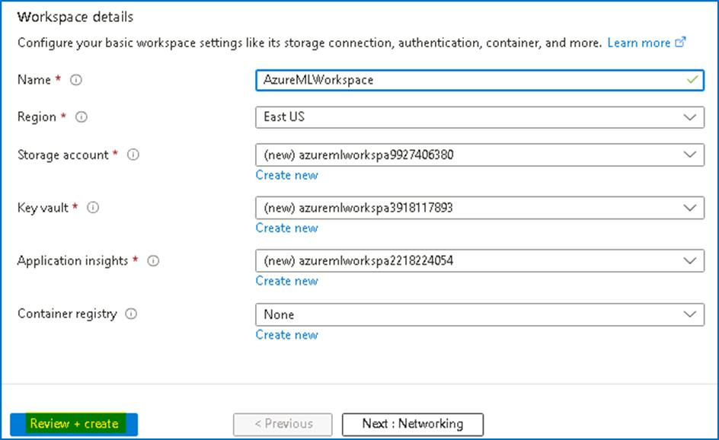

1. Once the Validation is completed, click on **Create**

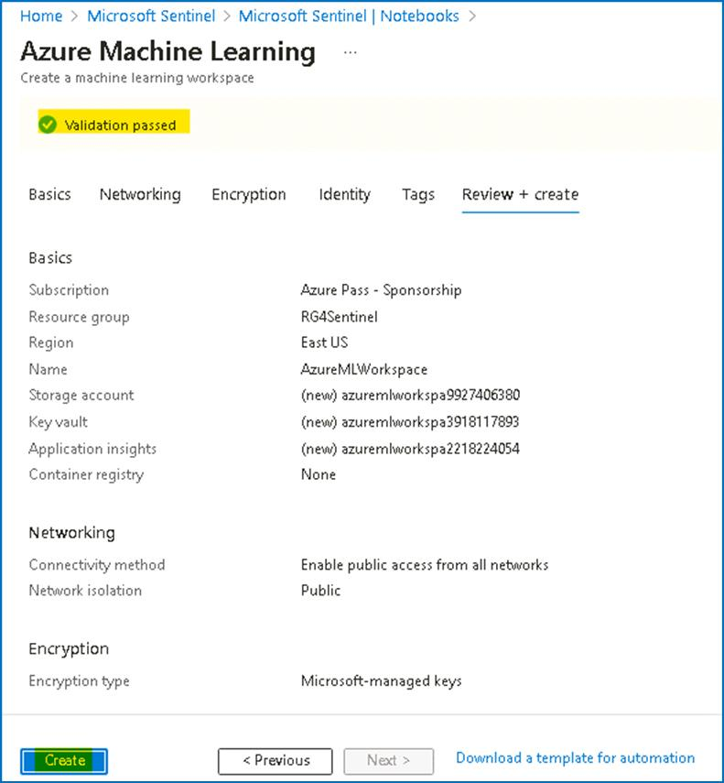

**Note:** It may take a few minutes to deploy the Machine Learning workspace.

1. Once the deployment is completed, navigate to the Microsoft Sentinel home page.

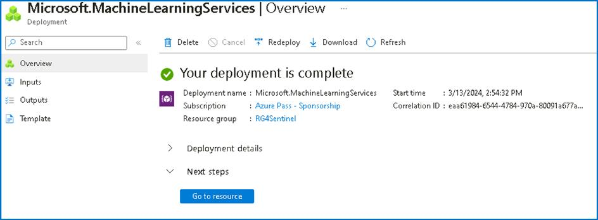

1. Once the deployment is completed, open the Microsoft Sentinel Workspace, select **Notebooks** then click on the dropdown for **Configure Azure Machine Learning** and select **Set default Azure ML workspace.**

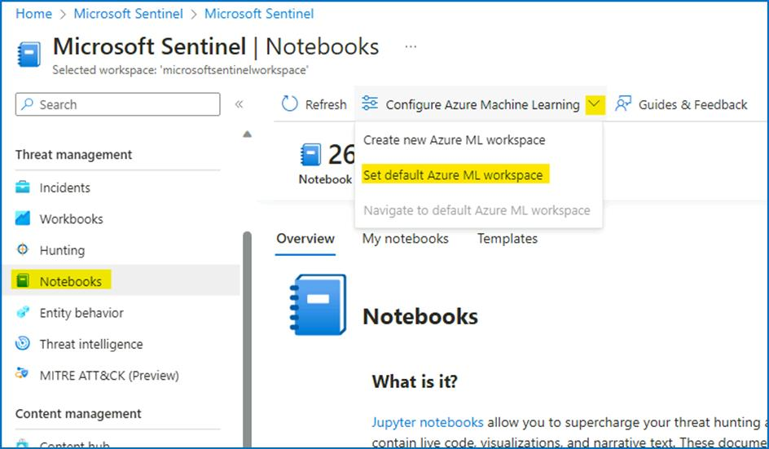

1. Under **Azure Machine Learning Workspace**, select **AzureMLWorkspace** and click **OK**.

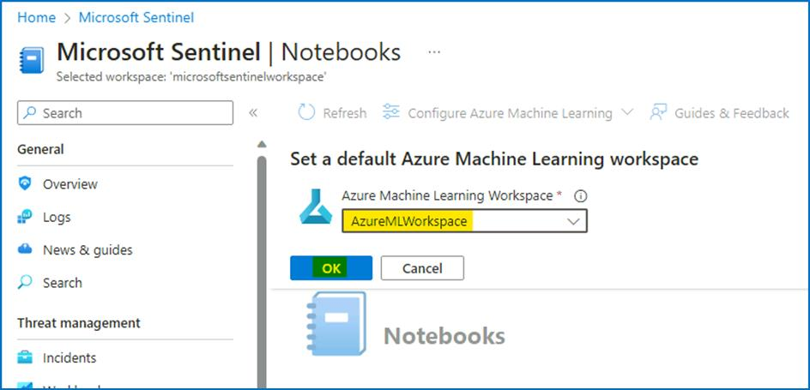

**Note** -- If the **AzureMLWorkspace** is not visible in the drop-down menu, then refresh the page and try again.

1. Select **Notebooks** again and then select the **Templates** tab from the middle command bar. And select **A Getting Started Guide for Microsoft Sentinel ML Notebooks**.

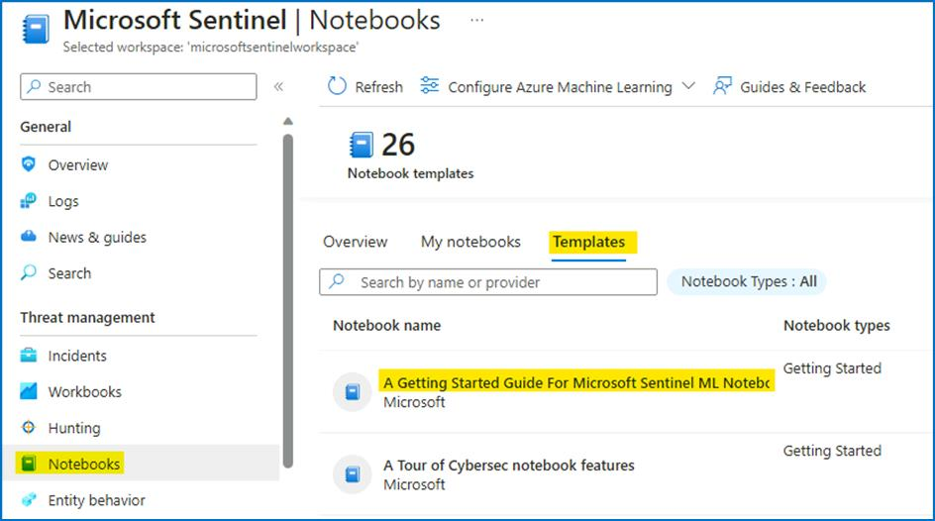

1. On the right pane, scroll down and select **Create from template** button.

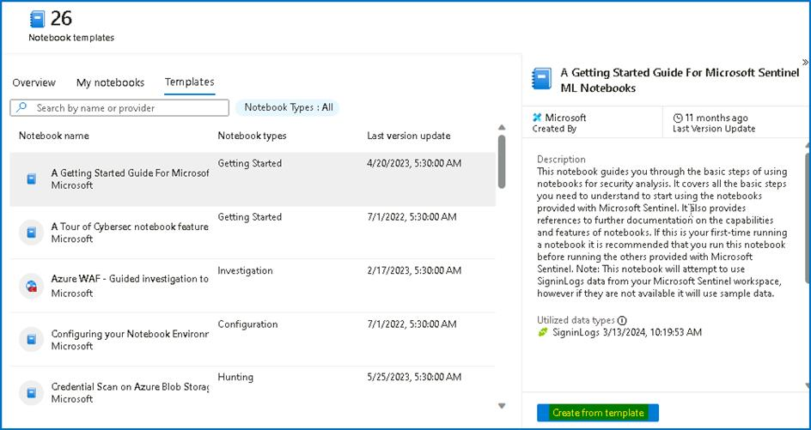

1. Review the default options and then select **Save**.

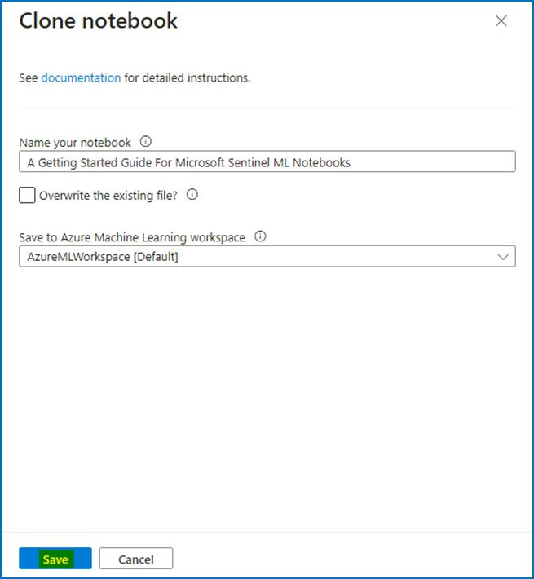

1. Once the saving is done, select the **Launch notebook** button. This will take you to the Microsoft Azure Machine Learning Studio.

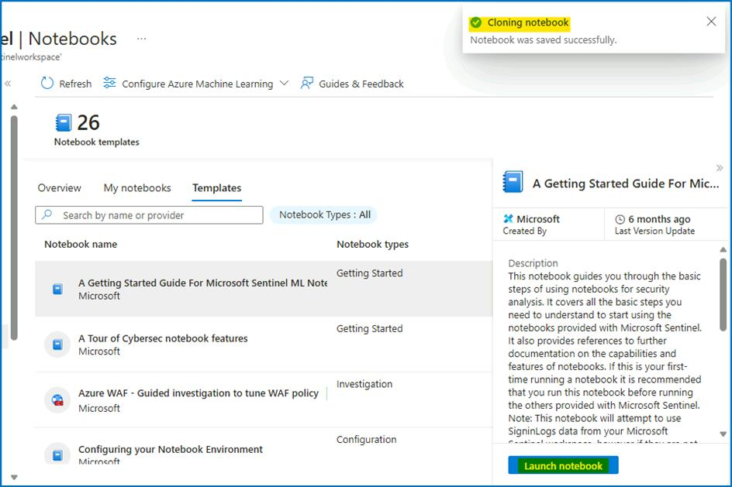

**Note:** You can also launch the workspace from **Notebooks** > **Configure Azure Machine Learning** > **Navigate to default Azure ML workspace.**

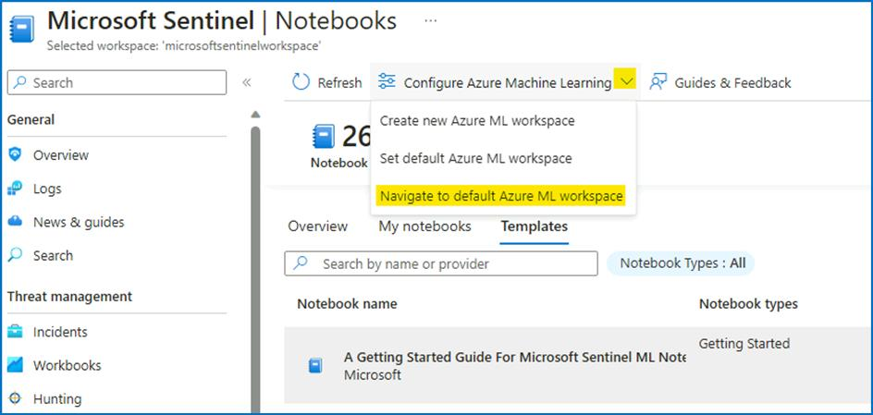

1. Click on the **Workspaces** from the left menu, and then click on the **AzureMLWorkspace**.

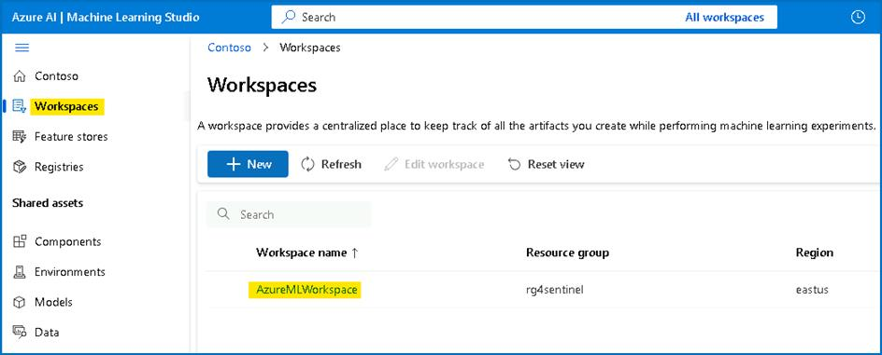

1. Press the **Cancel** button, for the survey questions and then click on **Notebooks** under Authoring.

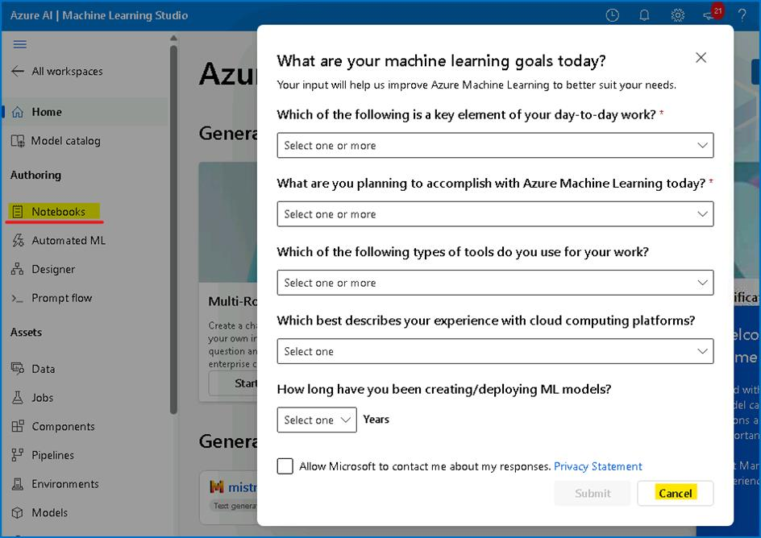

1. Select **Close** if an informational window appears in the Microsoft Azure Machine Learning Studio.

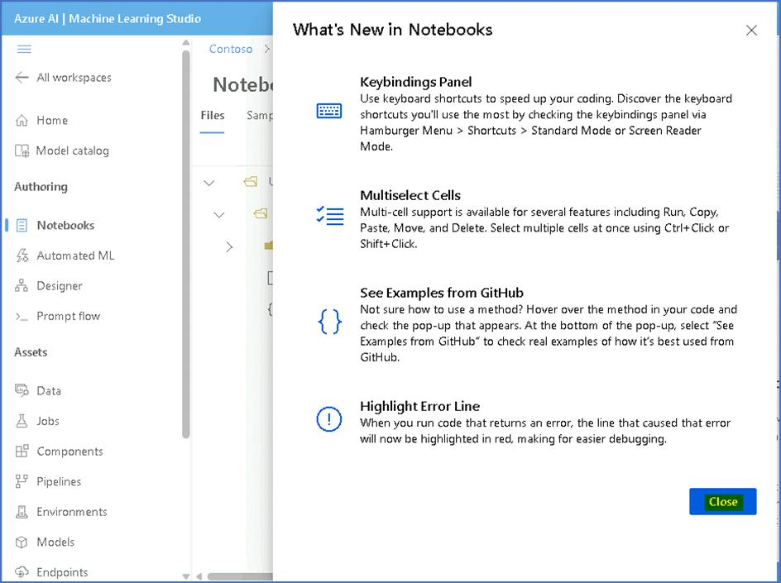

1. Click on Create compute button on the bottom right side of the screen.

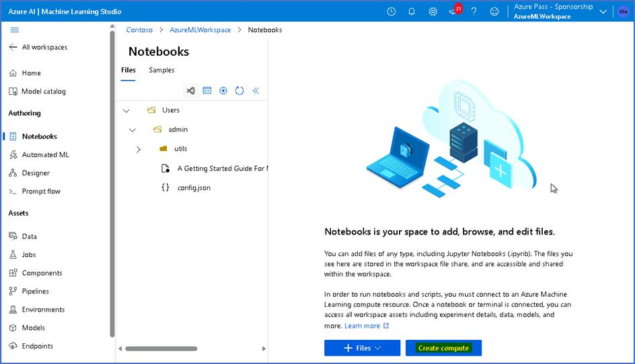

1. Provide the compute name as **SenComXXXXXX** [Substitute XXXXXX with random to make the **Compute name unique**. This will identify you compute instance.
2. Scroll down and select Workload type: **Development on Notebooks and light weight testing** then click on **Review + Create** button.

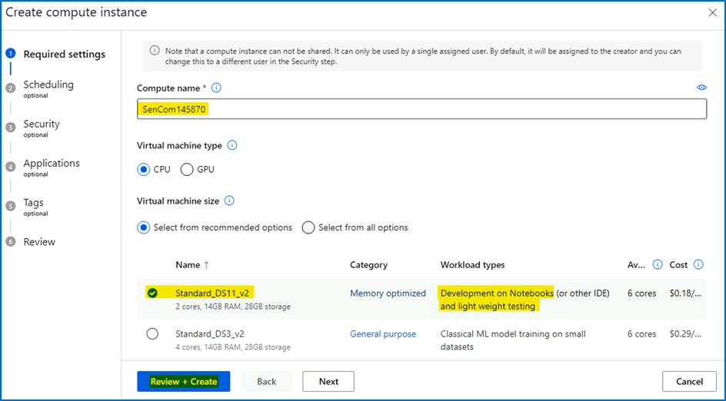

1. Select the **Create** button at the bottom of the screen.

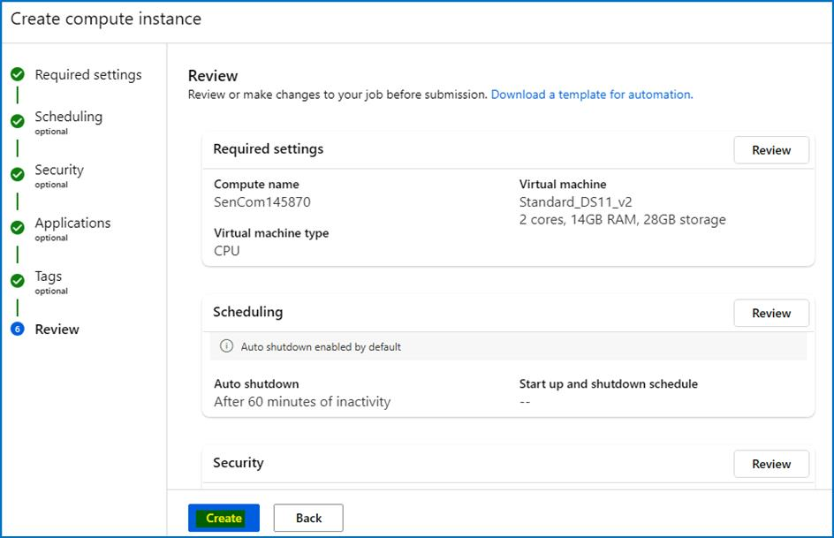

1. Close any feedback window that may appear. This will take a few minutes, you will see a notification (bell icon) when it is done and the *Compute instance* left icon turns from blue to green.

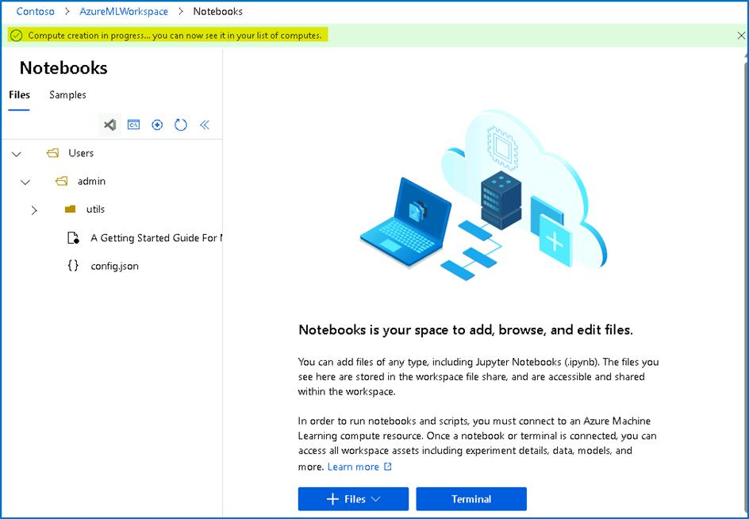

1. You should get the notification as shown in the below image after 1-2 minutes.

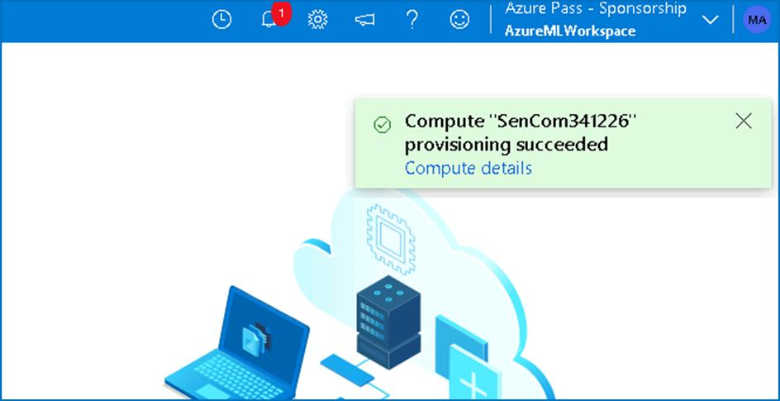

1. Click on the Terminal button after the Provision succeeded notification has appeared.

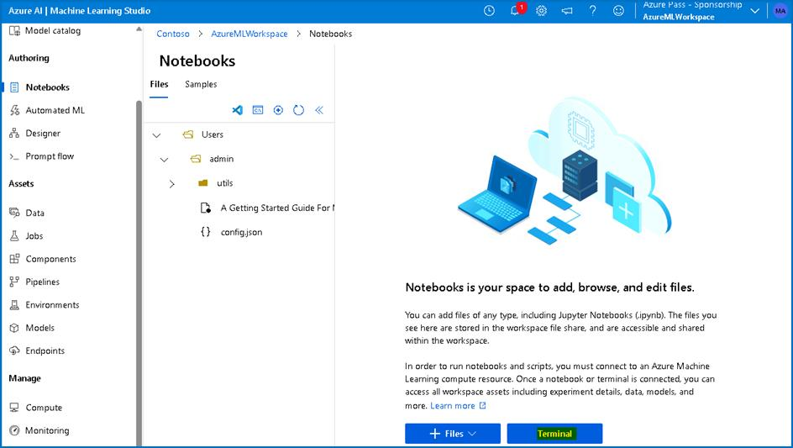

1. If the Terminal is launched correctly then no error should appear.

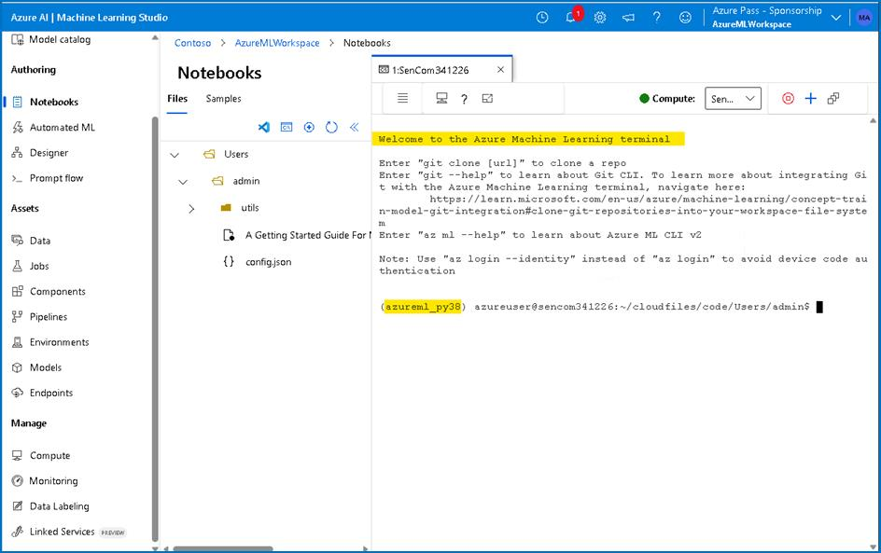

1. You have successfully created an Azure ML Compute resource.
2. From the terminal you can try the **az login** command and authenticate to login as shown below

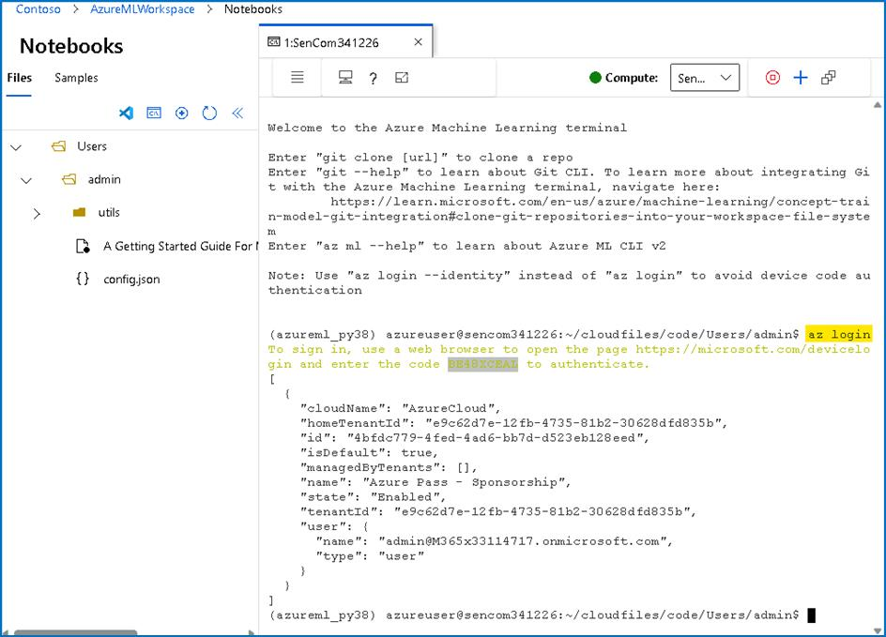

**Exercise 2: Getting started with Workbooks in Microsoft Sentinel**

**Time - 20 minutes**

**Task 1: Exploring workbook templates**

1. On the Azure Portal **http://portal.azure.com** and search for **Microsoft Sentinel** and click on **Microsoft Sentinel**.



1. Select **SwrkXXXXXXX**.



1. Now click on **Workbooks** under the **Threat Management** left blade and select the **Templates** tab.

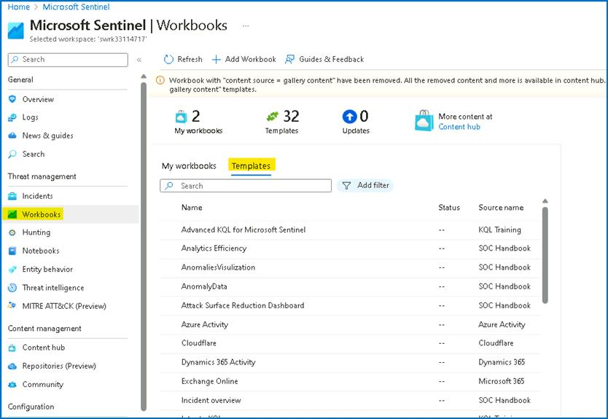

1. From the list select the **Azure Activity** template and click **View Template** button.

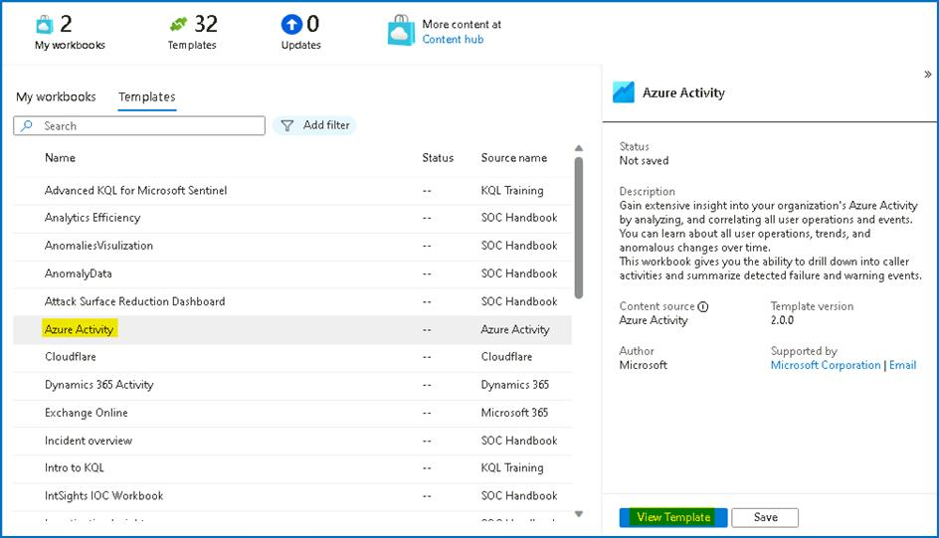

1. Review the contents of the workbook. It usually shows insights of your Azure subscription operations by collecting and analyzing the data from the Activity Log.

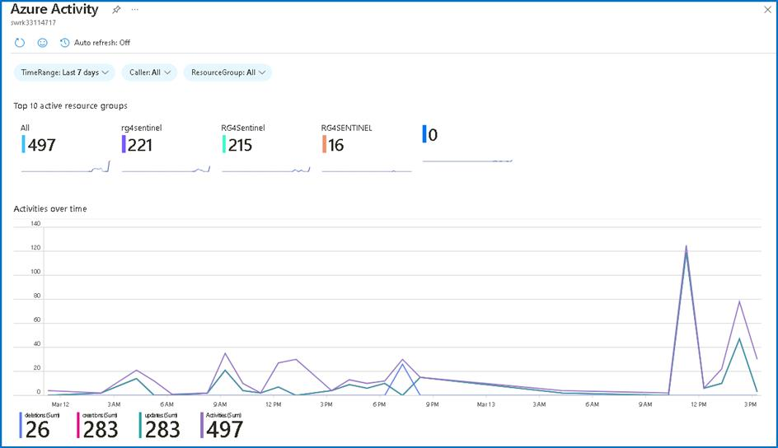

1. Close the workbook by selecting the **X** in the top-right corner.

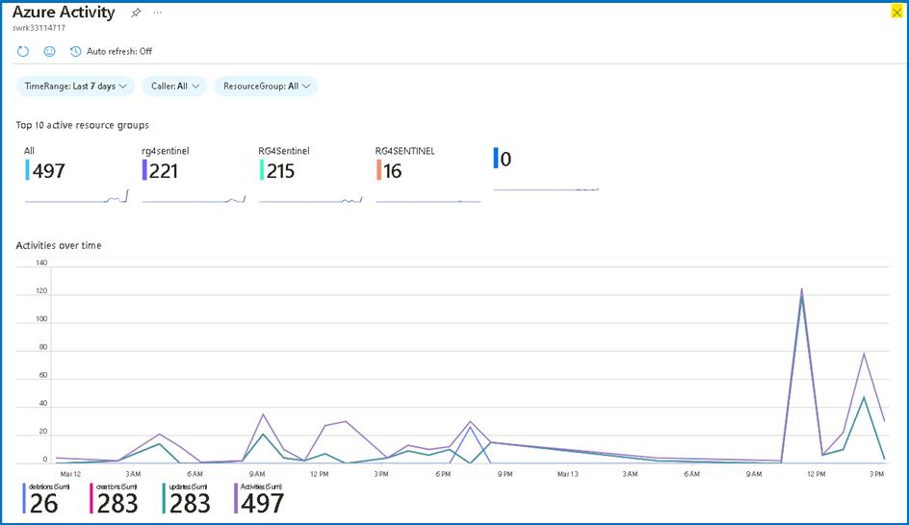

**Task 2: Save and modifying a workbook template**

In this task, you will save a workbook template and modify it.

1. While in the **Workbooks,** on the **Templates** tab, click the **Save** button for the **Azure Activity** workbook.

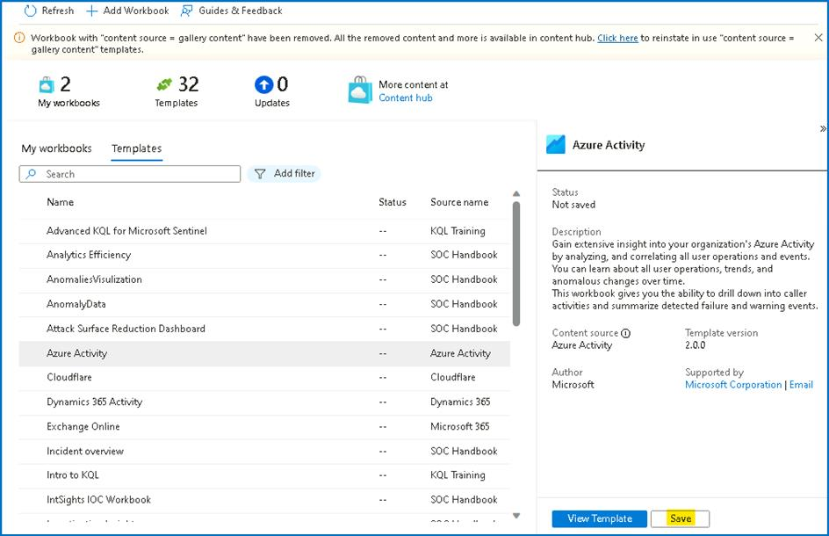

1. Leave **East US** as the default value for *Region* and select **OK**.

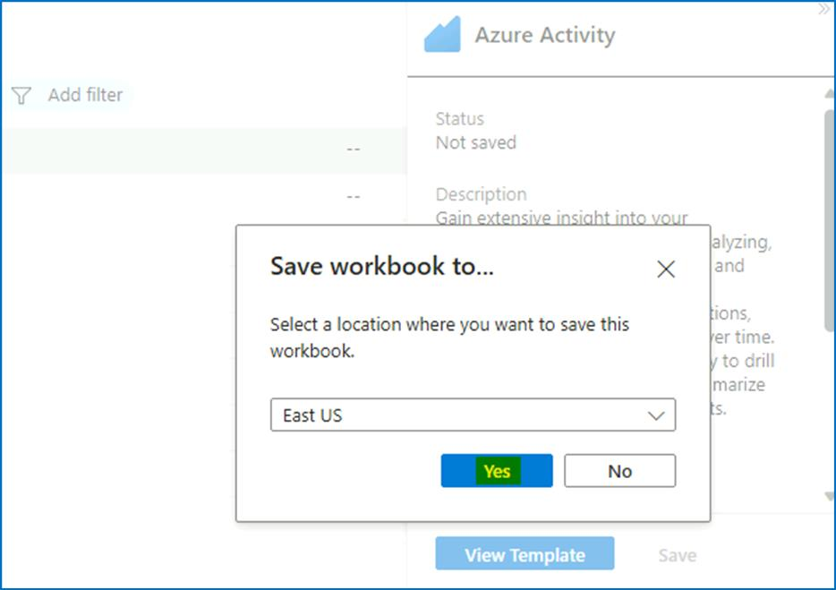

1. Select the **View saved workbook** button.

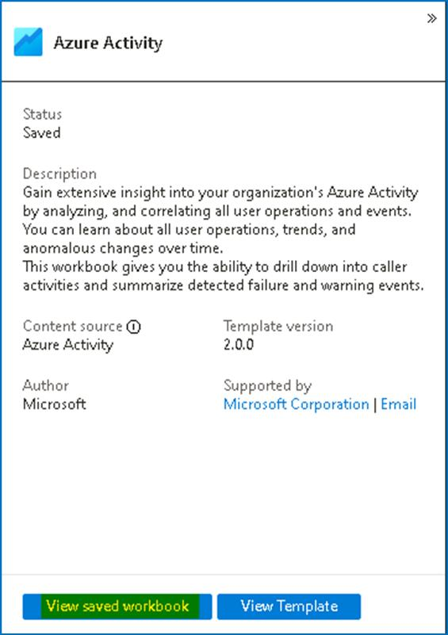

1. Select **Edit** in the command bar to enable changes in the workbook.

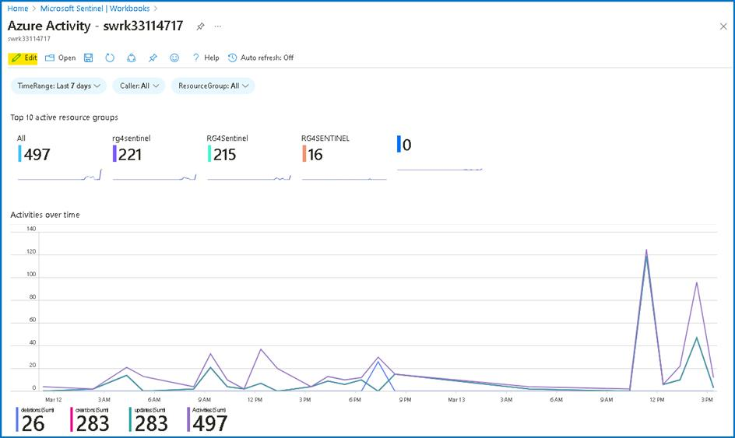

1. Scroll down to the **Caller activities**. Select the **Edit** button below the grid.

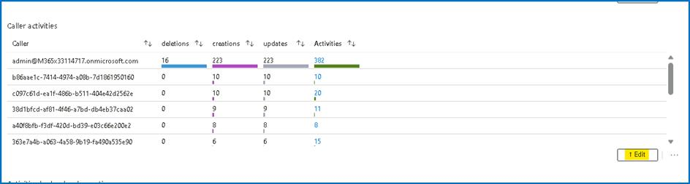

1. You can follow the next steps if there is data from the KQL query.\ Select the **Column Settings** button, it is located to the right of the** Run Query **command bar.

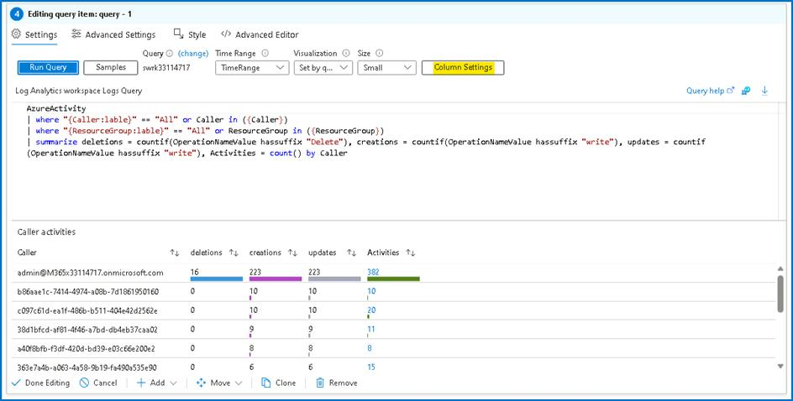

1. In the **Edit column settings** blade that appears within Columns select Activities.
2. Change the value for **Column renderer** to **Heatmap**. For **Color palette**, scroll down to select **32-color categorical**.

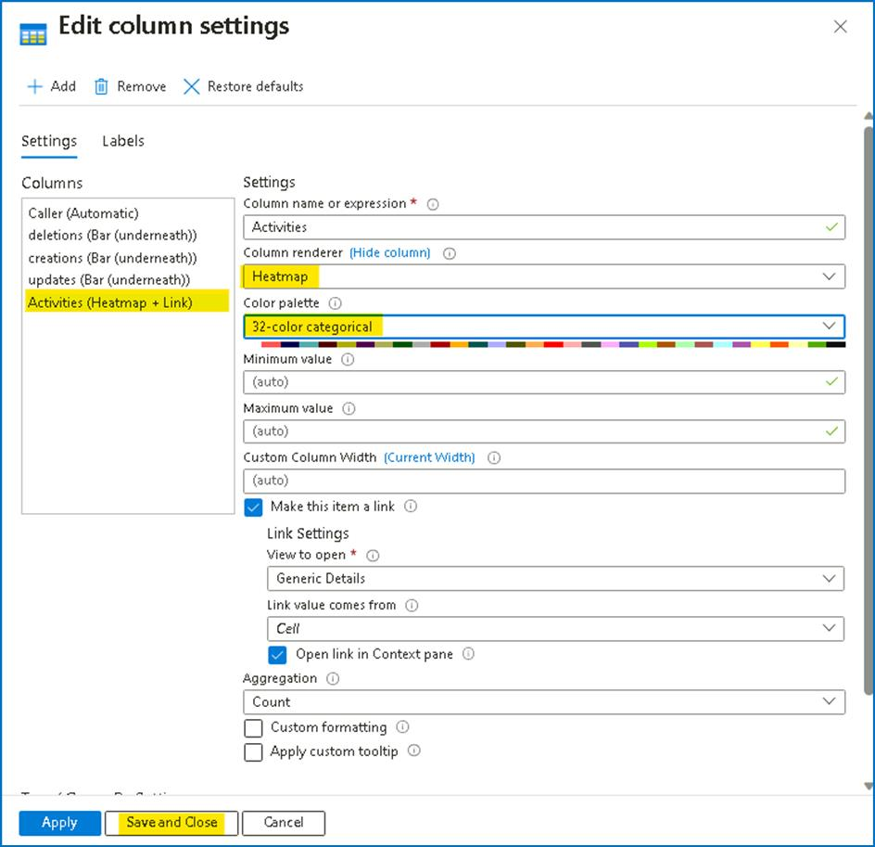

1. Select **Save and Close**. Notice the change in the *Activities* column.
2. Click on **Done Editing**

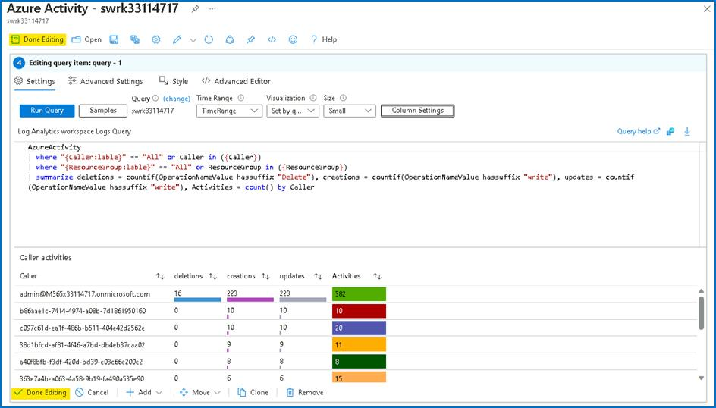

1. Close the workbook by selecting the **X** in the top-right corner.

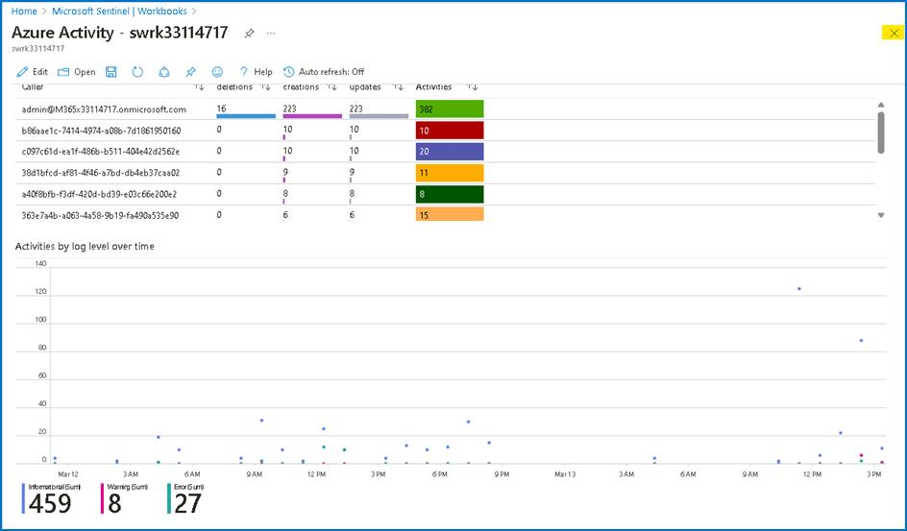

1. Close the Azure Activity workbook blade.

**Task 3: Creating a Workbook**

In this task, we will create a new workbook with advanced visualizations.

1. While still on the **Workbooks** area of the Microsoft Sentinel portal.
2. Select **+ Add workbook** to create a new workbook from scratch.

**Note:** Although it is a new workbook, a startup template is used.

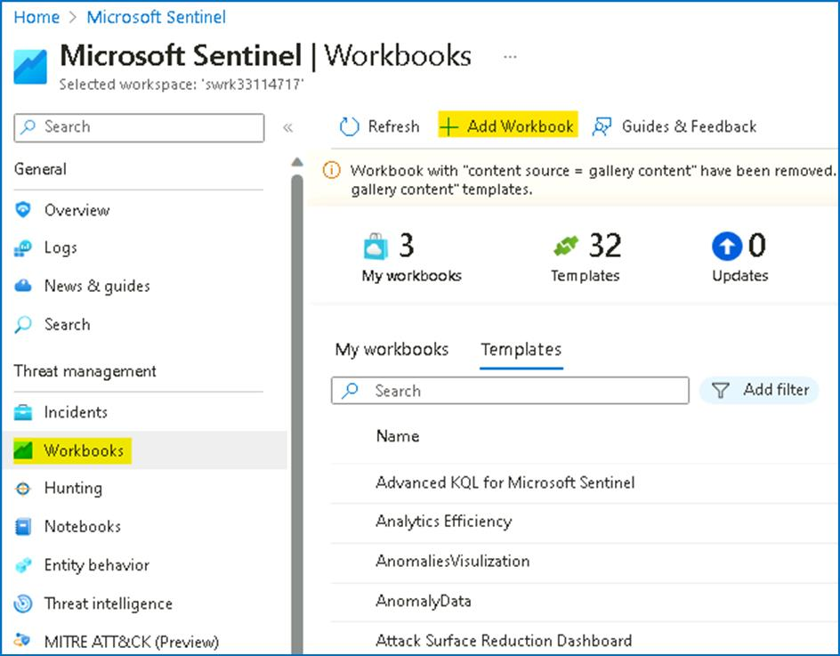

1. To edit the workbook, select **Edit**.

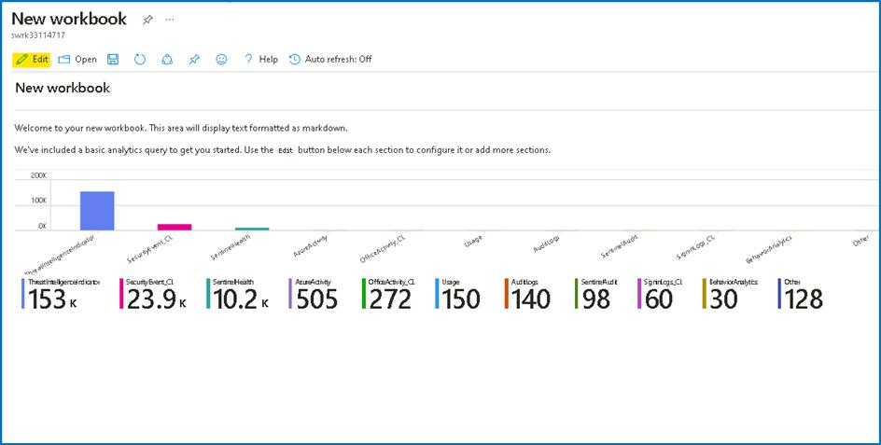

1. Select the **Edit** button below the first paragraph of the workbook.

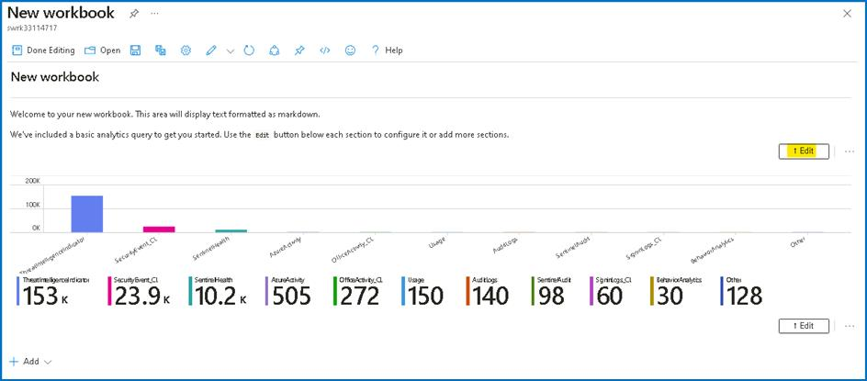

1. Type **# My workbook** in a new line on top of **## New workbook**.
2. Select **Done Editing** on the bottom of this section, **Editing text item: text -** **2**.

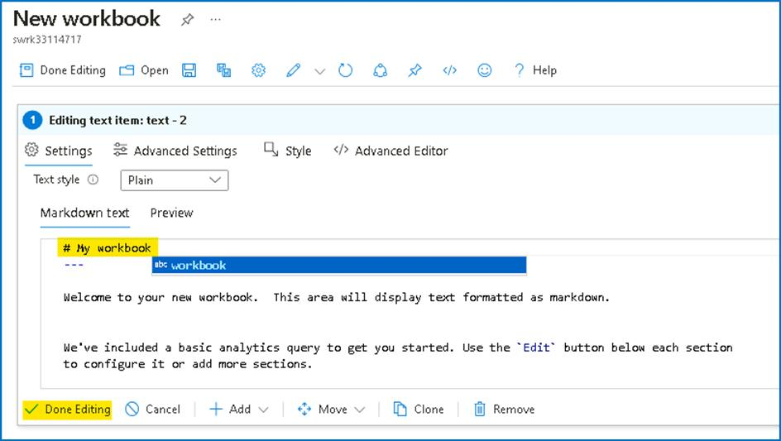

1. Notice that your header increased size and name changed.

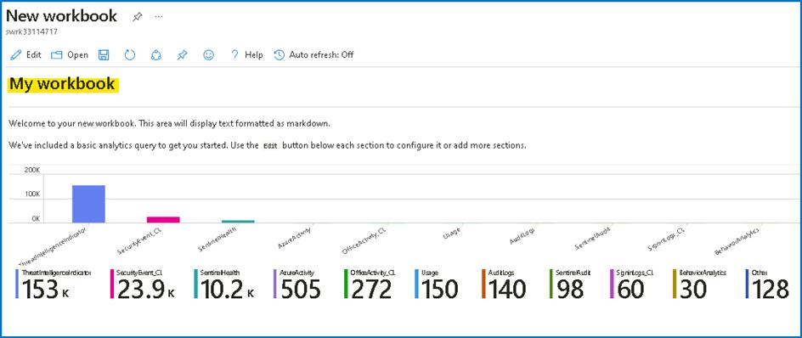

1. Click on **Edit** again and then select **Edit** below the only visible barchart graph.

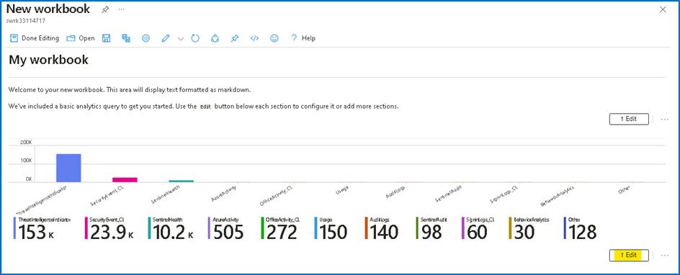

1. Review the KQL statement that provides a *union* statement of counts across all tables. Scroll down and select the **Done Editing** on the bottom menu, for the **Editing query item: query - 2**.

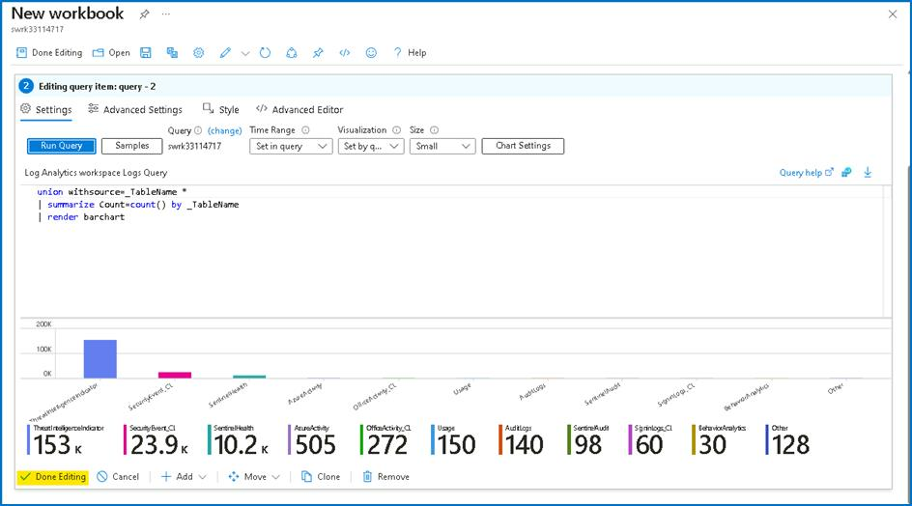

1. Select the ellipsis **...** next to the **Edit** button of the barchart graph, then select **+ Add**, then select **Add query**.

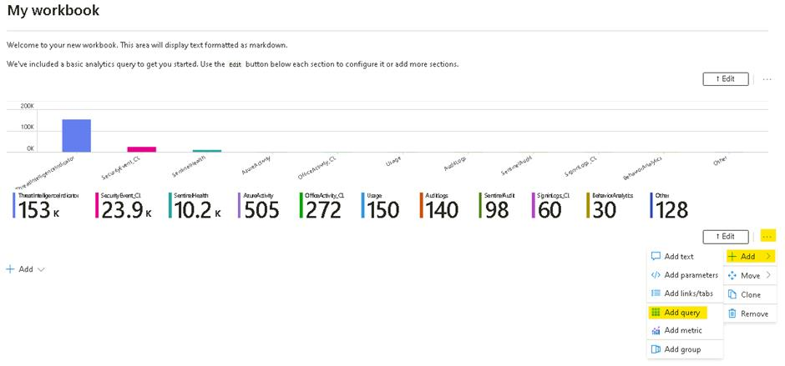

1. Type **SecurityEvent** into the query box. Change the **Time Range** to **Last hour**. Change the **Visualization** to **Time chart**.

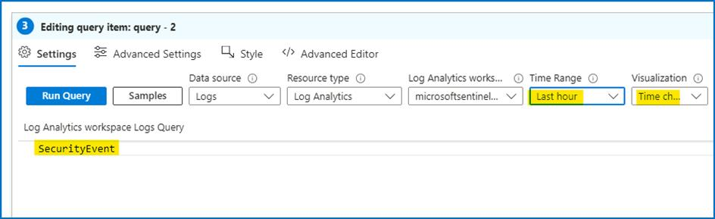

1. Select **Style** tab from the query's command bar. Select the **Make this item a custom width** box. Set the **Percent width** to **25** and **Maximum width** to **25**.

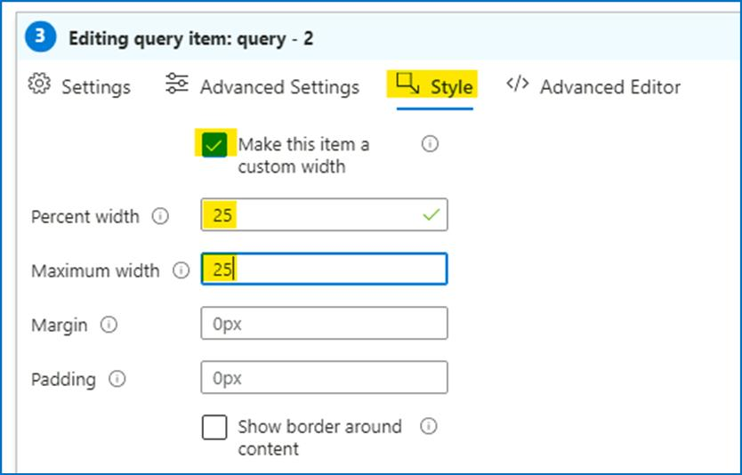

1. Now select **Advanced Settings** tab from the query\'s command bar. Select **Show refresh icon when not editing** box. Scroll down and select **Done Editing** on the bottom menu, for the new **Editing query item: query - 2**.

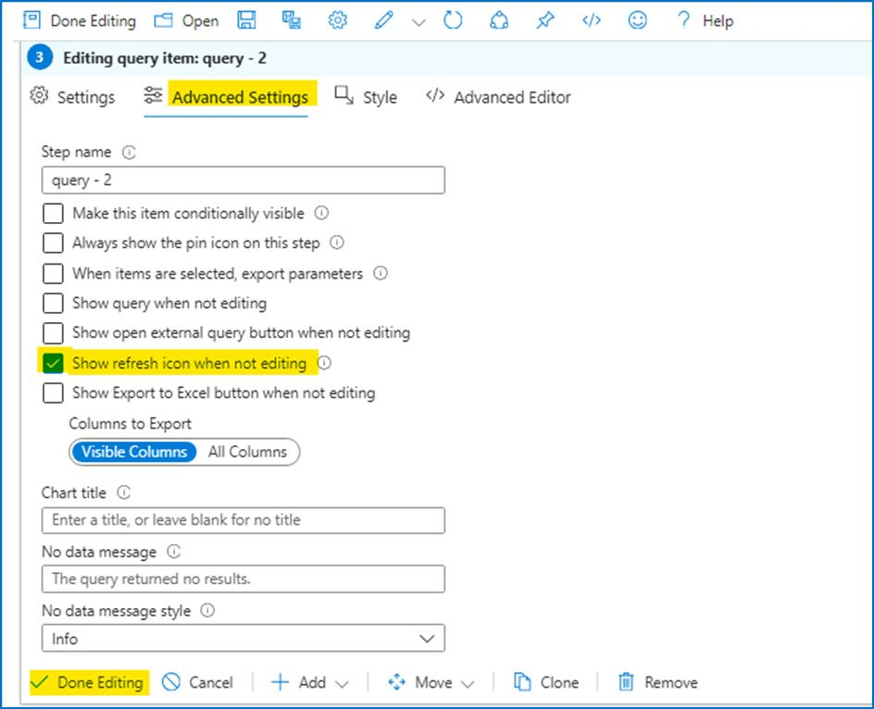

1. Scroll down and at the bottom of the workbook select **+ Add**, then **Add query**.

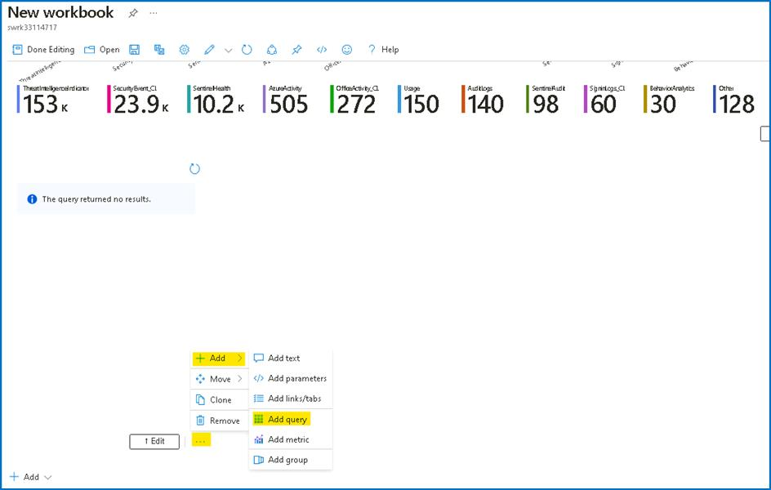

1. Type **SecurityEvent** into the query box. Change the **Time Range** to **Last hour**. Change the **Visualization** to **Grid**.

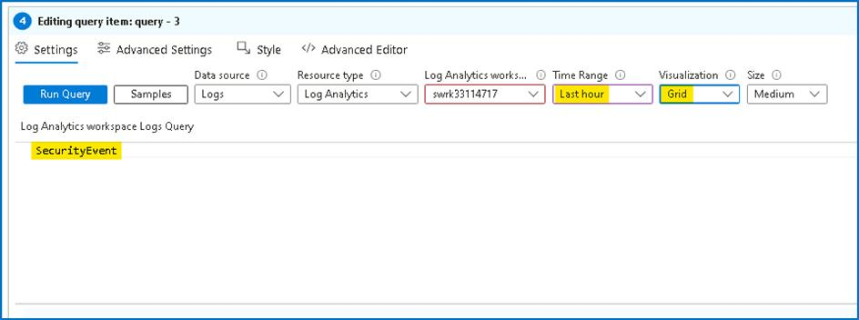

1. Select **Style** from the query\'s command bar. Select **Make this item a custom width** box. Set the **Percent width** to **75** and **Maximum width** to **75**. Scroll down and select **Done Editing** on the bottom menu, for the new **Editing query item: query - 3**.

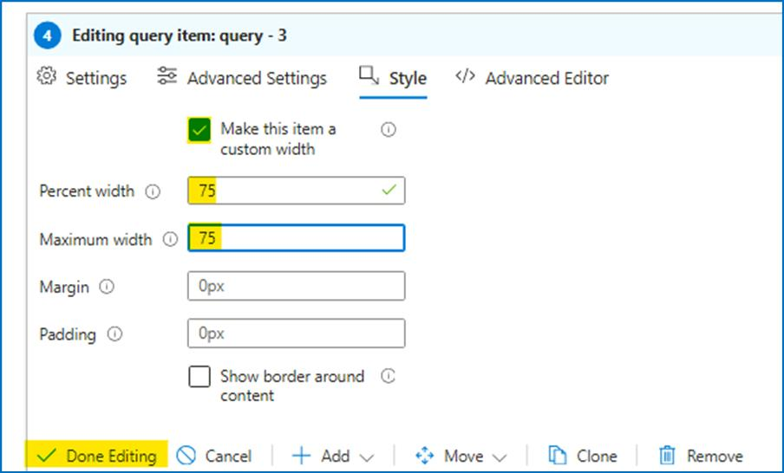

1. If required, click on **Done Editing** in Workbook\'s top command bar.

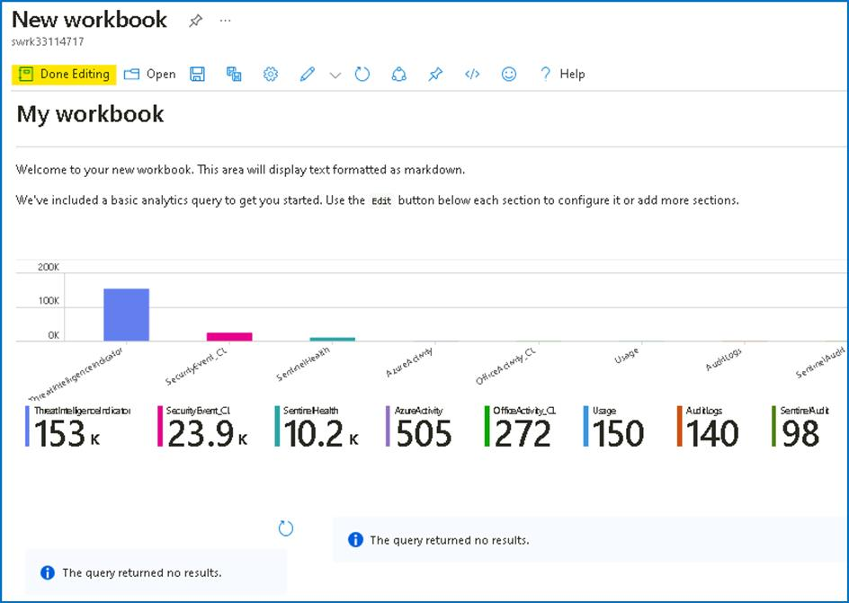

1. Select the **Save** icon, change the **Title** to **My Workbook**.

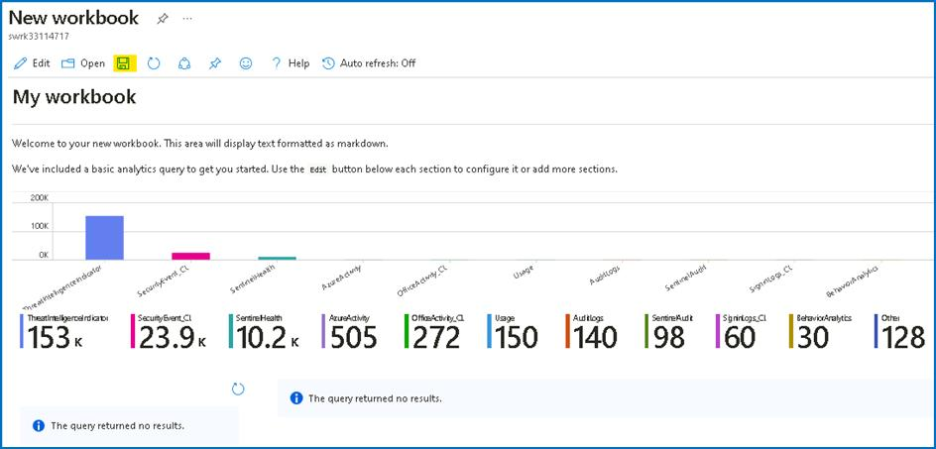

1. Select the **RG4Sentinel** resource group if needed and leave other values as default. Select **Apply** to commit the changes.

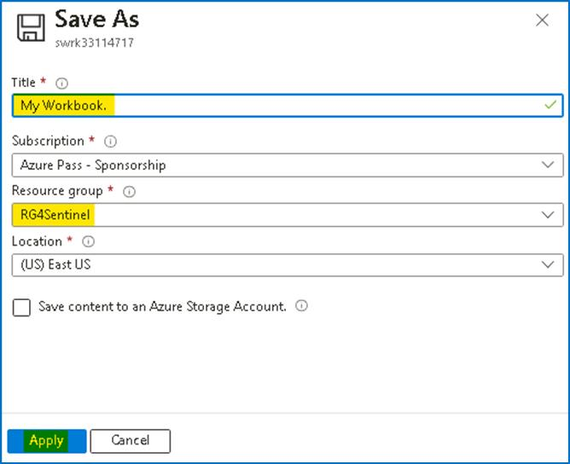

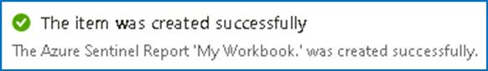

1. Close the workbook by selecting the **X** at the top-right or select **Workbooks** in the Microsoft Sentinel portal.

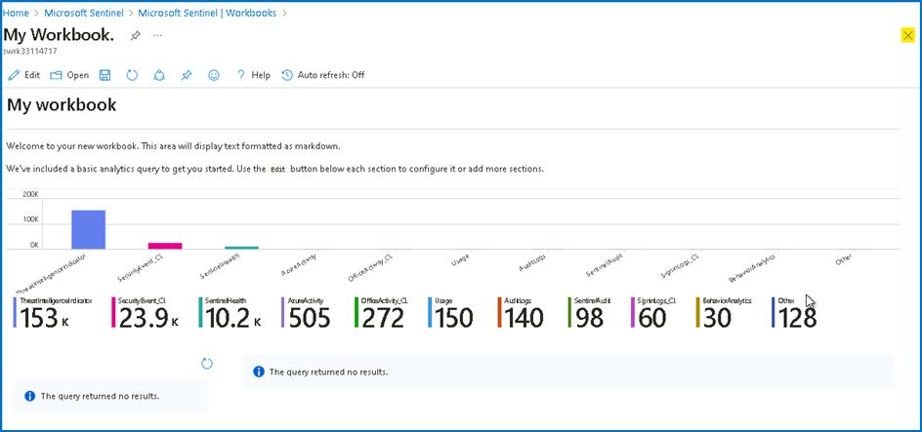

1. Back in the **Workbooks** page, you should be able to see **My workbooks**.

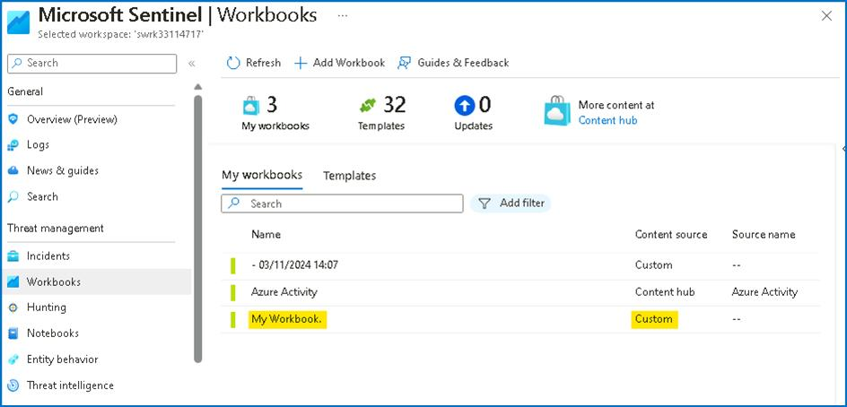

1. Select the workbook you just created, **My workbook**. On the right pane, select **View saved workbook** to review your workbook.

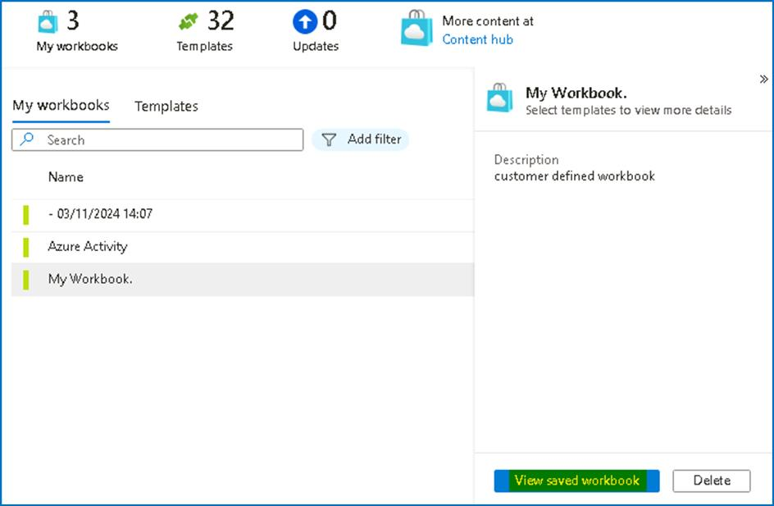

**Congratulation** you have completed Lab 7 !!!!!!!!!!!!

**Lab 8 - Repositories in Microsoft Sentinel**

**Exercise 1: Explore Repositories in Microsoft Sentinel**

**Time - 30 minutes**

**Task 1: Creating and exporting an analytical rule**

In this task, you will enable Entity behaviour analytics in Microsoft Sentinel.

1. On the Azure Portal **http://portal.azure.com** and search for **Microsoft Sentinel** and click on **Microsoft Sentinel**.



1. Select **SwrkXXXXXXX**.



1. Now click on **Analytics** under the **Configuration** area from the left blade. Select the **Malicious Inbox Rule** that you created earlier.

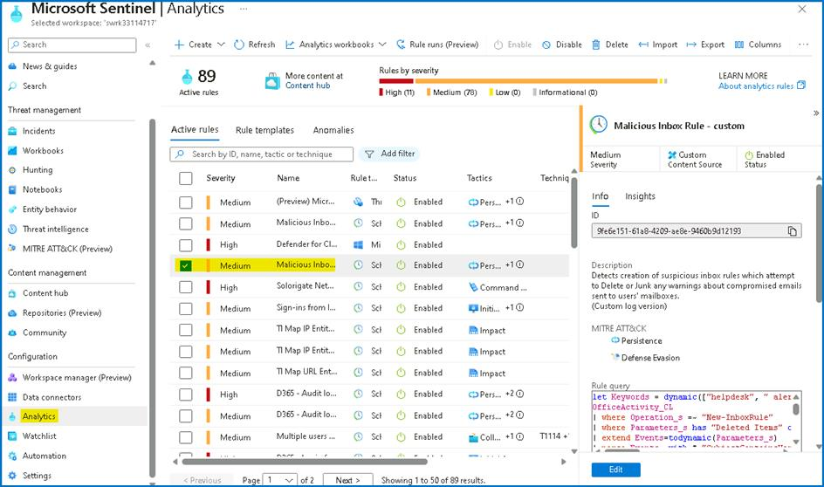

1. Select the **Export** from the toolbar. **Hint:** You might need to select the ellipsis icon **(...)** to see it.

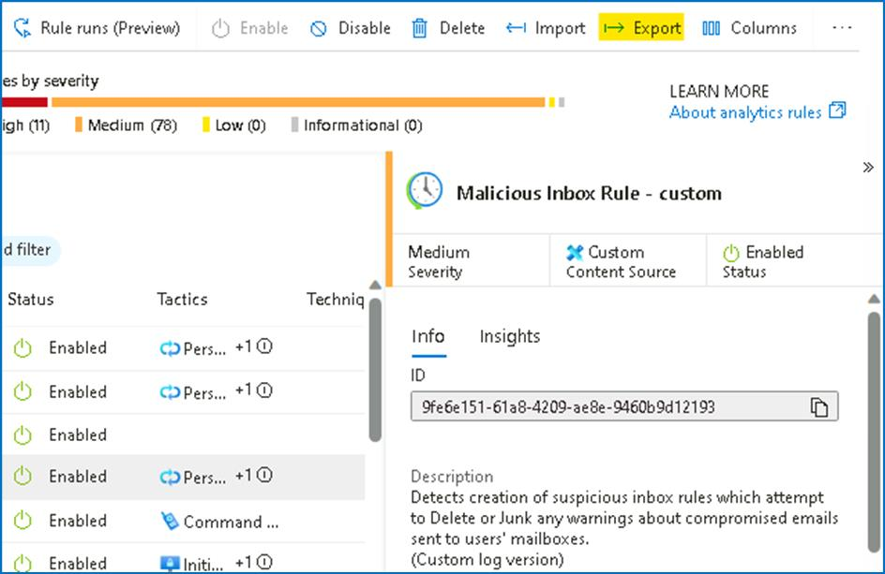

1. The rule is exported to a text file named **Azure_Sentinel_analytic_rule.json**. Select **Open file** below the name of the downloaded file.

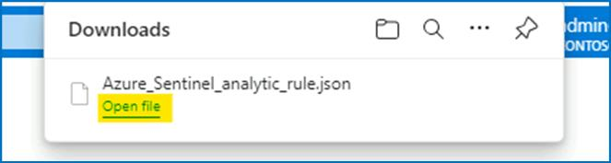

1. Select **More apps** and then select **Notepad** and then select **OK**.

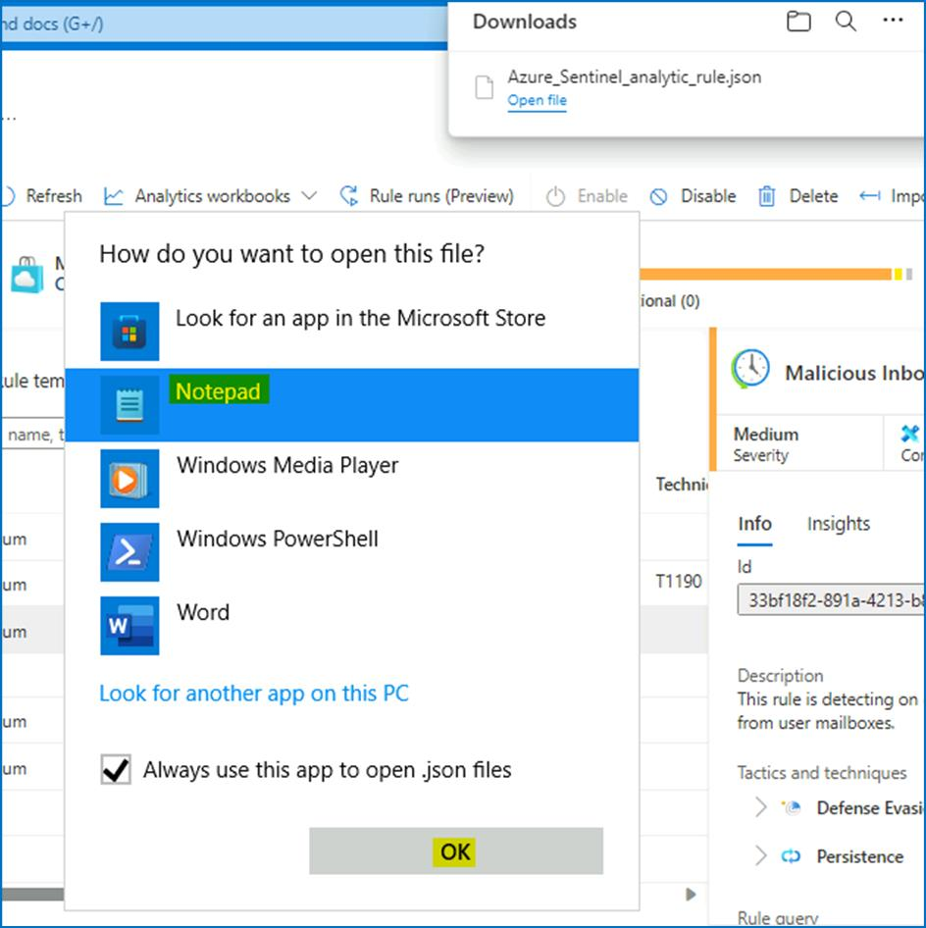

1. Review the **Azure Resource Manager** template and the close it when done.

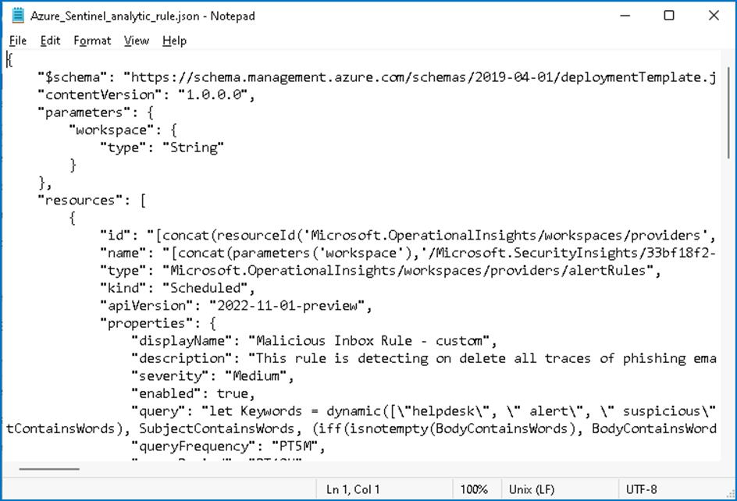

**Task 2: Creating our Azure DevOps environment**

In this task, you will create an Azure DevOps repository.

1. Open another tab in the browser and navigate to **https://aexprodcus1.vsaex.visualstudio.com/me?mkt=en-US**.
2. On the **We need a few more details** page, select **Continue**.

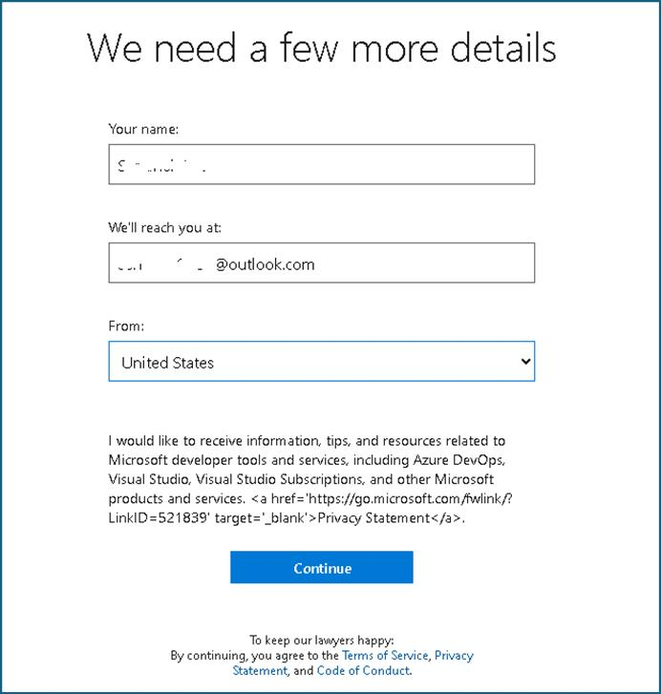

1. On the **Get started with Azure DevOps** page, select **Create new organization** and then select **Continue**.

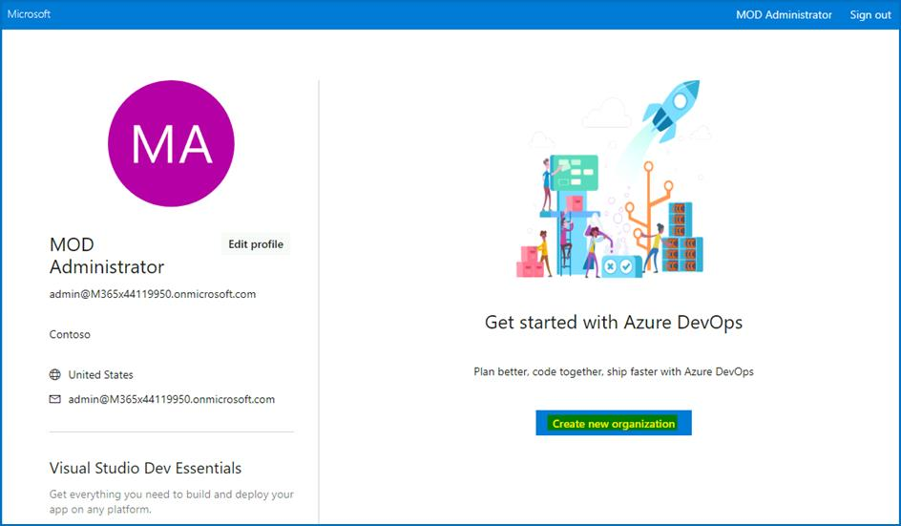

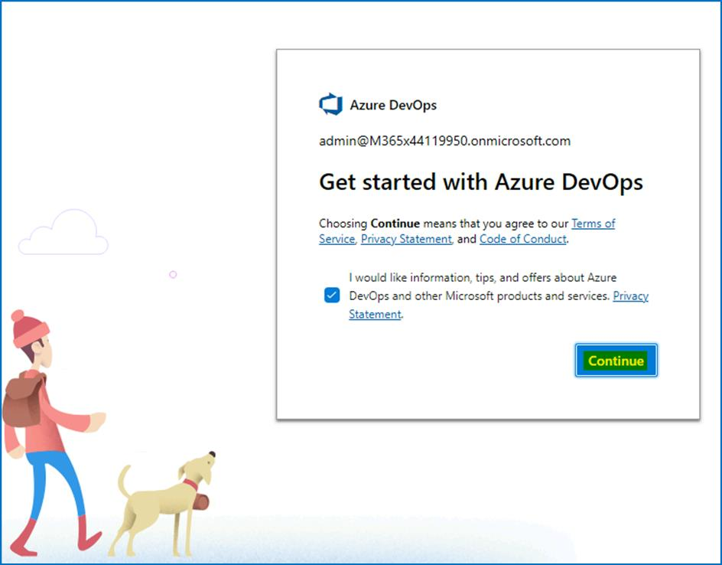

1. On the **Almost done**… page, enter a name for your DevOps organization that you would not want to use in the future like a random number **XXXXXX**. Under **We'll host your projects in**, select **United States**. Enter characters you see, then **Continue**.

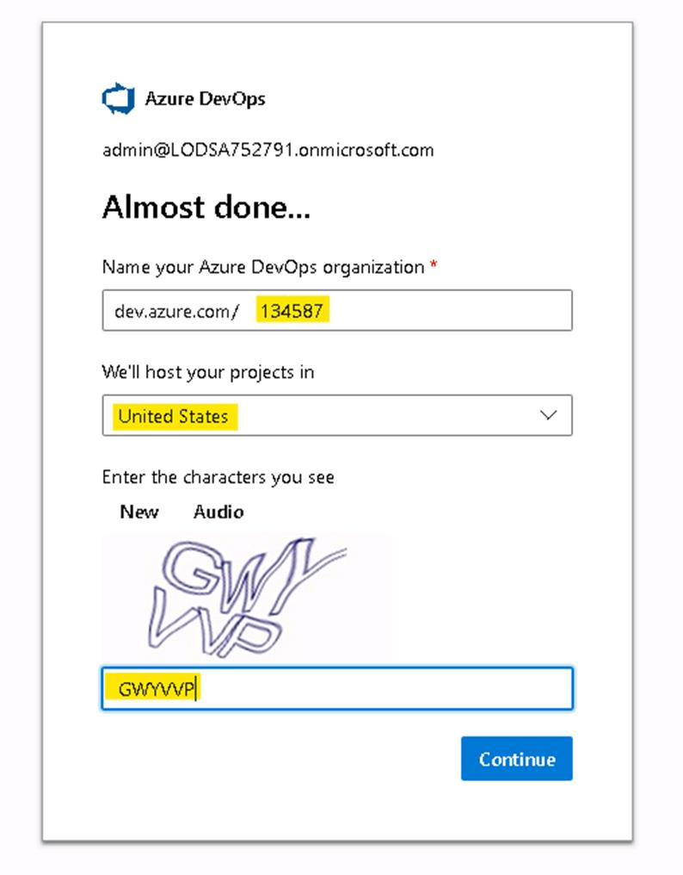

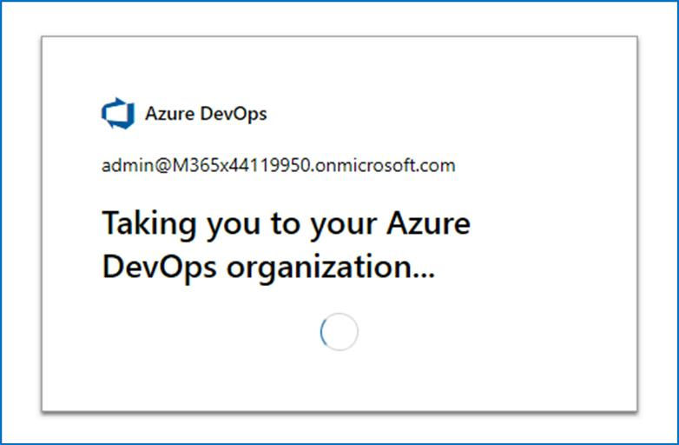

1. On the **Create a project to get started** page, enter **My Sentinel Content** and then select **Create project**.

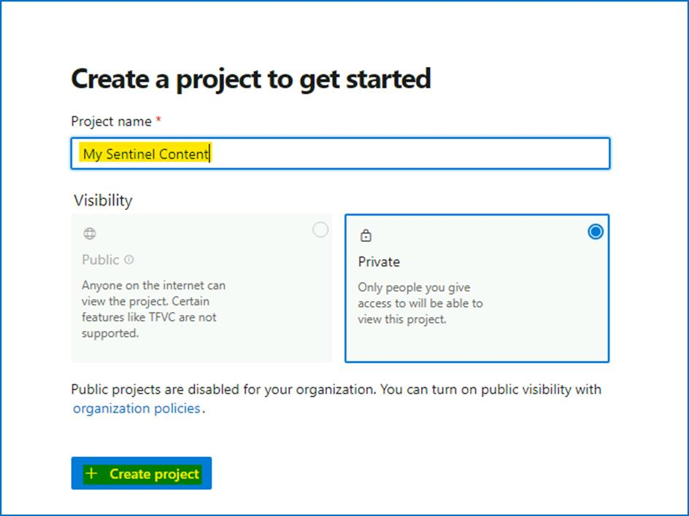

1. Navigate to **Repos** on the left pane. At the bottom of the page in the area **Initialize main branch with a README or gitignore**, select **Initialize**.

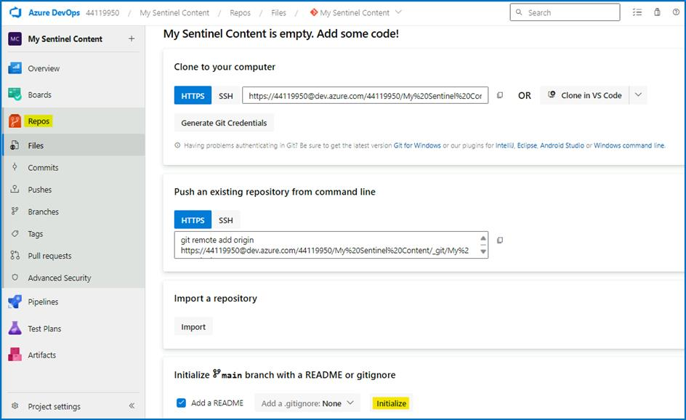

1. The page should show the Files for the Repo. The only file is README.md. On the Files (right side of the page) blade, the toolbar include options *Set up build*, *Clone*, ... Select the colon icon **(:)** to show more options. Select **Upload Files**.

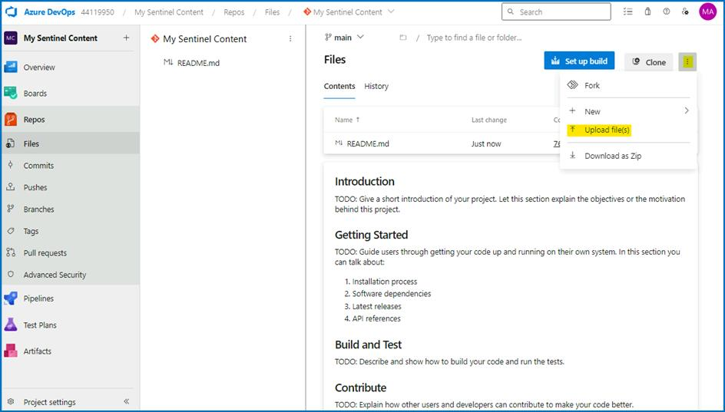

1. Select **Browse** and select the file **Azure_Sentinel_analytic_rule.json** from your **Downloads** directory. Select **Commit**.

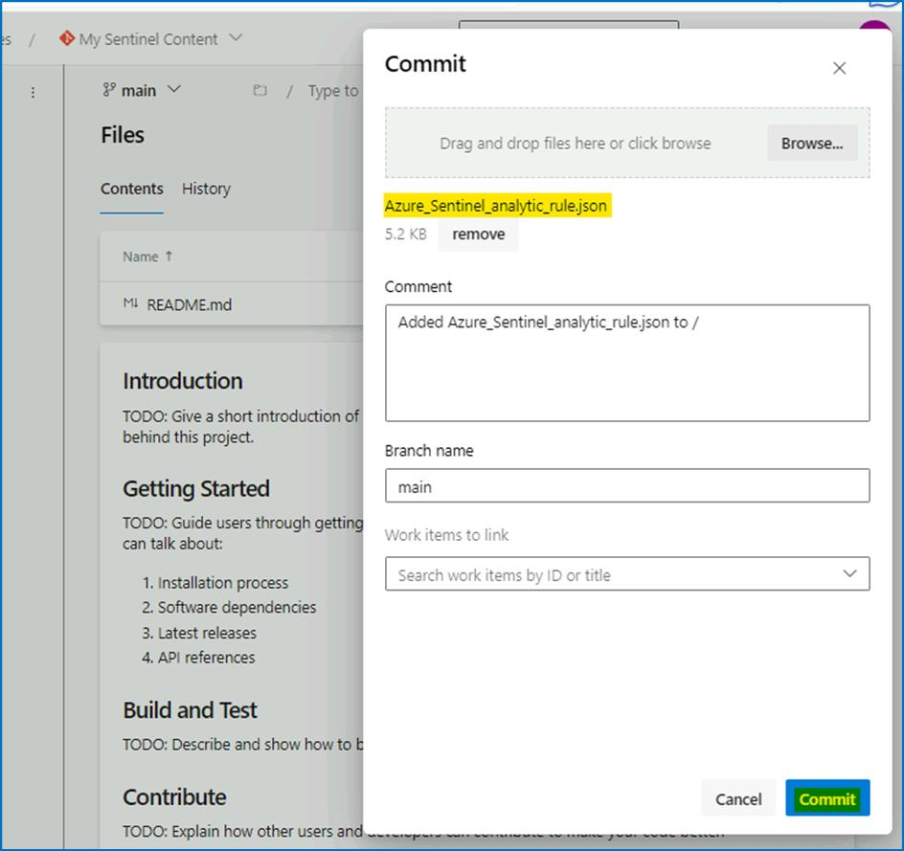

1. Select **Azure DevOps** on the top left corner of the page. This display your organization and projects. Select **Organization settings** from the bottom left of the page.

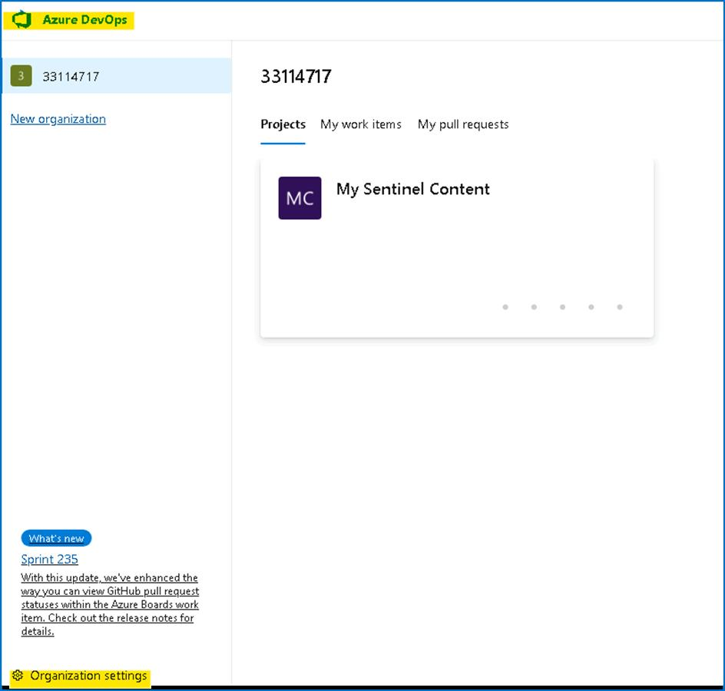

1. Select **Policies** under the **Security** area of the left blade. Toggle **On** **Third-party application access via OAuth** under the *\*Application connection policies* ***area.

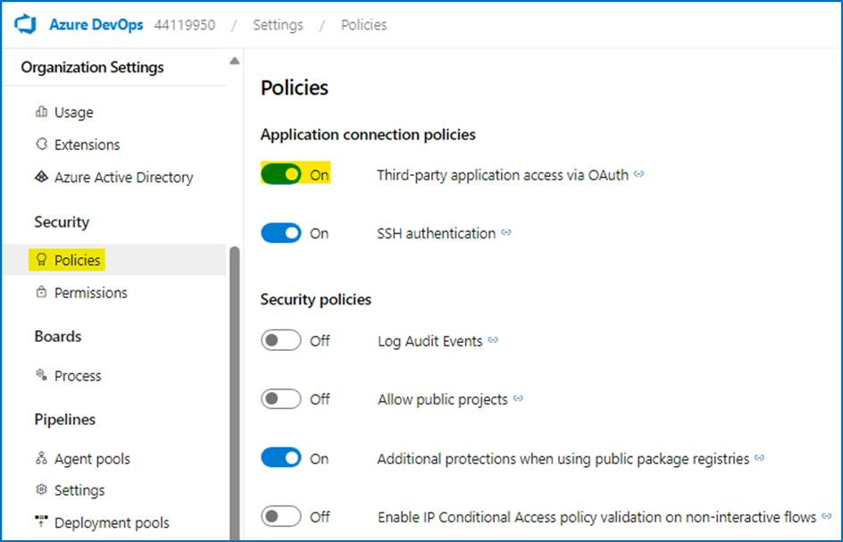

**Task 3: Connecting Sentinel to Azure DevOps**.

1. On the Azure Portal **http://portal.azure.com** and search for **Microsoft Sentinel** and click on **Microsoft Sentinel**.



1. Select **SwrkXXXXXXX**.



1. Now click on **Repositories (Preview)** in the **Content Management** section.

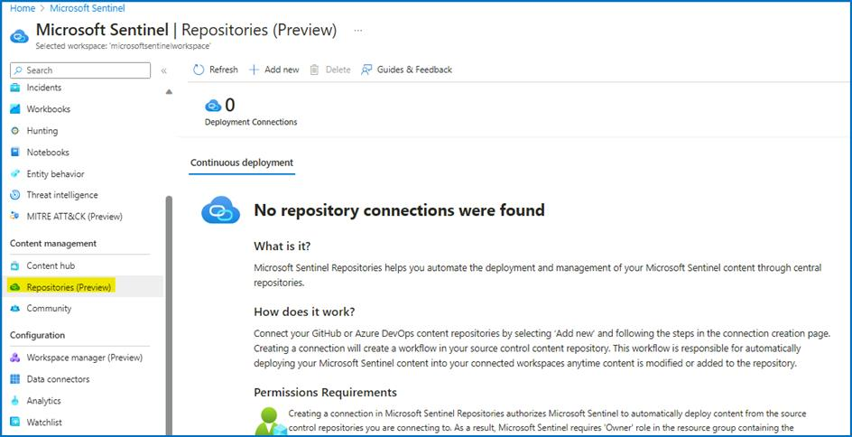

1. Select **+ Add new** button from the toolbar.

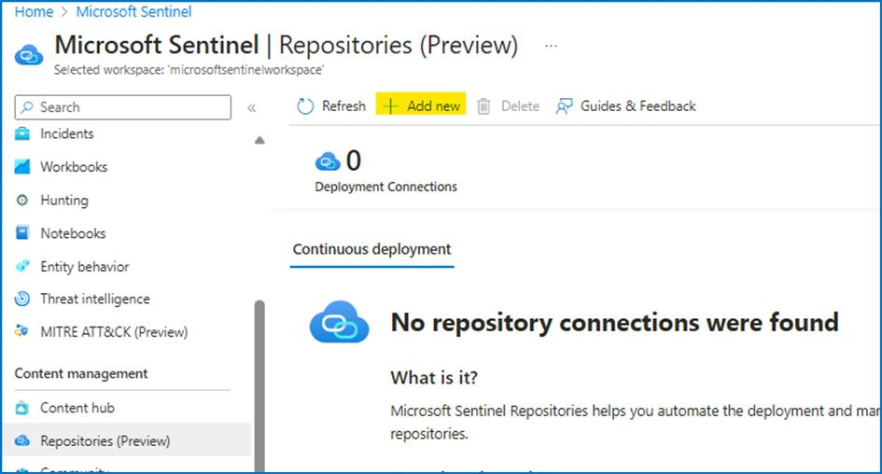

1. For the name enter **My Content**. For Source control, select **Azure DevOps**. Select **Authorize**.

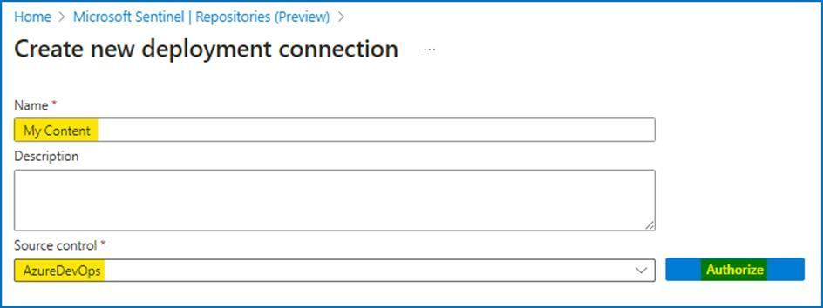

1. On the **Azure Sentinel V3 (Prod) by Microsoft** page scroll down the permissions request and then select **Accept**.

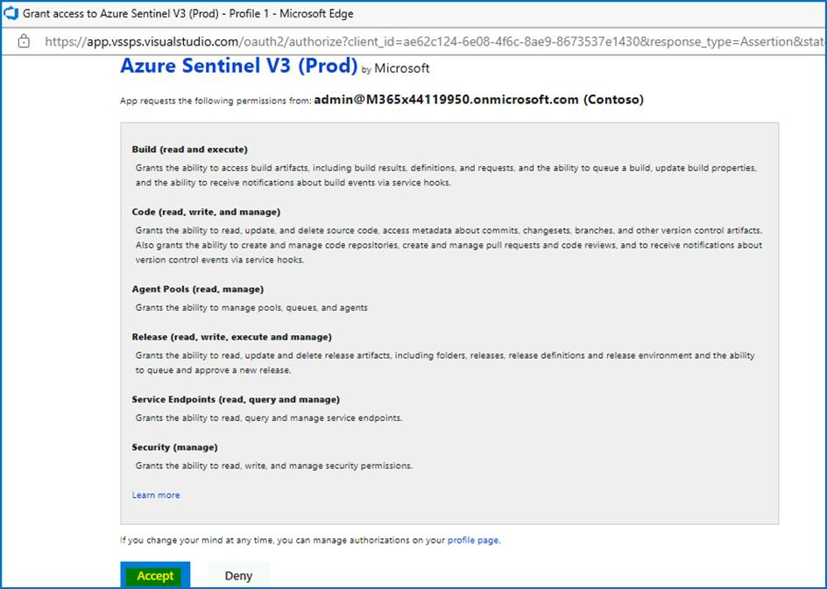

1. Select the **Organization** your created earlier. Select the Project you created earlier, **My Sentinel Content**. Select the Repository you created earlier, **My Sentinel Content**. Select the Branch **main**. Select all content types. Then select **Create**.

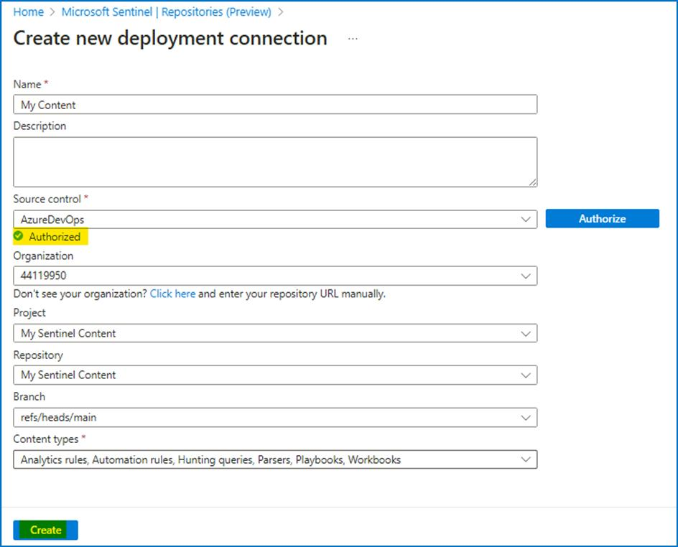

1. The Connection creation error can occur, close the page and return back to Repositories (Preview) page.

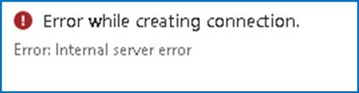

1. On the **Repositories** *(Preview)* page, select **Refresh**. Wait **until *Last* deployment status** is **Failed**.

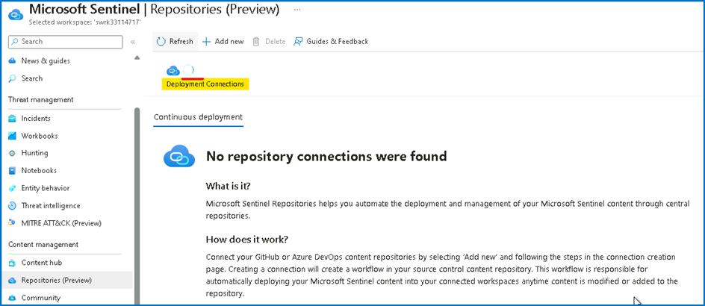

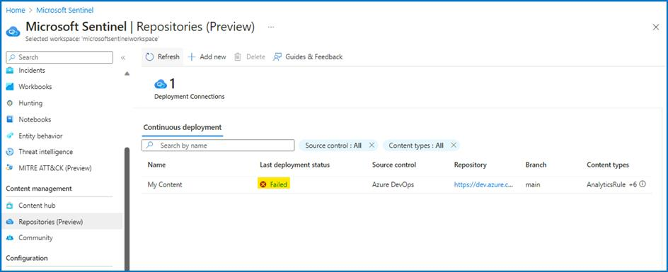

**Note:** The Failed status is due to limitations in the hosted lab environment. You would normally see Succeeded. Then you can see in the Analytics the imported rule Rule from Azure DevOps.

**Congratulation** you have completed Lab 8. In this lab, we had explored the advanced features of Microsoft Sentinel.